Digital Villa VTO (VTO6 Series)
User’s Manual

V2.0.1
Table of Contents

1 Product Overview 1
1.1 List of Models 1
1.2 VTO6000A 1
1.2.1 Front Panel 1
1.2.2 Rear Panel 2
1.3 VTO6110B/VTO6110BW/VTO6210B 2
1.3.1 Front Panel 2
1.3.2 Rear Panel 3
1.4 VTO6000C/VTO6000CM/VTO6100C 5
1.4.1 Front Panel 5
1.4.2 Rear Panel 7
2 Introduction to Web 9
2.1 Login 9
2.2 System Config 9
2.1.1 Local Config 10
2.2.2 LAN Config 12
2.2.3 Indoor Station Manager 12
2.2.4 Network Config 13
2.2.5 Change Password 13
2.3 Info Search 13
2.3.1 Call History 13
2.4 Status Statistics 14
2.4.1 VTH Status 14
2.5 Logout 14
3 Basic Function Introduction 15
3.1 Call Function 15
3.1.1 Call Manager Center 15
3.1.2 Call User 16
3.1.3 Group Call 16
3.2 Monitor 16
3.3 Unlock Function 16
3.4 Issue Card 17
3.5 Compensation of Light 17
3.6 Vandal Proof 17
3.7 Restore Backup 17
4. FAQ 18
Appendix 1 Technical Specifications 19
Appendix 2 Toxic or Hazardous Materials or Elements 22

Important Safeguards and Warnings
Please read the following safeguards and warnings carefully before using the product in order to avoid damages and losses.
Note:
- Do not expose the device to lampblack, steam or dust. Otherwise it may cause fire or electric shock.
- Do not install the device at position exposed to sunlight or in high temperature. Temperature rise in device may cause fire.
- Do not expose the device to humid environment. Otherwise it may cause fire.
- The device must be installed on solid and flat surface in order to guarantee safety under load and earthquake. Otherwise, it may cause device to fall off or turnover.
- Do not place the device on carpet or quilt.
- Do not block air vent of the device or ventilation around the device. Otherwise, temperature in device will rise and may cause fire.
- Do not place any object on the device.
- Do not disassemble the device without professional instruction.

Warning:
- Please use battery properly to avoid fire, explosion and other dangers.
- Please replace used battery with battery of the same type.
- Do not use power line other than the one specified. Please use it properly. Otherwise, it may cause fire or electric shock.

Special Announcement
- This manual is for reference only.
- All the designs and software here are subject to change without prior written notice.
-  All trademarks and registered trademarks are the properties of their respective owners.
- If there is any uncertainty or controversy, please refer to the final explanation of us.
-  Please visit our website for more information.

1 Product Overview

1.1 List of Models
This manual applies to multiple product models; please carefully confirm your model and its features.
Model | Chassis Material | Color | Unlock via IC card | Button Type | Lock Control Module
VTO6000A | Metal | Metal grey | N/A | Mechanical key | External
VTO6110B | Fireproof ABS | Black | Support | Touch button | External
VTO6110BW | Fireproof ABS | White | Support | Touch button | External
VTO6210B | Fireproof ABS | Black | Support | Touch button | Built-in
VTO6100C | Fireproof ABS | White | Support | Mechanical key | Built-in
VTO6000C | Fireproof ABS | White | Not support | Mechanical key | Built-in
VTO6000CM | Metal | Metal grey | Not support | Mechanical key | Built-in

1.2 VTO6000A

1.2.1 Front Panel
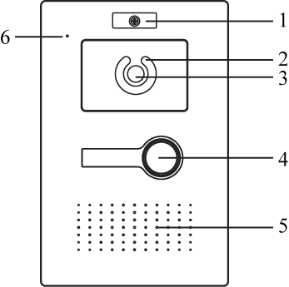
Figure 1- VTO6000A
No. | Port Name | Note
1 | Nameplate | You can fix company nameplate here.
2 | Compensation Light | Light compensation will automatically turn on during monitoring, calling, or connecting status if there is no enough light in environment.
3 | Camera | It monitors corresponding door region.
4 | Call Button | Call center or VTH.
5 | Speaker | Audio output.
6 | MIC | Audio input.

1.2.2 Rear Panel
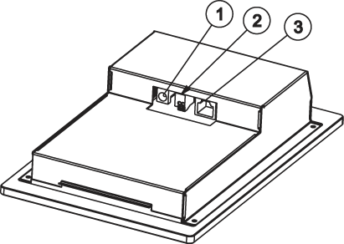
Figure 1- VTO6000A
No. | Component Name | Note
1 | Power | Connect to 12V DC.
2 | RS485 Port | May connect to access control extension module
3 | Network Port | Plug in network cable（RJ45 port）.

1.3 VTO6110B/VTO6110BW/VTO6210B

1.3.1 Front Panel
VTO6110B, VTO6110BW and VTO6210B’s front panel is as in Figure 1- .

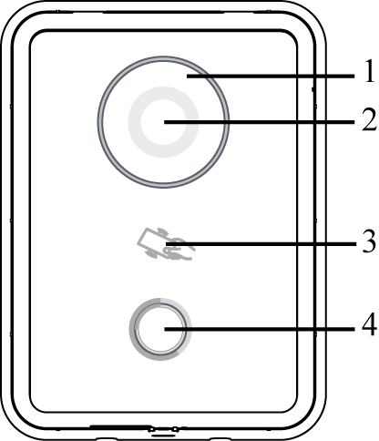
Figure 1- VTO6110B/VTO6110BW/VTO6210B

No. | Component Name | Note
1 | Compensation Light | Light compensation will automatically turn on during monitoring, calling, or connecting status if there is no enough light in environment.
2 | Camera | It monitors corresponding door region.
3 | Card Swiping Area | Authorize IC card and unlock by swiping IC card (must connect to access control extension module).
4 | Call Button | Lightly touch button area, to call center or VTH.  Blue NO: VTO is under standby status.

1.3.2 Rear Panel
VTO6110B and VTO6110BW’s rear panel is as in Figure 1- VTO6110B and VTO6110BW.
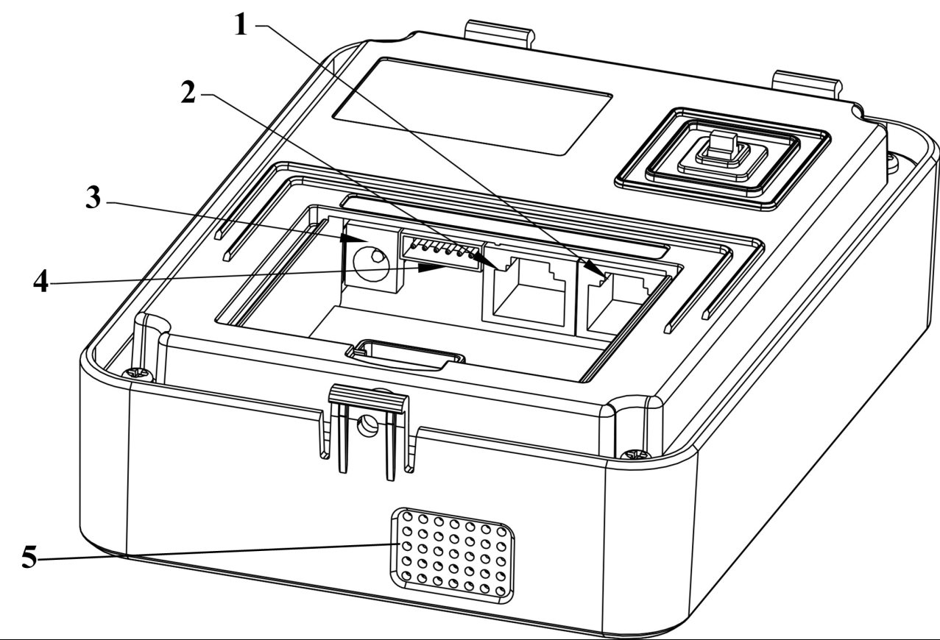
Figure 1- VTO6110B and VTO6110BW

No. | Component Name | Note
1 | Vandal Proof Switch | It will generate alarm sound and report to the center once VTO is forced to leave the wall.
2 | Network Port | Plug in network cable（RJ45 port）.
3 | Power | Connect to 12V DC.
4 | RS485 Port | May connect to access control extension module.
5 | Speaker | Audio output

VTO6210B’s rear panel is as in Figure 1- VTO6210B.

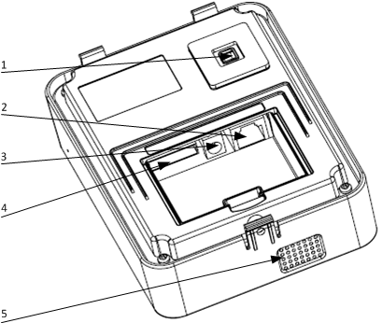
Figure 1- VTO6210B

No. | Component Name | Note
1 | Vandal Proof Switch | It will generate alarm sound and report to the center once VTO is forced to leave the wall.
2 | Network Port | Plug in network cable（RJ45 port）.
3 | Power | Connect to 12V DC.
4 | RS485 Port | May connect to door lock, door sensor and unlock button. It reserves port for other device.
5 | Speaker | Audio output

1.4 VTO6000C/VTO6000CM/VTO6100C

1.4.1 Front Panel
VTO6000C and VTO6000CM’s front panel is as in Figure 1- and VTO6100C’s front panel is as in Figure 1- .
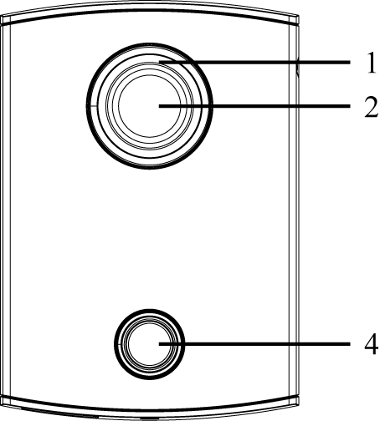
Figure 1- VTO6000C and VTO6000CM

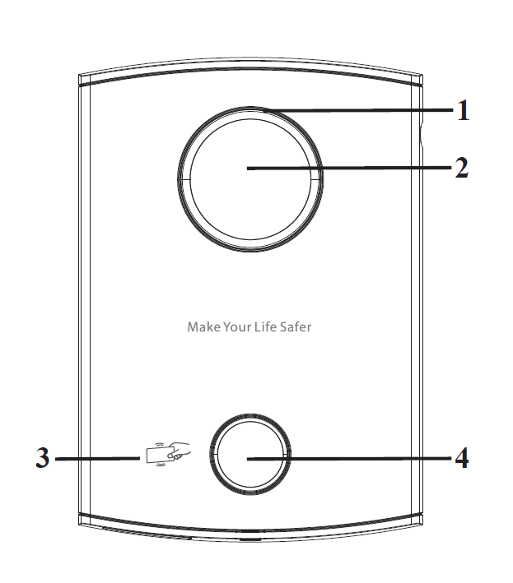
Figure 1- VTO6100C

No. | Component Name | Note
1 | Compensation Light | Light compensation will automatically turn on during monitoring, calling, or connecting status if there is no enough light in environment.
2 | Camera | It monitors corresponding door region.
3 | Card Swiping Area | Authorize IC card and unlock by swiping IC card (must connect to access control extension module).  Note:  Only VTO6100C supports IC card unlocking function. Silk-screen in this area may vary for different product.
4 | Call Button | Lightly touch button area, to call center or VTH.  Blue NO: VTO is under standby status.  Blue flashing: VTO is calling or in call status.  Yellow: IC card unlocking or call is abnormal.

1.4.2 Rear Panel

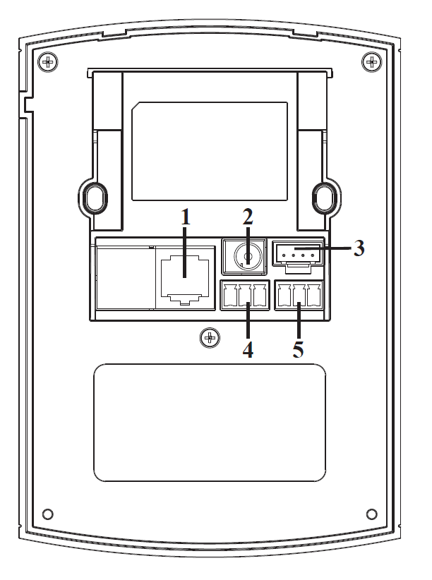
Figure 1- VTO6000C/VTO6000CM/VTO6100C
No. | Port Name | Note
1 | Network Port | Connect to network cable（RJ45 port）.
2 | Power | Connect to 12V DC.
3 | Debug Port | For installer use.
4 | Green Port 1 | Connect to lock.
5 | Green Port 2 | Connect to door sensor and unlock button.

2 Introduction to Web

2.1 Login
Here takes VTO6210B as an example.
First, make sure both PC and the VTO are connected to the Internet and follow these steps to login Web management page.
- In Internet Explorer input the IP address of VTO, press Enter. You will see the login page as in Figure 2- .

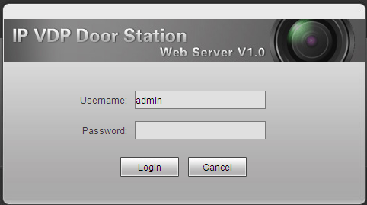
Figure 2-

- Input username and password.
- Click on Login.

Note: The default IP address of VTO is 10.22.5.189 or 192.168.1.110. Default username password is admin/admin. After you login for the first time, please change the password for security purpose.

2.2 System Config

2.1.1 Local Config

2.2.1.1 Local Config
In Local Config interface, you can view VTO model, version info and etc.
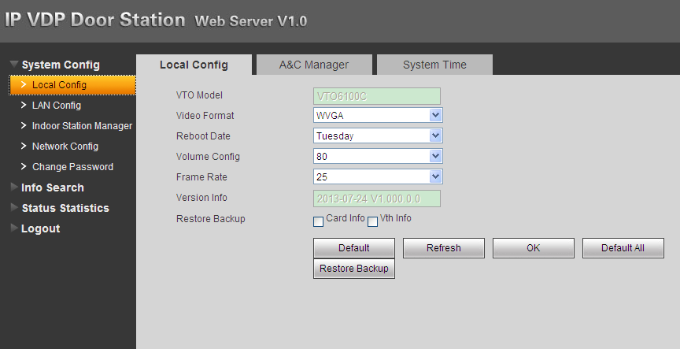
Figure 2-

Parameter | Note
VTO Model | Display VTO model, such as villa VTO, unit VTO.
Video Format | Set video format that collected by the camera, including: WVGA and D1.  WVGA resolution is 800×480; D1 resolution is 704×576.
Reboot Date | On the set date, device will automatically reboot.
Volume Config | Adjust device volume, range 0～100.
Frame Rate | NTSC: 30 fps, PAL: 25 fps.
Version Info | Display device version info.
Restore Backup | Mainly used to restore card no. and VTH info, refer to Ch 3.7.
Default | Only restore current Local Config page to default settings.
Default All | Device restores all parameters to default settings.  Every 30 minutes, VTO automatically saves card no. and VTH information in the system.

2.2.1.2 A&C Manager
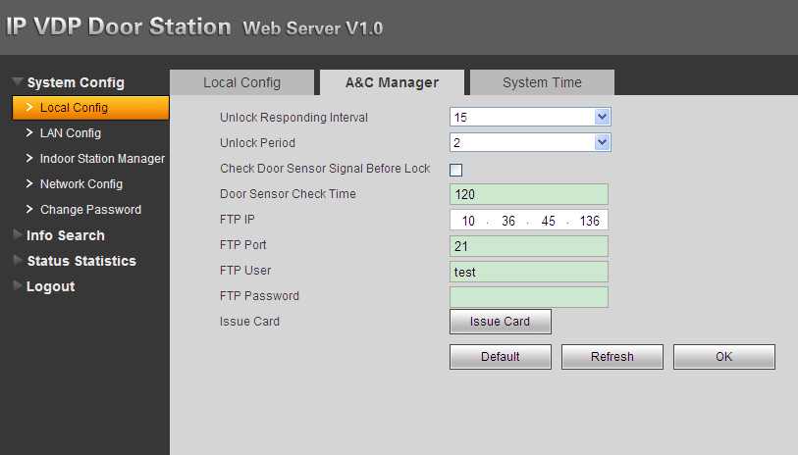
Figure 2-

Parameter | Note
Unlock Responding Interval | The interval between current unlock and next one, unit is second.
Unlock Period | Period door remains unlocked, unit is second.
FTP IP, FTP port, FTP user, FTP password | FTP server is used to store picture taken when card is swiped at VTO. User can login FTO to get these pictures.
Issue Card | Activate IC card of the VTO so user can swipe the IC card to unlock.  Note:  Please refer to Digital Villa VTO (VTO6 Series) Installation Guide V 2.0.0

2.2.1.3 System Time
Here you can set date format, time format, and input system date and time. You can also click on Sync PC to synchronize system time with PC time.

2.2.2 LAN Config
Here you can register VTO to center and set how to call center. Please refer to Ch 3.1.1.

2.2.3 Indoor Station Manager
In Indoor Station Manager interface, you can add VTH (digital indoor station), view VTH info and delete VTH.

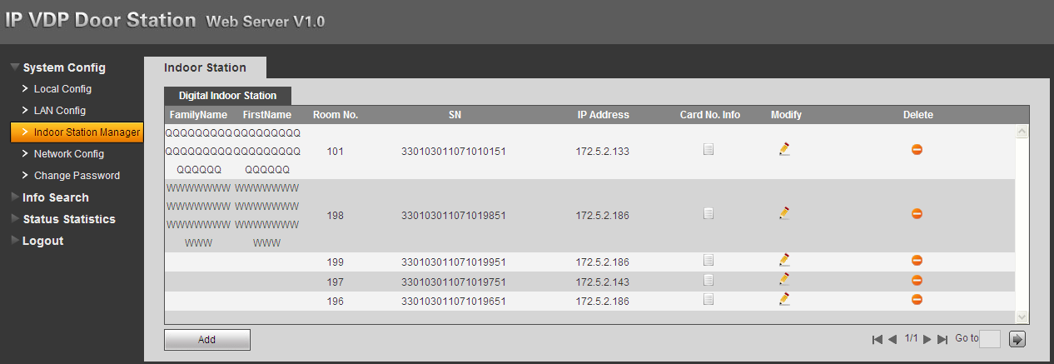
Figure 2-

Add VTH
In Indoor Station Manager interface, click on Add. The system pops up a window as in Figure 2- .
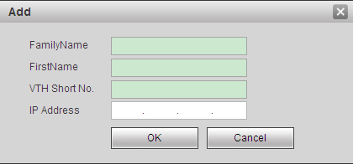
Figure 2-
Fill in VTH info as user’s name, VTH short no. and IP address.

Note:
VTH short no. consists of four digits, the first two digits can be within 01~99, the last two digits can be within 01~16.

2.2.4 Network Config
Here you can set VTO IP address, Subnet Mask and Default Gateway.
After you have modified IP address, Web page will reboot and go to the new IP address web page.

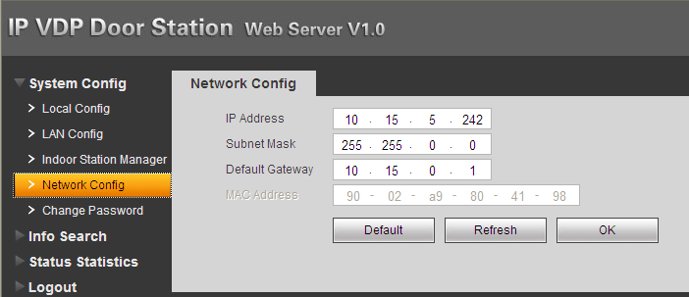
Figure 2-

2.2.5 Change Password
Here you can change login password of VTO webpage.

2.3 Info Search

2.3.1 Call History
Here you can view call history of VTO in Call History interface. It can save up to 1124 items. .
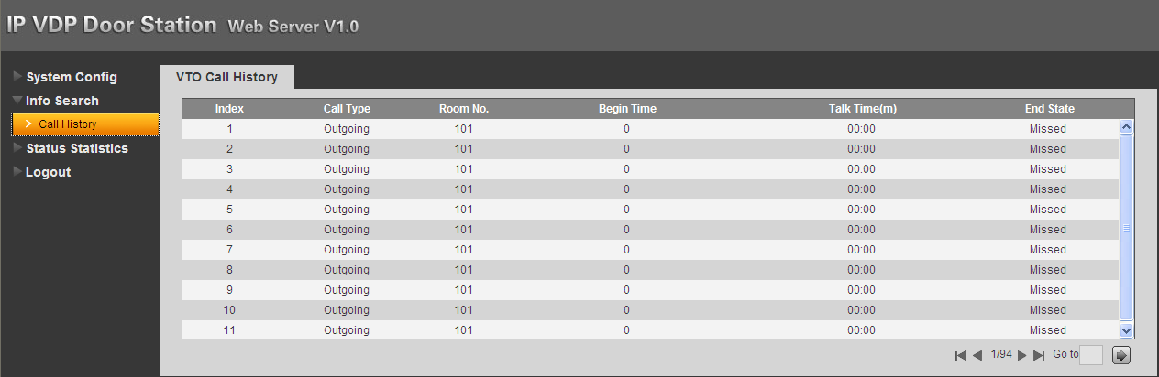
Figure 2-

2.4 Status Statistics

2.4.1 VTH Status
Here you can view connection status of VTH.
- Status
Offline: VTO and VTH are not connected, you cannot call, monitor, talk or etc.
Online: VTO and VTH are connected, you can call, monitor, talk and etc.
- MON
- Unmon: VTH is not monitoring.
- Onmom: VTH is monitoring.
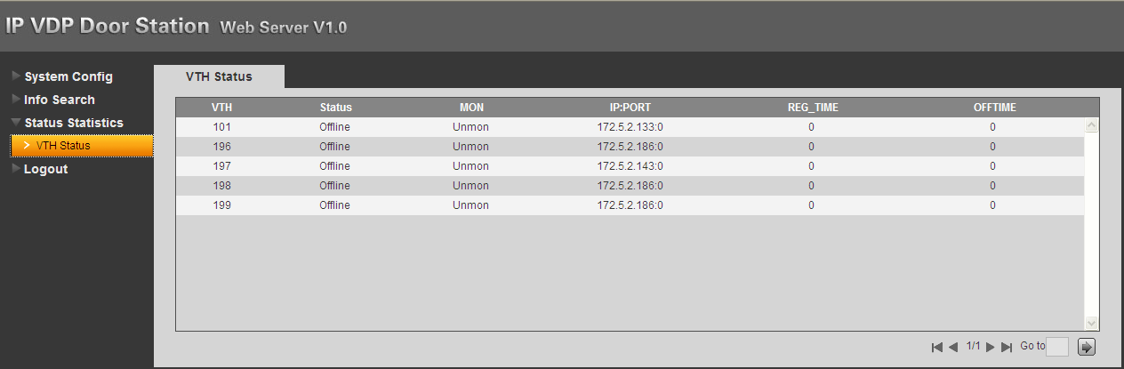
Figure 2-

2.5 Logout
Here you can reboot device or logout.
Click on logout to log out the system and it returns to login page.

3 Basic Function Introduction

3.1 Call Function

3.1.1 Call Manager Center
Check Register to the MGT Center, you can touch the button to call manager center. Now VTO can only call MGT Center. Manager center’s time can be set on management platform or villa VTO’s web-end. Once manager center picks up the call, you can perform a visual bidirectional talk with the manager center. You can touch the button on VTO to end call at any time.
- According to VTO configured for the center, fill in building no, building unit no. and VTO no.
- In LAN Config, check register to the MGT center, as in Figure 3- .
- Fill in MGT center IP address and MGT port no.
- Set call VTS time. Within this period, VTO can only call the center.
- Check Call VTS or not.
- Confirm all config, and click on OK. Enter Logout→ Reboot Devices, to manually reboot the device.

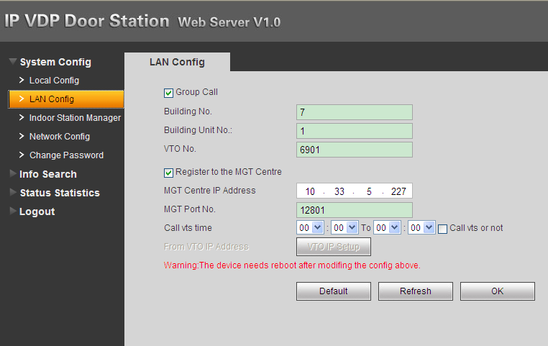
Figure 3-

3.1.2 Call User
Press Call button under standby status, and the VTO will call user. User may monitor VTO from VTH.
- On VTH, press Unlock button to unlock door.
- When VTH picks up, you can start talk with the VTH.
- If no one answers the call, then the call will end automatically and device returns to standby status.

3.1.3 Group Call
Group call is mainly used for one VTO. Press Call button on VTO to call multiple VTH at the same time.
VTH consists of master VTH and extension VTH. A system can only have a max of 1 master VTH and 5 extension VTHs. Please refer to Digital Villa VTO (VTO6 Series) Installation Guide V 1.0.0.

3.2 Monitor
Both VTS and VTH are able to monitor this VTO by enabling the camera to capture local circumstance.

3.3 Unlock Function
Unlock by Center

When center is called, calling or monitoring, center can remotely unlock door. VTO will return to standby interface after call ends or countdown stops.

Unlock under Calling Status

When VTH is called, calling or monitoring, VTH can remotely unlock door. VTO will return to standby interface after call ends or countdown stops.

Unlock by IC Card

At the card swiping area on VTO, swipe authorized IC card. You can unlock door when you pass identification.

3.4 Issue Card
Place IC card at the card swiping area to authorize it. User can swipe IC card to unlock door.
Note:
Some products do not support IC card, please refer to Ch 1.1.
The VTO supports two methods to issue card: platform and WEB. Please refer to Digital Villa VTO (VTO6 Series) Installation Guide V 1.0.0.

3.5 Compensation of Light
In dark environment or at night, the VTO adopts auto photoreception technology which achieves light compensation in connecting status.

3.6 Vandal Proof
There is one channel of vandal proof which will generate alarm sound and report to the manager center once VTO is forced to leave the wall.

3.7 Restore Backup
Restore Card Info
If you encounter abnormality with card info or accidently restore default settings, you can restore card info with this function.

Restore VTH Info
If VTH info is mistakenly changed, you can restore VTH info with this function.

Note: Every half hour, VTO automatically saves card and VTH info in the system. If you want to restore card and/or VTH info, you must restore within half hour after your last operation that change these info.

4. FAQ
- Q: I pressed the touch button, and the indicator turned on, but the VTO did not start a call?
A: Please check your operation process.
- Q: How to end a call when I am calling?
A: Please press button on VTO and there will be sound from the device.
- Q: The device could not boot up and there was no sound or light.
A: Please check if power supply is well plugged.
- Q: My call did not go though.
A: It is network connection error; please check the cables of the device and its extension.
- Q: VTO did not respond after I swiped IC card.
A: Please check if your card is authorized.
- Q: It says the card is invlid.
A: Please contact the administrator for confirmation.
- Q: I heard a beep sound when I swiped IC card, but the door did is still locked.
A: Please check if your card is authorized.
- Q: I have other problems not included above.
A: Please contact technical staffs for assistance.

Appendix 1 Technical Specifications
Model | VTO6000A
System
Main Processor | Embedded microcontroller
OS | Embedded LINUX OS
Video
Video Compression Standard | H.264
Input/Approaching Induction | 1.3 mega pixels CMOS HD camera
Night Vision | Support
Audio
Input | Omnidirectional microphone
Output | Built-in loudspeaker
Bidirectional Talk | Support bidirectional talk
Operation Mode
Input | One-key input（with backlight）
Lock Status Check | Support (Optional)
Network
Ethernet | 10M/100Mbps self-adaptation
Internet Protocol | TCP/IP
General
Power Supply | DC 10~15V
Power Consumption | Standby ≤1W ; working ≤10W
Temperature | -20℃~+70℃
Relative Humidity | 10%～90%RH
Dimensions | 151*48.5*230mm（L*W*H）
Weight | 0.96kg

Model | VTO6110B/VTO6110BW/VTO6210B
System
Main processor | Embedded microcontroller
OS | Embedded LINUX OS
Video
Video compression standard | H.264
Input/Approaching Induction | 1.3 mega pixels CMOS HD camera
Night vision | Support
Audio
Input | Omnidirectional microphone
Output | Built-in loudspeaker
Bidirectional talk | Support bidirectional talk
Operation Mode
Input | One-key input（with backlight）
Swipe card | Built-in IC card sensor
Alarm
Vandal proof | Support
Door status check | Support
Network
Ethernet | 10M/100Mbps self-adaptation
Internet protocol | TCP/IP
General
Power supply | DC 10~15V
Power consumption | Standby ≤1W ; working ≤10W
Temperature | -10℃~+60℃
Relative Humidity | 10~95%RH
Dimensions | 114.2mm*43mm*154.2mm（L*W*H）
Weight | 0.5kg

Model | VTO6000C/VTO6000CM/VTO6100C
System
Main processor | Embedded microcontroller
OS | Embedded LINUX OS
Video
Video compression standard | H.264
Input/Approaching Induction | 1.3 mega pixels CMOS HD camera
Night vision | Support
Audio
Input | Omnidirectional microphone
Output | Built-in loudspeaker
Bidirectional talk | Support bidirectional talk
Operation Mode
Input | One-key input（with backlight）
Swipe card | Built-in IC card sensor (for VTO6100C only)
Alarm
Vandal proof | Support
Door status check | Support
General
Ethernet | 10M/100Mbps self-adaptation
Internet protocol | TCP/IP
Power supply | DC 10~15V
Power consumption | Standby ≤1W ; working ≤10W
Temperature | -10℃~+60℃
Relative Humidity | 10~95%RH
Dimensions | 100*42*141mm（L*W*H）
Weight | 0.5kg

Note:
- This manual is for reference only. Slight difference may be found in user interface.
- All the designs and software here are subject to change without prior written notice.
- All trademarks and registered trademarks are the properties of their respective owners.
- If there is any uncertainty or controversy, please refer to the final explanation of us.
- Please visit our website or contact your local service engineer for more information.

