Access Control Extension Module DEE1010A
User’s Manual

V1.0.0

The product is shown as in Figure 1- .

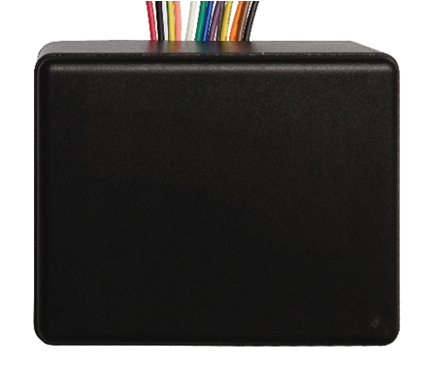
Figure 1-

Wiring function of access control extension module is shown as in Chart 1- .
Access Control Extension Module Wiring Function
Group | Color | Function | Color | Function
4-Pin Cable A | Black | GND | Brown | Door sensor response
4-Pin Cable A | Orange | Alarm input | Yellow | Open button
3-Pin Cable  (Lock Control) | Grey | NC | Blue | Public port
3-Pin Cable  (Lock Control) | Purple | NO
4-Pin Cable B | Green | Door station,  cascading 485+ | Black | Power ground
4-Pin Cable B | White | Door station,  cascading 485- | Red | +12V
2-Pin Cable | Pink | Card-reader 485+
2-Pin Cable | Yellowgreen | Card-reader 485-
Chart 1-

Access control extension module is suitable for 86-box installation, and this extension module can independently cooperate with access control, video door phone (VDP) and management platform, leading to simple access control extension. This module is communicating with upper level device via RS485 BUS, thus allows access control and card swiping function via card reader. Meanwhile this module has one channel of door sensor input, one channel of exit button input, one channel of alarm input, one channel of door lock control output and etc. Choice of Normally on or normally closed is available.

Access control extension module works together with corresponding management platform to bring about functions to issue card, delete card, open the door remotely and etc. The module uploads information regarding card swiping, access, and alarm to the management center, contributing to real time monitor of the door. Additionally, management center is able to configure access control specifications of the module, and set duration of valid swiping of card, time sync and etc. After releasing card authorization, even without main controller, access by card swiping or open button is still available.

Typical Wiring of an Access Control System:

Please see Figure 2- .

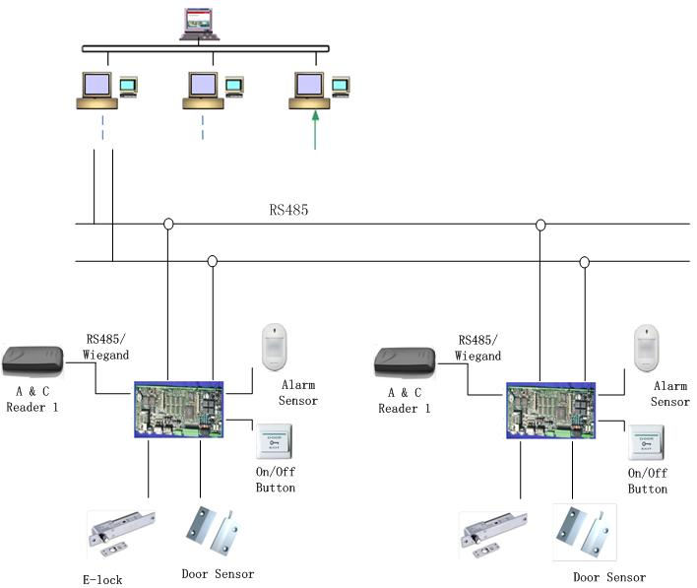
Figure 2-

Technical specifications are shown as in Chart 3- .

Model | DEE1010A
Access Control
Lock NO Output | Yes
Lock NC Output | Yes
Open Button | Yes
Door Status Detection | Yes
Operating Mode
Input | Card swiping input（card reader required）and open button
IC Card
Card Storage Limit | Max: 5000
Add Card & Delete Card | Yes
Real Time Clock
Clock Adjustment | Yes
RTC Time Protection in Outage | Yes
Alarm
External Alarm Input | 1 channel
Reporting
Card NO. | Yes
Access | Yes
Alarm | Yes
Specifications
Power | DC 9 ~ 15V
Power Consumption | Standby ≤0.5W ；working ≤1W
Environment | -10℃~+60℃
Environment | 10~95%RH
Dimensions | 68mm*52mm*24.5mm（length*width*height）
Weight | 0.042kg
Chart 3-

- Q：I can’t open door after swiping card?
A：You should report to corresponding management center. The issue maybe arises because: (1) Card authorization has expired; (2) Card is not authorized to open this door; or (3) No access allowed during this period.
B：Door sensor is damaged.
C：Card reader has poor contact.
D：Door locker or device is damaged.

- Q：The device can’t communicate with management center?
A：Check the connection of 485 cable.

- Q：I can’t open door by pressing open button?
A：Check the connection between the button and the device.

- Q：After the door opens, the lock remains unlocked?
A：Check if the door is closed.
B：Check if door sensor is properly connected. If there is no door sensor, please check with management center.

- Q：I have other unsure or unsolvable problems, what should I do?
A：Please contact technical support.

Note:
- This manual is for reference only. Slight difference may be found in user interface.
- All the designs and software here are subject to change without prior written notice.
- All trademarks and registered trademarks are the properties of their respective owners.
- If there is any uncertainty or controversy, please refer to the final explanation of us.
- Please visit our website or contact your local service engineer for more information.

