2-Wire Network Controller VTNC3000A
User’s Manual

V1.0.0

Table of Contents
1 Product Overview 1
1.1 Features 1
1.2 Device Structure 1
2 Installation 3
2.1 DIN-Rail Mount 3
2.2 Wall Mount 4
2.2.1 Screw 4
2.2.2 Installation Steps 4
Appendix 1 Technical Specification 5

Important Safeguards and Warnings
Please read the following safeguards and warnings carefully before using the product in order to avoid damages and losses.
Note:
- Do not expose the device to lampblack, steam or dust. Otherwise it may cause fire or electric shock.
- Do not install the device at position exposed to sunlight or in high temperature. Temperature rise in device may cause fire.
- Do not expose the device to humid environment. Otherwise it may cause fire.
- The device must be installed on solid and flat surface in order to guarantee safety under load and earthquake. Otherwise, it may cause device to fall off or turnover.
- Do not place the device on carpet or quilt.
- Do not block air vent of the device or ventilation around the device. Otherwise, temperature in device will rise and may cause fire.
- Do not place any object on the device.
- Do not disassemble the device without professional instruction.

Warning:
- Please use battery properly to avoid fire, explosion and other dangers.
- Please replace used battery with battery of the same type.
- Do not use power line other than the one specified. Please use it properly. Otherwise, it may cause fire or electric shock.

Special Announcement
- This manual is for reference only.
- All the designs and software here are subject to change without prior written notice.
- All trademarks and registered trademarks are the properties of their respective owners.
- If there is any uncertainty or controversy, please refer to the final explanation of us.
-  Please visit our website for more information.

Product Overview

Features
2-wire network controller supports 4 2-wire devices, to connect into network, see Figure 1-

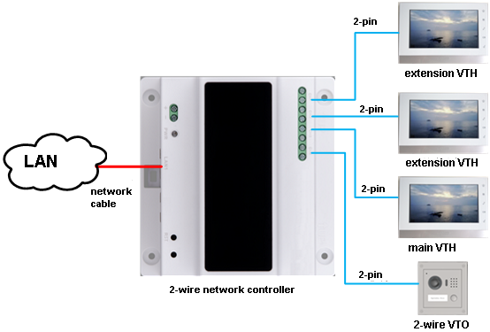
Figure 1-

Device Structure
Device structure is shown in Figure 1- .
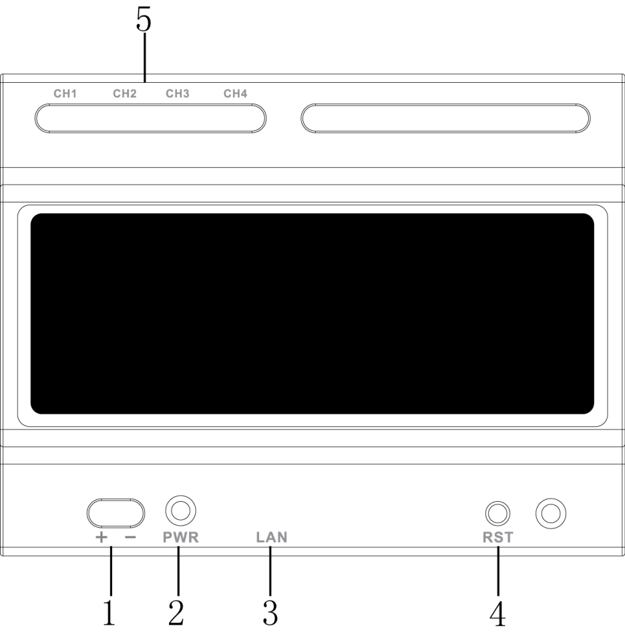
Figure 1-

No. | Component | Note
1 | Power Port | DC24V±10% input
2 | Power Indicator | Normally power on, indicator turns on
3 | Network Port | RJ45 port, connect LAN
4 | Reset | Reboot device
5 | 2-wire port | 4 groups of 2-wire port, connect to other 2-wire devices

Installation

DIN-Rail Mount
Hang the 2-wire network controller on the installation bracket with a hook. Press the 2-wire network controller, make buckle click into installation bracket. See Figure 2- .
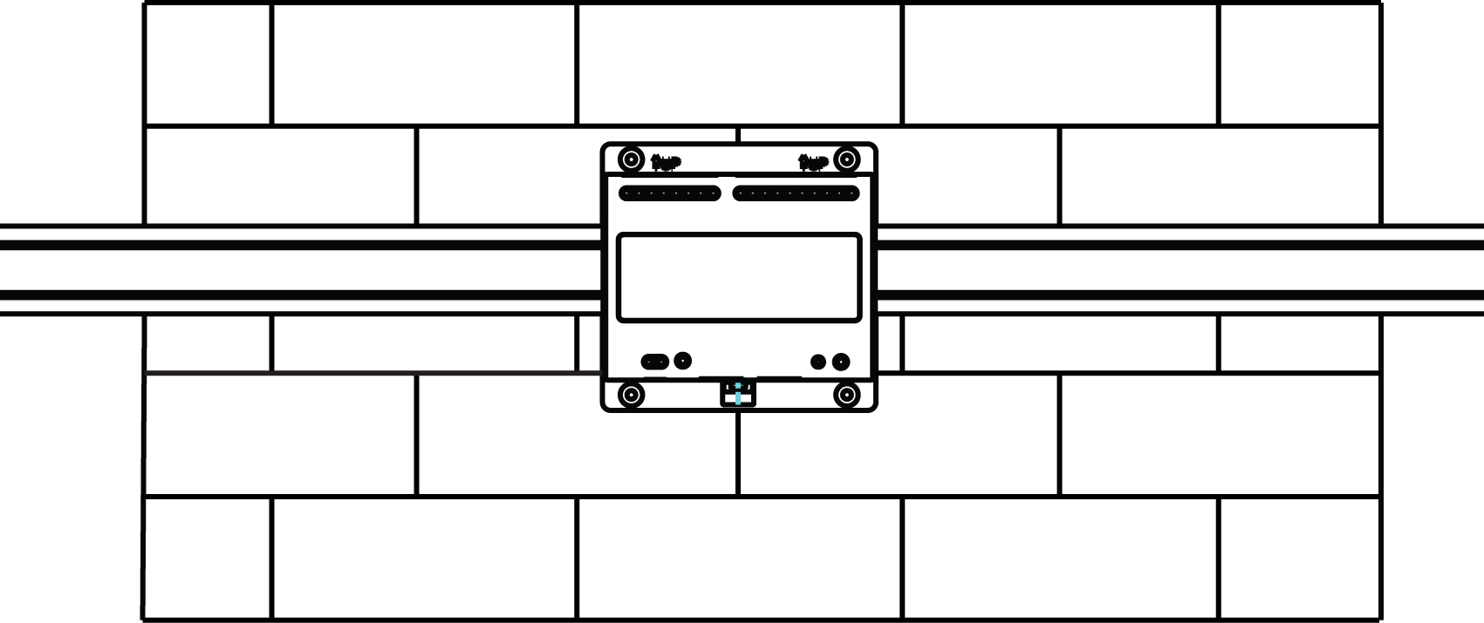
Figure 2-

Note:
- Before installation, please make sure the lower buckle is open as in Error: Reference source not found.
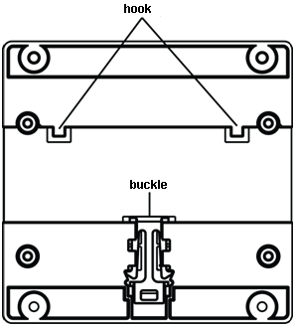
Figure 2-

Wall Mount

Screw
Component | Illustration | Quantity
ST3×18 Cross recessed pan head self-tapping screws - nickel silver | 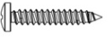 | 4
White expansion pipe ￠6×30mm | 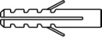 | 4

Installation Steps
- Place the device against the wall, mark four holes with a pencil, and dig hole with a electric drill
- Insert white expansion pipe into the holes.
- Lock the device on the wall with screws, see Figure 2- .
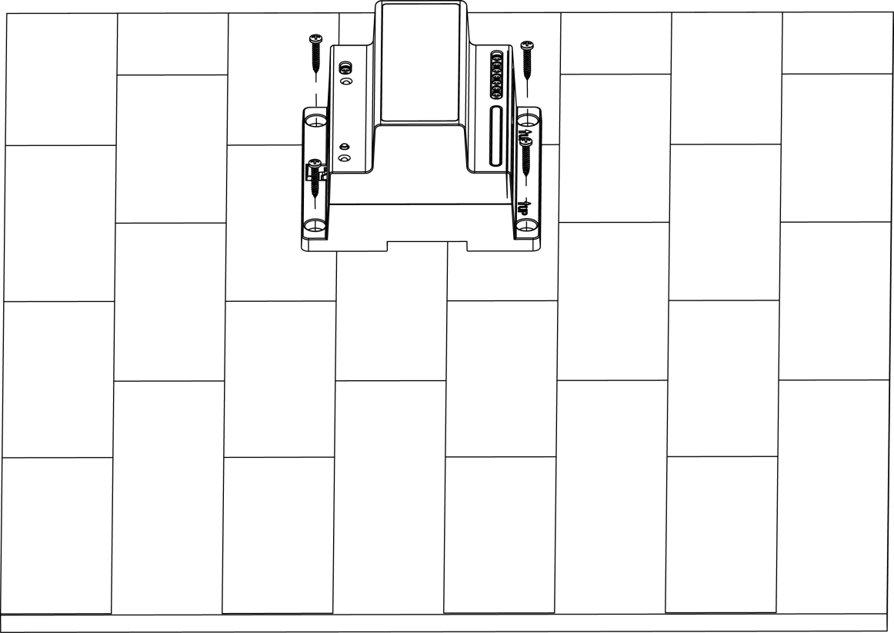
Figure 2-

Appendix 1 Technical Specification
Model | VTNC3000A
Power | DC 24V±10%
Consumption | Max consumption(4-CH output full load)：30W
Working Temperature | -10℃～55℃
Dimension（L×W×H） | 108 × 108 × 64 mm
Weight | 0.5kg

Note:
- This manual is for reference only. Slight difference may be found in the user interface.
- All the designs and software here are subject to change without prior written notice.
- All trademarks and registered trademarks mentioned are the properties of their respective owners.
- If there is any uncertainty or controversy, please refer to the final explanation of us.
- Please visit our website or contact your local retailer for more information.

