IR Speed Dome User’s Manual

Version 1.0

Table of Contents
1 Features and Functions 8
1.1 General Introduction 8
1.2 Features 8
1.2.1 On-Screen Menu 8
1.2.2 On-screen Tips 8
1.2.3 Support multiple protocols 8
1.2.4 Proportional Pan and Tilt 8
1.2.5 Preset Setup and Recall 8
1.2.6 Auto Scan 9
1.2.7 Auto Touring 9
1.2.8 Auto Pattern 9
1.2.9 Privacy Masking 9
1.2.10 IR Night Vision 9
1.2.11 Action on Alarm 9
1.2.12 Auto Flip 9
1.2.13 Self-diagnosis 9
1.2.14 Day/Night Mode (B/W & Color Mode) 9
1.2.15 Auto Focus 9
1.2.16 Backlight Compensation 10
1.2.17 Pan Tilt and Zoom 10
1.2.18 3D Intelligent Location 10
1.2.19 Idle Status 10
1.2.20 Image Flip 10
1.3 Specifications 10
1.3.1 Performance Specifications 10
1.3.2 Technical Specifications 11
2 Protocol, Baud Rate, Address setup 13
2.1 Protocol and Baud Rate Setup 13
2.2 Set address dial switch 14
3 Cable Connection 16
3.1 RS485 and Power Cable Connection 16
3.2 Alarm Cable Connection 17
3.2.1 System Layout 18
3.2.2 Alarm Connection 19
3.2.3 Keyboard Connection 19
4 Menu 21
4.1 Screen Menu Index 21
4.2 Self-diagnosis System Information 22
4.3 Main Menu 22
4.4 Menu Operation 23
4.4.1 System Information 23
4.4.2 Display Setting 24
4.4.3 Camera Setting 25
4.4.4 Function Setting 28
4.4.5 IR Light Setup 34
4.4.6 Alarm Setup 35
4.5 Dome Abnormal Phenomenon Operation 36
4.5.1 Restore to Factory Default Setup 36
4.5.2 PTZ Movement is not smooth 36
5 FAQ 37
5.1 Daily Maintenance 37
5.2 Problems and Solutions 37
6 Appendix Ⅰ Thunder Proof and Surge Protection 38
7 Appendix Ⅱ About RS485 Bus 39
7.1 RS485 Bus Main Feature 39
7.2 RS485 Bus Transmission Distance 39
7.3 Connection Methods and Terminal Resistance 39
7.4 The Problem in Practical Use 39
7.5 RS485 Bus FAQ 40
8 Appendix Toxic or Hazardous Materials or Elements 41

Welcome
Thank you for purchasing our product!
This user’s manual is designed to be a reference tool for the operation of your system.
Here you can find information about this speed dome features and functions, as well as a detailed menu tree.
Please keep it well for future reference!

Before installation and operation, please read the following safeguards and warnings carefully!

Important Safeguards and Warnings
1．Electrical safety
- All installation and operation here should conform to your local electrical safety codes.
- The power shall conform to the requirement in the SELV (Safety Extra Low Voltage) and the Limited power source is rated 24V AC in the IEC60950-1.
- We assume no liability or responsibility for all the fires or electrical shock caused by improper handling or installation.
- We are not liable for any problems caused by unauthorized modification or attempted repair.

2．Transportation Security
- No heavy stress, violent vibration or water splash are allowed during transportation, storage and installation.
- Please use the original packing material (or the material of the same quality) when you ship it back to the manufacturer.

3．Installation
- Do not apply power to the product before completing installation.
- Do not put object on the product.

4．Environment
- This series product should be installed in a cool, dry place away from direct sunlight, inflammable, explosive substances and etc.
- The working temperature ranges from -30℃—60℃ (Outdoor). Please keep it away from the electromagnetic radiation object and environment.
- Please keep the sound ventilation.
- Do not allow the water and other liquid falling into the device.
- Please make sure the CCD (CMOS) component is out of the radiation of the laser beam device. Otherwise it may result in CCD (CMOS) optical component damage.

5. Daily Maintenance
- Current series product has no power button. Please unplug all corresponding power cables before your begin installation or daily maintenance work.
- Please keep the dustproof cap back to protect the CCD or CMOS part if the device does not work for a long time.
- Do not touch CCD (CMOS) component. You can use the blower to clean the dust on the surface of the device. You can use the dry cloth with some alcohol or mild detergent to clear if necessary.
- Do not use the volatility solvent such as the benzene or thinner, or detergent with strong abradibility. It may result in lens damage or it may adversely affect the device performance.
- If there is too much dust, please use the water to dilute the mild detergent first and then use it to clean the device. Finally use the dry cloth to clean the device
6. About Accessories
Always use all the accessories recommended by manufacturer.
Before installation, please open the package and check that all the components are included in the package:
Contact you local retailer ASAP if something is missing in your package.

Features and Functions

General Introduction
This series IR speed dome product is an integrated high intelligent speed dome. It adopts water drop configuration design and has small and delicate shape. This is a digital and intelligent product of vivid video. It supports the auto IR light enable function in low illumination environments and the near and far light intelligent control. The installation is convenient.

The IR speed dome external ports adopt the buckle device to realize the quick installation. There is waterproof interface for the pipe thread. All of these make the installation easier. It supports various languages, real-time clock function and protocol auto recognition. It supports 360° continuously pan, 92°tilt and 180° auto flip. It can realize no blind spot monitor.

This series product can be widely used in remote monitor environments such as electric power, customs, and water conservancy. It is suitable for the monitor environments of low illuminations such as the village, town and suburb.

Features
This series speed dome has the following features:

On-Screen Menu
This series product menu supports multiple languages display and switch.
It is easy for you to view dome information and configure dome, camera parameters.

On-screen Tips
Here you can view:
- Preset name and system version (Software and hardware)
- Dome system temperature. (Optional. You can disable this function)
- Dome address. (Optional. You can disable this function)

Support multiple protocols
This series speed dome supports universally used protocols such as PELCO-P and PELCO-D. You can use various devices (such as matrix, control keyboard and DVR) and protocols to operate speed dome.

Proportional Pan and Tilt
This function keeps the image from moving too fast when there is a large amount of zoom.
Speed dome continually decreases or increases pan and tilt speeds in proportion to depth of zoom. When zooms speed is increasing, the camera moving speed becomes slow. When zooms speed is decreasing, the camera moving speed becomes fast.

Preset Setup and Recall
Preset function is to save the address information (such as PTZ pan/tilt, focus and etc) to the memory so that you can quickly adjust the dome and PTZ to the correct position. This series speed dome max supports 255 presets in PELCOD and PELCOP protocols. .

Auto Scan
Camera scans back and forth regularly in a horizontal field. Here you need to set left and right limit and scan speed. You can set 5 scanning paths.

Auto Touring
Add addresses into a routine in a desired order and then set time and stop duration for each address. The dome will begin an auto touring between these addresses. You can set 8 touring paths.

Auto Pattern
Memorize dome operation such as pan, tilt, and zoom to repeat. Focus and iris are in auto mode during auto pattern. For each pattern, the time should be less than 60 seconds. You can set 5 pattern paths.

Privacy Masking
Privacy masking is a user-defined, four-sided area that can not be viewed by you. The masking area will move with pan and tilt functions and automatically adjust in size as the lens zooms. You can set 8 privacy masking zones (Depends on camera type).

IR Night Vision
In the night vision status, it can use the IR light to spot the monitor object, or you can monitor the environments in the low illumination at night.

Action on Alarm
This series speed dome support three alarm activation operations. There are 7 alarm inputs (NO/NC). Alarms can be individually programmed to initiate an associated preset, scanning, or tour when received. Dome will return to a previously programmed state after alarm acknowledgement or to its previous position before alarm.

Auto Flip
As long as you continue to hold the keyboard joystick in the down position, the dome rotates 180 degrees and repositions itself for uninterrupted viewing of any subjects that passes directly beneath the dome.

Self-diagnosis
There is a self diagnosis procedure when dome boots up.
- Tilt and vertical engine check
- Camera diagnostics
- Display dome information and diagnosis information such as address, protocol, baud rate, type.

Day/Night Mode (B/W & Color Mode)
System supports auto/manual switch in low illumination. You can specify the switch time.
- In the auto mode and photosensitive resistance mode, the camera can automatically switch the CCD level according to the light change. In the manual mode, it can use the menu or the button to realize the color display, black and white display, and schedule switch. All the modes will have automatically activation operation on the IR light except the camera auto mode.
- This function works with the IR night vision function.

Auto Focus
Auto focus allows the lens to remain in focus during zoom-in, zoom-out and motion functions to get vivid image. You can use FAR or NEAR button to adjust focus manually.

Backlight Compensation
Balance the brightest and darkest sections of a scene to produce a more vivid picture.

Pan Tilt and Zoom
Supports zoom in and zoom out during tilt and pan movement.
In this period focus and iris are both in auto mode to get vivid image.

3D Intelligent Location
Working with DVR, just click part of the current scene will be displayed in the central window and automatically zooms. All of these allow you to trace precisely.

Idle Status
When there is no available order, you can use menu to set dome idle status after specified duration. The idle status includes turn to specified preset or go to scan, tour or pattern function.

Image Flip
You can enable image flip in the menu.
The flip function allows you to view continuous video.

Specifications

Performance Specifications
Built-in  Decode | All digital design. All data are in the connection board. No data loss when power off occurs.  - Integrated design, high stability.  - IR speed dome max support 255 presets. Support 8 auto touring. Each touring max has 32 presets.  - 5 auto scan.  - 5 auto pattern. Each pattern can max support 400 commands and the interval shall be less than 60s.  - Built-in direction indicator.  - RS485 BUS control.  - Support max 8 privacy mask zones(Depends on the camera type)  - 7 alarm inputs and 2 alarm outputs.  - Built-in various adjustable protocols, baud rate.
Built-in PTZ | - Fine stepper driver, stable performance, react quickly, precisely positioning.  - Integrated design, tight structure.  - Elegant mechanical driver device. Support 360 degrees continuous rotation, no monitor blind spot.  - 0.1°/s rotation speed while maintain stable image.  - 180 degrees tilt continuous monitor.
Built-in IR light | - Support zoom level has the higher priority (default), manual or the height has the higher priority.  - In the night vision status, it can use the IR light to spot the monitor object, or you can monitor the environments in the low illumination at night.
Built-in zoom lens, high sensitive, high resolution integrated digital process color camera. | - Auto focus  - Auto iris control  - Auto brightness control  - Auto white balance  - Auto day/night switch (Auto B/W & color switch)
OSD | - Preset title display  - View dome initial setup information  - Modify camera parameter  - Set preset  - Set auto scan  - Set 7 alarm inputs and 2 alarm outputs.  - Set auto patter  - Set auto day/night switch (Auto B/W & color switch)  - Set privacy mask zones

Technical Specifications
Power | AC 24V/3A（±20%）(Includes temperature control circuit)
Camera Driver Consumption | 11W
IR Light Consumption | ≤20W
Decoder | Built-in
Engine | Stepper motor
Preset | 255( in PELCO protocol)
Auto Tour | 8
Auto Pattern | 5
Auto Scan | 5
Privacy Mask | Maximum 8 zones
Alarm Input/Output | 7/2
Information | Time, address, dome title, dome coordinates, temperature and etc.
Lens | Adjust speed in accordance with lens
Auto Rotation | Tilt 92º auto rotates to pan 180 º
Auto Pan | 0 º -360º continuously
Manual Pan Motion Speed | 0.1º—200º/S
Preset Maximum Speed | 60 º～240º/s. There are 16-level. You can set from the menu.
Manual Tilt Motion | 0.1º—120º/S
Manual Tilt Scan Section | 0º—180º
Control Port | RS485 BUS
Baud Rate | 1200/2400/4800/9600 (Optional)
PTZ Scan Accuracy | 0.06 ± 0.015º
Signal Format | PAL/NTSC (Camera mode)
S/N Ratio | > 50dB
Effective Pixel | 768(H)*494(V) 795(H)*596(V)
Horizontal Resolution | 480TVL/540TVL
Fan | Fan works continuously
Humidity | ＜90%
Environment | -30℃—60℃（Outdoor）

Protocol, Baud Rate, Address setup
Before you operate, you need to set protocol, baud rate and address. Otherwise you can not control the product!

Protocol and Baud Rate Setup
Please configure the following settings before begin controlling dome:
- Protocol
- Baud rate
- Address
Note: Please reboot the speed dome to get all the setups activated!
Open the lower dome, the interface is shown as below. See Figure 2-1.
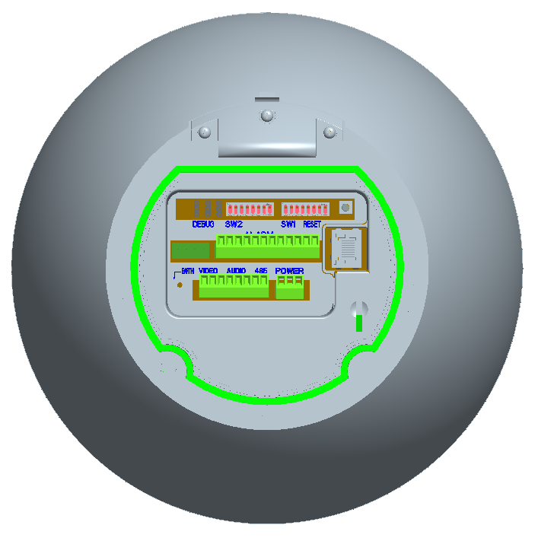
SW2 SW1
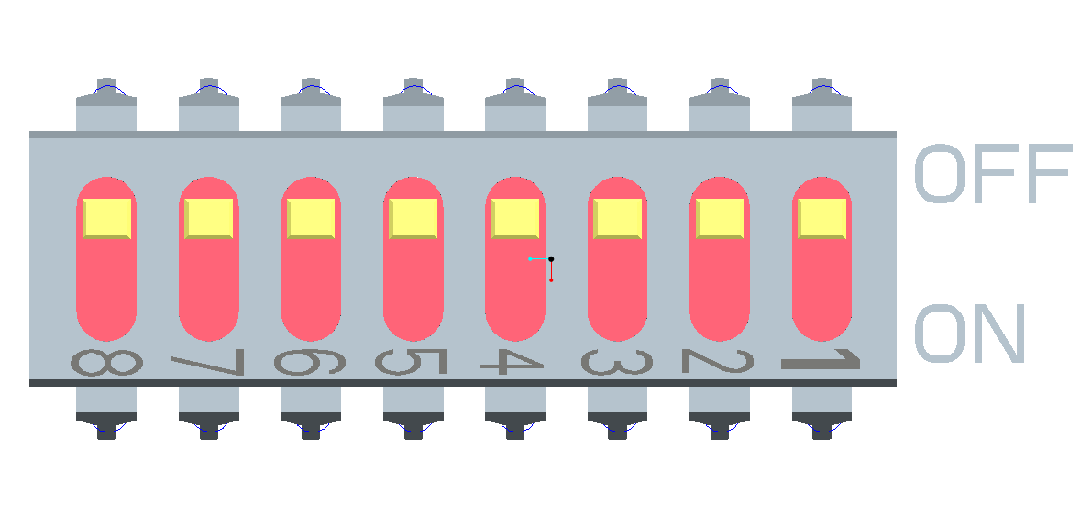
Figure 2-1
SW2
Figure 2-2

Please refer to the protocol sheets for detailed information.
Protocol |  |  | Baud rate |  | Parity |  | 120Ω | Connect to the 120Ω
1 | 2 | 3 | 4 | 5 | 6 | 7 | 8 |  | ON
Please note the speed dome cans automatically recognize the DH-SD, PELCO-D. PELCO-P. Usually you do not need to set.
1 | 2 | 3 | Communication Protocol
OFF | OFF | OFF | DH-SD（Compatible with China industrial standard protocol）
ON | OFF | OFF | PELCO-D
OFF | ON | OFF | PELCO-P
X | X | X | Reserved
Please refer to the baud rate sheet for detailed information.
4 | 5 | Baud Rate
OFF | OFF | 9600bps
ON | OFF | 4800bps
OFF | ON | 2400bps
ON | ON | 1200bps
Please refer to the parity setup sheet for detailed information.
6 | 7 | Parity
OFF | OFF | NONE
ON | OFF | EVEN
OFF | ON | ODD
ON | ON | NONE

Set address dial switch

SW1
Figure 2-3
The encode mode adopts binary system. 1 to 8 is the valid bit. The highest address bit is 255. You can refer to the following sheet for more information.
Address | 1 | 2 | 3 | 4 | 5 | 6 | 7 | 8
1 | OFF | OFF | OFF | OFF | OFF | OFF | OFF | OFF
1 | ON | OFF | OFF | OFF | OFF | OFF | OFF | OFF
2 | OFF | ON | OFF | OFF | OFF | OFF | OFF | OFF
3 | ON | ON | OFF | OFF | OFF | OFF | OFF | OFF
4 | OFF | OFF | ON | OFF | OFF | OFF | OFF | OFF
5 | ON | OFF | ON | OFF | OFF | OFF | OFF | OFF
6 | OFF | ON | ON | OFF | OFF | OFF | OFF | OFF
7 | ON | ON | ON | OFF | OFF | OFF | OFF | OFF
8 | OFF | OFF | OFF | ON | OFF | OFF | OFF | OFF
…… | …………………………………………………………………
254 | OFF | ON | ON | ON | ON | ON | ON | ON
255 | ON | ON | ON | ON | ON | ON | ON | ON

Cable Connection

RS485 and Power Cable Connection
There are three cable groups: power cable, RS 485 cable and video cable. They are used to transmit video signal, control signal and power connection. Please connect the power cable to the power socket of the speed dome, connect the RS485 cable to the RS485 port of the speed dome. See Figure 3-4 and Figure 3-5.
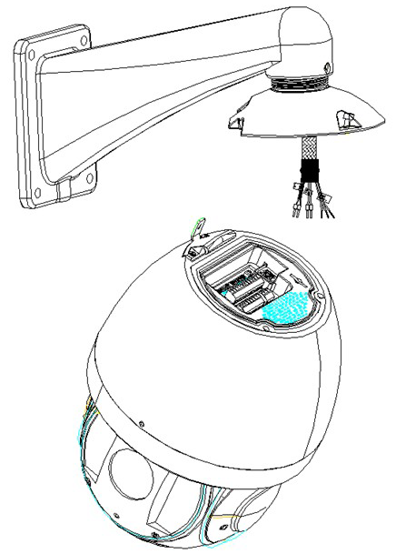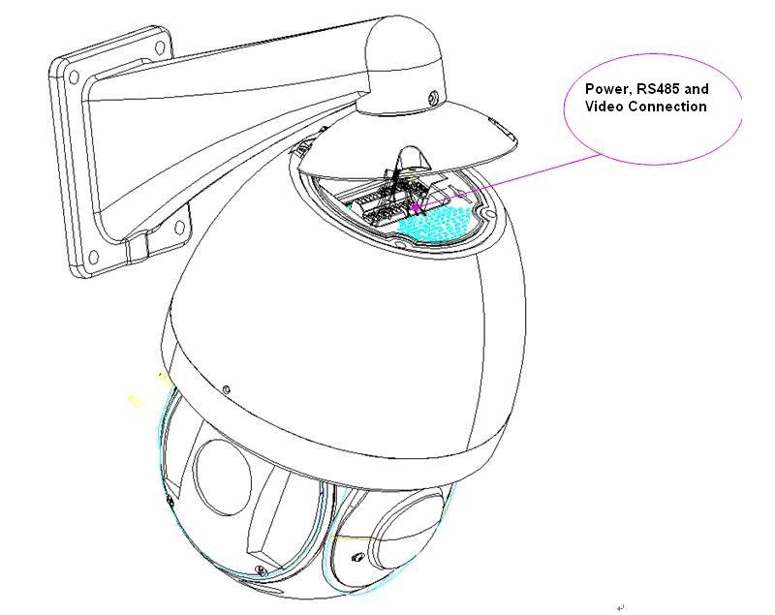
Figure 3-4
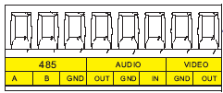

Figure 3-5
Name |  | Function
485 | A | 485-A. It is to control dome built-in PTZ.
485 | B | 485-B. It is to control dome built-in PTZ.
485 | GND | Ground.
AUDIO | OUT | Reserved audio port. Audio output port.  Right now the device does not support this function.
AUDIO | GND | Reserved audio port. Ground port audio.  Right now the device does not support this function.
AUDIO | IN | Reserved audio port. Audio connection port.  Right now the device does not support this function.
VIDEO | GND | Ground port.
VIDEO | OUT | Video output port.
Power port connection interface is shown as in Figure 3-6.
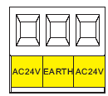
Figure 3-6
Name | Function
AC24V | 24V power port. Connect to the power cable.
EARTH | Ground port.
AC24V | 24V power port. Connect to power cable.

Alarm Cable Connection
Open the dome cover and take PTZ chip core out. Turn the core upside down; you can see the alarm port. See Figure 3-7.
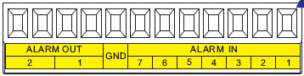
Figure 3-7
Name | Function
Alarm out：1-2 | - Two alarm output channels. When there is an alarm from current channel, system activates relay or not.  - Alarm output relay default setup is NO. You can use the jump-cap near the power board relay to set.  - NO：Normal open alarm output.  - NC：Normal close alarm output.
GND | Alarm input ground end.
Alarm in：1-7 | - Seven alarm input channels. It is to receive relay signal from the external alarm source. You can go to dome menu to activate specified preset or patter.  - When the activation mode is NO (normal open), dome alarms when there is low voltage. High voltage will not activate the alarm.  - When the activation mode is NC (normal close), dome alarms when there is high voltage. Low voltage will not activate the alarm.  Note:  - Dome alarm input message is ground mode.  - Dome alarm input signal are two modes: normal open and normal close.

System Layout

BUS connection
Please refer to Figure 3-8 and Figure 3-9 for BUS cable connection.
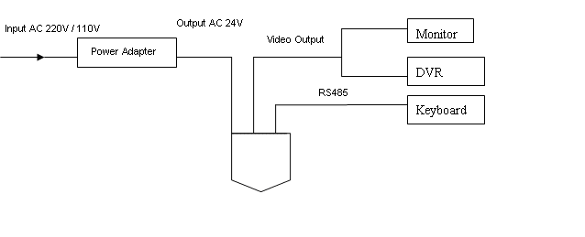
Figure 3-8
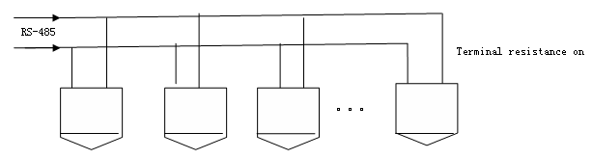
Figure 3-9
Note:
Please use shielded twisted pair. The shielded layer shall connect to GND firmly; otherwise it may affect communication or video work.

Star Connection
Please refer to Figure 3-10 for start connection information.
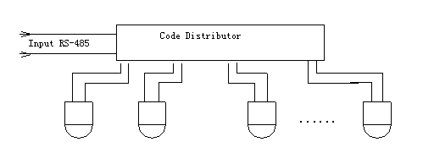
Figure 3-10

Alarm Connection
Please refer to Figure 3-11 for alarm connection information.
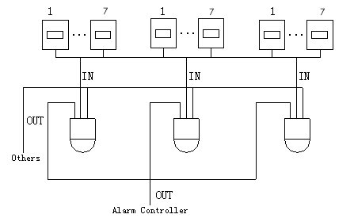
Figure 3-11

Keyboard Connection
This series dome supports keyboard operation. You can use keyboard to control the dome and PTZ. The display and control can work simultaneously. One keyboard can control maximum 255 speed domes. Please refer to Figure 3-12.
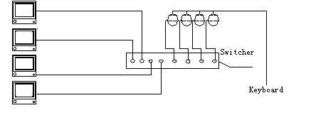
Figure 3-12
This IR speed dome protocol is open and supports multiple popular system platforms in today’s market. Please contact us freely if some matrix systems do not support dome camera communication protocol. The most direct and easy way is to use current system to process video signal and add some control keyboards to control speed dome. See Figure 3-13.
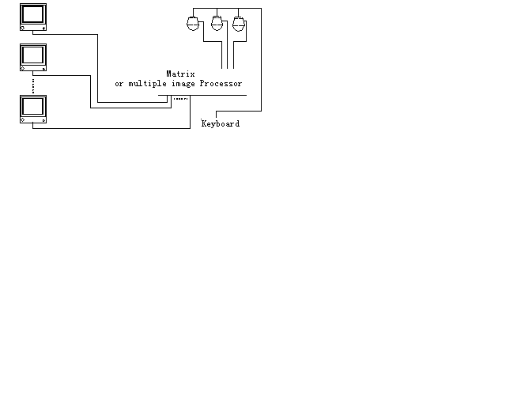
Figure 3-13

Menu

Screen Menu Index
Note:
ERR means current setup is invalid.
… means there is submenu.
INITIAL INFORMATION…
ADDR INFORMATION…
SYSTEM TIME SETTING…
SET NORTH
LANGUAGE ：ENGLISH
PTZ AUTO STOP:15S
FACTORY DEFAULT
RESTART
BACK
EXIT
SYSTEM INFORMATION

PRESET TITLE : ON (ON/OFF)
AZIMUTH DISP : ON (ON/OFF)
TIME DISP : OFF (ON/OFF)
POSITION : OFF (ON/OFF)
ZOOM DISP : OFF (ON/OFF)
INSIDE TEMP : ℃ (℃/F/OFF)
OUTSIDE T&H : OFF(℃/F/OFF)
IDLE TIME :1M
BACK
EXIT
DISPLAY SETTING

CAMERA SETTING

WB SETTING
EXPOSURE SETTING
DAY/NIGHT SETTING
FOCUS MODE : AUTO
FOCUS LIMT : 30CM
ZOOM SPEED : 08
DIGITAL ZOOM : OFF
APERTURE : 06
NEXT PAGE
BACK
EXIT

FUNCTION SETTING

PRESET
AUTO PAN
AUTO SCAN
AUTO CRUISE
AUTO PATTERN
IDLE MOTION
TIME TASK
AUTO RUN
PRIVACY MASKING
NEXT PAGE
BACK
EXIT

IR LIGHT SETTING

IR SENSITIVITY: 4(1-6)
SWITCH ZOOM: 6(2-10)
HEIGHT: 5(1-10)
IRLIGHT CTRL: ZOOM PRI (HEIGHT PRI, MANUAL)
NEAR LIGHT: 50(0-100, INTERVAL=5)
FAR LIGHT: 50(0-100, INTERVAL=5)
IRLIGHT COMP: 3(1-5)

ALARM SETTING
ALARM NO : 01
ACTION : NONE
CONTACT : N/O
PRESET : 001
AUTO SCAN: : 001
CRUISE : 001
RELAY OUT : OFF（OFF/1→5S/2→5S/1&2→5S）
RESET DELAY : 3S
SAVE
BACK
EXIT

EXIT

The above diagram illustrates the overall structure of the speed dome setup menu.
Note:
- ERR means current setup is invalid.
- Please make sure all the cable connections are right.

Self-diagnosis System Information
ADDR ：001-H
BAUD RATE ：9600
PARITY ：NONE
PROTOCOL ：PELCO-P
MODEL ：SD66XX
TEMP : 032℃
SOFTWARE ：V1.04.3
BACK
EXIT

After installation, please connect speed dome to power. The system goes on a self-diagnosis, and then it pops up the above interface to show the system information.
If there is anything wrong during the self-diagnosis, system pops up error code.
The above interface disappears after speed dome received the first command (or the display time lasts for 4 minutes.)
- ADDR: Here you can view dome address information. For example, 001-H, 1 is the address number, -H is hard address mode. –S is software address mode.
- Baud rate: Dome communication baud rate.
- Parity: Communication parity bit format.
- Protocol: Current communication protocol.
- Model: Dome type.
- Temperature: Current dome internal temperature.
- Software: Dome PTZ software version.

Main Menu
You can open the IP dome menu via control keyboard, matrix, or speed dome control terminal.
SYSTEM INFORMATION
DISPLAY SETTING
CAMERA SETTING
FUNCTION SETTING
IR LIGHT SETTING
ALARM SETTING
EXIT

- SYSTEM INFORMATION：Dome self-diagnosis information, address information, system time setup, set north direction, language, factory default setup, reboot and so on.
- DISPLAY INFORMATION: Display dome preset title, azimuth display, time, direction, dome internal temperature, dome external temperature information.
- CAMERA PARAMETERS：Display dome white balance setup, exposure setup, day/night setup, focus setup.
- FUNCTION SETTING ： Set preset, pan, scan, auto cruise, pattern, idle motion, time task and privacy mask function.
- IR LIGHT SETTING: Set dome IR sensitivity, switch rate, reference height, IR control principle, medium and far light bright, far light bright, IR light compensation and etc.
- ALARM SETTING ：Set dome alarm number, action, contact, preset, scan, cruise, replay out, reset delay, save setup and etc.
- EXIT ： Log out the system menu.

Menu Operation
In the speed dome main menu, you can use the left/right button on the keyboard or in the speed dome terminal menu to configure the system menu. Before setup, please move the cursor to the current item you want to configure.
- In main menu, please click confirm button to go to the sub menu or use left/right key to configure setup.
- Use up/down button to select back option and then click confirm button to go back to the previous menu.
- Use up/down button to select exit option and then click confirm button to log out system menu.
- All setup here will not lose when encounter power failure.

System Information
INITIAL INFORMATION
ADDR INFORMATION
SYSTEM TIME SETTING
SET NORTH
LANGUAGE : ENGLISH
PTZ AUTO STOP
FACTORY DEFAULT
RESTART
BACK
EXIT

- INITIAL INFORMATION: Move the cursor to INITIAL INFORMATION and then click confirm button to go to the third submenu.
- ADDR INFORMATION: Move the cursor to SITE INFORMATION and then click confirm button to go to the third submenu.
- SYSTEM TIME SETTING: Move the cursor to SYSTEM TIME SETTING and then click confirm button to go to the third submenu.
- SET NORTH DIRECTION: Set dome benchmark direction so that you can know the angel between the benchmark and then current location. Please move the cursor to the option and then click confirm button until you see O.K. Now you have set north direction.
- LANGUAGE: The dome menu language. There are several languages for you to select. Please use the left/right button on the keyboard or in the speed dome terminal menu to set.
- PTZ AUTO STOP: The PTZ stop the corresponding operation once it reaches the time you specified here. The option includes: close\5S\10S\15S\20S\25S\30S and etc. Please use the left/right button on the keyboard or in the speed dome terminal menu to set.
- FACTORY DEFAULT: Restore dome factory default setup. Please move the cursor to the option and then click confirm button until you see O.K. Now you can see the IP dome begin rebooting to restore factory default setup.
- RESTART: Reboot the speed dome.
- BACK: Go back to the previous menu.
- EXIT: Log out system menu.

Initialization information
ADDR ： 001-H
BAUD RATE ：9600
PARITY ：NONE
PROTOCOL ：PELCO-D
MODEL ：SD6663-HN
TEMP : 032℃
SOFTWARE ：v1.04.3
BACK
EXIT

Move the cursor to INITIAL INFORMATION and then click confirm button, you can see the above interface.
Here you can view dome basic information.

Address Information
ADDR TYPE : HARD
ADDR-HARD : 001
ADDR-SOFT : 001
BACK
EXIT

Move the cursor to SITE INFORMATION and then click confirm button.
- ADDR TYPE: There are two options: soft and hard. Please use the left/right button on the keyboard or in the speed dome terminal menu to set.
- ADDR-HARD: It is an address you set in the dial switch. You can not modify it through software.
- ADDR-SOFT: You can set address via software. It is to say, you can use menu to modify dome address. The value ranges from 1 to 255.
- BACK: Go back to the previous menu.
- EXIT: Log out system menu.

System Time Setting
YEAR : 2009
MONTH : 001
DATE : 017
WEEK : SUNDAY
HOUR : 013
MINU： : 052
SAVE
BACK
EXIT

- Move the cursor to SYSTEM TIME SETING and then click confirm button, you can go to the third submenu. Please use the left/right button on the keyboard or in the speed dome terminal menu to set. After completed setup, please click confirm button to save current setup. After you see speed dome menu displays OK, you can see the setup is valid now.

Display Setting

PRESET TITLE ：ON
AZIMUTH DISP ：ON
TIME DISP ：OFF
POSITION ：OFF
ZOOM DISP ：OFF
INSIDE TEMP ：℃
OUTSIDE T&H ：OFF
IDLE TIME : 1 Min
TITLE DISP ：OFF
BACK
EXIT

Move the cursor to DISPLAY SETUP and then click confirm button, you can go to the third submenu. Please use the left/right button on the keyboard or in the speed dome terminal menu to set. After completed setup, please click save button to save current setup.
- PRESET TITLE: Display dome preset title or not. Please use the left/right button on the keyboard or in the speed dome terminal menu to set. You can go to Function Setup->Preset section to set corresponding preset value and preset title.
- AZIMUTH DISP: Display dome current coordinates or not. Please use the left/right button on the keyboard or in the speed dome terminal menu to set
- TIME DISP: Display dome system time or not. Please use the left/right button on the keyboard or in the speed dome terminal menu to set.
- POSITION: Display the angel between the benchmark and then current location. Please use the left/right button on the keyboard or in the speed dome terminal menu to set.
- ZOOM DISP: Display speed dome zoom speed or not. Please use the left/right button on the keyboard or in the speed dome terminal menu to set.
- INSIDE TEMPERATURE: Display dome internal temperature or not. There are three options: ℃/F/Off. Please use the left/right button on the keyboard or in the speed dome terminal menu to set.
- OUTSIDE TEMPERATURE AND HUMIDITY: Display dome external temperature and humidity. There are three options: ℃/F/Off. Please use the left/right button on the keyboard or in the speed dome terminal menu to set.
- IDLE TIME: The option includes close/1/2/3/4/5min. The system will exit the menu automatically once there is no menu operation during the time you specify here. Close means always show the menu.
- BACK: Go back to the previous menu.
- EXIT: Log out system menu.

Camera Setting
WB SETTING
EXPOSURE SETTING
DAY/NIGHT SETTING
FOCUS MODE ：AUTO
FOCUS LIMIT : 30CM
ZOOM SPEED : 08
DIGITAL ZOOM : OFF
APERTURE : 09
NEXT PAGE
BACK
EXIT

Move the cursor to CAMERA SETTING and then click confirm button, you can go to the submenu.
- WHITE BALANCE SETUP: Move the cursor to current option and then click confirm button, you can go to the third menu.
- EXPOSURE SETTING: Move the cursor to current option and then click confirm button, you can go to the third menu.
- DAY/NIGHT: Set day/night mode. Move the cursor to current option and then click confirm button, you can go to the third menu. There are three options: auto/manual/off. Please use the left/right button on the keyboard or in the speed dome terminal menu to set.
- FOCUS MODE: There are two modes: Manual/Auto. Please use the left/right button on the keyboard or in the speed dome terminal menu to set.
- ZOOM SPEED; The zoom speed value ranges from 1 to 8. The bigger the value, the faster the speed. Please use the left/right button on the keyboard or in the speed dome terminal menu to set.
- DIGITAL ZOOM: There are two options: on/off. Please use the left/right button on the keyboard or in the speed dome terminal menu to set.
- APERTURE: It is to adjust the lens to achieve clear video. The value ranges from 1 to 16. Please use the left/right button on the keyboard or in the speed dome terminal menu to set.
- NEXT PAGE: It includes the following options: picture flip, freeze function, camera factory default setup, camera restart. Please use the left/right button on the keyboard or in the speed dome terminal menu to set.
- BACK: Go back to previous menu.
- EXIT: Log out system menu.

White Balance Setup

WB MODE ： AUTO
R GAIN ： 001
B GAIN ： 001
BACK
EXIT

Move the cursor to WHITE BALANCE MODE and then click confirm button, you can go to the submenu.
- WHITE BALANCE MODE: Set white balance adjustment mode. There are two modes: auto/manual. Please use the left/right button on the keyboard or in the speed dome terminal menu to set.
- R GAIN: Before you set R GAIN option, please note the mode shall not be auto. The value ranges from 000 to 254. Please use the left/right button on the keyboard or in the speed dome terminal menu to set.
- B GAIN: Before you set B GAIN option, please note the mode shall not be auto. The value ranges from 000 to 254. Please use the left/right button on the keyboard or in the speed dome terminal menu to set.
- BACK: Go back to previous menu.
- EXIT: Log out system menu.

Exposure Setting
AE MODE : AUTO
GAIN SETTING : 02
SHUTTER : 1/50
IRIS SETTING : 11
EXPOSURE COM : 08
SLOW AE : 01
SLOW SHUTTER ON
BLC : OFF
WDR ENBALE : OFF
BACK
EXIT

- AE MODE: Here you can set the camera exposure mode. It includes: auto/manual/AV (iris priority)/TV (shutter priority). Please use the left/right button on the keyboard or in the speed dome terminal menu to set.
  - Auto: It becomes valid after you set the exposure compensation, backlight compensation (BLC), slow shutter, wide dynamic region (WDR).
  - Manual: It becomes valid after you set the gain setting, shutter, iris setting, wide dynamic region (WDR).
  - AV: It becomes valid after you set the exposure setting, iris setting, wide dynamic region (WDR).
  - TV: It becomes valid after you set the shutter setting, exposure compensation, wide dynamic region (WDR).
- GAIN SETTING: The value ranges from 1 to 16. Default value is 2. Please use the left/right button on the keyboard or in the speed dome terminal menu to set.
- SHUTTER: You can set shutter speed here. The value ranges from 1/3 to 1/10000. Default value is 1/50. Please use the left/right button on the keyboard or in the speed dome terminal menu to set.
- IRIS SETTING: The value ranges from 1 to 18. Default value is 11. Please use the left/right button on the keyboard or in the speed dome terminal menu to set.
- EXPOSURE COM: The value ranges from 1 to 15. Default value is 8. Please use the left/right button on the keyboard or in the speed dome terminal menu to set.
- SLOW AE: In the strong light environment, you can lower the camera exposure speed to capture the image and enhance the definition. The value ranges from 1 to 16. The bigger the value, the higher the exposure speed. Please use the left/right button on the keyboard or in the speed dome terminal menu to set. Please make sure your camera supports this function.
- SLOW SHUTTER: In lower illumination environment, you can lower the cameras auto exposure time to capture the image and enhance the definition. Please note for the moving object, the image trail phenomenon may occur. Please use the left/right button on the keyboard or in the speed dome terminal menu to set.
- BLC: It is an abbreviation for back light compensation. System can compensate the object in the dark light to achieve a clear video. Please use the left/right button on the keyboard or in the speed dome terminal menu to set.
- WDR ENBALE: It is an abbreviation for wide dynamic region. Please make sure your camera supports current function. This function can adjust the video brightness when the contrast between the strong light and the dark light is too high. Please use the left/right button on the keyboard or in the speed dome terminal menu to set.
- BACK: Go back to previous menu.
- EXIT: Log out system menu.

Day/Night Setting
Move the cursor to DAY/NIGHT SETTING and then click confirm button, you can go to the submenu.
DAY/NIGHT ：AUTO
DAY TIME ：07H 00M
NIGHT TIME : 19H 00M
SAVE
BACK
EXIT

- DAY/NIGHT: There are four options: auto/time/night/day. Please use the left/right button on the keyboard or in the speed dome terminal menu to set.
- DAY TIME: Current setup becomes valid when day/night mode is Time. Move the cursor to DAY TIME item and then click confirm button to go to setup. Please user up/down button to set the value. After completed setup, please click confirm button to exit and move the cursor to Save button to save current setup.
- NIGHT TIME: Current setup becomes valid when day/night mode is Time. Move the cursor to DAY TIME item and then click confirm button to go to setup. Please user up/down button to set the value. After completed setup, please click confirm button to exit and move the cursor to save button to save current setup.
- SAVE: This button is for DAY TIME and NIGHT TIME setup. After you set the day time (or night time), you need to move the cursor here and then click confirm button to save current time setup. For other setups, you do not need to use this button.
- BACK: Go back to previous menu.
- EXIT: Log out system menu.

Next Page
Move the cursor to NEXT PAGE and then click confirm button, you can go to the submenu.
PICTURE FLIP ：OFF
FREEZE FUNCTION ：OFF
CAMERA FACTORY DEFAULT
CAMERA RESTATRT
BACK
EXIT

- PICTURE FLIP: This function allows you to turn the image rotation 180 degrees. There are two options: on/off. Please use the left/right button on the keyboard or in the speed dome terminal menu to set.
- FREEZE FUNCTION: This function allows the system from one preset to another preset, without showing the video during the PTZ movement. There are two options: on/off. Please use the left/right button on the keyboard or in the speed dome terminal menu to set.
- CAMERA FACTORY DEFAULT SETTING: Move the cursor to current item and then click confirm button to restore factory default setup.
- CAMERE RESTART: Move the cursor to current item and then click confirm button to reboot the camera.
- BACK: Go back to previous menu.
- EXIT: Log out system menu.

Function Setting
PRESET
PAN
SCAN
AUTO CRUISE
PATTERN
IDLE MOTION
TIME TASK
PRIVACY MASKING
BACK
EXIT

Please go back to main menu and move the cursor to FUNCTION SETTING, click confirm button. You can see the above interface.
- PRESET: Move the cursor to PRESET and then click confirm button to go to the third submenu.
- PAN: Move the cursor to PAN and then click confirm button to go to the third submenu.
- SCAN: Move the cursor to SCAN and then click confirm button to go to the third submenu.
- AUTO CRUISE: Move the cursor to AUTO CRUISE and then click confirm button to go to the third submenu.
- PATTERN: Move the cursor to PATTERN and then click confirm button to go to the third submenu.
- IDLE MOTION: Move the cursor to IDLE MOTION and then click confirm button to go to the third submenu.
- TIME TASK: Move the cursor to TIME TASK and then click confirm button to go to the third submenu.
- PRIVACY MASKING: Move the cursor to PRIVACY MASKING and then click confirm button to go to the third submenu.
- BACK: Go back to previous menu.
- EXIT: Log out system menu.

Preset Setup
PRESET NO ：001
TITLE ：PRESET001
SETTING
CALL
BACK
EXIT

Move the cursor to PRESET button and then click confirm button to go to set interface.
- PRESET NO: Please use left/right key to modify preset number. The value ranges from 1 to 80.
- TITLE：Title text is the label used for you to identify the camera. System will automatically name a title for the camera.
- SETTING: Please input preset number first and then select the monitor zone. Please move the cursor to setting and click confirm button. The system will pop up a message: PRESET: ***. Here *** means preset number. And the SETTING column pops up an OK. Now you successfully added a preset. Please note, you need to enable display preset title function first (Main menu->display setting->preset title).Repeat the above procedures to set more presets. Once you want to modify a preset, you can input the preset number you want to modify and then follow the above steps to set the preset. You can successfully modify a preset content.
- CALL: Here is to recall preset. Move the cursor to PRESET NO and then input corresponding preset value. Then move the cursor to CALL and then click confirm button to go to a preset.
- BACK: Go back to previous menu.
- EXIT: Log out system menu.
For PELCO protocol user, please refer to the following special functions:
- Call preset: Call preset 28 or preset 95 to go to dome menu. Call preset 29 or preset 99 to go to scan. Call preset 24 or preset 81 to go to pattern. Call preset 25 or preset 82 to go to cruise (tour). Call preset 30 or preset 96 to stop scan or pattern. Call preset 31 or preset 83 to begin rotation. Call preset 33 to enable PTZ 180 degrees rotation. Call preset 34 to set dome position as 0.
- Set preset: Set preset 26 or 92 to set scan left limit. Set preset 27 or 93 to set scan right limit. Set preset 22 or 79 to begin record. Set preset 23 or 80 to stop record.

Pan
PAN SPEED ：160
RUN
STOP
BACK
EXIT

Move the cursor to PAN button and then click confirm button to go to setup interface.
- PAN SPEED: Set dome rotation speed. The Value ranges from 1 to 255. Please use the left/right button on the keyboard or in the speed dome terminal menu to set.
- RUN: Move the cursor to call item and then click confirm button. The dome begins 360 degrees continuous rotation.
- STOP: Highlight stop item and then click confirm button. The dome stops rotation.
- BACK: Go back to previous menu.
- EXIT: Log out system menu.

Scan
SCAN NO ： 001
SET LEFT LIMIT
SET RIGHT LIMIT
SCAN SPEED ：160
RUN
STOP
BACK
EXIT

Move the cursor to SCAN button and then click confirm button.
- SCAN NO：Here is to set auto scan number. The value ranges from 1 to 5. Please use the left/right button on the keyboard or in the speed dome terminal menu to set.
- SET LEFT LIMIT：Here is to set camera left address. Click confirm button to save current setup.
- SET RIGHT LIMIT：Here is to set camera right address. Click confirm button to save current setup.
- SCAN SPEED: The value ranges from 1 to 255. Please use the left/right button on the keyboard or in the speed dome terminal menu to set.
- RUN: Please input auto scan number first, and then please move the cursor to RUN and click confirm button to activate auto scan function.
- STOP: Here is to terminate auto scan function.
- BACK: Go back to previous menu.
- EXIT: Log out system menu.

Cruise (Touring)
CRUISE NO： : 001
CRUISE SETTING
DELETE CRUISE
RUN
STOP
BACK
EXIT

Move the cursor to highlight CRUISE item and then click confirm button to go to set interface.
- CRUISE NO ：Here is to ser tour number. The value ranges from 1 to 8. Please use the left/right button on the keyboard or in the speed dome terminal menu to set.
- CRUISE SETTING: Move the cursor to cruise setting item and then click confirm button. You can see the following interface. Here you can add or remove the preset, and set the corresponding dwell time and call speed. One cruise can max include 32 presets. The preset value ranges from 0 to 200.

NO PRESET DWELL SPEED
01 000 005 013
02 000 005 013
03 000 005 013
… … … …
32 000 005 013

  - DWELL: Here is t set dwell time. The value ranges from 3s to 255s. Default value is 5 seconds. Please use the left/right button on the keyboard or in the speed dome terminal menu to set.
  - SPEED: The speed value ranges from 1 to 16. The default value is 13.
When you move the cursor to one cruise number, you can use left/right button to turn the page. There are 8 cruises in each page and there are total 4 pages.
When you move the cursor to one cruise number, please click confirm button to set the cruise. Please use up/down button to set preset number, dwell time and speed. Use the left/right button to go to the next cruise. Click confirm button you can exit the setup. After you completed the setup, move the cursor to back button to go to the previous interface.
- DELETE CRUISE：Here is to delete a cruise. Input cruise number in CRUISE NO and then move the cursor to DELETE cruise, click confirm button to delete.
- CALL: Here is to activate cruise. Input touring number in touring NO and highlight CALL, click confirm button to activate touring.
- STOP: Here is to terminate touring.
- BACK: Go back to previous menu.
- EXIT: Log out system menu.

Pattern

PATTERN NO: 001
PROGRAM START
PROGRAM STOP
RUN
STOP
BACK
EXIT

Pattern function can memory PTZ operation and camera focus zoom in and zoom out.
From the start position, dome begins auto movement repeatedly.
This series IP dome supports maximum 5 patterns and one pattern can max support 400 commands.
Move the cursor to PATTERN and click confirm button.
- PATTERN NO： Here is to set pattern number. The value ranges from 1 to 5. Please click left/right key to configure.
- PROGRAM START: Here is to memorize pattern starting point. An icon OK pops up in screen to prompt you system begins memory pattern.
- PROGRAM STOP：Here is to set pattern stop point. After all the movement, move the cursor to PROGRAM STOP and then click confirm button. Now you have set one pattern. System pops up an icon OK to prompt you system has memories one pattern.
- RUN：Here is to activate pattern. Input pattern number, move the cursor to RUN and click confirm button, system begins running pattern.
- STOP: Here is to stop current pattern. Input pattern number, move the cursor to STOP and click confirm button. System stops current pattern.
- BACK: Go back to previous menu.
- EXIT: Log out system menu.
Note:
- The dwell time between two orders should be less than one minute, otherwise system will set to default value as one minute.
- After click PROGRAM STOP, do not click CALL button before icon “●” disappears completely.
- Any manual operation during the pattern procedure will terminate current dome pattern operation.

Privacy Masking (Window blank)
Please make sure you current camera supports this function.
PRIVACY NO ：001
ACTIVATE : OFF
RESIZE : ↑
DELETE
SAVE
BACK
EXIT

Move the cursor to PRIVACY ZONE and click confirm button, system goes to privacy mask setup interface.
For SONY series cameras
There are maximum 8 privacy mask zones in 360 degrees .The tilt angle ranges from 0 to 70 degrees.
For HITACHI series cameras
There are maximum 8 privacy mask zones in 360 degrees. System supports two privacy zones in one screen (Tilt angle ranges from 0 to 45 degrees.)
Note:
- For security reasons, please set privacy zone a little bit larger than the privacy object size.
- Each time, after modifications you need to move the cursor to SAVE button and then click confirm button to get all setup activated. Otherwise, privacy zone may not move correspondingly with the object.
Please enter privacy zone menu, now all the privacy zones are closed.
Move the cursor to PRIVACY NO, please use left/right key to set different privacy zones.
For example, shift to 001 section and then move the cursor to ACTIVATE.
Secondly, use left/right key to select ON mode. Now there is a privacy zone in the screen centre.
Thirdly, use PTZ to move camera so that privacy object fit well with screen centre.
Fourthly, move the cursor to RESIZE and then click left and right key to adjust privacy zone direction and size.
Fifthly, move the cursor to SAVE and then click confirm button to exit.
- PRIVACY NO：Here is to set privacy mask zones. Please use the left/right button on the keyboard or in the speed dome terminal menu to set. The value ranges from 1 to 8.
- ACTIVATE: There are two settings: on and off. When activate function is on, the privacy mask function will be activated and displays in the screen. When activate function is off, the privacy mask function will be closed and the blank will not displayed in the screen.
- RESIZE：It is to adjust the privacy zone size. Please continue pressing direction button to widen or narrow zone size. ← is to narrow the horizontal width and → is to widen the horizontal width. ↑ is to widen vertical height and ↓ is to narrow the vertical height.
- SAVE：Here is to save user setup.
- DELETE: Here is to delete setup and restore default setting.
- BACK: Go back to previous menu.
- EXIT: Log out system menu.

Idle Motion

IDLE FUNC ：OFF
IDLE TIME ：010MIN
IDLE ACTION ：PRESET
PRESET NO ：001
AUTO SCAN NO ：001
CRUISE NO ：001
PATTERN NO ：001
SAVE
BACK
EXIT

When there is no available command for specified time, dome automatically goes on the previous set functions.
- IDLE FUNCTION ：There are two modes ON/OFF. Please use left/right key to set.
- IDLE TIME: System idle period. The value ranges from 1 to 720 minutes. Please use the left/right button on the keyboard or in the speed dome terminal menu to set.
- IDLE ACTION：There are several functions you can select: NONE/PRESET/SCAN/TOURING/PATTERN. Please use the left/right button on the keyboard or in the speed dome terminal menu to set.
- PRESET NO： Here is for you to set preset number. The value ranges from 1 to 255. System goes to specified preset when idle status is on.
- AUTO SCAN NO： The value ranges from 1 to 5. Please use the left/right button on the keyboard or in the speed dome terminal menu to set. System begins specified scan when idle status is on.
- CRUISE NO： The value ranges from 1 to 8. Please use the left/right button on the keyboard or in the speed dome terminal menu to set. System begins specified touring when idle status is on.
- PATTERN NO：The value ranges from 1 to 5. Please use the left/right button on the keyboard or in the speed dome terminal menu to set. System begins specified pattern when idle status is on.
- SAVE：Move the cursor to SAVE and click confirm button to save current setup.
- BACK: Go back to previous menu.
- EXIT: Log out system menu.

Time Task
TIME TASK ：OFF
START TIME ：06H 00M
END TIME : 10H 00M
TASK ACTION : SCAN
PRESET : 001
SCAN : 001
TOUR : 001
PATTERN : 001
SAVE
BACK
EXIT

- TIME TASK: Schedule task allows the speed dome to implement corresponding setup during the specified time. There are two options: on/off. Please use the left/right button on the keyboard or in the speed dome terminal menu to set.
- START TIME: Here you can set the task begin time. Move the cursor to current item and then click confirm button to set the time. Please use the up/down button to set the detailed value and then use left/right button to go to the next setup item. After you completed the setup, please click confirm button to exit start time setup and then move the cursor to the SAVE button to save current setup.
- END TIME: Here you can set the task end time. Move the cursor to current item and then click confirm button to set the time. Please use the up/down button to set the detail value and then use left/right button to go to the next setup item. After you completed the setup, please click confirm button to exit end time setup and then move the cursor to the SAVE button to save current setup.
- TASK ACTION; The option here includes: none/tour/scan/preset/patter. Please use left/right button to set.
- PRESET: The speed dome will go to the selected preset at the specified time if you select the time task as preset. The value ranges from 1 to 80.
- SCAN: The speed dome will go to the selected scan at the specified time if you select the time task as scan. The value ranges from 1 to 5.
- TOUR: The speed dome will go to the selected preset at the specified time if you select the time task as tour. The value ranges from 1 to 8.
- PATTERN: The speed dome will go to the selected pattern at the specified time if you select the time task as pattern. The value ranges from 1 to 5.
- SAVE: After you completed the above setup, you need to move the cursor here and then click confirm button to save current time setup.
- BACK: Go back to the previous menu.
- EXIT: Log out the system menu.

IR Light Setup
IR SENSITIVITY: 4(1-6)
SWITCH ZOOM: 6(2-10)
HEIGHT: 5(1-10)
IRLIGHT CTRL: ZOOM PRI (HEIGHT PRI, MANUAL)
NEAR LIGHT: 50(0-100, INTERVAL=5)
FAR LIGHT: 50(0-100, INTERVAL=5)
IRLIGHT COMP: 3(1-5)

Move the cursor to highlight IR LIGHT SETTING button and then click confirm button.
- IR SENSITIVITY: Here you can enable the IR light sensitivity function.
- SWITCH ZOOM: It is the zoom rate of the near light, and far light.
- HEIGHT: It is the speed dome installation height from the ground.
- IRLIGHT CTRL: There are three options: Zoom rate has the higher priority, height has the higher priority, manual.
- NEAR LIGHT: It is the medium and near light brightness.
- FAR LIGHT: It is the far light brightness.
- IR LIGHT COMPENSATION: It is the whole compensation level of the IR light.

Alarm Setup
ALARM NO ：01
ACTION ：NONE
CONTACT ：N/O
PRESET ：001
AUTO SCAN ：001
CRUISE ：001
RELAY OUT ：OFFS
RESET DELAY ：3S
SAVE
BACK
EXIT

Move the cursor to highlight ALARM SETTING button and then click confirm button.
- ALARM NO: Here is to set alarm input. Alarm input value ranges from 1 to 7. Please use the left/right button on the keyboard or in the speed dome terminal menu to set.
- ACTION: Action on alarm function. It includes NONE/PRESET/AUTO SCAN/TOURING functions. Please use the left/right button on the keyboard or in the speed dome terminal menu to set.
- CONTACT：You can set system activation operation once alarm occurred. There are two alarm signal mode: normal open (N/O) and normal closed (N/C). Please use the left/right button on the keyboard or in the speed dome terminal menu to set.
- PRESET NO：Please use the left/right button on the keyboard or in the speed dome terminal menu to set. The camera will turn to the specified preset to monitor after alarm occurs.
- AUTO SCAN：Please use the left/right button on the keyboard or in the speed dome terminal menu to set. The camera will begin auto scan after alarm occurs.
- CRUISE：Please use the left/right button on the keyboard or in the speed dome terminal menu to set. The camera will begin auto cruise when alarm occurs.
- RELAY OUT: Here is to set relay alarm mode and reset time. There are several options: off/1→5S/2→5S/1&2→5S.
- 1→5S：1 means the first relay output.5S means the relay will reset automatically in five seconds after alarm occurs.
- 1&2→5S：1&2 means the first relay and the second relay work at the same time.
- RESET DELAY: Here is for you to set alarm reset time. Please use the left/right button on the keyboard or in the speed dome terminal menu to set: 3 seconds/10 seconds/30 seconds/60 seconds /120seconds. The dome will go back to previous setup after alarm acknowledgement.
- SAVE：Move the cursor to SAVE and then click confirm button to save current setup.
- BACK: Go back to previous menu.
- EXIT: Log out system menu.

Dome Abnormal Phenomenon Operation

Restore to Factory Default Setup
From main menu-> SYSTEM INFORMATION, move cursor to FACTORY DEFAULT and click confirm button. Dome will reboot and all the setups restore to factory default setup.

PTZ Movement is not smooth
From menu to SYSTEM INFORMATION, move cursor to RESTART and click confirm button. This reboot will not modify all activated setup (such as preset, tour and pattern)

FAQ

Daily Maintenance
Please clean dome cover regularly to get vivid image.
Handle the cover with care. Use water to wash. Don’t use cloth to clean.
Use mild detergent to clean if there is too much dust.
Note:
The sweat from your hand may erode plating surface, your nail may scrape dome cover result in blur image.

Problems and Solutions
SYMPTOM | CAUSE | SOLUTION
No self-diagnosis, no video signal when I connect dome to power. | Red LED is not on.  - 24V AC does not apply to the power. Or connection is too loose.  - Power off or Transformer problem. | - Check 24V AC power is connected or properly earthed.  - Check power supply condition or check 24V transformer.
 | Red LED light is on  - 24V AC power is low  - Something wrong with power socket. | - Use multimeter to check dome load.  - Please contact retailer to replace power socket.
No self diagnosis.  There is a noise | Power supply is inadequate. | Replace power socket.
No self diagnosis.  There is a noise | Mechanical malfunction. | Need electrical engineer help.
Self diagnosis is ok.  No video signal | Power connection is too loose. | connect tightly
Self diagnosis is ok.  No video signal | Check the circuit connection. | Connect again
Self diagnosis is ok.  No video signal | Video switch connection is wrong or improper operation. | Please refer to user’s manual for cable connection information.
Self diagnosis is o.k. but I can not operate the dome. | Control circuit is not properly connected | check control cable connection.
Self diagnosis is o.k. but I can not operate the dome. | Dome address, protocol or baud rate setup is not right. | Please refer to user’s manual for detailed information.
Video signal loss occurs in high speed rotation. | Power supply is not sufficient | Replace power socket.
Video signal is not successive | Circuit connection is too loose. | Connect tightly.
Video signal is not successive | Video switch or power problem | Need electrical engineer help.
Video is not clear. | Focus is in manual mode. | Control manually.
Video is not clear. | Dome cover is dirty. | Wash dome cover
During camera switch, there is a tilt movement in the monitor. | Camera power is not in the same Phase. | When several domes are connected to one transformer, please connect the transformer output cable to the domes’ same side.

Appendix Ⅰ Thunder Proof and Surge Protection
This series speed dome adopts TVS lighting protection technology. It can effectively prevent damages from various pulse signals below 1500W, such as sudden lighting and surge. While maintaining your local electrical safety code, you still need to take necessary precaution measures when installing the speed dome in the outdoor environment.

- The distance between the signal transmission cable and high-voltage device (or high-voltage cable) shall be at least 50 meters.
- Outdoor cable layout shall go under the penthouse if possible.
- For vast land, please use sealing steel tube under the land to implement cable layout and connects one point to the earth. Open floor cable layout is forbidden.
- In area of strong thunderstorm hit or near high sensitive voltage (such as near high-voltage transformer substation), you need to install additional high-power thunder protection device or lightning rod.
- The thunder protection and earth of the outdoor device and cable shall be considered in the building whole thunder protection and conform to your local national or industry standard.
- System shall adopt equal-potential wiring. The earth device shall meet anti-jamming and at the same time conforms to your local electrical safety code. The earth device shall not short circuit to N (neutral) line of high voltage power grid or mixed with other wires. When connect the system to the earth alone, the earth resistance shall not be more than 4Ω and earth cable cross-sectional area shall below 25 mm2. See Figure 6-14.
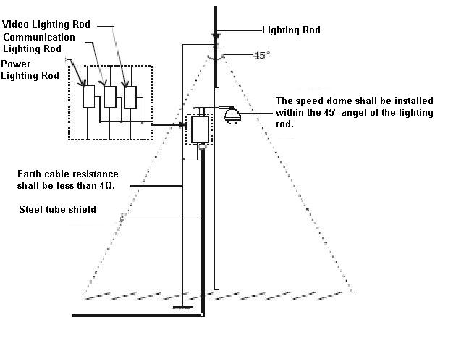
Figure 6-14

Appendix Ⅱ About RS485 Bus

RS485 Bus Main Feature
RS485 is semi duplex communication cable of impedance 120Ω. Its max load amount is 32 effective loads (including main control device and devices to be charged).

RS485 Bus Transmission Distance
When we take 0.56mm (24AWG) twisted-pair as communication cable, the max transmission distance (theoretically) are listed below (according to different baud rates).
Baud Rate | Max Distance
2400 BPS | 1800M
4800 BPS | 1200M
9600 BPS | 800M

In the following situations, the max transmission distance shall become shorter accordingly:
- The communication cable is a little bit thin;
- The surrounding environment has strong electromagnetic interference;
- There are too much devices connected to the RS485 bus;
And vice versa, the max transmission distance shall become longer.

Connection Methods and Terminal Resistance
1) RS485 bus requires all devices use the following connection methods. Both terminals shall have 120Ωresistance. See Figure 7-15.
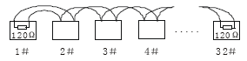
Figure 7-15
Or you can refer to for the simplified way as in Figure 7-16. But the distance between “D” shall not exceed 7M.

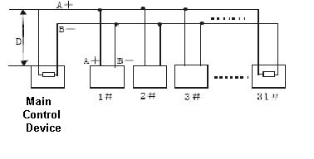
Figure 7-16
2) Please refer to chapter 2.1 for 120Ω resistance information on the main board.

The Problem in Practical Use
In practical usage, we usually adopt star type connection. The terminal resistance shall connect to the furthest two devices (Such as device 1# and device 15# in Figure 7-17 ). But this connection way does not conform to RS485 Bus standard. When the distances between devices are too long, the signal reflection occurs and anti-jamming decreases, thus the signal reliability becomes very low. You can see speed dome is not under control or speed dome is running automatically and can not stop.

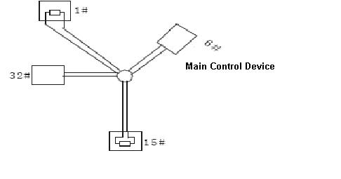
Figure 7-17
In this situation, we recommend RS485 distributor. This device can turn star type connection into the connection that conforms to RS485 bus industry standard, which can avoid the above mentioned problems and enhance communication reliability. See Figure 7-18.
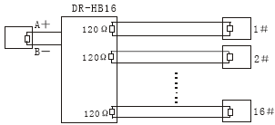
Figure 7-18

RS485 Bus FAQ
Phenomenon | Possible Reasons | Solution
Speed dome can run self-diagnosis but I can not control it. | - Host address(baud rate) and speed dome address(baud rate) are not match;  - Positive and negative end of RS485 Bus are misconnected;  - Connection cable is loose；  - RS485 Bus connection are cut off; | - Modify host or speed dome setup ；  - Switch RS485 positive end and negative end；  - Fix connection cable firmly；  - Replace RS485 Bus.
I can control the speed dome but is not smooth | - RS485 Bus connection are not good；  - One RS485 bus is off；  - The distance between host and speed dome is too far；  - Parallel connected too much speed domes. | - Connect RS 485 Bus again；  - Replace RS485 Bus；  - Add terminal matching resistance；  - Add RS485 distributor.

Appendix Toxic or Hazardous Materials or Elements
Component Name | Toxic or Hazardous Materials or Elements
Component Name | Pb | Hg | Cd | Cr VI | PBB | PBDE
Sheet Metal | ○ | ○ | ○ | ○ | ○ | ○
Plastic Parts
PCB
Housing | ○ | ○ | ○ | ○ | ○ | ○
Camera Driver | ○ | ○ | ○ | ○ | ○ | ○
Bearing | ○ | ○ | ○ | ○ | ○ | ○
Connection Cable
Motor
(If possible)
Power
(If possible)
Bracket
(If possible)
Accessories | ○ | ○ | ○ | ○ | ○ | ○
Note
O: Indicates that the concentration of the hazardous substance in all homogeneous materials in the parts is below the relevant threshold of the SJ/T11363-2006 standard.
X: Indicates that the concentration of the hazardous substance of at least one of all homogeneous materials in the parts is above the relevant threshold of the SJ/T11363-2006 standard.

Note
- This manual is for reference only. Slight difference may be found in the user interface.
- All the designs and software here are subject to change without prior written notice.
- If there is any uncertainty or controversy, please refer to the final explanation of us.
- Please visit our website or contact your local service engineer for more information.

