Speed Dome In-ceiling Installation Manual
- Accessories
Before the installation, please refer to the packing list in the box to check all the accessories listed are included in the bag.
- Environments
The in-ceiling intelligent speed dome is suitable for the indoor in-ceiling installation. The installation environments shall meet the following requirements:
  - The space above the ceiling shall have at least 250mm height.
  - The ceiling thickness ranges from 5 to 40mm.
  - The ceiling can min sustain the 5x weight of the speed dome and its accessories.
1.3 Installation Steps
1.3.1 Open Holes in the Ceiling
Take the installation location map from the bag and then paste it on the ceiling to dig the corresponding holes. Please make sure the diameter error is less than 2mm.
1.3.2 Cable Connection
Connect the power cable, video cable, control cable, network cable, (audio alarm) to the composite cable of the intelligent speed dome as your requirements.
1.3.3 Install the In-ceiling Intelligent Speed Dome to the Ceiling.
Use your hands to hold the fixed brackets at the both sides of the inside enclosure and then push the speed dome inside enclosure to the round holes of the ceiling. Please make sure the fixed brackets are totally in the holes. Turn the captive screw at the centre of the white plastic buckle to secure the brackets on the ceiling firmly. See Figure 1.
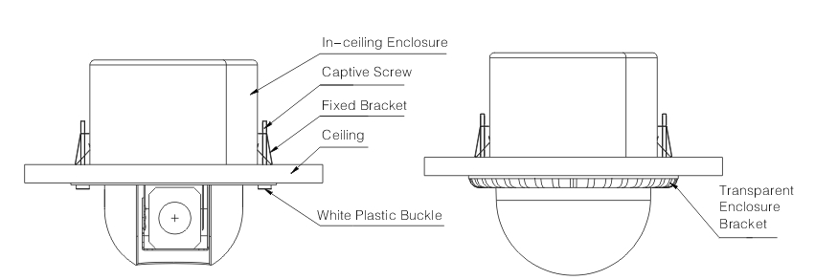
Figure 1 Figure 2

1.3.4 Install Transparent Enclosure
Please line up the two small crescent marks in the inside of the enclosure bracket to the nick of the enclosure, Insert the white plastic buckle of one side firmly and then insert the other side until you hear a clear sound of “Ping”. Please make sure the bracket of the transparent enclosure is fixed on the inside enclosure. Remove the protection film from the enclosure. Now the installation completed. See Figure 2.

Analog Speed Dome Installation Additioanl Setup
  - Initial Setup
- Address Bit: 1
- Baud Rate: 9600
- Parity: None
- 120ΩMatching Resistance: Off
  - Dial Switch Setup
Before you control the speed dome, please set the baud rate and address first so that the speed dome can has response to the control command. See Figure 3.
▲Note：
Open the transparent enclosure of the speed dome; you can see the dial switch button at the PTZ main board. Please follow the steps listed below to set the baud rate, address and etc.
Please reboot the speed dome to activate new setup!
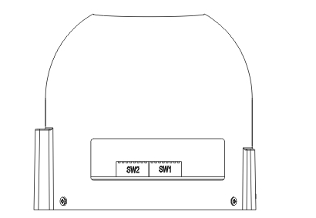
Figure 3
The two dial switches of the quick-installation speed dome are SW1 and SW2. They are to specify the speed dome parameters such as protocol, baud rate, address and etc respectively. When the button is ON, it is 1. In the SW1 and SW2, 1 is the lowest bit and the 8 is the highest bit.
Please note this series speed dome can automatically recognize the China industrial standard protocol, PELCO-D. PELCO-P. Usually you do not need to set the protocol.

2.2.1 Communication Protocol and Baud Rate
The speed dome protocol, baud rate and address interface is shown as in Figure 5.
SW1 is to set the speed dome protocol, baud rate, and address. Among the bit 1 to bit 8: 1-4 is to set protocol address, 5 and 6 are to set baud rate. 7 and 8 are to set parity. See Figure 4.
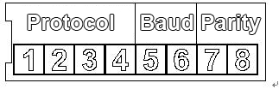
Figure 4
1 | 2 | 3 | 4 | Communication Protocol
OFF | OFF | OFF | OFF | China industrial standard protocol
ON | OFF | OFF | OFF | PELCO-D
OFF | ON | OFF | OFF | PELCO-P
X | X | X | X | Reserved
Sheet 1 Communication Protocol Setup
▲ Note：Please note this series speed dome can automatically recognize the China industrial standard protocol, PELCO-D. PELCO-P. Usually you do not need to set the protocol.
5 | 6 | Baud Rate
OFF | OFF | 9600bps
ON | OFF | 4800bps
OFF | ON | 2400bps
ON | ON | 1200bps
Sheet 2 Baud Rate Setup
7 | 8 | Parity
OFF | OFF | NONE
ON | OFF | EVEN
OFF | ON | ODD
ON | ON | NONE
Sheet 3 Parity Setup
2.2.2 Address Setup
The speed dome address setup interface is shown as in Figure 5.
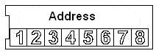
Figure 5
SW2 is to set the address. The encode mode adopts binary system. 1 to 8 is valid bit. The highest address bit is 255. You can refer to the sheet for more information. See Sheet 4.
Address | 1 | 2 | 3 | 4 | 5 | 6 | 7 | 8
1 | OFF | OFF | OFF | OFF | OFF | OFF | OFF | OFF
1 | ON | OFF | OFF | OFF | OFF | OFF | OFF | OFF
2 | OFF | ON | OFF | OFF | OFF | OFF | OFF | OFF
3 | ON | ON | OFF | OFF | OFF | OFF | OFF | OFF
4 | OFF | OFF | ON | OFF | OFF | OFF | OFF | OFF
5 | ON | OFF | ON | OFF | OFF | OFF | OFF | OFF
6 | OFF | ON | ON | OFF | OFF | OFF | OFF | OFF
7 | ON | ON | ON | OFF | OFF | OFF | OFF | OFF
8 | OFF | OFF | OFF | ON | OFF | OFF | OFF | OFF
…… | …………………………………………………………………
254 | OFF | ON | ON | ON | ON | ON | ON | ON
255 | ON | ON | ON | ON | ON | ON | ON | ON
Sheet 4 Address Setup

2.3 Terminal Matching Resistance Setup
There is terminal resistance 120Ω on the main board. There are two modes: See Figure 6.
 | 1-2 | 2-3
120Ω | ON | OFF

Figure 6
The factory default setup is shown as in Figure 7. Right now, the jumper (Connection board) is on the pin 2 and pin 3. The 120Ω resistance does not connect to the device.
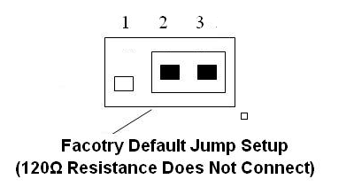
Figure 7
If you want to connect the 120Ω resistance, please remove the jumper from the pin 2 and pin 3 and connect to pin 1 and pin 2. Now the 120Ω is connected to the circuit. See Figure 8.
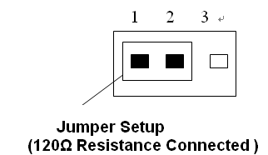
Figure 8

Note:
- This manual is for reference only. Slight difference may be found in the user interface.
- All the designs and software here are subject to change without prior written notice.
- All trademarks and registered trademarks are the properties of their respective owners.
- If there is any uncertainty or controversy, please refer to the final explanation of us.
- Please visit our website or contact your local service engineer for more information.

