Intelligent Speed Dome Installation Manual

Version 1.0.2

Table of Contents
1 INTELLIGENT SPEED DOME INSTALLATION 1
1.1 Installation Environments 1
1.2 Check installation space and installation location intension 1
1.3 About cable 1
1.4 Please keep all package material well for future use 1
2 SETUP BEFORE INSTALLATION 3
2.1 Check Accessories 3
2.2 Open Device 3
2.3 Dial Switch Setup (Analog Speed Dome) 3
2.3.1 Initial Setup 4
2.3.2 Dial Switch Buttons 4
2.3.3 Baud Rate and Parity Setup 5
2.3.4 Speed Dome Address Setup 5
2.3.5 Terminal Matching Resistance Setup 6
2.4 Dial Switch Setup (HDCVI Intelligent Speed Dome) 7
2.4.1 Initial Setup 7
2.4.2 Dial Switch Buttons 7
2.4.3 Baud Rate and HD/SD Video Format Setup 8
2.4.4 Speed Dome Address Setup 8
2.4.5 Terminal Matching Resistance Setup 9
2.5 RESET and SD Card Installation (Network Speed Dome) 10
2.6 Cable Connection 10
3 INSTALLATION 12
3.1 Wall Mount Installation 12
3.1.1 Component Installation 12
3.1.2 Wall Mount Installation Steps 12
3.2 In-Ceiling Mount 14
3.2.1 Installation Components 14
3.2.2 In-ceiling Mount Installation Steps 14
4 APPENDIX Ⅰ LIGHTENING PROTECTION AND SURGE PROTECTION 17
5 APPENDIX Ⅱ ABOUT RS485 BUS 18
5.1 RS485 Bus Main Feature 18
5.2 RS485 Bus Transmission Distance 18
5.3 The Problem in Practical Use 18
5.4 RS485 Bus FAQ 19
6 APPENDIX Ⅲ THE 24V AC WIRE GAUGE AND TRANSMISSION DISTANCE RELATIONSHIP SHEET 20
7 APPENDIX Ⅳ12V DC WIRE GAUGE AND TRANSMISSION DISTANCE RELATIONSHIP SHEET 21
8 APPENDIX V WIRE GAUGE REFERENCE SHEET 22

Welcome
Thank you for purchasing our speed dome!
Please read the following safeguards and warnings carefully before you install or use the product!

Important Safeguards and Warnings
Safety Measures
1. Qualified Engineer Needed
- The installation engineer or maintenance engineer shall have corresponding CCTV system installation certificate or maintenance qualification certificate.
- The installation engineer or maintenance engineer shall have qualification certificate for work at height.
- The installation engineer or maintenance engineer shall have the basic knowledge and operation technique for low-voltage cable layout and low-voltage electronic cable connection.
- Please read the installation manual carefully and keep it well for future reference,
- We are not liable for any problems caused by unauthorized modifications or attempted repair.

2. Lifting Appliance Requirement
- Please select the proper speed dome installation mode and use the lifting appliances at the safety environment.
- The lifting appliances shall have the enough capacity to reach the installation height.
- The lifting appliances shall have safe performance.

The precaution measures include two types: Warning and Note.
- Warning: It is to alert you there is an optional risk of death or series injury!
- Note: It is to alert you there is an optional risk of damage or property loss!

Warning
- All installation and operation here should conform to your local electrical safety codes. We assume no liability or responsibility for all the fires or electrical shock caused by improper handling or installation.
- Be sure to use all the accessories (such as power adapter) recommended by manufacturer.
- Do not connect several speed domes to one power adapter. It may result in overheat or fire if it exceeds the rated load.
- Before you connect the cable, install or uninstall, or begin the daily maintenance work, please turn off the power and unplug the power cable.
- Please make sure the produce is secure firmly on the wall or the ceiling.
- Please turn off the power and unplug the power cable, If there is any smoke, disgusting smell, or noise. Please contact your local retailer or customer service centre for help.
- All the examination and repair work should be done by the qualified service engineers. We are not liable for any problems caused by unauthorized modifications or attempted repair.

Note
1. Safety Transportation
- Heavy stress, violent vibration or water splash are not allowed during transportation, storage and installation.
- This series product must use split type package during the transportation.
- We are not liable for any damage or problem resulting from the integrated package during the transportation.
2. When device is malfunction
Shut down the device and disconnect the power cable immediately if there is smoke, abnormal smell or abnormal function. Please contact your local retailer ASAP.

3. Do not try to dismantle or modify the device
- There is risk of personal injury or device damage resulting from opening the shell.
- Please contact your local retailer if there is internal setup or maintenance requirement.
- We are not liable for any problems caused by unauthorized modifications or attempted repair.

4. Do not allow other object falling into the device
- Please make sure there is no metal or inflammable, explosive substance in the speed dome.
- The above mentioned objects in the device may result in fire, short-circuit or damage.
- Please shut down the device and disconnect the power cable if there is water or liquid falling into the camera. Please contact your local retailer ASAP.
- Please pay attention to the camera. Avoid the sea water or rain to erode the camera.

5. Handle carefully
Do not allow this series product fall down to the ground.
Avoid heavy vibration.

6. Installation Environment Requirement
- This series speed dome should be installed in a cool, dry place away from direct sunlight, inflammable, explosive substances and etc.
- This series product shall be away from the strong electromagnetism radiant, please keep it away from wireless power, TV transmitter, transformer and etc.

7. Daily Maintenance
- Please use the soft cloth to clean dust on the shell, or you can use soft cloth with cleaning liquid to clean the shell and then use soft cloth to make it dry.
- Do not use gasoline, dope thinner or other chemical material to clean the shell. It may result in shell transfiguration or paint flake.
- Do not allow the plastic or rubber material to touch the shell for a long time. It may result in paint flake.

INTELLIGENT SPEED DOME INSTALLATION

Installation Environments
Basic Requirement
- All installation and operation here should conform to your local electrical safety codes.
- Before installation, please open the package and check all the components are included. Please make sure the speed dome installation environment and installation mode can meet your requirement. If there is special requirement, please contact your local retailer for more information.
- We assume no liability or responsibility for all the fires or electrical shock caused by improper handling or installation.

Check installation space and installation location intension
Please make sure the installation environment has enough space to install the speed dome and its corresponding bracket.
Please make sure the ceiling, wall and the bracket can support the speed dome and its corresponding installation component. It shall sustain the 8X weight of the speed dome.

About cable
Please select the cable according to your transmission distance.
The minimum video coaxial-cable requirement is:
- 75 ohm.
- Full cable with copper conductor
- 95% knitted copper shield
- Please refer to Appendix 2 for RS485 communication cable information.
International Model | Max Transmission Distance  (Ft\M)
RG59/U | 750Ft (229M)
RG6/U | 1,000Ft (305M)
RG11/U | 1,500Ft (457M)
Note: The above can be applied to analog speed dome and network speed dome
International Mode | Max Transmission Distance  (M\Ft)
SYV-75-3 | 720P（25fps\30fps)：500M/1640Ft
SYV-75-3 | 720P（50fps\60fps)：300M/984Ft
SYV-75-3 | 1080P（25fps\30fps):300M/984Ft
Note: The above can be applied to HDCVI speed dome

Select eclectic wire according to your transmission distance:
- For 24V AC series product, please refer to Appendix 3.
- For 12V DC series product, please refer to Appendix 4.

Please keep all package material well for future use
Please keep speed dome package material well in case you need to send it back to your local retailer or manufacturer for maintenance work.
Non-original package material may result in device damage during the transportation.

SETUP BEFORE INSTALLATION

Check Accessories
Before the installation, please check the accessories one by one according to the packing list. Please make sure all the components listed are included.

Open Device
This section is for intelligent analog speed dome, intelligent network speed dome, and intelligent tracking speed dome.
Remove the package and then take out the device. Open the transparent cover and take out the packing material EPE around the speed dome drive. See Figure 2-1.
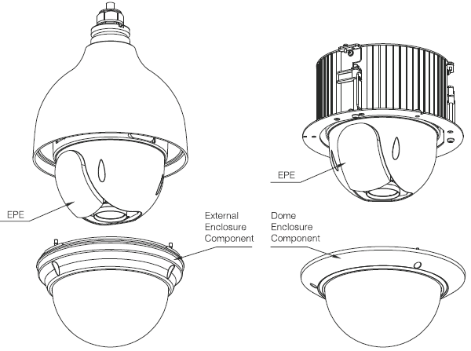
Figure 2-1

Dial Switch Setup (Analog Speed Dome)
Open the rear cover you can see there are two dial switches on the PTZ for you to set address, baud rate and etc. See Figure 2-2.
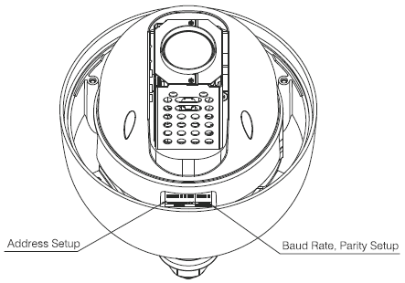
Figure 2-2

Initial Setup
The default setup is:
- Address: 1
- Baud rate: 9600
- Parity: None
- 120Ω resistance: OFF

Dial Switch Buttons
Before you control speed dome, please set the speed dome address, baud rate, parity. Otherwise, you can not control the device! See Figure 2-3.
- Open speed dome rear cover, you can view the dial switch buttons on the PTZ main board. You can follow the steps listed below to set the speed dome address, baud rate, and parity. Please note you need to restart the device to activate the new setup!
- For wall mount speed dome, you need to take out the packing material EPE, set the dial switch buttons and then put it back to the transparent enclosure module.

There are two dial switch buttons on the PTZ. You can use them to set speed dome address, baud rate, and parity respectively. It is 1 when you set the button as ON.
For address dial switch, 1 is the lowest bit and the 8 is the highest bit.
For baud rate and parity setup, 1 is the lowest bit and the 4 is the highest bit.
Please note the intelligent speed dome can automatically self-adapt, PELCO-D, PELCO-P. and the industrial standard protocol, control protocol doesn’t need to be set via dial.
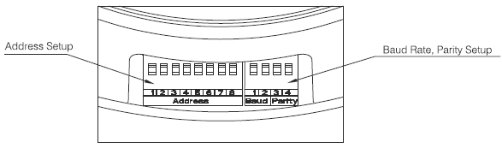
Figure 2-3

Baud Rate and Parity Setup
For the dial switch button 1-4. 1 and 2 is to set baud rate. 3 and 4 is to set parity. Please refer to the following figure for detailed information. See Figure 2-4.
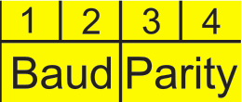
Figure 2-4
Please refer to the baud rate sheet for detailed information.
1 | 2 | Baud Rate
OFF | OFF | 9600bps
ON | OFF | 4800bps
OFF | ON | 2400bps
ON | ON | 1200bps
Please refer to the parity setup sheet for detailed information.
3 | 4 | Parity
OFF | OFF | NONE
ON | OFF | EVEN
OFF | ON | ODD
ON | ON | NONE

Speed Dome Address Setup
The address interface is shown as in Figure 2-5.
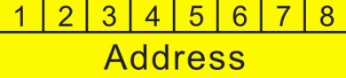
Figure 2-5
The encode mode adopts binary system. 1 to 8 is valid bit. The highest address bit is 255. You can refer to the following sheet for more information.

Address | 1 | 2 | 3 | 4 | 5 | 6 | 7 | 8
1 | OFF | OFF | OFF | OFF | OFF | OFF | OFF | OFF
1 | ON | OFF | OFF | OFF | OFF | OFF | OFF | OFF
2 | OFF | ON | OFF | OFF | OFF | OFF | OFF | OFF
3 | ON | ON | OFF | OFF | OFF | OFF | OFF | OFF
4 | OFF | OFF | ON | OFF | OFF | OFF | OFF | OFF
5 | ON | OFF | ON | OFF | OFF | OFF | OFF | OFF
6 | OFF | ON | ON | OFF | OFF | OFF | OFF | OFF
7 | ON | ON | ON | OFF | OFF | OFF | OFF | OFF
8 | OFF | OFF | OFF | ON | OFF | OFF | OFF | OFF
…… | …………………………………………………………………
254 | OFF | ON | ON | ON | ON | ON | ON | ON
255 | ON | ON | ON | ON | ON | ON | ON | ON

Terminal Matching Resistance Setup
There is terminal resistance 120Ω on the main board. There are two modes: See Figure 2-6.
 | 1-2 | 2-3
120Ω | ON | OFF

Figure 2-6
The factory default setup is shown as in Figure 2-7. Right now, the jumper (Connection board) is on the pin 2 and pin 3. The 120Ω resistance does not connect to the device.
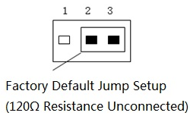
Figure 2-7
If you want to connect the 120Ω resistance, please remove the jumper from the pin 2 and pin 3 and connect to pin 1 and pin 2. Now the 120Ω is connected to the circuit. See Figure 2-8.
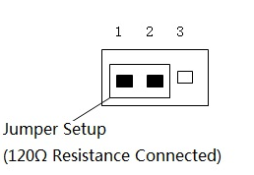
Figure 2-8

Dial Switch Setup (HDCVI Intelligent Speed Dome)
Open the rear cover you can see there are two dial switches on the PTZ for you to set address, baud rate and etc. See Figure 2-9.
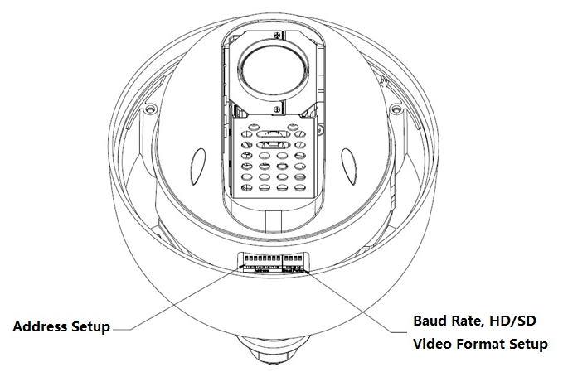
Figure 2-9
Note:
HDCVI intelligent speed dome can’t implement dial and relevant RS485 setup when it only uses coaxial control.

Initial Setup
The default setup is:
- Address: 1
- Baud rate: 9600
- HD/SD video format: HD
- 120Ω resistance: OFF

Dial Switch Buttons
Before you control speed dome, please set the speed dome address, baud rate and HD/SD video format. Otherwise, you cannot control the device! See Figure 2-10.
- Open speed dome rear cover, you can view the dial switch buttons on the PTZ main board. You can follow the steps listed below to set the speed dome address, baud rate, and HD/SD video format.
- Please note you need to restart the device to activate the new setup!
- For wall mount speed dome, you need to take out the packing material EPE, set the dial switch buttons and then put it back to the transparent enclosure module.

There are two dial switch buttons on the PTZ. You can use them to set speed dome address, baud rate, and HD/SD video format respectively. It is 1 when you set the button as ON.
For address dial switch, 1 is the lowest bit and the 8 is the highest bit.
For baud rate and HD/SD video format setup, 1 is the lowest bit and the 4 is the highest bit.
Please note the intelligent speed dome can automatically self-adapt, PELCO-D, PELCO-P. and the industrial standard protocol, control protocol doesn’t need to be set via dial.
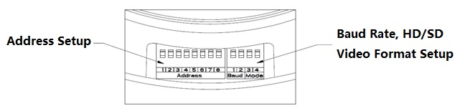
Figure 2-10

Baud Rate and HD/SD Video Format Setup
For the dial switch button 1-4. 1 and 2 is to set baud rate. 3 and 4 is to set HD/SD video format setup. Please refer to the following figure for detailed information. See Figure 2-11.
Figure 2-11
Please refer to the baud rate sheet for detailed information.
1 | 2 | Baud Rate
OFF | OFF | 9600bps
ON | OFF | 4800bps
OFF | ON | 2400bps
ON | ON | 1200bps
Please refer to the HD/SD video format setup sheet for detailed information.
3 | 4 | HD/SD video format
OFF | OFF | HD
ON | OFF | SD
OFF | ON | Self-adapt
ON | ON | HD

Speed Dome Address Setup
The address interface is shown as in Figure 2-12.
Figure 2-12
The encode mode adopts binary system. 1 to 8 is valid bit. The highest address bit is 255. You can refer to the following sheet for more information.
Address | 1 | 2 | 3 | 4 | 5 | 6 | 7 | 8
1 | OFF | OFF | OFF | OFF | OFF | OFF | OFF | OFF
1 | ON | OFF | OFF | OFF | OFF | OFF | OFF | OFF
2 | OFF | ON | OFF | OFF | OFF | OFF | OFF | OFF
3 | ON | ON | OFF | OFF | OFF | OFF | OFF | OFF
4 | OFF | OFF | ON | OFF | OFF | OFF | OFF | OFF
5 | ON | OFF | ON | OFF | OFF | OFF | OFF | OFF
6 | OFF | ON | ON | OFF | OFF | OFF | OFF | OFF
7 | ON | ON | ON | OFF | OFF | OFF | OFF | OFF
8 | OFF | OFF | OFF | ON | OFF | OFF | OFF | OFF
…… | …………………………………………………………………
254 | OFF | ON | ON | ON | ON | ON | ON | ON
255 | ON | ON | ON | ON | ON | ON | ON | ON

Terminal Matching Resistance Setup
There is terminal resistance 120Ω on the main board. There are two modes: See Figure 2-13.
 | 1-2 | 2-3
120Ω | ON | OFF

Figure 2-13
The factory default setup is shown as in Figure 2-14. Right now, the jumper (Connection board) is on the pin 2 and pin 3. The 120Ω resistance does not connect to the device.
Figure 2-14
If you want to connect the 120Ω resistance, please remove the jumper from the pin 2 and pin 3 and connect to pin 1 and pin 2. Now the 120Ω is connected to the circuit. See Figure 2-15.
Figure 2-15

RESET and SD Card Installation (Network Speed Dome)
After opening the speed dome, there is a RESER button on the PTZ mainboard shown as in Figure 2-16. The RESET button is used to reset network system.
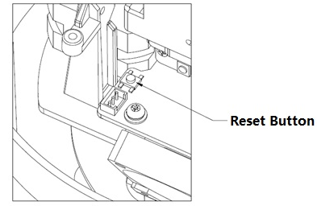
Figure 2-16
The Micro-SD card is installed on the camera module for data storage. See Figure 2-17.
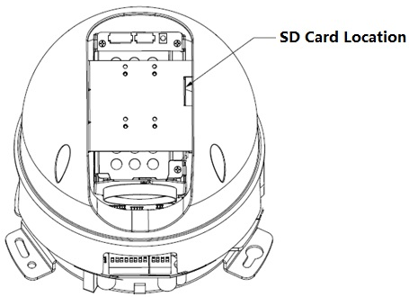
Figure 2-17
Note:
Please contact the technical support of our company if you have any questions.

Cable Connection
Please connect the power cable, video output cable, audio cable, RS485 control cable, alarm input/output pin, network cable, high-frequency cable, fiber cable according to your actual requirements. Pleas use insulation tape to seal the cable connection ports to do proper waterproof work.
Note
The video port is covered the heat shrink tube of high shrinking ratio. After the video connection, please heat the tube to make sure the video port is damp proof and water proof.

INSTALLATION
The intelligent speed dome adopts wall mount/in-ceiling mount mode.

Wall Mount Installation

Component Installation
The wall mount bracket and intelligent speed dome is shown as in Figure 3-9.
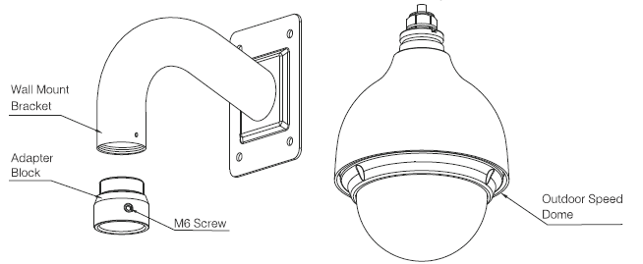 Figure 3-9

Wall Mount Installation Steps

Installation Environments
The wall mount speed dome can be installed in the hard construction wall in the indoor or outdoor environments. Before the installation, please make sure:
- The wall is thick enough to install the expansion bolt.
- The ceiling can at least sustain the 8x weight of the speed dome, bracket and the accessories.

Installation Steps
  - Dig a hole of 50mm diameter for cable exit in the installation wall.
  - In Figure 3-10, connect the adapter block to the internal thread of the wall mount bracket, until it reaches the end and then fix the set screw. Pull the intelligent speed dome composite cable through the adapter block and pull it out of the other end of the wall mount bracket. Line up the hook at the top of the external enclosure to the inside hole of the adapter block and then push it to the end, and then secure the three screws of the adapter block firmly. Please note this step is very important. Please make sure the screws are firm, otherwise, it may result in falling risk of the intelligent speed dome.

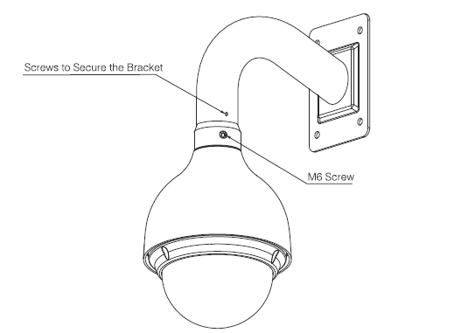
Figure 3-10

  - Dig holes in the wall according to the installation holes at the bottom of the wall mount bracket. Please make sure the cable exit of the bracket is facing the round hole of the wall. Insert expansion bolts (not provided) to the holes you just dug. Connect the composition cable and then pull it through the hole in the wall. Use four hex screws and flat washer to secure the bracket on the wall of the expansion bolts. See Figure 3-11.
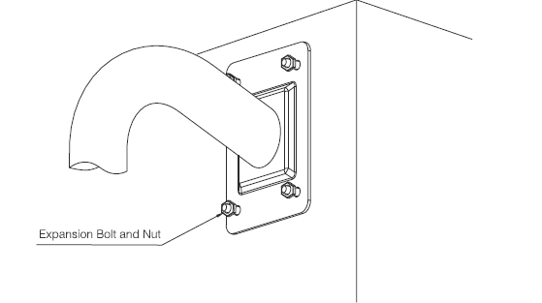
Figure 3-11
Now the installation is complete. See Figure 3-12.
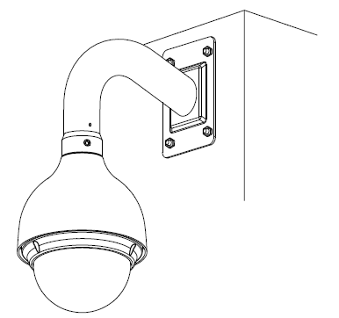
Figure 3-12

In-Ceiling Mount

Installation Components
The in-ceiling mount bracket and component is shown as in Figure 3-13.
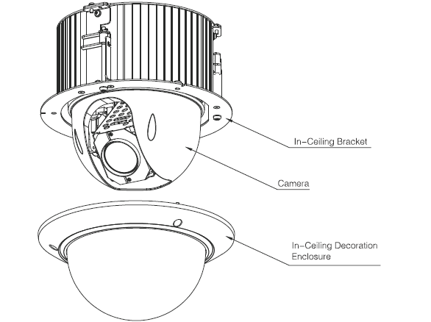
Figure 3-13

In-ceiling Mount Installation Steps

Installation Environments
The ceiling mount speed dome can be installed in the hard construction wall in the indoor environments. Before the installation, please make sure:
- The ceiling thickness ranges from 10mm-40mm.
- The ceiling can at least sustain the 8x weight of the speed dome, bracket and the accessories.

Installation Steps
  - Please refer Figure 3-14, confirm the installation position and then use the ceiling installation position map to dig holes in the ceiling. 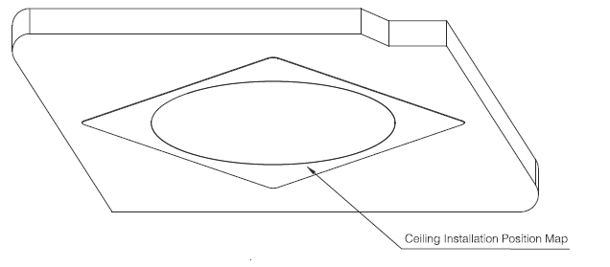
Figure 3-14
  - Connect the composition cables and then put the cables to the hole you just dug. Push the in-ceiling bracket and the speed dome components to the hole. Secure the screw and fasten the mount plate. See Figure 3-15.
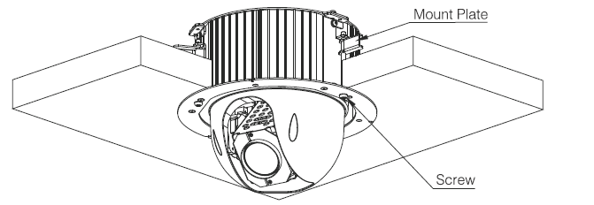
Figure 3-15
  - Please refer to Figure 3-16 to use three screws to fix the in-ceiling decoration cover on the in-ceiling mount components. See Figure 3-17.
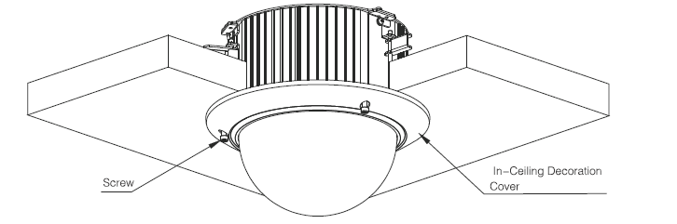
Figure 3-16
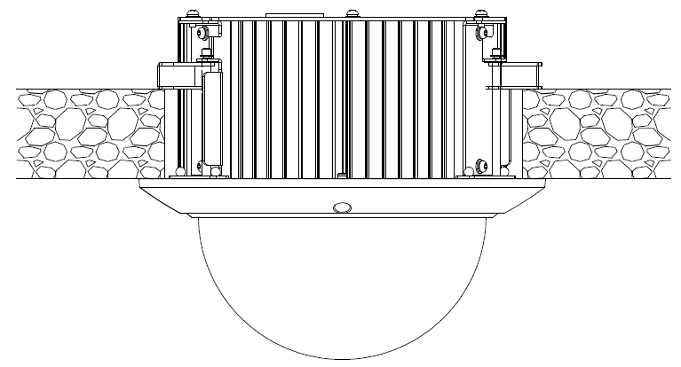
Figure 3-17

APPENDIX Ⅰ LIGHTENING PROTECTION AND SURGE PROTECTION
This series speed dome adopts TVS lighting protection technology. It can effectively prevent damages from various pulse signals below 6000V, such as sudden lighting and surge. While maintaining your local electrical safety code, you still need to take necessary precaution measures when installing the speed dome in the outdoor environment.

- The distance between the signal transmission cable and high-voltage device (or high-voltage cable) shall be at least 50 meters.
- Outdoor cable layout shall go under the penthouse if possible.
- For vast land, please use sealing steel tube under the land to implement cable layout and connects one point to the earth. Open floor cable layout is forbidden.
- In area of strong thunderstorm hit or near high sensitive voltage (such as near high-voltage transformer substation), you need to install additional high-power thunder protection device or lightning rod.
- The thunder protection and earth of the outdoor device and cable shall be considered in the building whole thunder protection and conform to your local national or industry standard.
- System shall adopt equal-potential wiring. The earth device shall meet anti-jamming and at the same time conforms to your local electrical safety code. The earth device shall not short circuit to N (neutral) line of high voltage power grid or mixed with other wires. When connect the system to the earth alone, the earth resistance shall not be more than 4Ω and earth cable cross-sectional area shall be below 25 mm². See Figure 4-1.
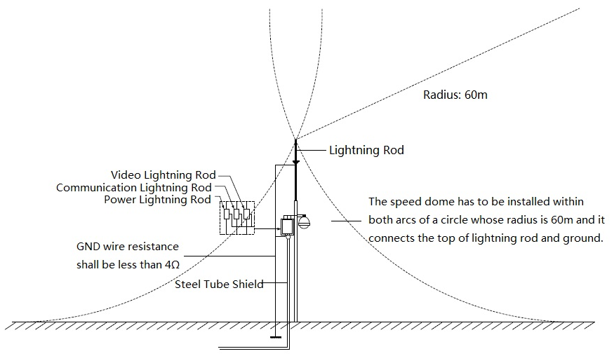
Figure 4-1

APPENDIX Ⅱ ABOUT RS485 BUS

RS485 Bus Main Feature
RS485 is semi duplex communication cable of impedance 120Ω. Its max load amount is 32 effective loads (including main control device and devices to be charged).

RS485 Bus Transmission Distance
When we take 0.56mm (24AWG) twisted-pair as communication cable, the max transmission distance (theoretically) are listed below (according to different baud rates).
Baud Rate | Max Distance
2400 BPS | 1800M
4800 BPS | 1200M
9600 BPS | 800M

In the following situations, the max transmission distance shall become shorter accordingly:
- The communication cable is a little bit thin;
- The surrounding environment has strong electromagnetic interference;
- There are too much devices connected to the RS485 bus;
And vice versa, the max transmission distance shall become longer.

The Problem in Practical Use
In practical usage, we usually adopt star type connection. The terminal resistance shall connect to the furthest two devices (Such as device 1# and device 15# in Figure 5-2 ). But this connection way does not conform to RS485 Bus standard. When the distances between devices are too long, the signal reflection occurs and anti-jamming decreases, thus the signal reliability becomes very low. You can see speed dome is not under control or speed dome is running automatically and can not stop.

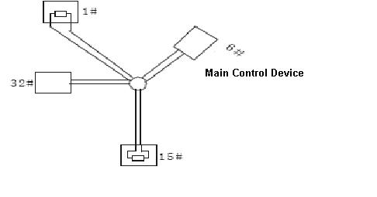
Figure 5-2
In this situation, we recommend RS485 distributor. This device can turn star type connection into the connection that conforms to RS485 bus industry standard, which can avoid the above mentioned problems and enhance communication reliability. See Figure 5-3.
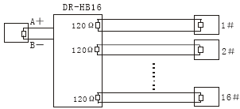
Figure 5-3

RS485 Bus FAQ
Phenomenon | Possible Reasons | Solution
Speed dome can run self-diagnosis but I can not control it. | - Host address(baud rate) and speed dome address(baud rate) are not match;  - Positive and negative end of RS485 Bus are misconnected;  - Connection cable is loose；  - RS485 Bus connection are cut off; | - Modify host or speed dome setup ；  - Switch RS485 positive end and negative end；  - Fix connection cable firmly；  - Replace RS485 Bus.
I can control the speed dome but is not smooth | - RS485 Bus connection are not good；  - One RS485 bus is off；  - The distance between host and speed dome is too far；  - Parallel connected too much speed domes. | - Connect RS 485 Bus again；  - Replace RS485 Bus；  - Add terminal matching resistance；  - Add RS485 distributor.

APPENDIX Ⅲ THE 24V AC WIRE GAUGE AND TRANSMISSION DISTANCE RELATIONSHIP SHEET
It is the recommended transmission distance when the cable diameter is fixed and the 24V AC power consumption is below 10%. For the AC device, the max permission voltage power consumption is 10%. For example, when a device of rated power 20W installed from the transformer 141 inches (42m), then the min cable diameter is 0.8000mm.
mm  Feet（m）  w | 0.8000 | 1.000 | 1.250 | 2.000
5 | 488.52（148.90） | 763.31（232.66） | 1192.67（363.53） | 3053.25（930.63）
10 | 244.26（74.45） | 381.66（116.33） | 596.34（181.76） | 1526.62（465.31）
15 | 162.84（49.63） | 254.44（77.55） | 397.56（121.18） | 1017.75（310.21）
20 | 122.13（37.23） | 190.83（58.16） | 298.17（90.88） | 763.31（232.66）
25 | 97.70（29.78） | 152.66（46.53） | 238.53（72.71） | 610.65（186.13）
30 | 81.42（24.82） | 127.22（38.78） | 198.78（60.59） | 508.87（155.10）
35 | 69.79（21.27） | 109.04（33.24） | 170.38（51.93） | 436.18（132.95）
40 | 61.06（18.61） | 95.41（29.08） | 149.08（45.44） | 381.66（116.33）
45 | 54.28（16.54） | 84.81（25.85） | 132.52（40.39） | 339.25（103.40）
50 | 48.85（14.89） | 76.33（23.27） | 119.27（36.35） | 305.32（93.06）
55 | 44.41（13.54） | 69.39（21.15） | 108.42（33.05） | 277.57（84.60）
60 | 40.71（12.41） | 63.61（19.39） | 99.39（30.29） | 254.44（77.55）
65 | 37.58（11.45） | 58.72（17.90） | 91.74（27.96） | 234.87（71.59）
70 | 34.89（10.64） | 54.52（16.62） | 85.19（25.97） | 218.09（66.47）
75 | 32.57（9.93） | 50.89（15.51） | 79.51（24.24） | 203.55（62.04）
80 | 30.53（9.31） | 47.71（14.54） | 74.54（22.72） | 190.83（58.16）
85 | 28.74（8.76） | 44.90（13.69） | 70.16（21.38） | 179.60（54.74）
90 | 27.14（8.27） | 42.41（12.93） | 66.26（20.20） | 169.62（51.70）
95 | 25.71（7.84） | 40.17（12.25） | 62.77（19.13） | 160.70（48.98）
100 | 24.43（7.45） | 38.17（11.63） | 59.63（18.18） | 152.66（46.53）

APPENDIX Ⅳ12V DC WIRE GAUGE AND TRANSMISSION DISTANCE RELATIONSHIP SHEET
The recommended max transmission distance is under the following environments: The wire diameter is fixed and the DC 12V power voltage loss rate is below 10%. For the device of DC power supplying, the max allowed voltage loss rate is 10%. All the wires listed in the following sheet are copper wire. (Copper wire resistance)

mm  Feet（m）  w | 0.8000 | 1.000 | 1.250 | 2.000
5 | 122.13（37.23） | 190.83（58.16） | 298.17（90.88） | 763.31（232.66）
10 | 61.06（18.61） | 95.41（29.08） | 149.08（45.44） | 381.66（116.33）
15 | 40.71（12.41） | 63.61（19.39） | 99.39（30.29） | 254.44（77.55）
20 | 30.53（9.31） | 47.71（14.54） | 74.54（22.72） | 190.83（58.16）
25 | 24.43（7.45） | 38.17（11.63） | 59.63（18.18） | 152.66（46.53）
30 | 20.35（6.20） | 31.80（9.69） | 49.69（15.15） | 127.22（38.78）
35 | 17.45（5.32） | 27.26（8.31） | 42.60（12.98） | 109.04（33.24）
40 | 15.27（4.65） | 23.85（7.27） | 37.27（11.36） | 95.41（29.08）
45 | 13.57（4.14） | 21.20（6.46） | 33.13（10.10） | 84.81（28.85）
50 | 12.21（3.72） | 19.08（5.82） | 29.82（9.09） | 76.33（23.27）
55 | 11.10（3.38） | 17.35（5.29） | 27.11（8.26） | 69.39（21.15）
60 | 10.18（3.10） | 15.90（4.85） | 24.85（7.57） | 63.61（19.39）
65 | 9.39（2.86） | 14.68（4.47） | 22.94（6.99） | 58.72（17.90）
70 | 8.72（2.66） | 13.63（4.15） | 21.30（6.49） | 54.52（16.62）
75 | 8.14（2.48） | 12.72（3.88） | 19.88（6.06） | 50.89（15.51）
80 | 7.63（2.33） | 11.93（3.64） | 18.64（5.68） | 47.71（14.54）
85 | 7.18（2.19） | 11.23（3.42） | 17.54（5.35） | 44.90（13.69）
90 | 6.78（2.07） | 10.60（3.23） | 16.56（5.05） | 42.41（12.93）
95 | 6.43（1.96） | 10.04（3.06） | 15.69（4.78） | 40.17（12.25）
100 | 6.11（1.86） | 9.54（2.91） | 14.91（4.54） | 38.17（11.63）

APPENDIX V WIRE GAUGE REFERENCE SHEET
Metric bare wire diameter  （mm） | AWG | SWG | Bare wire cross section  （mm²）
0.050 | 43 | 47 | 0.00196
0.060 | 42 | 46 | 0.00283
0.070 | 41 | 45 | 0.00385
0.080 | 40 | 44 | 0.00503
0.090 | 39 | 43 | 0.00636
0.100 | 38 | 42 | 0.00785
0.110 | 37 | 41 | 0.00950
0.130 | 36 | 39 | 0.01327
0.140 | 35 | / | 0.01539
0.160 | 34 | 37 | 0.02011
0.180 | 33 | / | 0.02545
0.200 | 32 | 35 | 0.03142
0.230 | 31 | / | 0.04115
0.250 | 30 | 33 | 0.04909
0.290 | 29 | 31 | 0.06605
0.330 | 28 | 30 | 0.08553
0.350 | 27 | 29 | 0.09621
0.400 | 26 | 28 | 0.1257
0.450 | 25 | / | 0.1602
0.560 | 24 | 24 | 0.2463
0.600 | 23 | 23 | 0.2827
0.710 | 22 | 22 | 0.3958
0.750 | 21 | / | 0.4417
0.800 | 20 | 21 | 0.5027
0.900 | 19 | 20 | 0.6362
1.000 | 18 | 19 | 0.7854
1.250 | 16 | 18 | 1.2266
1.500 | 15 | / | 1.7663
2.000 | 12 | 14 | 3.1420
2.500 | / | / | 4.9080
3.000 | / | / | 7.0683

Note
- This manual is for reference only. Slight difference may be found in the user interface.
- All the designs and software here are subject to change without prior written notice.
- All trademarks and registered trademarks are the properties of their respective owners.
- If there is any uncertainty or controversy, please refer to the final explanation of us.
- Please visit our website or contact your local service engineer for more information.

