IR Intelligent Speed Dome Installation Manual

Version 1.1.3

Table of Contents
1 IR INTELLIGENT SPEED DOME INSTALLATION 1
1.1 Installation Preparation 1
1.2 Initial Setup 2
1.3 Dial Switch Setup (Analog Speed Dome) 2
1.3.1 Dial Switch Description 2
1.3.2 Parity Setup 3
1.3.3 Baud Rate Setup 3
1.3.4 Speed Dome Address Setup 3
1.4 Dial Switch Setup (HDCVI Speed Dome) 3
1.4.1 Dial Switch Description 3
1.4.2 HD/SD Video Format Setup 4
1.4.3 Baud Rate Setup 4
1.4.4 Speed Dome Address Setup 4
1.5 Reset and SD Card Installation (Network Speed Dome) 5
1.6 Speed Dome Installation 5
1.6.1 Overview 5
1.6.2 Installation Conditions 6
1.6.3 Dig Installation Holes 6
1.6.4 Speed Dome Installation 6
2 HANG MOUNT INSTALLATION 8
2.1 Installation Components 8
2.2 Installation 8
2.2.1 Installation Requirements 8
2.2.2 Installation Steps 8
3 CORNER MOUNT BRACKET 12
3.1 Component Installation 12
3.2 Installation 12
3.2.1 Installation Requirements 12
3.2.2 Installation Steps 12
4 POLE MOUNT BRACKET 14
4.1 Installation 14
4.1.1 Installation Requirements 14
4.1.2 Installation Steps 14
5 BRACKET DIMENSIONS 16
5.1 Wall Mount Bracket 16
5.2 Hanging Mount Bracket (Multiple Lengths) 16
5.3 Corner Mount Bracket 17
5.4 Pole mount bracket 17
6 APPENDIX Ⅰ THUNDER PROOF AND SURGE PROTECTION 18
7 APPENDIX Ⅱ ABOUT RS485 BUS 19
7.1 RS485 Bus Main Feature 19
7.2 RS485 Bus Transmission Distance 19
7.3 The Problem in Practical Use 19
7.4 RS485 Bus FAQ 20
8 APPENDIX Ⅲ SAFETY ROPE INSTALLATION 21

Welcome
Thank you for purchasing our speed dome!
Please read the following safeguards and warnings carefully before you install or use the product!

Important Safeguards and Warnings
Safety Measures
1. Qualified Engineer Needed
- The installation engineer or maintenance engineer shall have corresponding CCTV system installation certificate or maintenance qualification certificate.
- The installation engineer or maintenance engineer shall have qualification certificate for work at height.
- The installation engineer or maintenance engineer shall have the basic knowledge and operation technique for low-voltage cable layout and low-voltage electronic cable connection.
- Please read the installation manual carefully and keep it well for future reference,
- We are not liable for any problems caused by unauthorized modifications or attempted repair.

2. Lifting Appliance Requirement
- Please select the proper speed dome installation mode and use the lifting appliances at the safety environment.
- The lifting appliances shall have the enough capacity to reach the installation height.
- The lifting appliances shall have safe performance.

The precaution measures include two types: Warning and Note.
- Warning: It is to alert you there is an optional risk of death or series injury!
- Note: It is to alert you, there is an optional risk of damage or property loss!

Warning
- All installation and operation here should conform to your local electrical safety codes.
The power shall conform to the requirement in the SELV (Safety Extra Low Voltage) and the rated voltage conformed to Limited Power Source according to the IEC60950-1. (Power supply requirement is subject to the device label).
- We assume no liability or responsibility for all the fires or electrical shock caused by improper handling or installation.
- Be sure to use all the accessories (such as power adapter) recommended by manufacturer.
- Do not connect several speed domes to one power adapter. It may result in overheat or fire if it exceeds the rated load.
- Before you connect the cable, install or uninstall, or begin the daily maintenance work, please turn off the power and unplug the power cable.
- Please make sure the produce is secure firmly on the wall or the ceiling.
- Please turn off the power and unplug the power cable, If there is any smoke, disgusting smell, or noise. Please contact your local retailer or customer service centre for help.
- All the examination and repair work should be done by the qualified service engineers. We are not liable for any problems caused by unauthorized modifications or attempted repair.

Note
1. Safety Transportation
- Heavy stress, violent vibration or water splash are not allowed during transportation, storage and installation.
- This series product must use split type package during the transportation.
- We are not liable for any damage or problem resulting from the integrated package during the transportation.
2. When device is malfunction
Shut down the device and disconnect the power cable immediately if there is smoke, abnormal smell or abnormal function. Please contact your local retailer ASAP.

3. Do not try to dismantle or modify the device
- There is risk of personal injury or device damage resulting from opening the shell.
- Please contact your local retailer if there is internal setup or maintenance requirement.
- We are not liable for any problems caused by unauthorized modifications or attempted repair.

4. Do not allow other object falling into the device
- Please make sure there is no metal or inflammable, explosive substance in the speed dome.
- The above mentioned objects in the device may result in fire, short-circuit or damage.
- Please shut down the device and disconnect the power cable if there is water or liquid falling into the camera. Please contact your local retailer ASAP.
- Please pay attention to the camera. Avoid the sea water or rain to erode the camera.

5. Handle carefully
Do not allow this series product fall down to the ground.
Avoid heavy vibration.

6. Installation Environment Requirement
- This series speed dome should be installed in a cool, dry place away from direct sunlight, inflammable, explosive substances and etc.
- This series product shall be away from the strong electromagnetism radiant, please keep it away from wireless power, TV transmitter, transformer and etc.

7. Daily Maintenance
- Please use the soft cloth to clean dust on the shell, or you can use soft cloth with cleaning liquid to clean the shell and then use soft cloth to make it dry.
- Do not use gasoline, dope thinner or other chemical material to clean the shell. It may result in shell transfiguration or paint flake.
- Do not allow the plastic or rubber material to touch the shell for a long time. It may result in paint flake.

IR INTELLIGENT SPEED DOME INSTALLATION

Installation Preparation
Basic Requirement
- All installation and operation here should conform to your local electrical safety codes.
- Before installation, please open the package and check all the components are included. Please make sure the speed dome installation environment and installation mode can meet your requirement. If there is special requirement, please contact your local retailer for more information.
- We assume no liability or responsibility for all the fires or electrical shock caused by improper handling or installation.

Check installation space and installation location intension
Please make sure the installation environment has enough space to install the speed dome and its corresponding bracket.
Please make sure the ceiling, wall and the bracket can support the speed dome and its corresponding installation component. It shall sustain the 8X weight of the speed dome.
About cable
Please select the cable according to your transmission distance.
The minimum video coaxial-cable requirement is:
- 75 ohm.
- Full cable with copper conductor
- 95% knitted copper shield
International Model | Max Transmission Distance  (Ft\M)
RG59/U | 750Ft (229M)
RG6/U | 1,000Ft (305M)
RG11/U | 1,500Ft (457M)
Note:
The above can be applied to analog speed dome and network speed dome
International Model | Max Transmission Distance  (M\Ft)
SYV-75-3 | 720P(25fps\30fps)：500M/1640Ft
SYV-75-3 | 720P(50fps\60fps)：300M/984Ft
SYV-75-3 | 1080P(25fps\30fps): 300M/984Ft
Note:
The above can be applied to HDCVI speed dome.
Set dial switch button
Set dial switch button according to control protocol and speed dome address. (Please refer to user’s manual for detailed information.)

Please keep all package material well for future use
Please keep speed dome package material well in case you need to send it back to your local retailer or manufacturer for maintenance work.
Non-original package material may result in device damage during the transportation.

Check Accessories
Before the installation, please check the accessories one by one according to the packing list. Please make sure all the components listed are includes.

Initial Setup
The default setup is:
- Address: 1
- Baud rate: 9600
- Parity: None.

Dial Switch Setup (Analog Speed Dome)

Dial Switch Description
There are two dial switch buttons on the PCB of one side of the speed dome (There are labels.). You can use them to set speed dome baud rate, address and etc. See Figure 1-1 . It is 1 when you set the button as ON.
For the protocol dial switch, you can refer to the following sheet. 1 is the lowest bit and the 8 is the highest bit. 1~3 is NC neutral bit, 4 is the setting bit for 120Ω matched resistance, ON is to connect 120Ω matched resistance, 5, 6 are the setting bit for parity, 7, 8 are the setting bit for baud rate. Only when you cut off the power or restart the system after dial switch setup, can the setup be valid.
Note:
The IR speed dome can automatically recognize the PELCO-D. PELCO-P and industry standard protocol, control protocol doesn’t need to be set via dial.
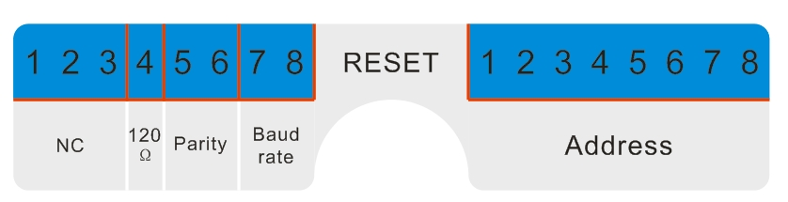
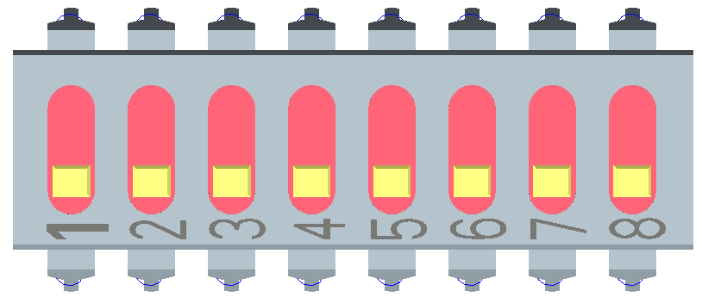
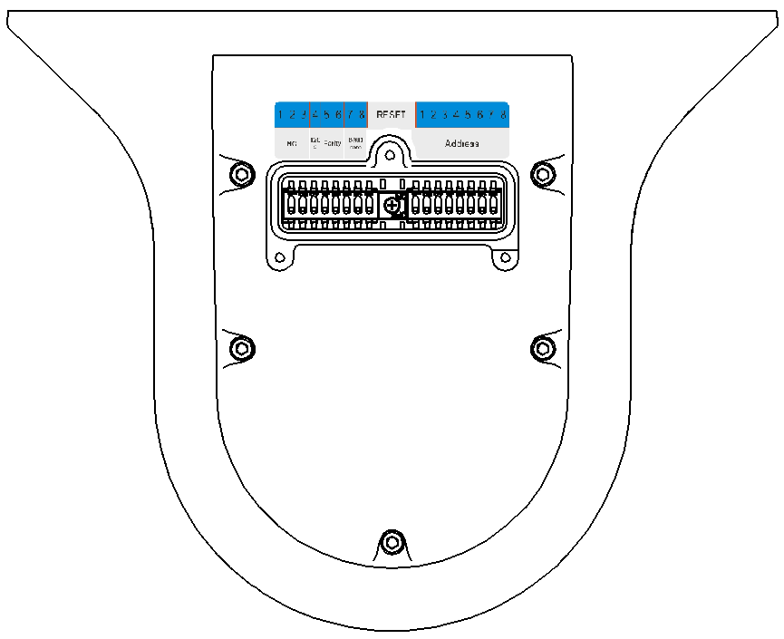
1. Address and protocol dial label
2. Protocol dial switch.
3. Address dial switch.
1
2
3
ON
OFF
Figure 1-1

Parity Setup
Please refer to the parity setup sheet for detailed information.
5 | 6 | Parity
OFF | OFF | NONE
ON | OFF | EVEN
OFF | ON | ODD
ON | ON | NONE

Baud Rate Setup
Please refer to the baud rate sheet for detailed information.
7 | 8 | Baud Rate
OFF | OFF | 9600bps
ON | OFF | 4800bps
OFF | ON | 2400bps
ON | ON | 1200bps

Speed Dome Address Setup
The speed dome uses dial switch to set address number, the encode mode adopts binary system. 1 to 8 is valid bit. The highest address bit is 255. You can refer to the following sheet for more information.
Address | 1 | 2 | 3 | 4 | 5 | 6 | 7 | 8
1 | OFF | OFF | OFF | OFF | OFF | OFF | OFF | OFF
1 | ON | OFF | OFF | OFF | OFF | OFF | OFF | OFF
2 | OFF | ON | OFF | OFF | OFF | OFF | OFF | OFF
3 | ON | ON | OFF | OFF | OFF | OFF | OFF | OFF
4 | OFF | OFF | ON | OFF | OFF | OFF | OFF | OFF
5 | ON | OFF | ON | OFF | OFF | OFF | OFF | OFF
6 | OFF | ON | ON | OFF | OFF | OFF | OFF | OFF
7 | ON | ON | ON | OFF | OFF | OFF | OFF | OFF
8 | OFF | OFF | OFF | ON | OFF | OFF | OFF | OFF
…… | …………………………………………………………………
254 | OFF | ON | ON | ON | ON | ON | ON | ON
255 | ON | ON | ON | ON | ON | ON | ON | ON

Dial Switch Setup (HDCVI Speed Dome)

Dial Switch Description
There are two dial switch buttons on the PCB of one side of the speed dome (There are labels.). You can use them to set speed dome baud rate, address and etc. See Figure 1-2. It is 1 when you set the switch as ON.
For the protocol dial switch, you can refer to the following sheet. 1 is the lowest bit and the 8 is the highest bit. 1~3 is NC neutral bit, 4 is the setting bit for 120Ω matched resistance, ON is to connect 120Ω matched resistance, 5, 6 are the setting bit for HD/SD video format, 7, 8 are the setting bit for baud rate. Only when you cut off the power or restart the system after dial switch setup, can the setup be valid.
Note:
The IR speed dome can automatically recognize the PELCO-D. PELCO-P and industry standard protocol, control protocol doesn’t need to be set via dial.
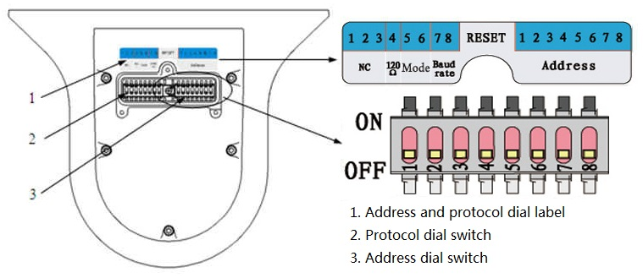
Figure 1-2

HD/SD Video Format Setup
Please refer to the following sheet for more details about HD/SD video format.
5 | 6 | HD/SD Video Format
OFF | OFF | HD
ON | OFF | SD
OFF | ON | Self-adapt
ON | ON | HD

Baud Rate Setup
Please refer to the following sheet for more details about baud rate.
7 | 8 | Baud rate
OFF | OFF | 9600bps
ON | OFF | 4800bps
OFF | ON | 2400bps
ON | ON | 1200bps

Speed Dome Address Setup
The speed dome uses dial switch to set address number, the encode mode adopts binary system. 1 to 8 is valid bit. The highest address bit is 255. You can refer to the following sheet for more information.

Address | 1 | 2 | 3 | 4 | 5 | 6 | 7 | 8
1 | OFF | OFF | OFF | OFF | OFF | OFF | OFF | OFF
1 | ON | OFF | OFF | OFF | OFF | OFF | OFF | OFF
2 | OFF | ON | OFF | OFF | OFF | OFF | OFF | OFF
3 | ON | ON | OFF | OFF | OFF | OFF | OFF | OFF
4 | OFF | OFF | ON | OFF | OFF | OFF | OFF | OFF
5 | ON | OFF | ON | OFF | OFF | OFF | OFF | OFF
6 | OFF | ON | ON | OFF | OFF | OFF | OFF | OFF
7 | ON | ON | ON | OFF | OFF | OFF | OFF | OFF
8 | OFF | OFF | OFF | ON | OFF | OFF | OFF | OFF
…… | …………………………………………………………………
254 | OFF | ON | ON | ON | ON | ON | ON | ON
255 | ON | ON | ON | ON | ON | ON | ON | ON

Reset and SD Card Installation (Network Speed Dome)
You can see there are a RESET button, dial switch button and Micro-SD card slot on one side of the PCB of the speed dome. See Figure 1-3. It is 1 when you set the button as ON.RESET button is to restore factory default setup. Micro-SD card is to save the data.
You can refer to the sheet for dial switch information.
1 | 2 | ON | OFF
120Ω | NC | Connect to 120Ω

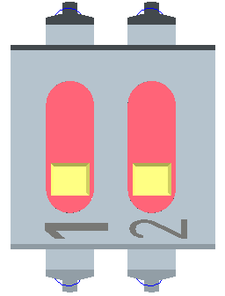
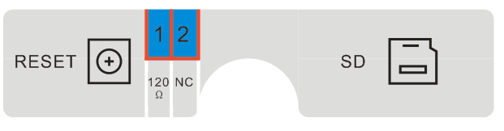
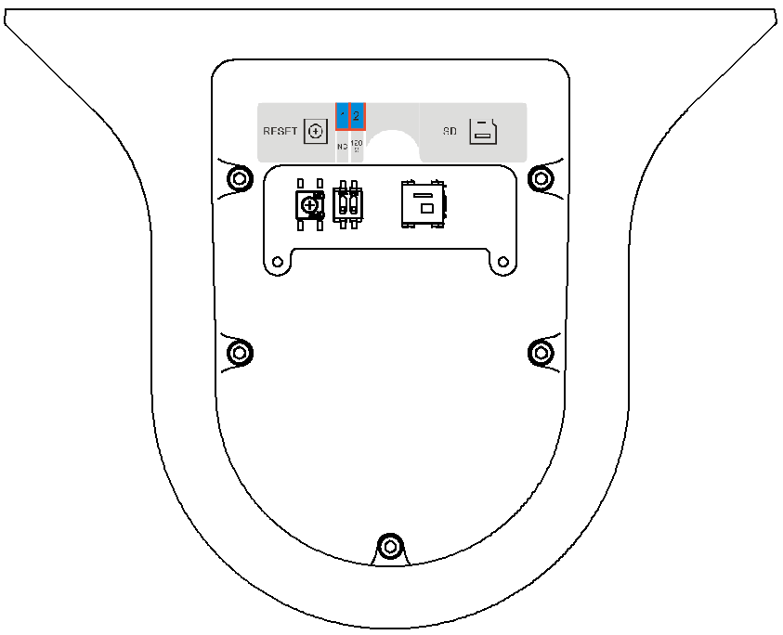
1
2
3
4
ON
OFF
1. RESET button and dial switch label
2. RESET button.
3. Dial switch on-off button
4. Micro-SD card slot
Figure 1-3
Note:
For some speed domes there is only reset button and dial switch, or no any other buttons on the PCB board (without tag) of the lateral ear; for some speed domes, the SD card is installed on the module, please refer to the actual device for more details.

Speed Dome Installation
Note:
This chapter of installation includes IR intelligent speed dome and network IR intelligent speed dome.

Overview
The speed dome has various brackets suitable for different environments. For detailed information, please refer to chapter 2 and chapter 4. Here we are going to install the IR speed dome with the analog wall mount bracket.

Installation Conditions
Wall mount bracket is for the indoor and outdoor hard wall construction environments.
Before the installation, please make sure the wall thickness can sustain the expansion bolt. The wall can support at least the 8X of the speed dome weight.

Dig Installation Holes
Draw the installation holes in the wall according to the holes at the bottom of the wall mount bracket. Dig the installation holes. Insert the expansion bolts into the holes. (Please note the expansion bolts are not included in the accessories bag.). See Figure 1-4.
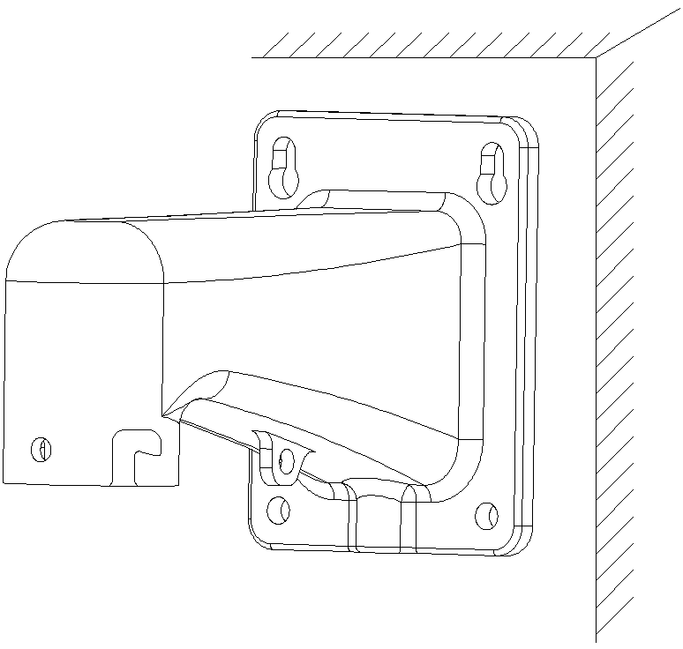
Installation Holes
Figure 1-4

Speed Dome Installation
Step1: Connect the speed dome to the bracket.
Use the quick installation screw of the speed dome and the quick instillation block to fix the speed dome on the bracket. Use the M6 inner hex screw to secure firmly. See Figure 1-5.
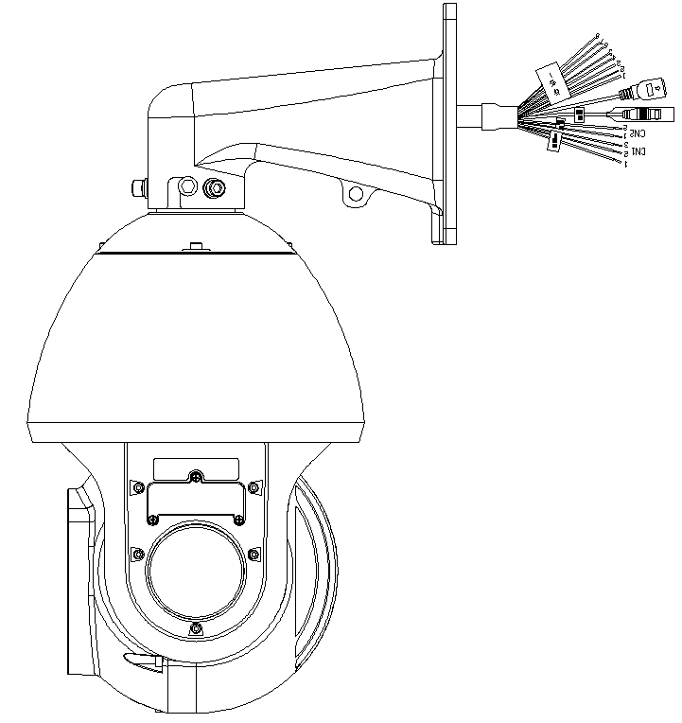
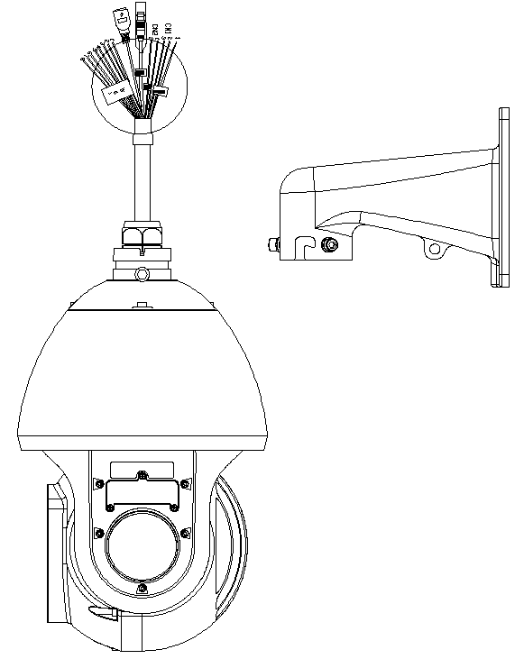
Cable
Speed Dome
Bracket
Quick Installation Port
Quick Installation Screw
M6 Inner Hex Screw
Figure 1-5

Step 2: Cable connection
Connect the video, RS485, power (Network, alarm, audio and optical fiber are optional) to the corresponding ports. Please note the cable description here is for reference only.

Step3: Secure the bracket
Secure the speed dome and the bracket to the wall firmly. See Figure 1-6.
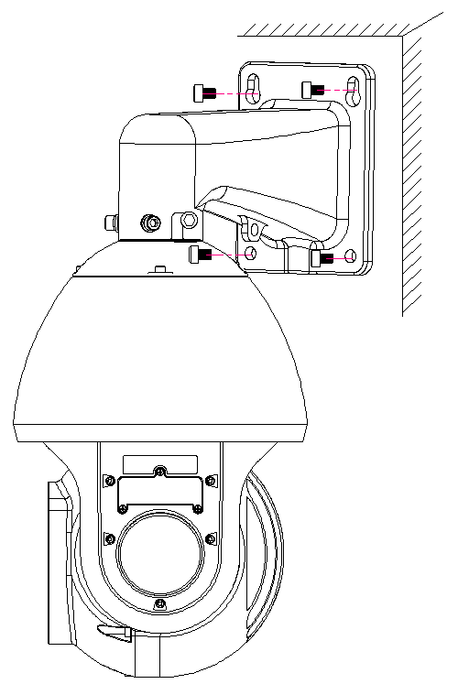
Figure 1-6

HANG MOUNT INSTALLATION

Installation Components
Please refer to the following sheet for bracket and components information. See Figure 2-2.
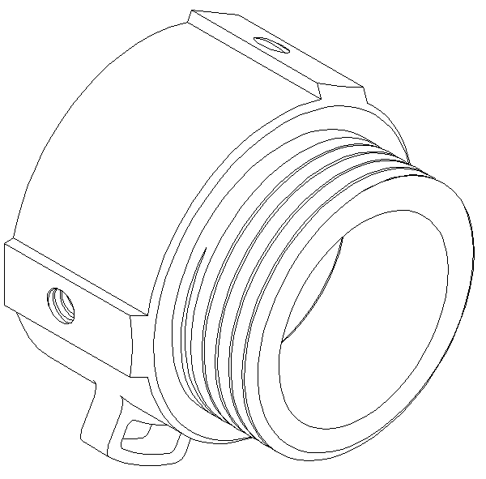
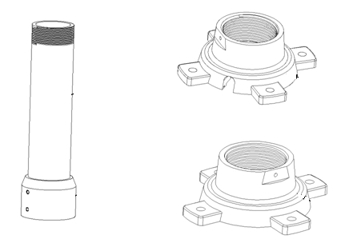
Straight Pole
Screw thread Connection
Hang Mount Bracket Connection Plate（With Cable Exit Slot ）

Adapter Block
Safety Rope Hole
Hang Mount Bracket Connection Plate（Without Cable Exit Slot 2

Figure 2-2

Installation

Installation Requirements
The hang mount speed dome can be installed in the hard construction wall in the indoor or outdoor environments. Before the installation, please make sure:
- The wall is thick enough to install the expansion bolt.
- The wall can at least sustain the 8x weight of the speed dome.

Installation Steps
For the speed dome without the straight pole, please refer to the contents below.
Step 1: Dig Holes
Draw the installation holes in the wall according to the holes at the bottom of the connection plate. Dig the installation holes. Insert the expansion bolts into the holes. (Please note the expansion bolts are not included in the accessories bag.). See Figure 2-3.
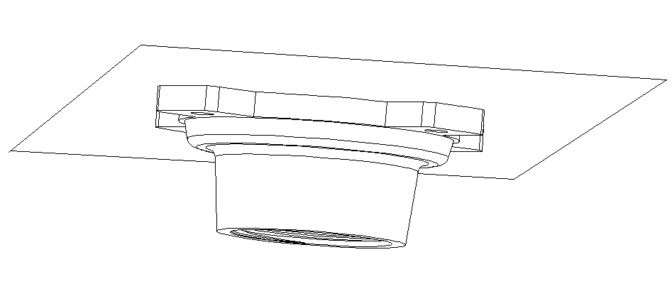
Installation Holes
Figure 2-3
Step 2: Installation bracket components.
Fix the connection plate to the ceiling and then turn the connection block to the bracket connection plate. See Figure 2-4.
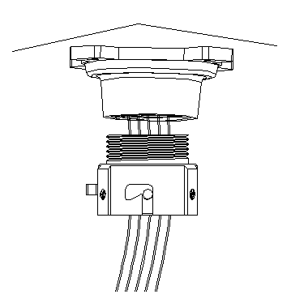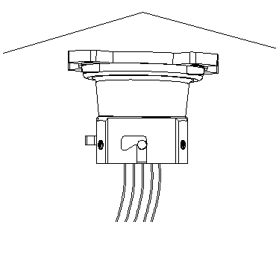
Hang Mount Bracket Connection Plate
Adapter Block
Figure 2-4
Step 3: Connect cable and the speed dome.
Connect the safety rope of the speed dome to the safety rope hole of the adapter block. Now you can connect the cable: video, RS485, power (network, alarm, audio are optional). Please note the cables listed here is for reference only.
Use the quick installation screw of the speed dome and the quick instillation port of the adapter block to fix the speed dome on the adapter block. Use the M6 inner hex screw to secure firmly.
See Figure 2-5.
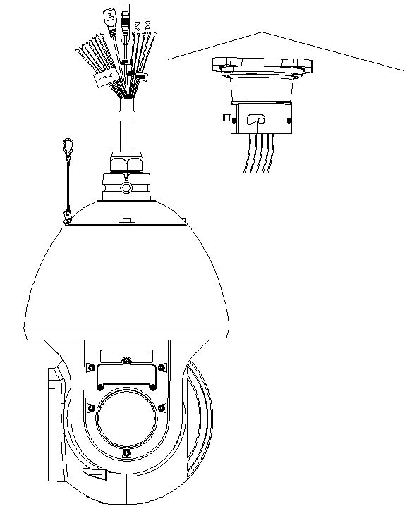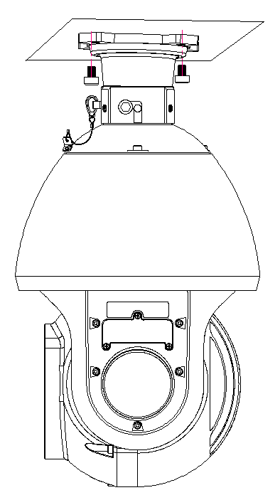
Safety Rope
Quick Installation Screw
Quick Installation Port
Figure 2-5
Please note, if the speed dome is installed in the outdoor environments, you need to paste the silica gel on the surface of the flange and the surface and the cable exit.

For the speed dome with the straight pole, please refer to the contents below.
Step 1: Dig holes
Draw the installation holes in the wall according to the holes at the bottom of the connection plate. Dig the installation holes. Insert the expansion bolts into the holes. (Please note the expansion bolts are not included in the accessories bag.). See Figure 2-3.

Step 2: Components installation
Fix the bracket connection plate to the ceiling and then turn the straight pole to the connection plate. Turn the adapter block into the straight pole of the bracket. See Figure 2-6.
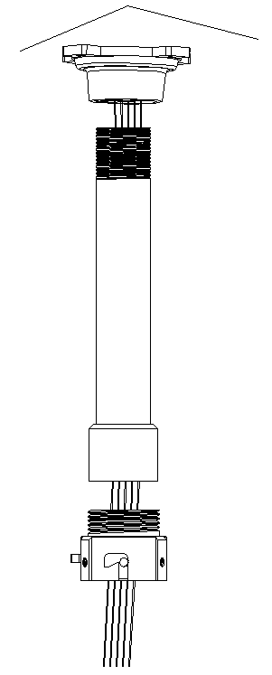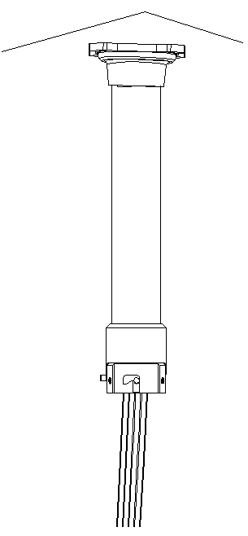
Figure 2-6
Step 3: Connect cable and the speed dome.
Connect the safety rope of the speed dome to the safety rope hole of the adapter block. Now you can connect the cable: video, RS485, power (network, alarm, audio are optional). Please note the cables listed here is for reference only.
Use the quick installation screws of the speed dome and the quick installation port of the adapter block to fix the speed dome on the adapter block. Finally, you can use the M6 inner hex screws to secure the speed dome firmly. See Figure 2-7.
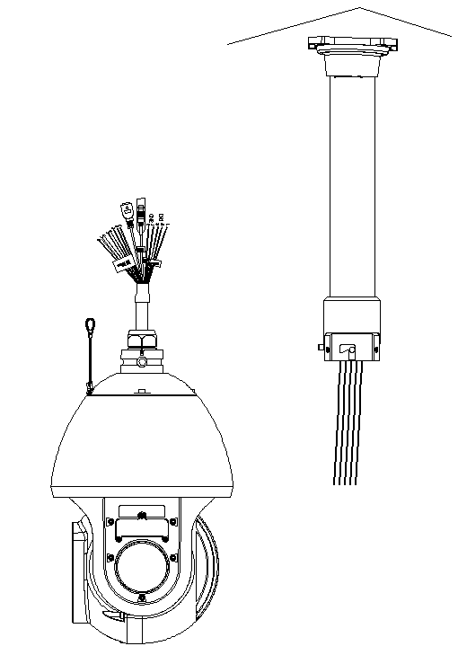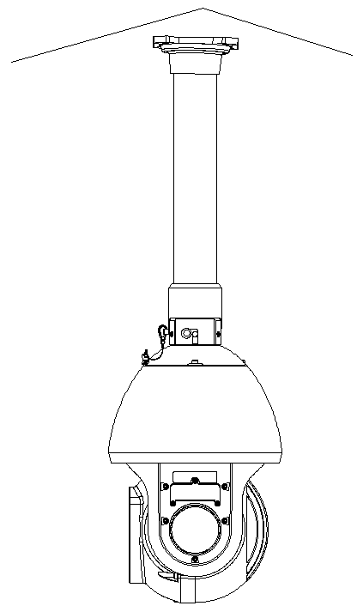
Safety Rope
Quick Installation Screw
Quick Installation Port
Figure 2-7
Please note, if the speed dome is installed in the outdoor environments, you need to paste enough Teflon tape at the top screw thread of the steeve and then turn the steeve to the flange firmly. Please paste the silica gel on the steeve connection surface to do the waterproof work.

CORNER MOUNT BRACKET

Component Installation
Corner mount bracket and its components are shown as below. See Figure 3-8.
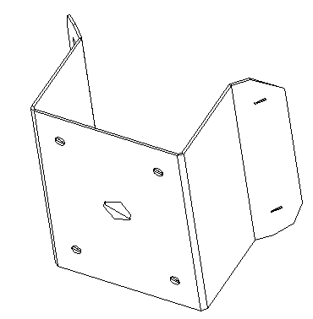
Figure 3-8

Installation

Installation Requirements
The corner mount speed dome can be installed in the hard construction wall in the indoor or outdoor environments where there is a 90 degrees angle. Before the installation, please make sure:
- The wall is thick enough to install the expansion bolt.
- The wall can at least sustain the 8x weight of the speed dome.

Installation Steps
Step1: Install corner mount bracket.
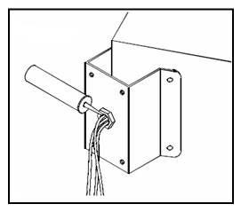
Please draw four holes position in the wall according to the holes of the corner installation accessories. See Figure 3-9.

Installation holes

Figure 3-9
Step 2: Speed dome installation
For detailed information, Please refer to chapter 1.6.
After the installation, it is shown as in Figure 3-10.
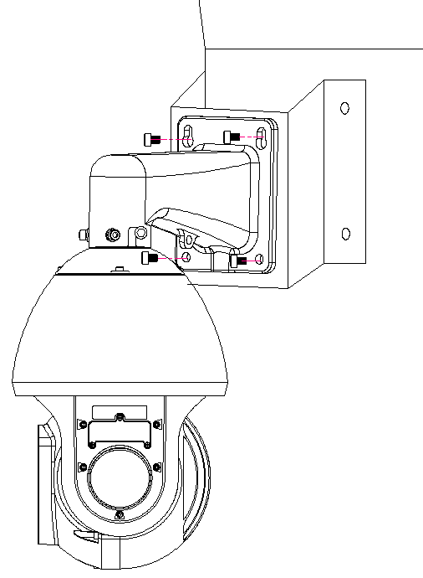
Figure 3-10

POLE MOUNT BRACKET
Pole mount bracket and its components are shown as below. See Figure 4-11.
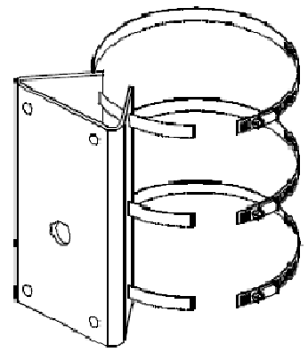
Figure 4-11

Installation

Installation Requirements
The corner mount speed dome can be installed in the hard construction wall in the indoor or outdoor environments.
Before the installation, please make sure:
- The pole bracket can sustain the 8X weight of the speed dome.
- The diameter of the pole structure shall comply with the installation dimension of the clamp.

Installation Steps
Step 1: Fix bracket and the pole.
Install clamp and then pole mount bracket. Pull the cable out of the pole accessories and then use clamp to fix the pole accessories to the pole. See Figure 4-12.
Finally, you can use glass cement to the output hole to secure waterproof.
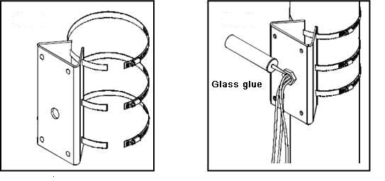

Clamp and pole bracket connection Pole bracket and the pole connection

Figure 4-12
Step 2: Install speed dome.
For detailed information, Please refer to chapter 1.6.
After the installation, the interface is shown as in Figure 4-13.
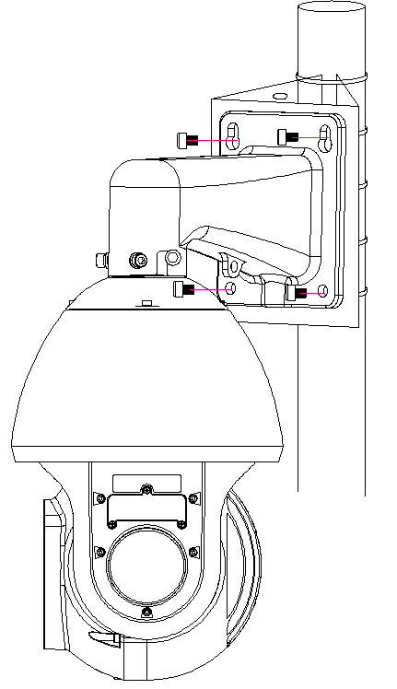
Figure 4-13

BRACKET DIMENSIONS

Wall Mount Bracket
The wall mount bracket dimensions are shown as below. See Figure 5-14.
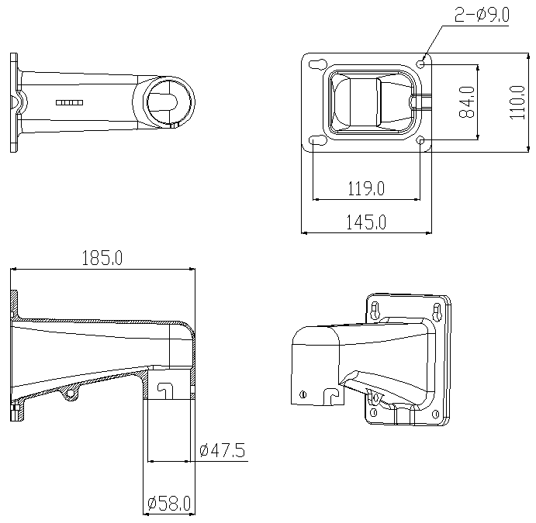
Figure 5-14

Hanging Mount Bracket (Multiple Lengths)
The hanging mount bracket is shown as below. See Figure 5-15.
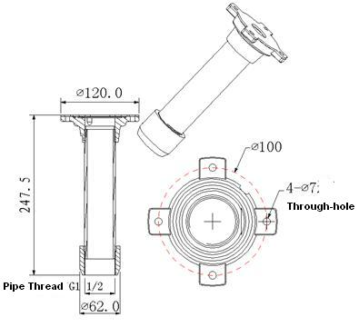
Figure 5-15

Corner Mount Bracket
The corner mount bracket is shown as below. See Figure 5-16.
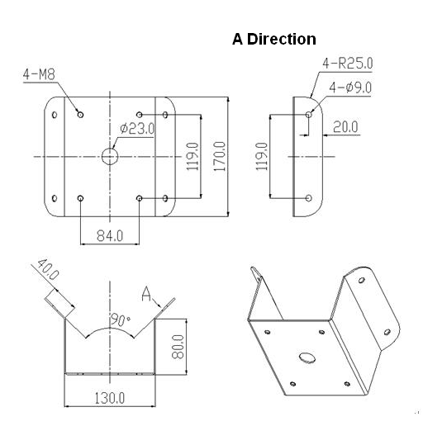
Figure 5-16

Pole mount bracket
The corner mount bracket is shown as below. See Figure 5-17.
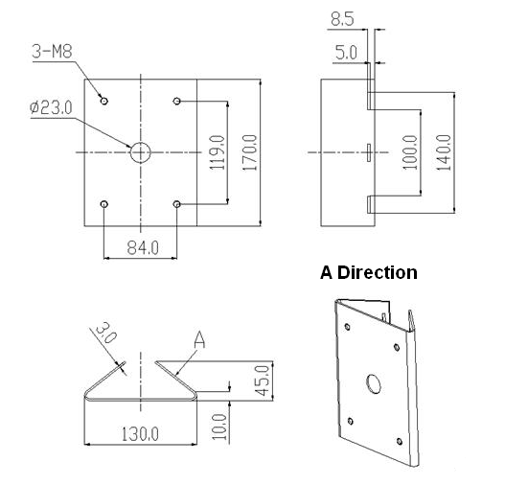
Figure 5-17

APPENDIX Ⅰ THUNDER PROOF AND SURGE PROTECTION
This series speed dome adopts TVS lighting protection technology. It can effectively prevent damages from various pulse signals below 6000V, such as sudden lighting and surge. While maintaining your local electrical safety code, you still need to take necessary precaution measures when installing the speed dome in the outdoor environment.

- The distance between the signal transmission cable and high-voltage device (or high-voltage cable) shall be at least 50 meters.
- Outdoor cable layout shall go under the penthouse if possible.
- For vast land, please use sealing steel tube under the land to implement cable layout and connects one point to the earth. Open floor cable layout is forbidden.
- In area of strong thunderstorm hit or near high sensitive voltage (such as near high-voltage transformer substation), you need to install additional high-power thunder protection device or lightning rod.
- The thunder protection and earth of the outdoor device and cable shall be considered in the building whole thunder protection and conform to your local national or industry standard.
- System shall adopt equal-potential wiring. The earth device shall meet anti-jamming and at the same time conforms to your local electrical safety code. The earth device shall not short circuit to N (neutral) line of high voltage power grid or mixed with other wires. When connect the system to the earth alone, the earth resistance shall not be more than 4Ω and earth cable cross-sectional area shall be below 25 mm². See Figure 6-1.
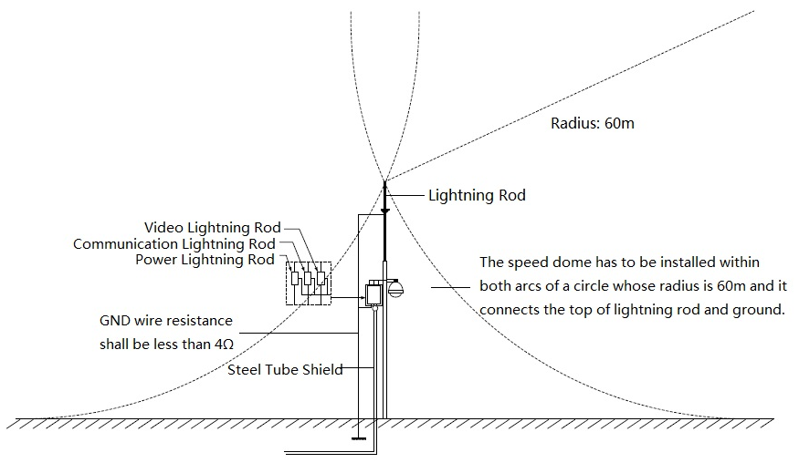
Figure 6-1

APPENDIX Ⅱ ABOUT RS485 BUS

RS485 Bus Main Feature
RS485 is semi duplex communication cable of impedance 120Ω. Its max load amount is 32 effective loads (including main control device and devices to be charged).

RS485 Bus Transmission Distance
When we take 0.56mm (24AWG) twisted-pair as communication cable, the max transmission distance (theoretically) are listed below (according to different baud rates).
Baud Rate | Max Distance
2400 BPS | 1800M
4800 BPS | 1200M
9600 BPS | 800M

In the following situations, the max transmission distance shall become shorter accordingly:
- The communication cable is a little bit thin;
- The surrounding environment has strong electromagnetic interference;
- There are too much devices connected to the RS485 bus;
And vice versa, the max transmission distance shall become longer.

The Problem in Practical Use
In practical usage, we usually adopt star type connection. The terminal resistance shall connect to the furthest two devices (Such as device 1# and device 15# in Figure 7-2 ). But this connection way does not conform to RS485 Bus standard. When the distances between devices are too long, the signal reflection occurs and anti-jamming decreases, thus the signal reliability becomes very low. You can see speed dome is not under control or speed dome is running automatically and can not stop.

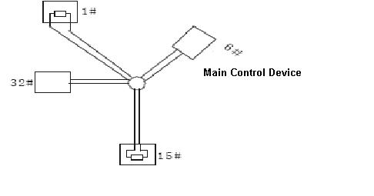
Figure 7-2
In this situation, we recommend RS485 distributor. This device can turn star type connection into the connection that conforms to RS485 bus industry standard, which can avoid the above mentioned problems and enhance communication reliability. See Figure 7-3.
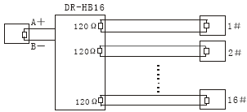
Figure 7-3

RS485 Bus FAQ
Phenomenon | Possible Reasons | Solution
Speed dome can run self-diagnosis but I can not control it. | - Host address(baud rate) and speed dome address(baud rate) are not match;  - Positive and negative end of RS485 Bus are misconnected;  - Connection cable is loose；  - RS485 Bus connection are cut off; | - Modify host or speed dome setup ；  - Switch RS485 positive end and negative end；  - Fix connection cable firmly；  - Replace RS485 Bus.
I can control the speed dome but is not smooth | - RS485 Bus connection are not good；  - One RS485 bus is off；  - The distance between host and speed dome is too far；  - Parallel connected too much speed domes. | - Connect RS 485 Bus again；  - Replace RS485 Bus；  - Add terminal matching resistance；  - Add RS485 distributor.

APPENDIX Ⅲ SAFETY ROPE INSTALLATION
Remove one M4 screw from the speed dome and then use the M4 screw of the safety rope to fix the safety rope on the speed dome.
Please note the contents in this chapter are for hang (pendant) mount installation only.
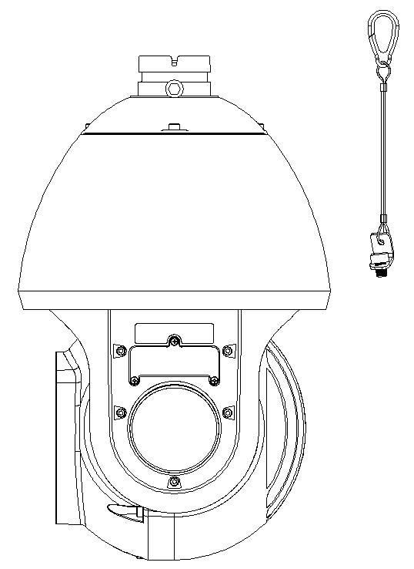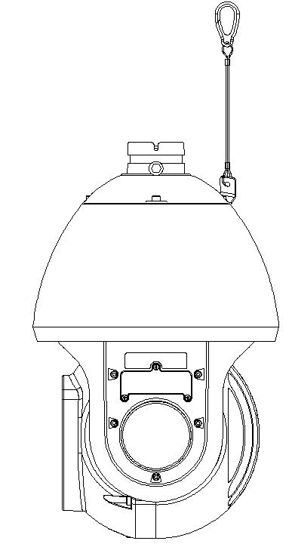
Speed Dome M4 Screw
Safety Rope
M4 Screw of the Safety Rope
Speed Dome

Note
- This manual is for reference only. Slight difference may be found in the user interface.
- All the designs and software here are subject to change without prior written notice.
- All trademarks and registered trademarks are the properties of their respective owners.
- If there is any uncertainty or controversy, please refer to the final explanation of us.
- Please visit our website or contact your local service engineer for more information.

