红色为修改.

**Dahua Mini Network Dome Camera Quick Start Guide**

**Version 1.0.2**

**Zhejiang Dahua Technology CO., LTD.**

**Welcome**

Thank you for purchasing our network camera!

This quick start guide is designed to be a reference tool for your system.

Please keep this start guide well for future reference.

Please open the accessory bag to check the items one by one in accordance with the list below. Contact your local retailer ASAP if something is missing or damaged in the bag.

**1．Electrical safety**

All installation and operation here should conform to your local electrical safety codes.

The power shall conform to the requirement in the SELV (Safety Extra Low Voltage) and the Limited power source is rated 12V DC or 24V AC in the IEC60950-1. (Refer to general introduction) **Please note: Do not connect these two power supplying sources to the device at the same time; it may result in device damage! The product must be grounded to reduce the risk of electronic shock.**

We assume no liability or responsibility for all the fires or electrical shock caused by improper handling or installation.

We are not liable for any problems caused by unauthorized modification or attempted repair.

**2．Transportation security**

Heavy stress, violent vibration or water splash are not allowed during transportation, storage and installation.

**3．Installation**

Do not apply power to the camera before completing installation.

Please install the proper power cut-off device during the installation connection.

Always follow the instruction guide the manufacturer recommended.

**4．Qualified engineers needed**

All the examination and repair work should be done by the qualified service engineers.

We are not liable for any problems caused by unauthorized modifications or attempted repair.

**5．Environment**

This series network camera should be installed in a cool, dry place away from direct sunlight, inflammable, explosive substances and etc.

Please keep it away from the electromagnetic radiation object and environment.

Please make sure the CCD (CMOS) component is out of the radiation of the laser beam device. Otherwise it may result in CCD (CMOS) optical component damage.

Please keep the sound ventilation.

Do not allow the water and other liquid falling into the camera.

Thunder-proof device is recommended to be adopted to better prevent thunder.

The grounding studs of the product are recommended to be grounded to further enhance the reliability of the camera.

**6. Daily Maintenance**

Please shut down the device and then unplug the power cable before you begin daily maintenance work.

Do not touch the CCD (CMOS) optic component. You can use the blower to clean the dust on the lens surface.

Always use the dry soft cloth to clean the device. If there is too much dust, please use the water to dilute the mild detergent first and then use it to clean the device. Finally use the dry cloth to clean the device.

Please put the dustproof cap to protect the CCD (CMOS) component when you do not use the camera.

Dome enclosure is the optical component, do not touch the enclosure when you are installing the device or clean the enclosure when you are doing maintenance work. Please use professional optical clean method to clean the enclosure. Improper enclosure clean method (such as use cloth) may result in poor IR effect of camera with IR function.

**7. Accessories**

Be sure to use all the accessories recommended by manufacturer.

Before installation, please open the package and check all the components are included.

Contact your local retailer ASAP if something is broken in your package.

|  |  |
| --- | --- |
| Accessory Name | Amount |
| Network Camera Unit | 1 |
| Installation Accessories bag | 1 |
| Quick Start Guide | 1 |
| CD | 1 |
| Warranty Card and Certificate | 1 |

**Table of Contents**

1 Framework 4

1.1 Structure 4

1.2 Dimensions 5

2 Installation 7

2.1 Device Installation 7

3 Quick Configuration Tool 9

3.1 Overview 9

3.2 Operation 9

4 Web Operation 11

4.1 Network Connection 11

4.2 Login and Main Interface 11

Appendix Toxic or Hazardous Materials or Elements 13

# Framework

## Structure

Please refer to the following figure for detailed information. See and Figure 1-2.

Note:

Figures in this chapter are for reference only. Different product models may refer to different figures. Please use figure (a) or (b) according to the actual product.

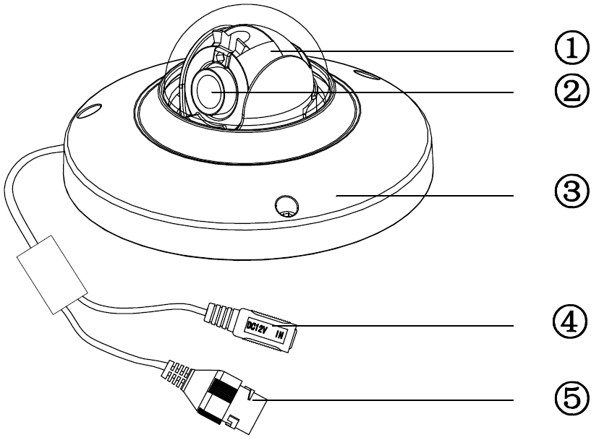

Figure 1‑1 Structure (a)

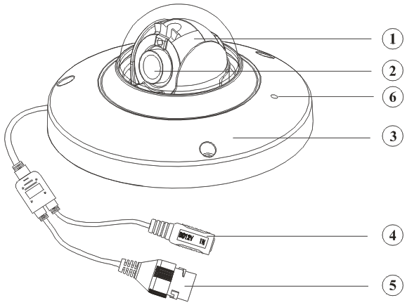

Figure 1‑2 Structure (b)

Please refer to the following sheet for detailed structure information.

| SN | Name |
| --- | --- |
| 1 | X-Y-Z rotation module |
| 2 | Device lens |
| 3 | Dome camera enclosure |

Please refer to the following sheet for detailed port information.

|  |  |  |
| --- | --- | --- |
| SN | Name | Function |
| 4 | Power input port | Connect to the DC 12+ power to input the power. |
| 5 | Network port | Network data input, output and PoE.  Note:   * Some devices do not support PoE. * Before making crystal head, pull the anti-dust, waterproof cover through network cable. |
| 6 | MIC hole | Audio input |

## Dimensions

Please refer to the following figure for the dimension information. The unit is mm. See through .

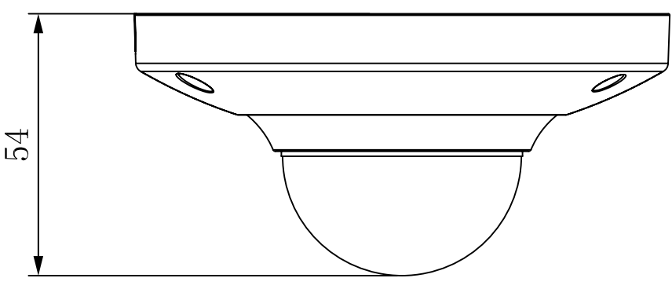

Figure 1‑3 Dimension illustration 1

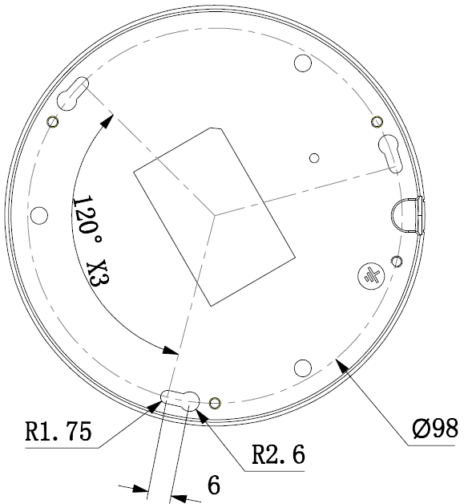

Figure 1‑4 Dimension illustration 2

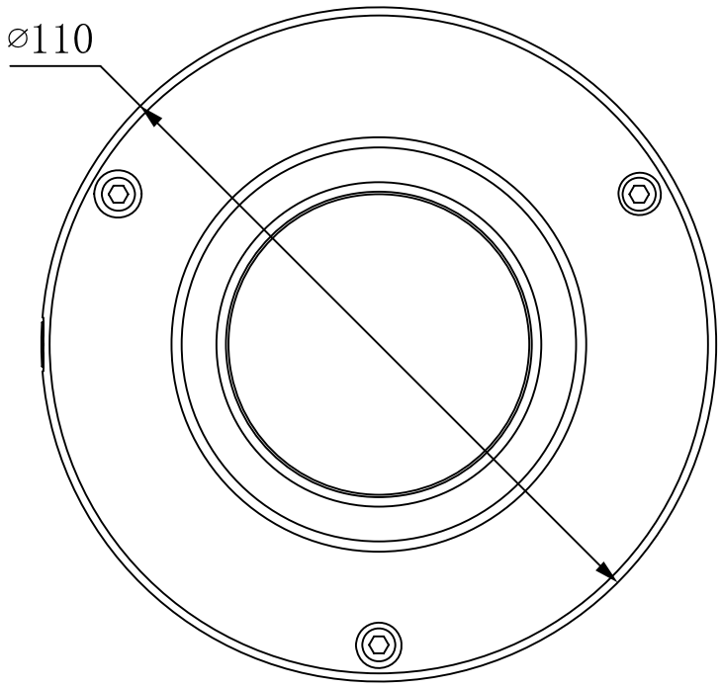

Figure 1‑5 Dimension illustration 3

# Installation

## Device Installation

**Important**

**Please make sure the installation surface can min support the 3X weight of the camera and the bracket.**

Please refer to the steps listed below.

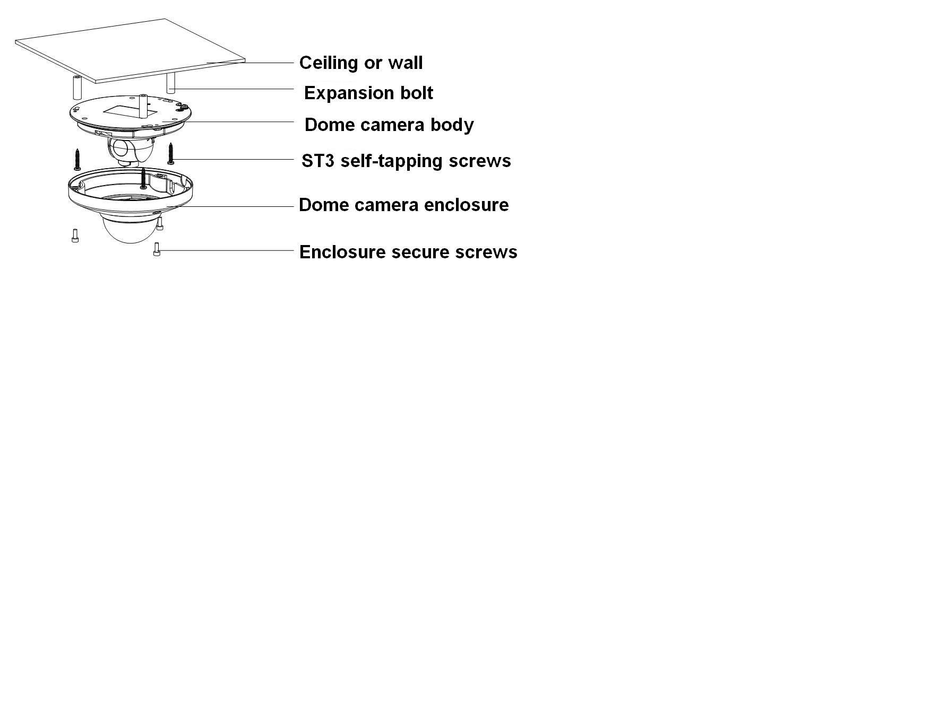

Figure ‑ Device installation illustration 1

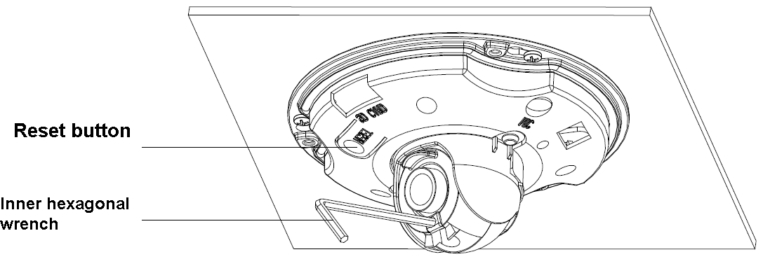

Figure ‑ Device installation illustration 2

**Step1**

Use the inner hexagonal wrench (provided) to loose the three inner hexagon screws in the dome cover and then open the cover.

**Step 2**

Please take the installation map in the accessories bag, and then paste it on the ceiling or the wall according to your monitor area requirements.

**Step 3**

Draw and then dig three plastic expansion bolts holes on ceiling or other installation surface and then insert three expansion bolts in the holes. Secure these three bolts firmly.

Note:

* Please dig a “cable exit hole” in the surface according to the installation map if you want to draw out the cable from the top of the installation surface.
* You need to use the proper tool to open up the side port of the U-cable channel of the dome camera pedestal if you want to draw out the cable from the side port of the cable channel when you are installing the device cable. And then you can draw out the cable from the cable channel of the pedestal.

**Step 4**

Adjust the device installation pedestal to the proper position and then draw the cable through the cable exit you just dug in the ceiling (wall). Line up the TOP direction of the device to the installation map and then line up the three screw holes in the device pedestal to the three plastic expansion bolt holes in the installation position. Put the three self-tapping screws in the three plastic expansion bolts firmly. Now the dome camera is secure in the installation surface.

**Step 5**

Loosen the two M3 secure screws of the lens rotation structure (Do not remove, loosen a little bit will be OK.). Use the inner hexagonal wrench to insert them to the inner hexagonal holes and then use the wrench to turn the lens. Adjust the lens to the proper monitor angle and then secure the screws of the lens rotation structure. The lens adjust angle ranges are: flip (0°~+75°), video pan rotation (-15°~+15°) , video rotation angle(-15°~+15°).

**Step 6**

Line up the dome camera cover to the cable exits and put the cover back. Use the inner hexagonal wrench to secure the three inner hexagonal screws firmly. Now the installation completed.

**Note:**

**If you want to restore default settings of device, you shall open device front cover, and press Reset button in Figure 2-2 with power on for 10s.**

**If you want to use WPS function of device, you shall open device front cover, and press Reset button in Figure 2-2 with power on for 1-2 seconds, then press the WPS button of the router, generally the device will connect to corresponding router within one minute (supported by some series)**

# Quick Configuration Tool

## Overview

Quick configuration tool can search current IP address, modify IP address. At the same time, you can use it to upgrade the device.

Please note the tool only applies to the IP addresses in the same segment.

## Operation

Double click the “ConfigTools.exe” icon, you can see an interface is shown as in .

In the device list interface, you can view device IP address, port number, subnet mask, default gateway, MAC address and etc.

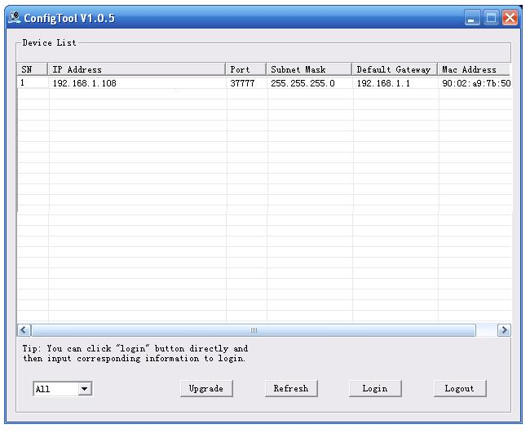

Figure 3‑ Search interface

Select one IP address and then right click mouse, you can see an interface is shown as in .

Select the “Open Device Web” item; you can go to the corresponding web login interface.

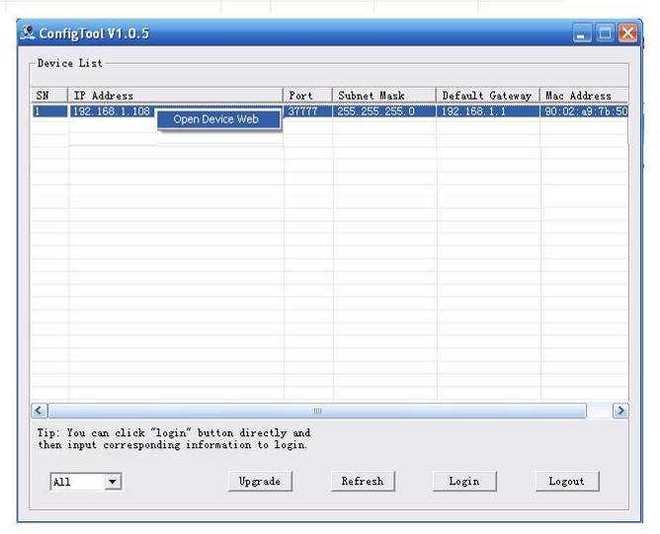

Figure 3‑ Search interface 2

If you want to modify the device IP address without logging in the device web interface, you can go to the configuration tool main interface to set.

In the configuration tool search interface (), please select a device IP address and then double click it to open the login interface. Or you can select an IP address and then click the Login button to go to the login interface. See Figure 3-3.

In Figure 3-3, you can view device IP address, user name, password and port. Please modify the corresponding information to login.

Please note the port information here shall be identical with the port value you set in TCP port in Web Network interface. Otherwise, you cannot login the device.

If you are using device background upgrade port 3800 to login, other setups are all invalid.

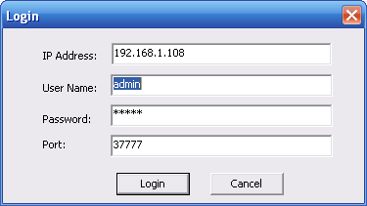

Figure 3‑3 Login prompt

After you logged in, the configuration tool main interface is shown as below. See Figure 3-4.

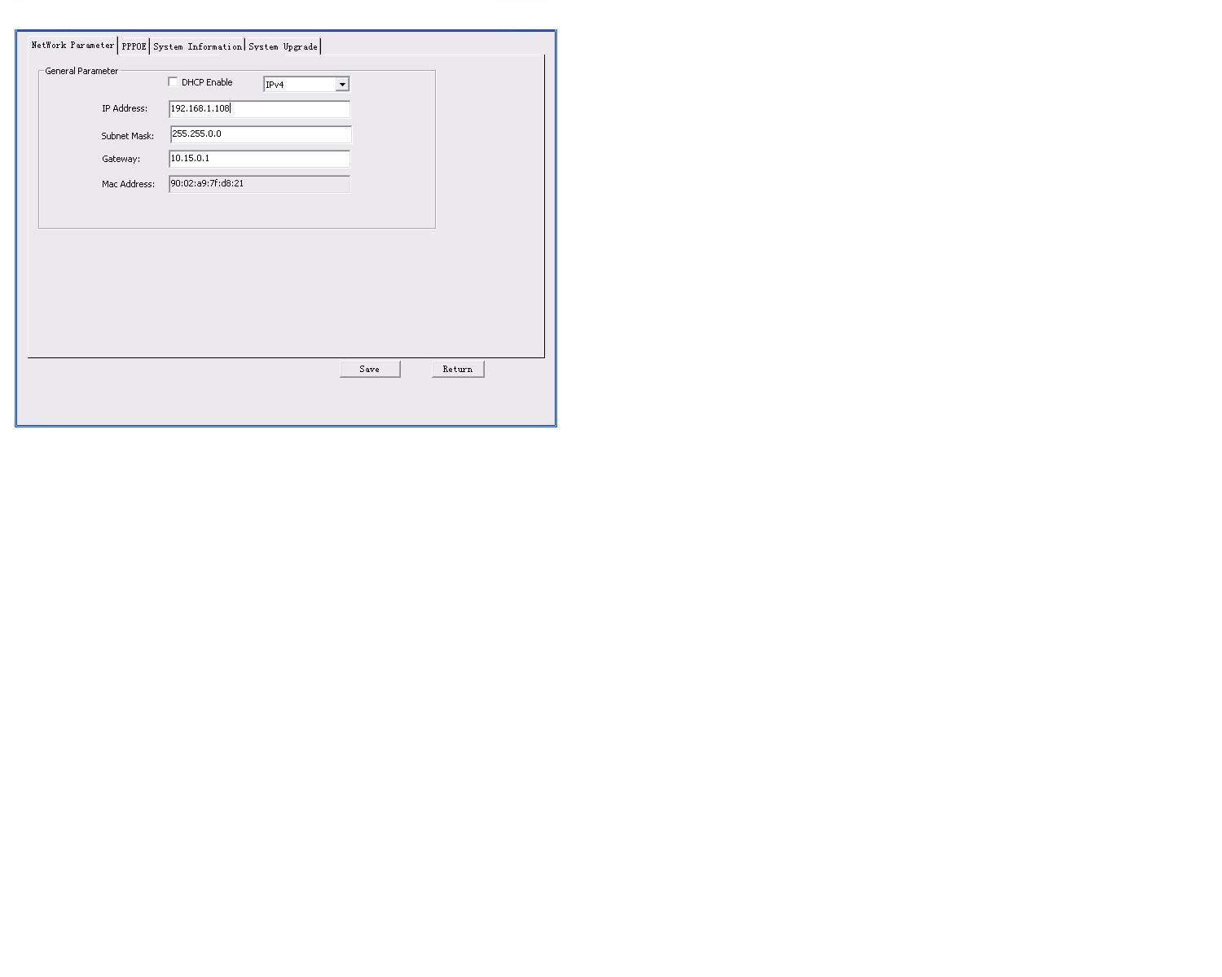

Figure 3‑4 Main interface

**For detailed information and operation instruction of the quick configuration tool, please refer to the *Quick Configuration Tool User’s Manual* included in the resources CD.**

# Web Operation

This series network camera products support the Web access and management via PC.

Web includes several modules: Monitor channel preview, system configuration, alarm and etc.

## Network Connection

Please follow the steps listed below for network connection.

* Make sure the network camera has connected to the network properly.
* Please set the IP address, subnet mask and gateway of the PC and the network camera respectively. Network camera default IP address is 192.168.1.108. Subnet mask is 255.255.255.0. Gateway is 192.168.1.1
* Use order ping ***.***.***.***(* network camera address) to check connection is OK or not.

## Login and Main Interface

Open IE and input network camera address in the address bar. See .

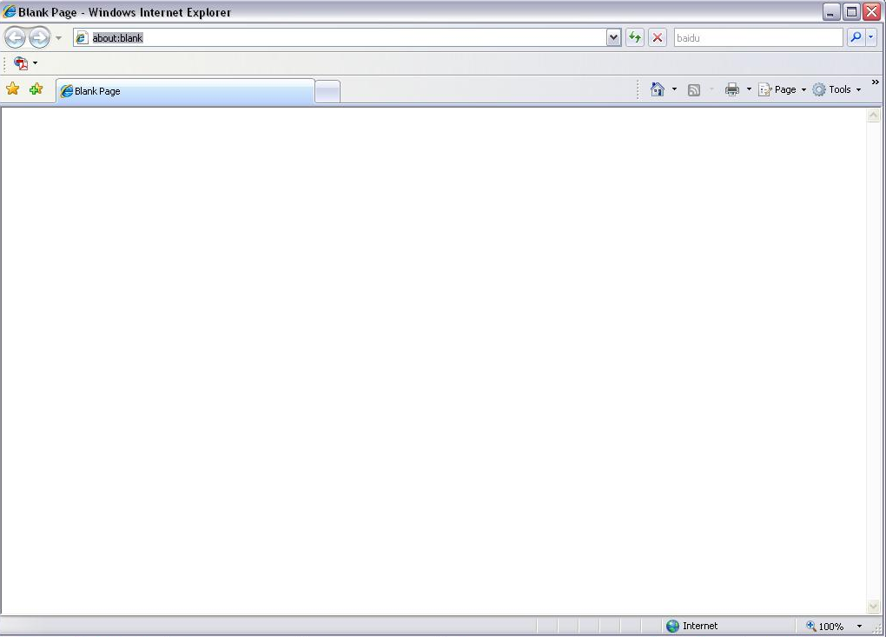

Input your IP address here

Figure 4- IP address

The login interface is shown as below. See .

Please input your user name and password.

Default factory name is admin and password is admin.

**Note: For security reasons, please modify your password after you first login.**

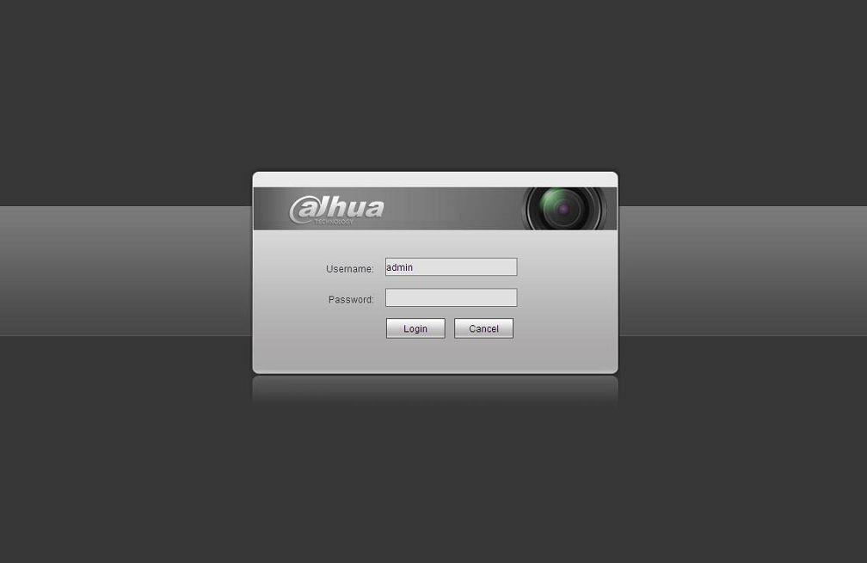

Figure 4- Web login

After you successfully logged in, please install WEB plug-in unit. Please refer to the Web Operation Manual included in the resource CD for detailed operation instruction.

See .

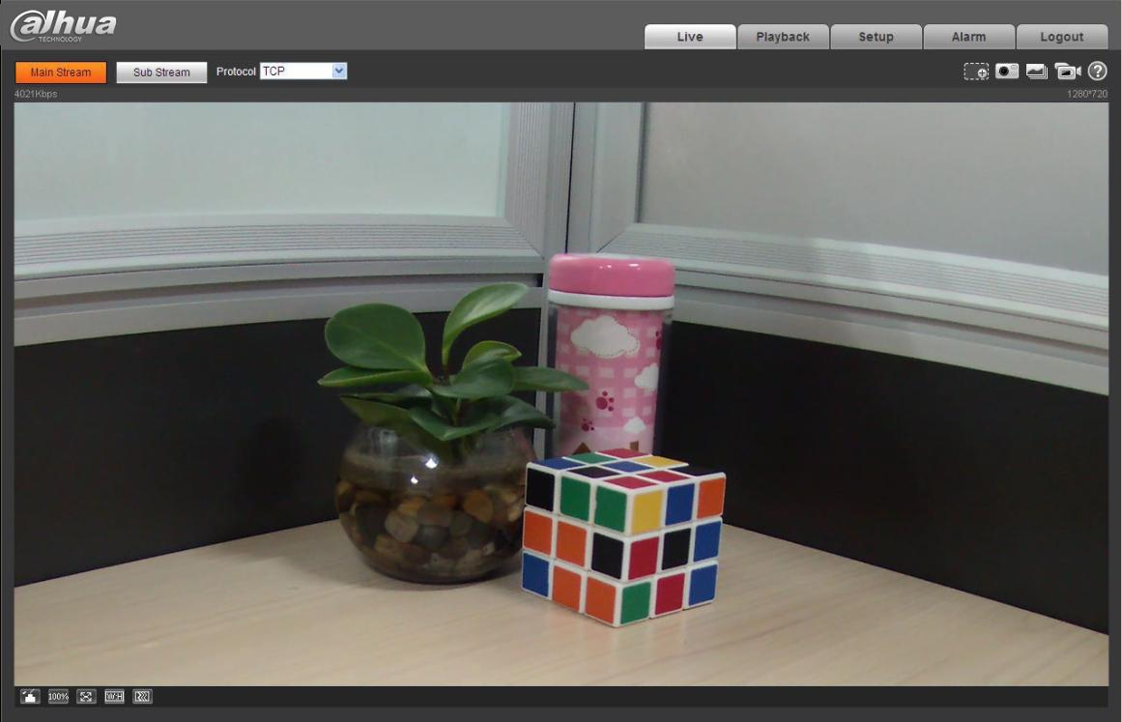

Figure 4- Web monitoring window

# Appendix Toxic or Hazardous Materials or Elements

|  |  |  |  |  |  |  |
| --- | --- | --- | --- | --- | --- | --- |
| **Component Name** | **Toxic or Hazardous Materials or Elements** | | | | | |
| **Pb** | **Hg** | **Cd** | **Cr VI** | **PBB** | **PBDE** |
| Circuit Board Component | ○ | ○ | ○ | ○ | ○ | ○ |
| Device Construction Material | ○ | ○ | ○ | ○ | ○ | ○ |
| Wire and Cable | ○ | ○ | ○ | ○ | ○ | ○ |
| Packing Components | ○ | ○ | ○ | ○ | ○ | ○ |
| Accessories | ○ | ○ | ○ | ○ | ○ | ○ |

O: Indicates that the concentration of the hazardous substance in all homogeneous materials in the parts is below the relevant threshold of the SJ/T11363-2006 standard.

X: Indicates that the concentration of the hazardous substance of at least one of all homogeneous materials in the parts is above the relevant threshold of the SJ/T11363-2006 standard. During the environmental-friendly use period (EFUP) period, the toxic or hazardous substance or elements contained in products will not leak or mutate so that the use of these (substances or elements) will not result in any severe environmental pollution, any bodily injury or damage to any assets. The consumer is not authorized to process such kind of substances or elements, please return to the corresponding local authorities to process according to your local government statutes.

**Note**

* **This quick start guide is for reference only. Slight difference may be found in the user interface.**
* **All the designs and software here are subject to change without prior written notice.**
* **If there is any uncertainty or controversy, please refer to the final explanation of us.**
* **Please visit our website or contact your local service engineer for more information.**



**Zhejiang Dahua Technology CO., LTD.**

Address：No.1199 Bin’an Road, Binjiang District, Hangzhou, PRC.

Postcode: 310053

Tel: +86-571-87688883

Fax: +86-571-87688815

Email:overseas@dahuatech.com

Website: www.dahuatech.com