**A Series HD Wi-Fi Network Camera**

**Quick Start Guide**

**Version 1.0.0**

**Welcome**

Thank you for purchasing our network camera!

This quick start guide is designed to be a reference tool for your system.

Please keep this start guide well for future reference.

Please open the accessory bag to check the items one by one in accordance with the list below. Contact your local retailer ASAP if something is missing or damaged in the bag.

**Important Safeguards and Warnings**

**1．Electrical safety**

All installation and operation here should conform to your local electrical safety codes.

Please check if the power supply is correct before operating the device.

The power shall conform to the requirement in the SELV (Safety Extra Low Voltage) and the Limited power source is rated 12V DC, DC5V or AC24V in the IEC60950-1. (Power supply requirement is subject to the device label).

Please install easy-to-use device for power off before installing wiring, which is for emergent power off when necessary.

Please prevent the line cord from being trampled or pressed, especially the plug, power socket and the junction from the device.

**Note: Do not connect these two power supplying sources to the device at the same time; it may result in device damage!**

We assume no liability or responsibility for all the fires or electrical shock caused by improper handling or installation.

We are not liable for any problems caused by unauthorized modification or attempted repair.

**2．Environment**

Please don’t aim the device at strong light (such as lighting, sunlight and so on) to focus; otherwise it may cause overexposure (It is not the device malfunction), which will affect the longevity of CCD or CMOS.

Please transport, use and store the device within the range of allowed humidity and temperature.

Please don’t keep the device in a place which is wet, dusty, extremely hot, and extremely cold and with strong electromagnetic radiation or unstable lighting.

Please do not allow water and other liquid falling into the camera in case that the internal components are damaged.

Please do not allow rain or damp to the indoor device in case fire or lightning may occur.

Please keep the sound ventilation in case of heat accumulation.

Please pack the device with standard factory packaging or material with same quality when transporting the device.

Heavy stress, violent vibration or water splash are not allowed during transportation, storage and installation.

**3. Operation and Daily Maintenance**

Please do not touch the heat dissipation component of the device directly in order to avoid scald.

Please do not dismantle the device; there is no component which can be fixed by users themselves in the machine. It may cause water leakage or bad image for the device due to unprofessional dismantling.

It is recommended to use the device with thunder proof device in order to improve thunder proof effect.

The grounding holes of the product are recommended to be grounded to further enhance the reliability of the camera.

Do not touch the CCD (CMOS) optic component directly. You can use the blower to clean the dust or dirt on the lens surface. Please use a dry cloth wetted by alcohol to wipe away the dust gently if it is necessary to clean.

Always use the dry soft cloth to clean the device. If there is too much dust, please use the water to dilute the mild detergent first and then use it to clean the device. Finally use the dry cloth to clean the device. Don’t use volatile solvent like alcohol, benzene, thinner and etc or strong detergent with abrasiveness, otherwise it will damage the surface coating or reduce the working performance of the device.

Dome cover is an optical device, please don’t touch or wipe cover surface directly during installation and use, please refer to the following methods to deal with once dirt is found:

Stained with dirt

Use oil-free soft brush or hair dries to remove it gently.

Stained with grease or fingerprint

Use soft cloth to wipe the water drop or oil gently to make it dry, then use oil-free cotton cloth or paper soaked with alcohol or detergent to wipe from the lens center to outward. It is ok to change the cloth and wipe several times if it is not clean enough.

**Warning**

Please use the standard accessories provided by manufacturer and make sure the device is installed and fixed by professional engineers.

Please prevent the device surface from the radiation of laser beam when using laser beam device.

Please do not provide two or more power supply modes for the device, otherwise it may cause damage to the device.

**Statement**

Please refer to the actual product for more details; the manual is just for reference.

The manual will be regularly upgraded according to the product update; the upgraded content will be added in the manual without prior announcement.

Please contact the supplier or customer service if there is any problem occurred when using the device.

Please contact the customer service for the latest procedure and supplementary documentation.

There may be deviation between the actual value of some data and the value provided in the manual due to the reasons such as the real environment is not stable and so on. Please refer to the company’s final explanation if there is any doubt or dispute.

The company is not liable for any loss caused by the operation which is not followed by the manual.

Before installation, please open the package and check all the components are included.

Contact your local retailer ASAP if something is broken in your package.

|  |  |
| --- | --- |
| Accessory Name | Amount |
| Network Camera Unit | 1 |
| Quick Start Guide | 1 |
| Installation Accessories Bag | 1 |
| Installation Pedestal | 1 |
| CD | 1 |

**Table of Contents**

1 Structure 1

1.1 Structure Info 1

1.2 Framework and Dimension 2

2 Device Installation 4

2.1 Installation Steps 4

2.2 Restore Factory Default Setup Introduction 5

3 Quick Configuration Tool 6

3.1 Overview 6

3.2 Operation 6

4 Web Operation 8

4.1 Network Connection 8

4.2 Login and Main Interface 8

# Structure

## Structure Info

You can refer to the following figure for structure information. See .

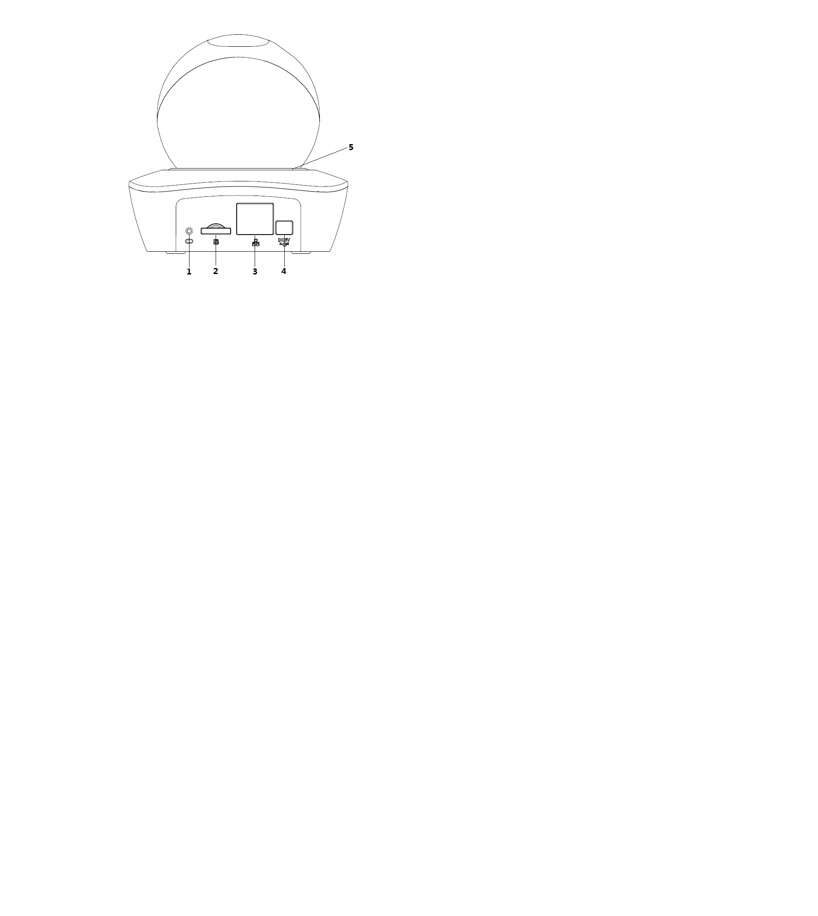

Figure ‑

Please refer to the following sheet for detailed information.

| **SN** | **Name** |
| --- | --- |
| 1 | Reset/WPS button (For reset, long press for 8 seconds; for WPS, one quick press) |
| 2 | SD card slot |
| 3 | Network port |
| 4 | Power port |
| 5 | Indicator light |

Sheet 1-1

Please refer to the following sheet for more details about indicator light.

|  |  |
| --- | --- |
| **Indicator light status** | **Device status** |
| Red light spinning | Device activating |
| Green light spinning | Device matching |
| Yellow light breathing | Device network connection failure |
| Blue light spinning | Device connection success (network connection) |
| Red light flashing | Device upgrading |
| Red light breathing | Device alarm |

Sheet 1-2

## Framework and Dimension

Please refer to the following two figures for dimension information. The unit is mm. See and .

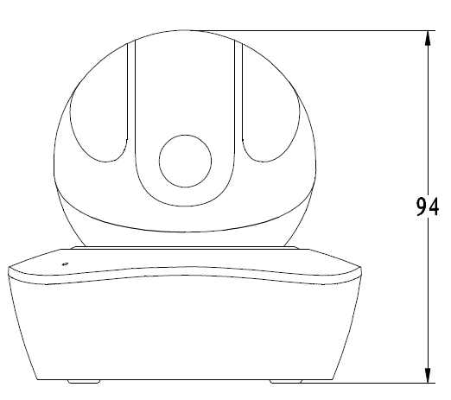

Figure ‑ Dimension illustration 1

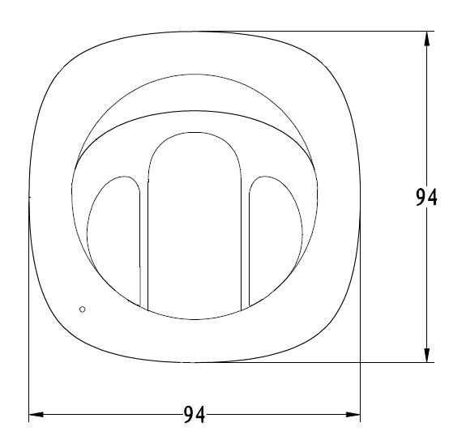

Figure ‑ Dimension illustration 2

# Device Installation

## Installation Steps

**Important**

Before the installation, please make sure the installation environments can at least support 3x weight of the camera.

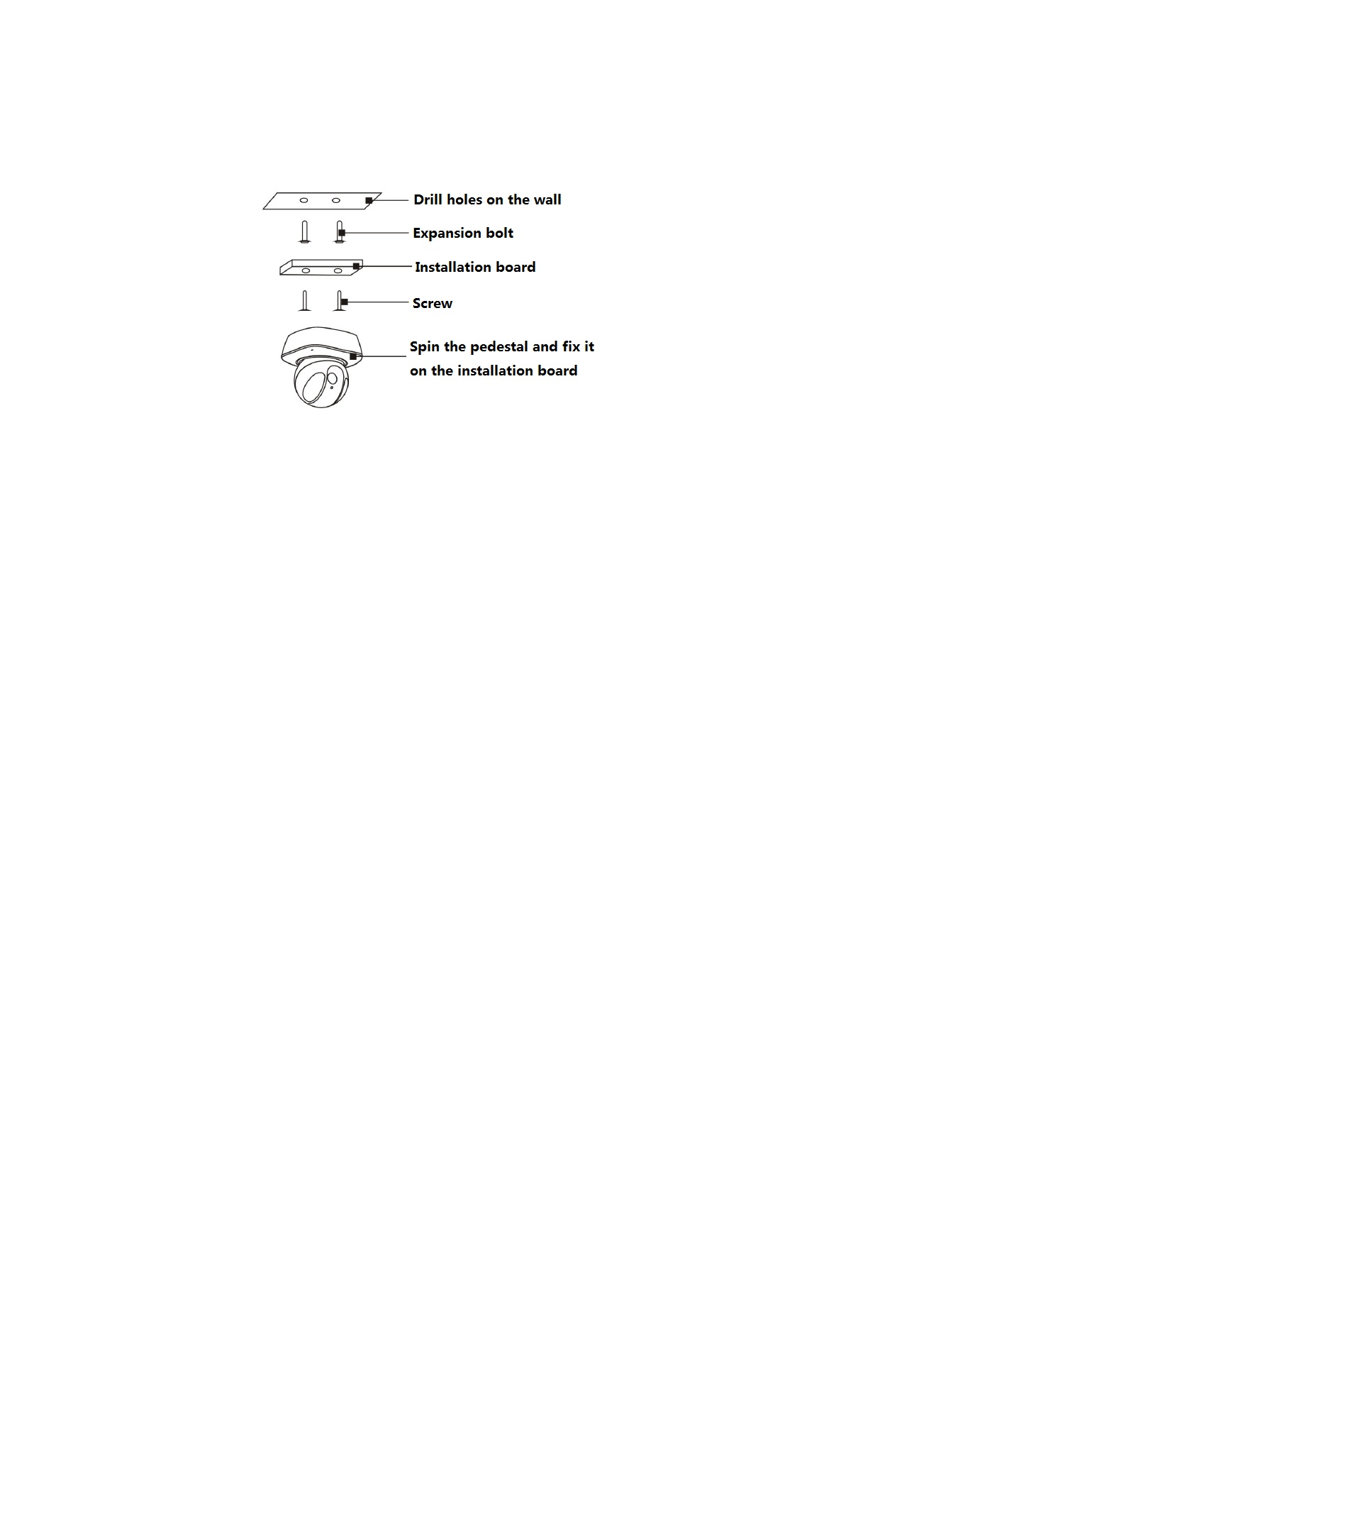

Figure 2-1

## Restore Factory Default Setup Introduction

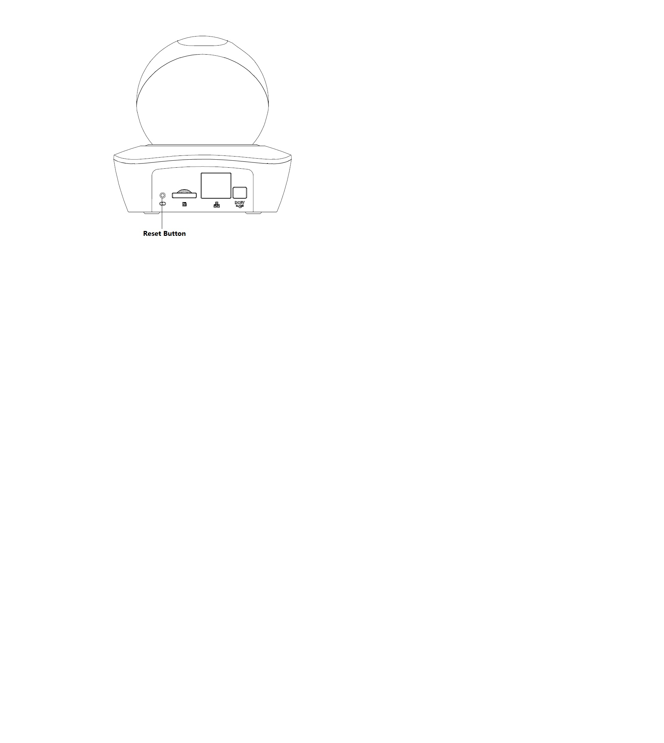

Figure 2-2

Press the reset button for 10 seconds to restore factory default setup.

# Quick Configuration Tool

## Overview

Quick configuration tool can search current IP address, modify IP address. At the same time, you can use it to upgrade the device.

Please note the tool only applies to the IP addresses in the same segment.

## Operation

Double click the “ConfigTools.exe” icon; you can see an interface is shown as in .

In the device list interface, you can view device IP address, port number, subnet mask, default gateway, MAC address and etc.

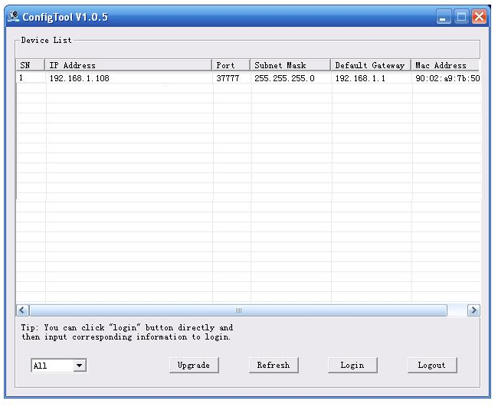

Figure 3‑ Search interface

Select one IP address and then right click mouse, you can see an interface is shown as in .

Select the “Open Device Web” item; you can go to the corresponding web login interface.

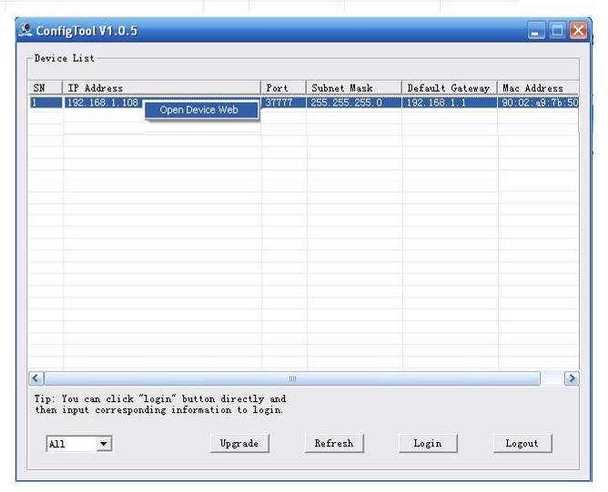

Figure 3‑ Search interface 2

If you want to modify the device IP address without logging in the device web interface, you can go to the configuration tool main interface to set.

In the configuration tool search interface (), please select a device IP address and then double click it to open the login interface. Or you can select an IP address and then click the Login button to go to the login interface. See Figure 3-3.

In Figure 3-3, you can view device IP address, user name, password and port. Please modify the corresponding information to login.

Please note the port information here shall be identical with the port value you set in TCP port in Web Network interface. Otherwise, you cannot login the device.

If you are using device background upgrade port 3800 to login, other setups are all invalid.

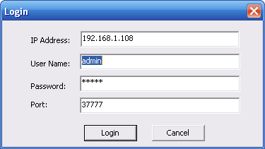

Figure 3‑3 Login prompt

After you logged in, the configuration tool main interface is shown as below. See Figure 3-4.

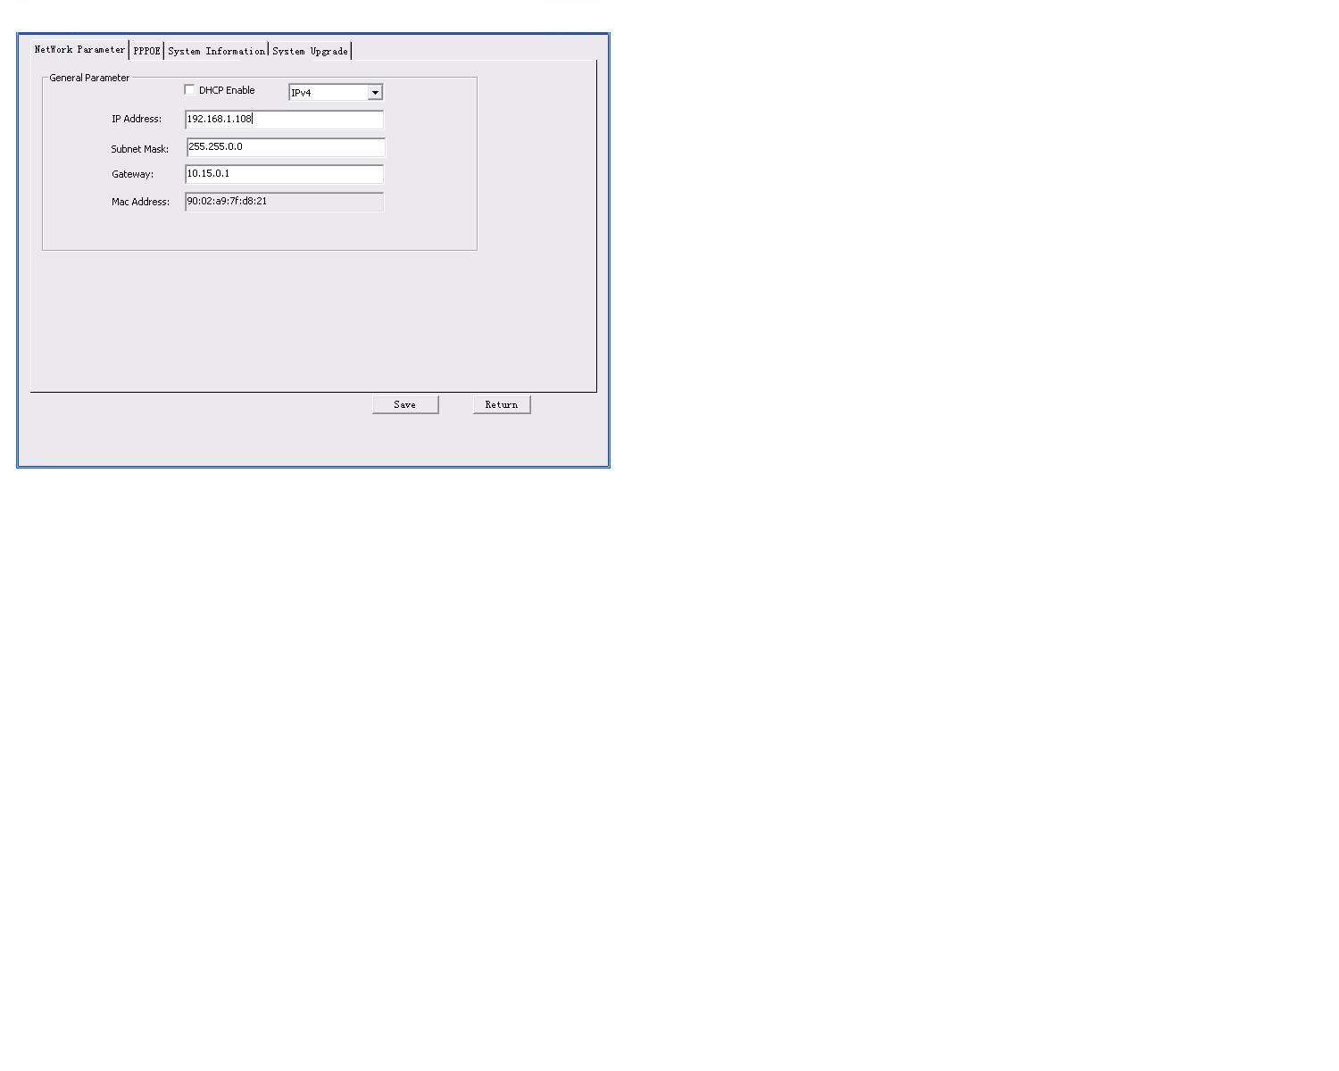

Figure 3‑4 Main interface

**For detailed information and operation instruction of the quick configuration tool, please refer to the *Quick Configuration Tool User’s Manual* included in the resources CD.**

# Web Operation

This series network camera products support the Web access and management via PC.

Web includes several modules: Monitor channel preview, system configuration, alarm and etc.

## Network Connection

Please follow the steps listed below for network connection.

* Make sure the network camera has connected to the network properly.
* Please set the IP address, subnet mask and gateway of the PC and the network camera respectively. Network camera default IP address is 192.168.1.108. Subnet mask is 255.255.255.0. Gateway is 192.168.1.1
* Use order ping ***.***.***.***(* network camera address) to check connection is OK or not.

## Login and Main Interface

Open IE and input network camera address in the address bar. See .

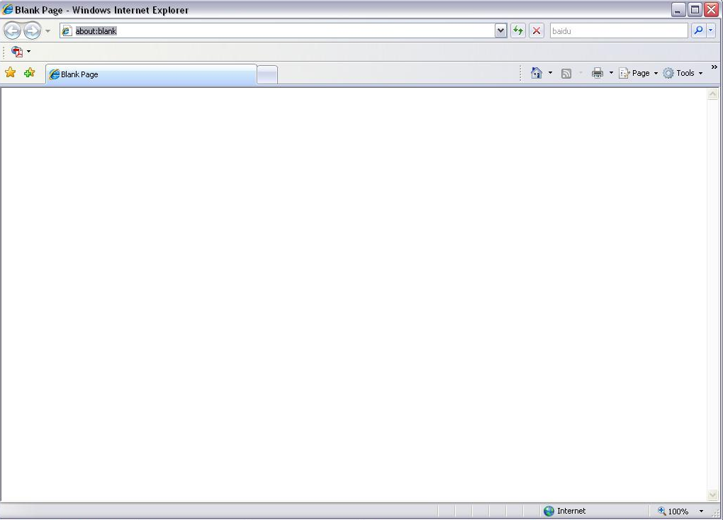

Input your IP address here

Figure 4- IP address

The login interface is shown as below. See .

Please input your user name and password.

Default factory name is admin and password is admin.

**Note: For security reasons, please modify your password after you first login.**

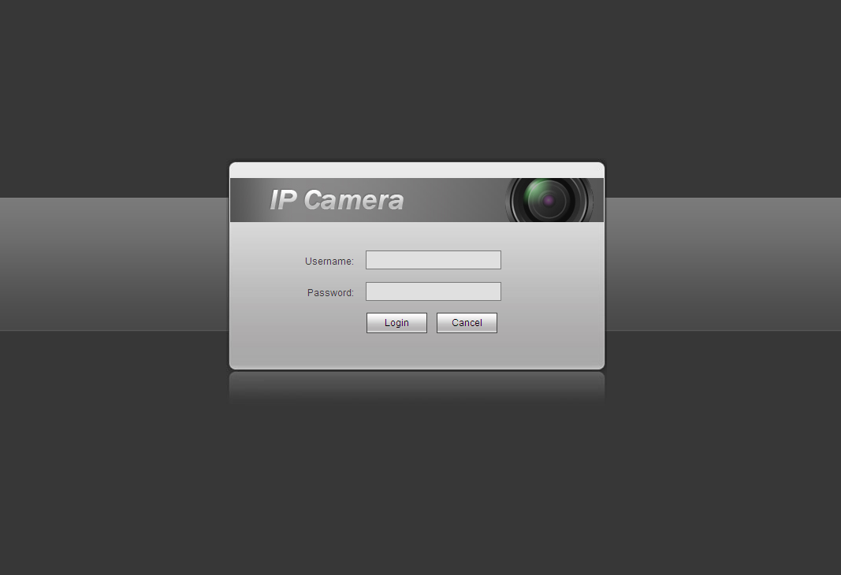

Figure 4- Web login

If it is your first time to log in, system pops up warning information to ask you whether install web plug-in or not after you logged in for one minute. For detailed plug-in installation, please refer to the Web Operation Manual included in the resource CD.

After you logged in, you can see the main window. See .

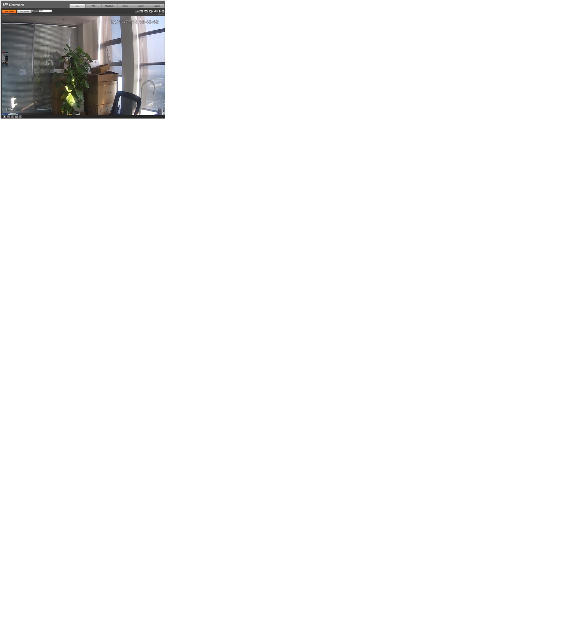

Figure 4- Web monitoring window

Please refer to the Web Operation Manual included in the resource CD for detailed operation instruction.

**Note:**

* **This quick start guide is for reference only. Slight difference may be found in user interface.**
* **All the designs and software here are subject to change without prior written notice.**
* **All trademarks and registered trademarks mentioned are the properties of their respective   
  owners.**
* **If there is any uncertainty or controversy, please refer to the final explanation of us.**
* **Please visit our website or contact your local service engineer for more information.**