**IR Wi-Fi Bullet Camera Quick Start Guide**

**V 1.0.1**

# Packing List

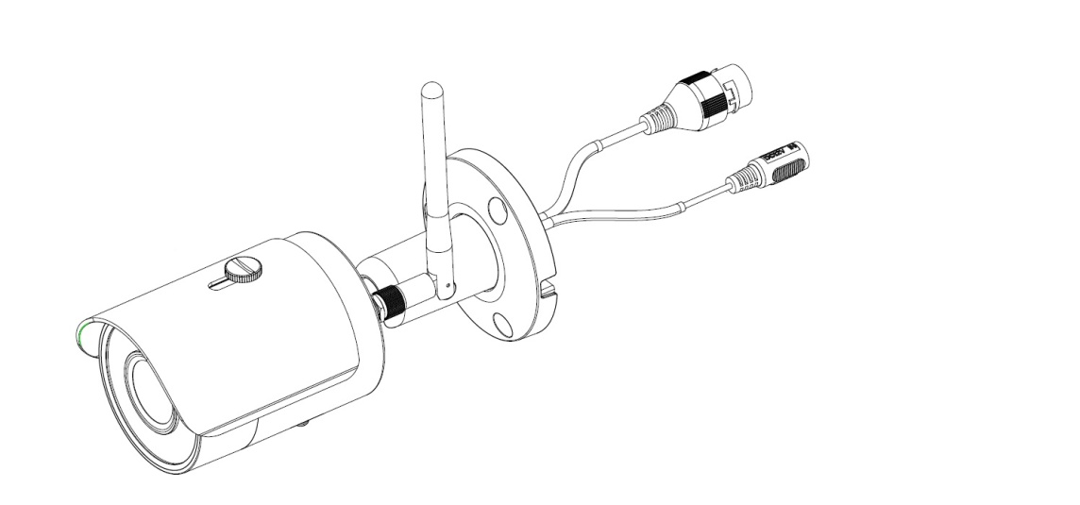

Device × 1

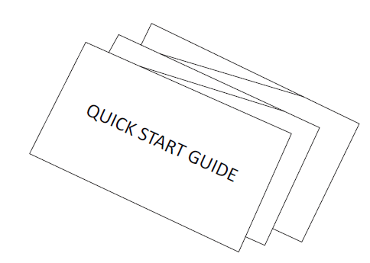 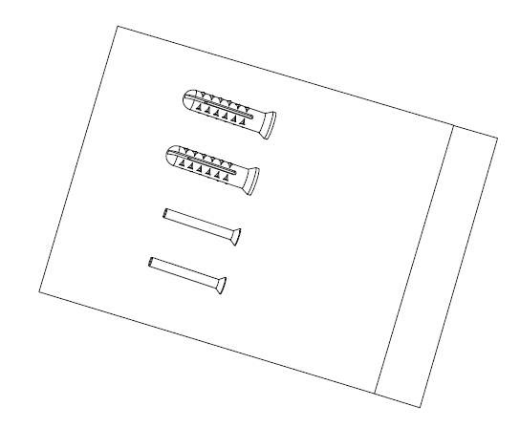

QSG ×1 Screw Package ×1

# Product Appearance

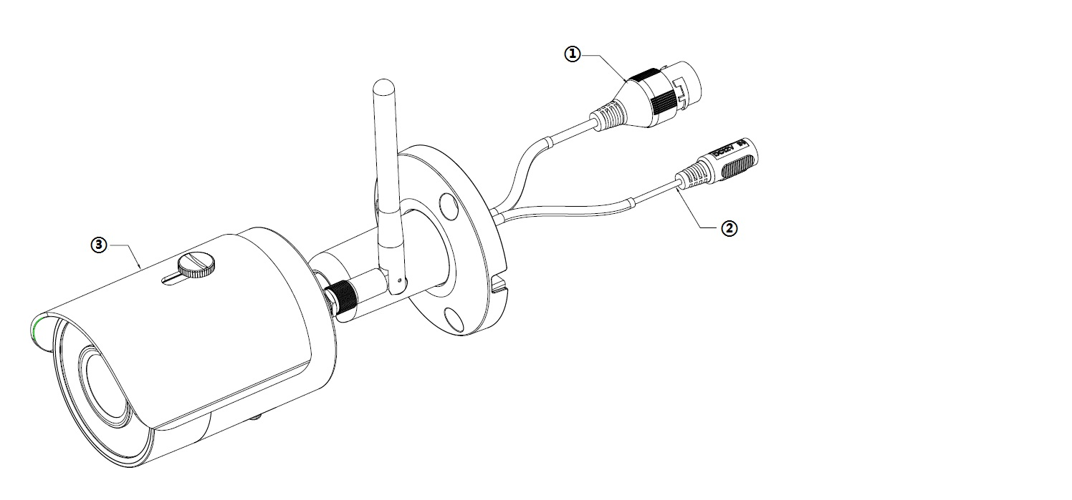

Figure 2-1

Please refer to the following sheet for more details about the device.

|  |  |
| --- | --- |
| **SN** | **Name** |
|  | Network port |
|  | Power port |
|  | Unit device |

Sheet 2-1

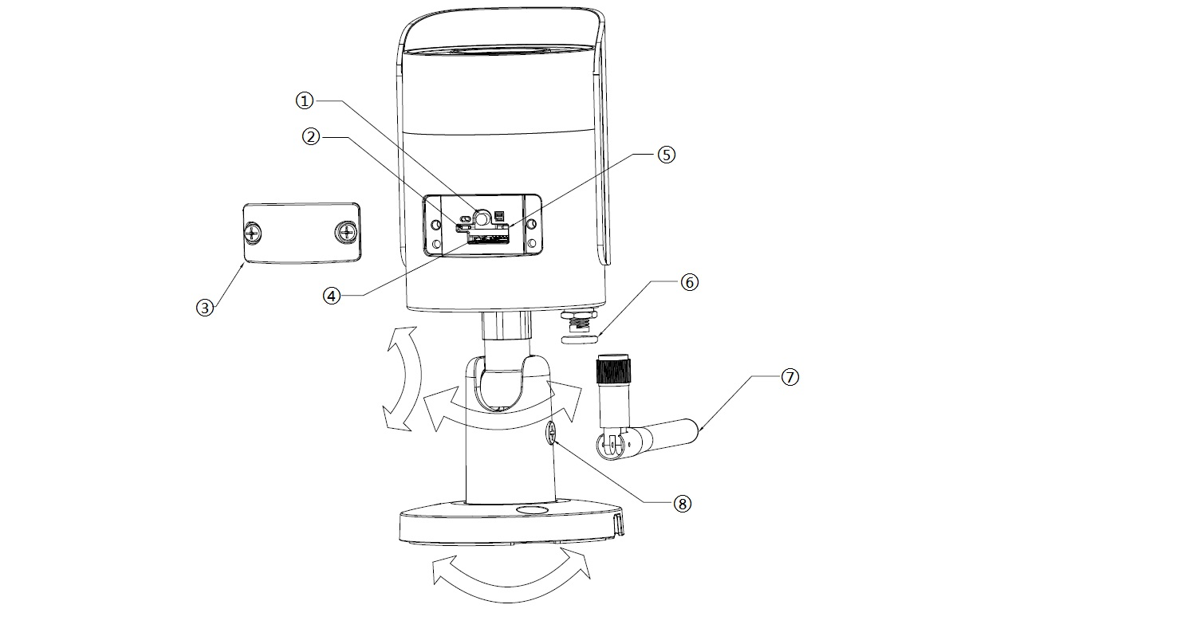

Figure 2-2

Please refer to the following sheet for more details about each component.

| **SN** | **Name** |
| --- | --- |
|  | Reset/WPS (Wi-Fi Protected Setup) button |
|  | Indicator light 1 |
|  | Lower cover |
|  | Micro SD card slot |
|  | Indicator light 2 |
|  | Waterproof ring |
|  | Wifi antenna |
|  | Locking screw |

Sheet 2-2

**Note:**

For reset, long press for 8 seconds and then the light off; For WPS (Wi-Fi Protected Setup), one quick press. Please refer to the following sheet for more details about status of indicator light.

|  |  |
| --- | --- |
| **Indicator light status** | **Device status** |
| Red light normally on | Booting |
| Green light slow flashing | Booting completed, await wifi config, enter smart config status; |
| Green light quick flashing | Wifi smart config in progress, including WPS (Wi-Fi Protected Setup), management frame and etc. |
| Green light normally on | Wifi connection succeeded, operate normally. |
| Red and green lights flash alternately | Device upgrade |
| Red light slow flashing | Network connection failure or disconnection after network connection success. |
| Red light quick flashing | Device malfunction, fail to boot up; alarm or SD card malfunction |

Sheet 2-3

# Operate by EasyViewer

**Step 1**

Power on the camera.

**Step 2**

Connect iphone to a WiFi signal.

**Step 3**

Open EasyViewer (downloaded from APP Store), choose Device Manager.

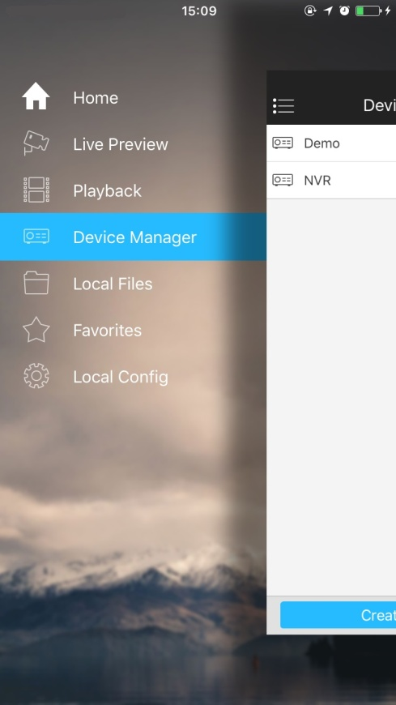

Figure 3-1

**Step 4**

Please select “P2P” when the network cable is connected, select “WiFi configuration” for wireless connection. Here is an example of wireless connection.

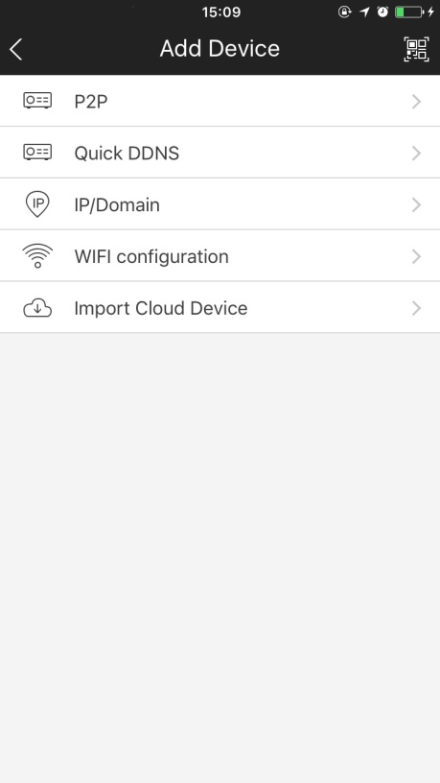

Figure 3-2

**Step 5**

Input a device name and scan the QR code on camera, then “next”.

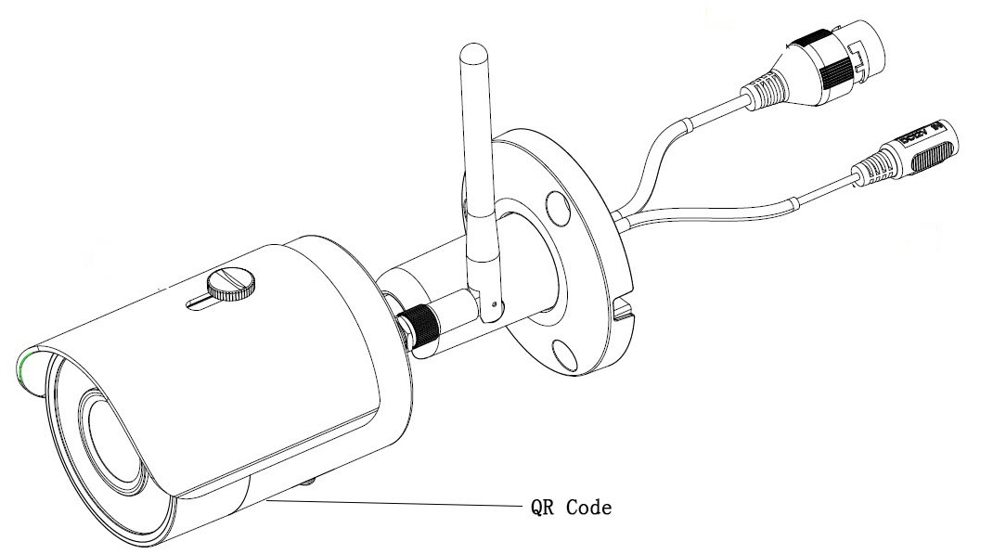

Figure 3-3

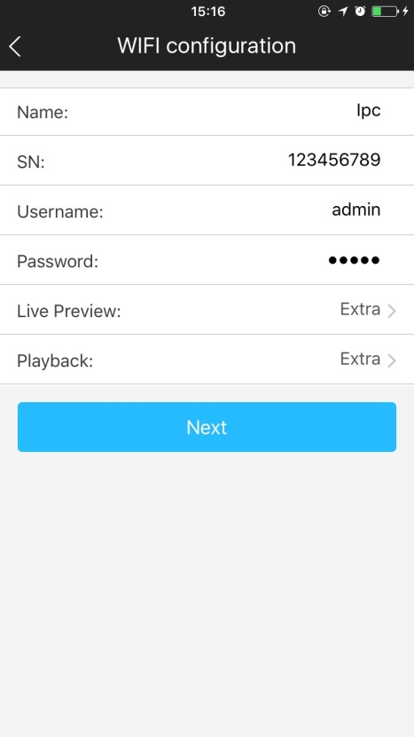

Figure 3-4

**Step 6**

Input the WiFi password, then “next”.

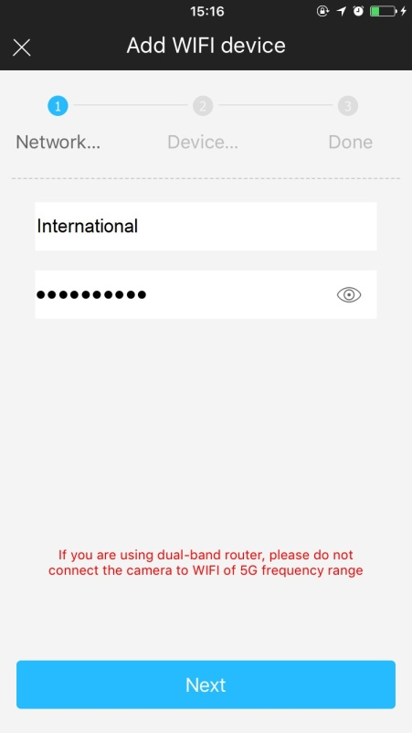

Figure 3-5

Step 7

Connection succeeds.

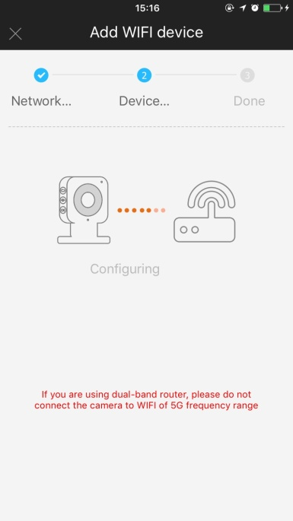 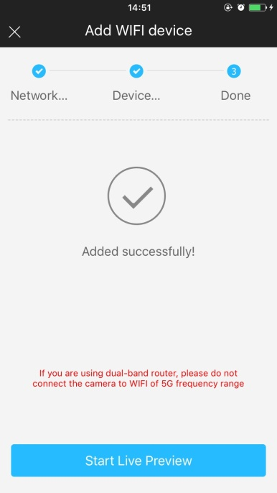 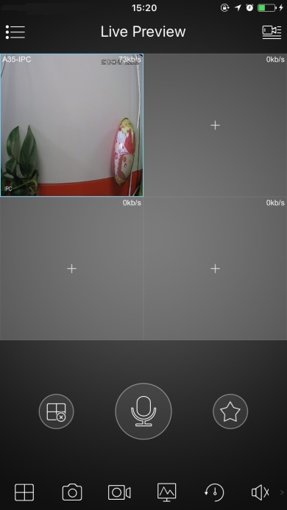

Figure 3-6 Figure 3-7 Figure 3-8

**Note:**

Please try again or check the WiFi password if it failed.

The WiFi configuration will be closed if activating WPS (Wi-Fi Protected Setup) function, please reset the device if you still need to configure WiFi via EasyViewer.

# Device Installation

**Important**

Before the installation, please make sure the installation environment can at least support 3x weight of the camera.

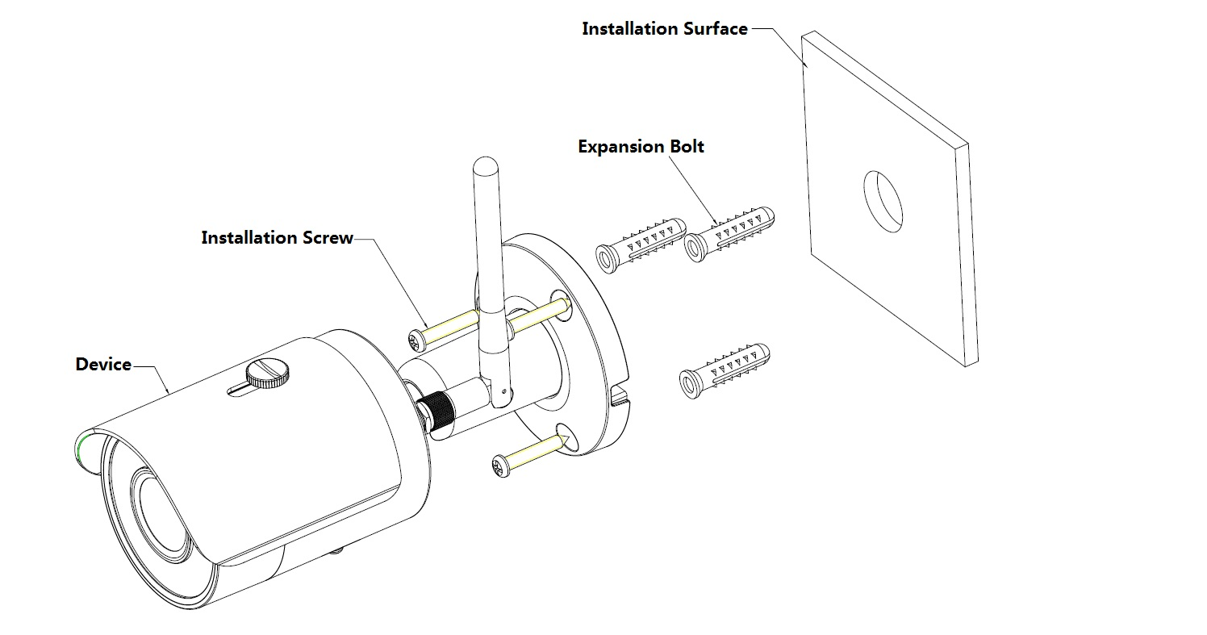

Figure 4-1

Please see Figure 4-1 and Figure 4-2.

**Step 1**

Dig holes on the installation surface (wall or ceiling).

**Step 2**

Open accessories bag, take out expansion bolt and insert it into the hole you just dug.

**Step 3**

Open accessories bag, take out installation screws. Tighten the screws to fix the device on the installation surface (wall or ceiling). You can move device sunshade back and forth. When you have fixed the device, you must tighten screws on sunshade.

**Step 4**

Plug external wiring of the device properly.

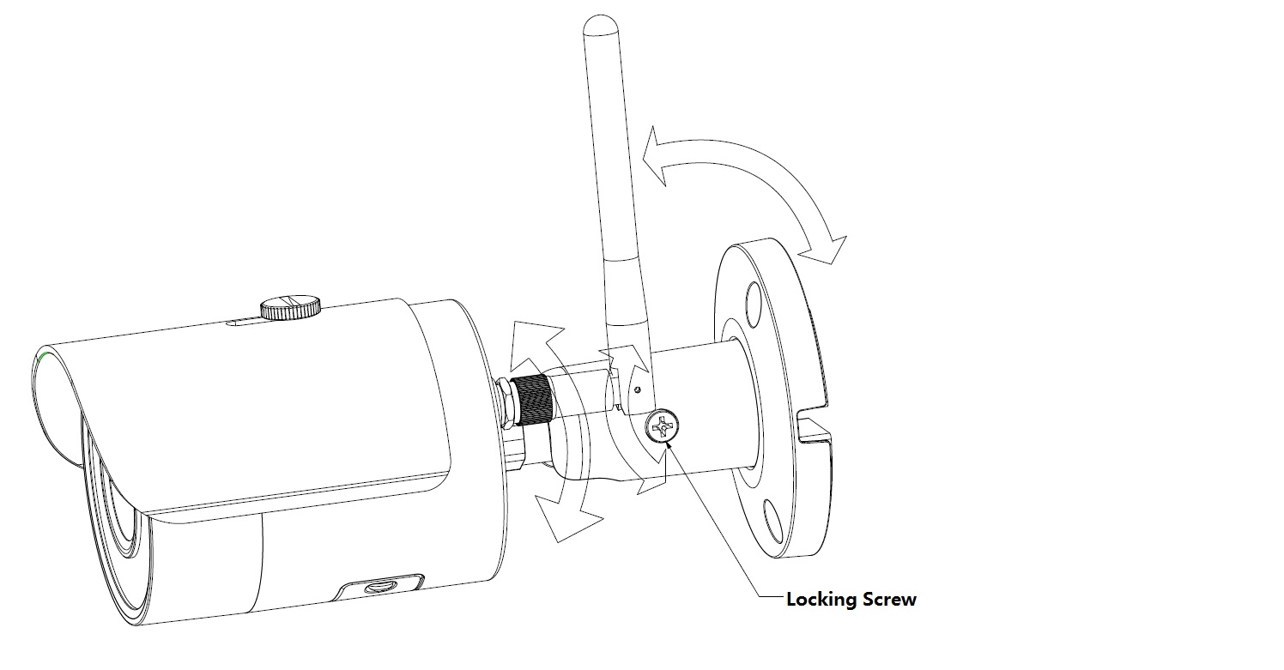

Figure 4-2

**Step 5**

Use cross screwdriver (in accessories bag) to loosen adjusting screw.

**Step 6**

Adjust the device in all possible directions, and set its monitoring direction according to the requirements.

**Step 7**

Use cross screwdriver to tighten the adjusting screws.

**Note:**

* **This quick start guide is for reference only. Slight difference may be found in user interface.**
* **All the designs and software here are subject to change without prior written notice.**
* **All trademarks and registered trademarks mentioned are the properties of their respective   
  owners.**
* **If there is any uncertainty or controversy, please refer to the final explanation of us.**
* **Please visit our website or contact your local service engineer for more information.**