Dahua IR Wi-Fi Bullet Camera Quick Start Guide

V 1.0.2
Dahua Vision Technology CO., LTD

Packing List
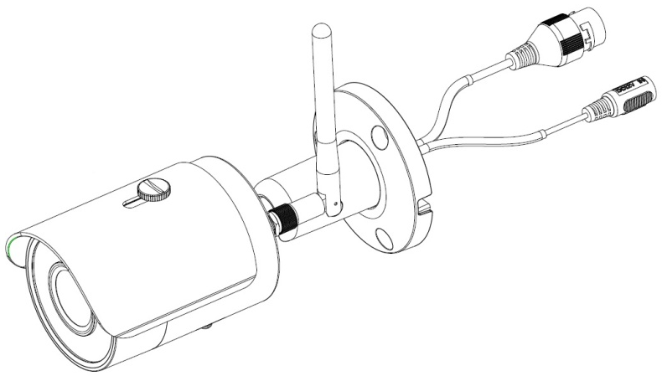
Device × 1

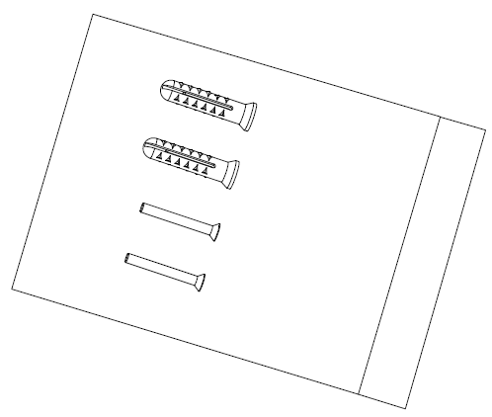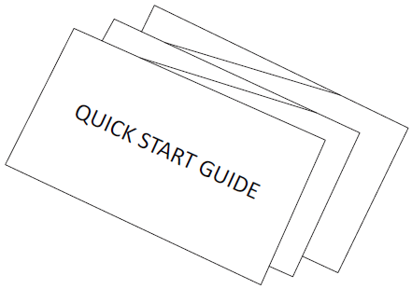
Screw Package ×1 QSG ×1

Product Appearance

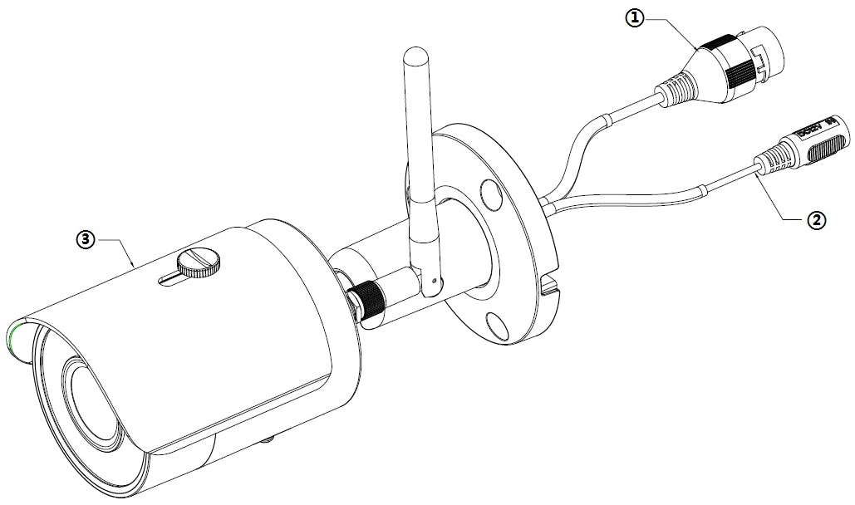
Figure 2-1

Please refer to the following sheet for more details about the device.
SN | Name
 | Ethernet port
 | Power port
 | Unit device
Sheet 2-1
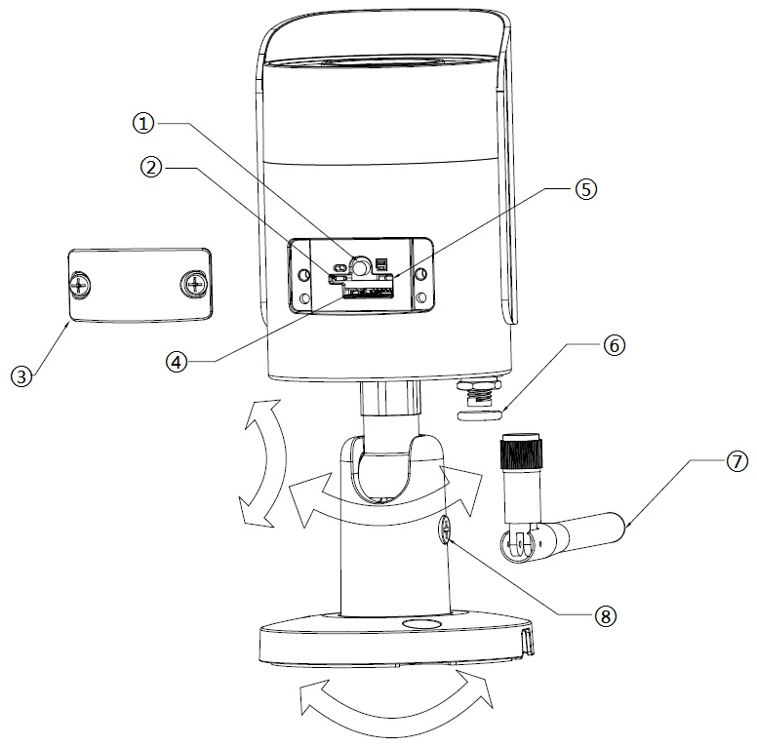

Figure 2-2
Please refer to the following sheet for more details about each component.

SN | Name
 | Reset/ WPS (Wi-Fi Protected Setup) button
 | Indicator light 1
 | Lower cover
 | Micro SD card slot
 | Indicator light 2
 | Waterproof ring
 | Wi-Fi antenna
 | Locking screw

Sheet 2-2
Note:
For reset, long press for 8 seconds and then the light off; For WPS (Wi-Fi Protected Setup), one quick press.
Please refer to the following sheet for more details about status of indicator light.

Indicator light status | Device status
Red light stably on | Booting
Green light slow flashing | Booting completed, await Wi-Fi config, enter smart config status;
Green light quick flashing | Wi-Fi smart config in progress, including WPS (Wi-Fi Protected Setup), management frame, etc.
Green light stably on | Wi-Fi connection succeeded, operate normally.
Red and green lights flash alternately | Device upgrade
Red light slow flashing | Network disconnection.
Red light quick flashing | Device fail to boot up; alarm or SD card does not work
Sheet 2-3

Operate by Easy4ip APP
Step 1
Power on the device with power adapter.
Step 2
Connect your smart phone to your Wi-Fi network. Scan the “Easy4ip” QR on the packing box, download and install the Easy4ip APP.
Step 3
Open Easy4ip APP (take IOS as an example), tap login to login the APP, see Figure 3-1. Please register an account for your first use.
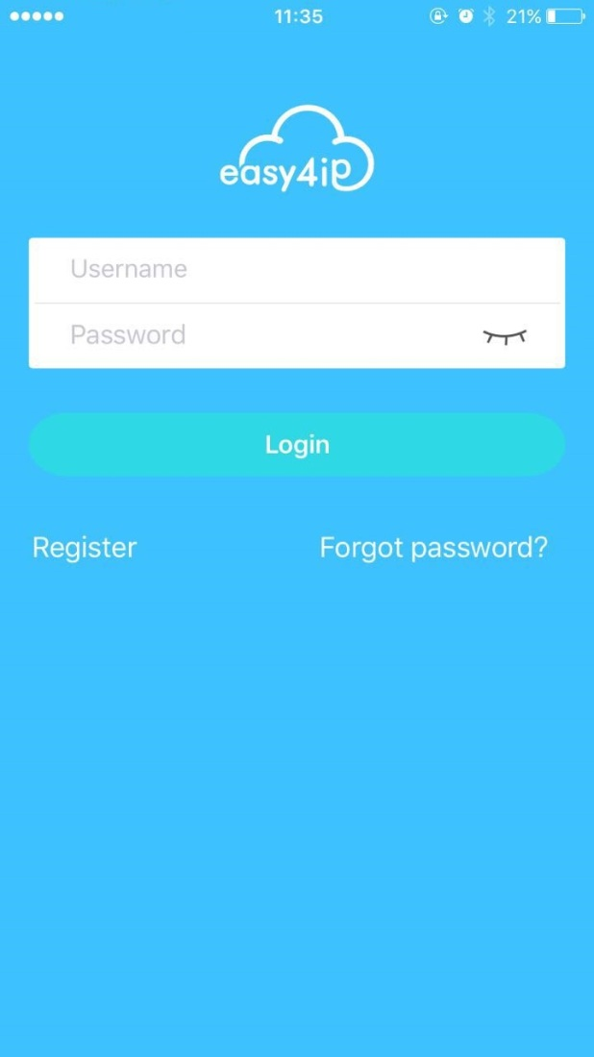
Figure 3-1
Step 4
Please tap “+” to add new devices after you log in your account.

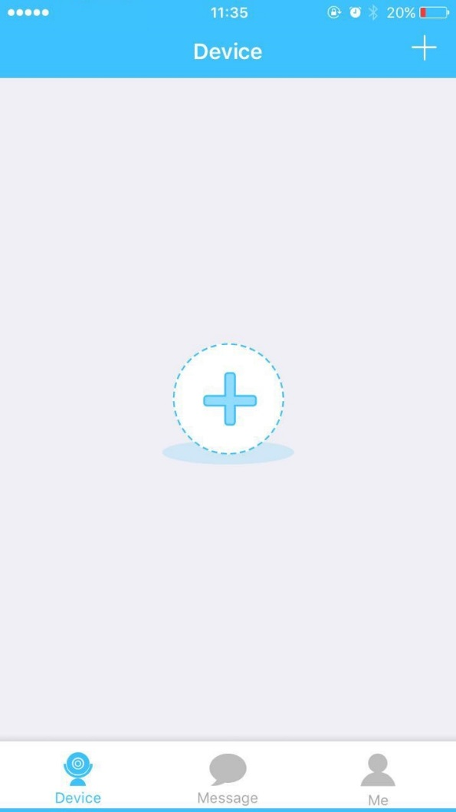
Figure 3-2
Step 5
Scan the QR code on the back of the camera to get the SN, you can also tap “Continue without scanning” and manually input the SN number on the next page.
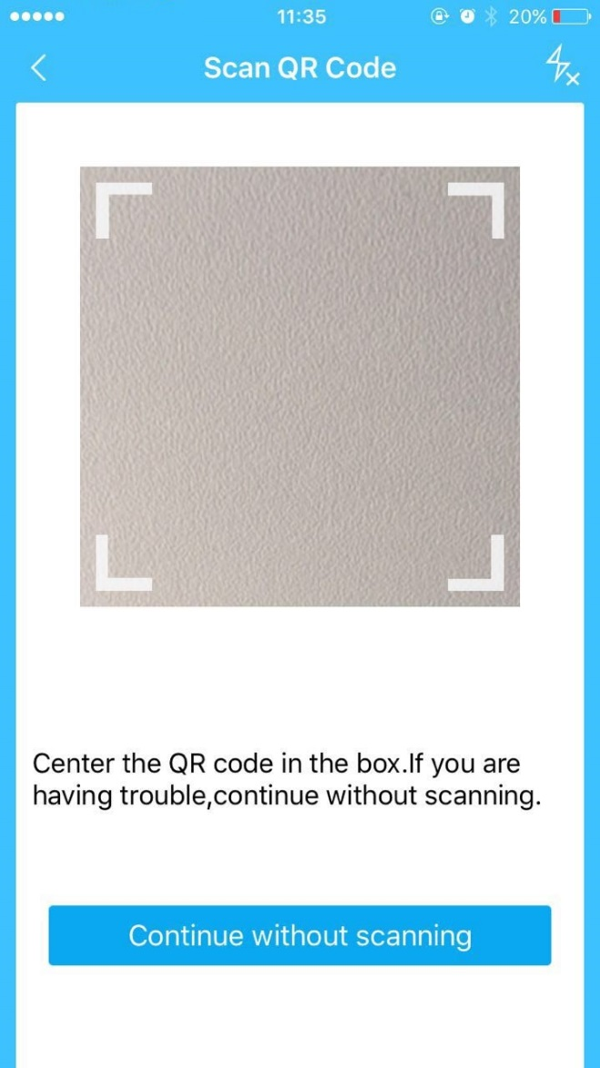
Figure 3-3

Step 6
Fill in the Username and Password of the new camera, both of which are admin by default.
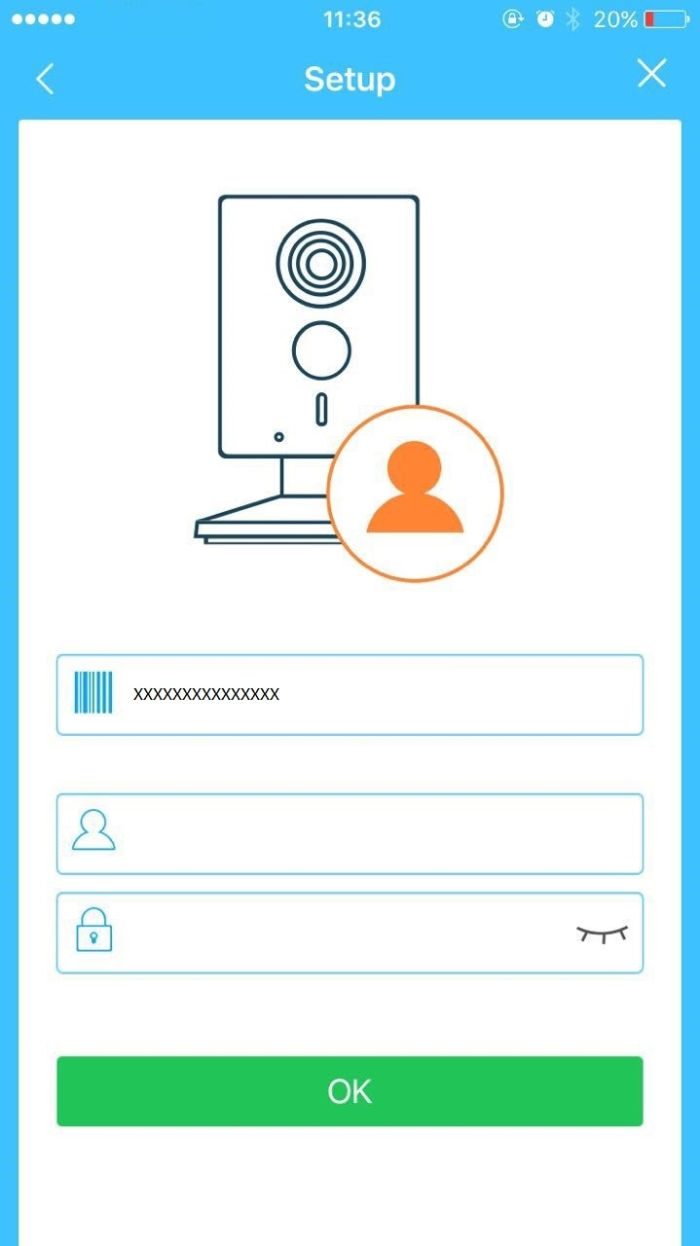
Figure 3-4
Step 7
Select “Yes, config Wi-Fi”, and fill in your Wi-Fi password, then tap “Next”.
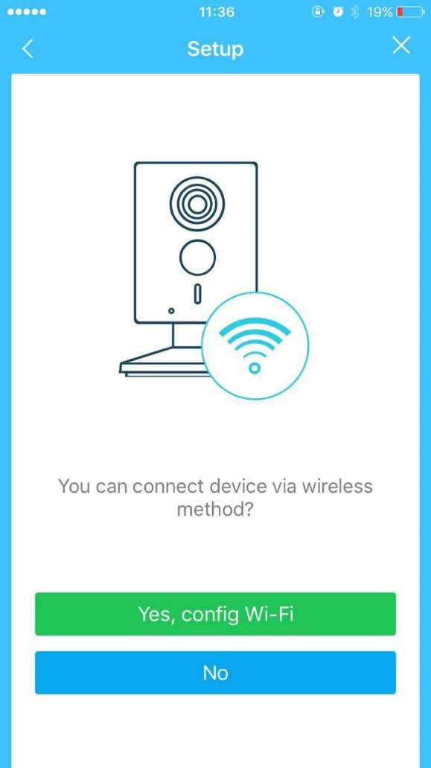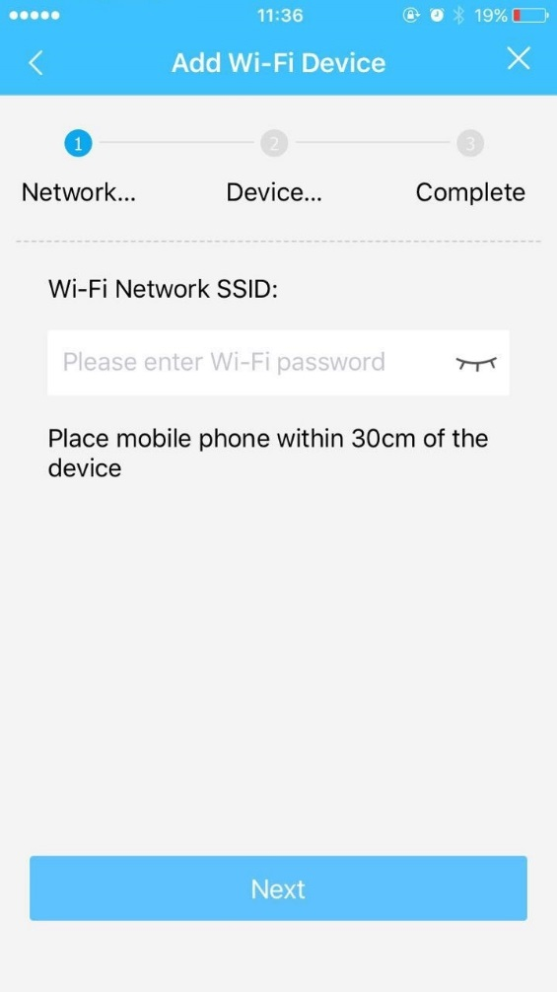
Figure 3-5 Figure 3-6

Step 8
Your Camera will be added to your account.
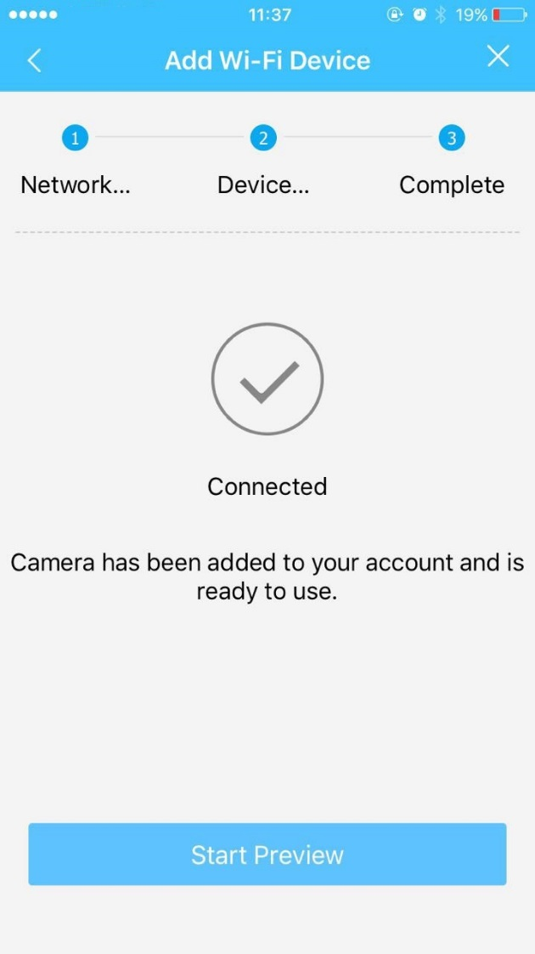
Figure 3-7
Note:
- If you have more cameras, please follow steps 4-8 to add them one by one.
- If you want to change the Wi-Fi signal, please reset the camera to factory default and repeat steps 4-8 to add the device.

Device Installation
Important
Before the installation, please make sure the installation environment can at least support 3x weight of the camera.
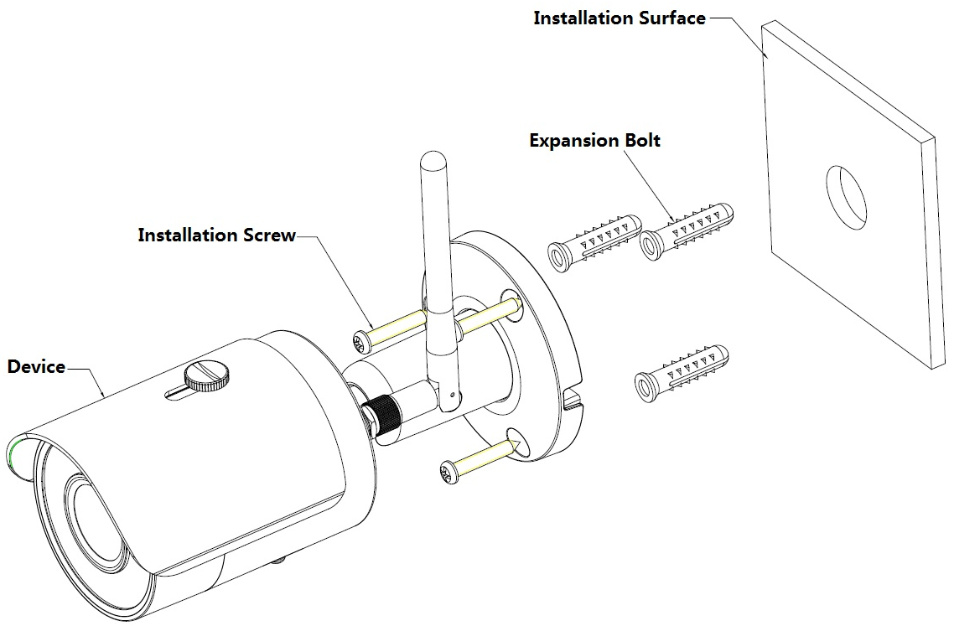
Figure 4-1
Please see Figure 4-1 and Figure 4-2.
Step 1
Dig holes on the installation surface (wall or ceiling).
Step 2
Open accessories bag, take out expansion bolt and insert it into the hole you just dug.
Step 3
Open accessories bag, take out installation screws. Tighten the screws to fix the device on the installation surface (wall or ceiling). You can move device sunshade back and forth. When you have fixed the device, you must tighten screws on sunshade.
Step 4
Plug external wiring of the device properly.
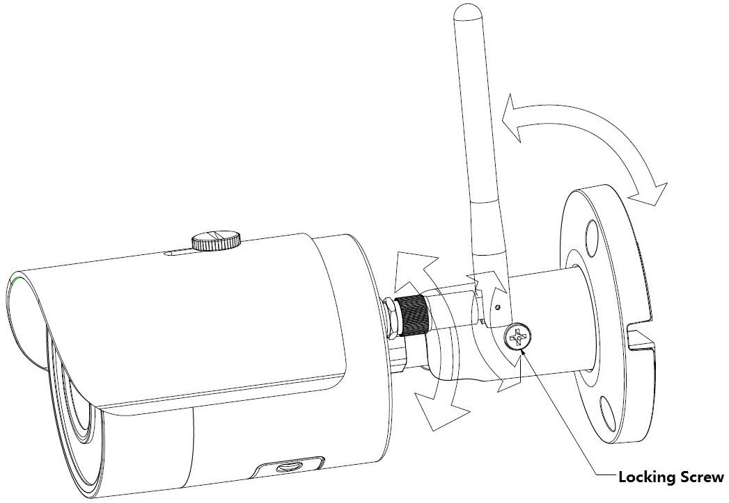
Figure 4-2
Step 5
Use cross screwdriver (in accessories bag) to loosen adjusting screw.
Step 6
Adjust the device in all possible directions, and set its monitoring direction according to the requirements.
Step 7
Use cross screwdriver to tighten the adjusting screws.

Note:
- This quick start guide is for reference only. Slight difference may be found in user interface.
- All the designs and software here are subject to change without prior written notice.
- All trademarks and registered trademarks mentioned are the properties of their respective
owners.
- If there is any uncertainty or controversy, please refer to the final explanation of us.
- Please visit our website or contact your local service engineer for more information.



Dahua Vision Technology Co., Ltd
Address：No.1199 Bin’an Road, Binjiang District, Hangzhou, PRC.
Postcode: 310053
Tel: +86-571-87688883
Fax: +86-571-87688815
Email:overseas@dahuatech.com
Website: www.dahuasecurity.com

