**Dahua C Series Home Camera Quick Start Guide**

**V 1.0.4**

**Dahua Vision Technology CO., LTD**

# Packing List

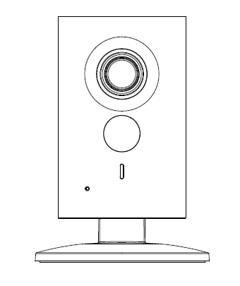 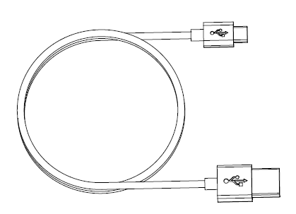

Device × 1 USB ×1

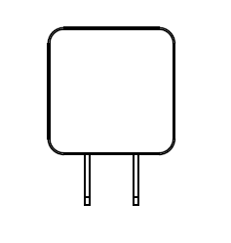 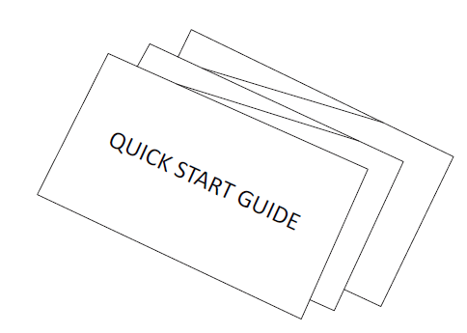

Power Adapter ×1 QSG ×1

 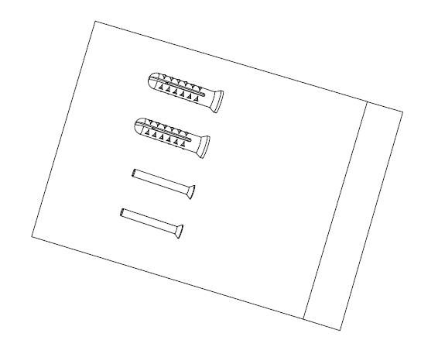

Iron Plate（for magnetic installation） ×1 Screw Package ×1

# Product Appearance

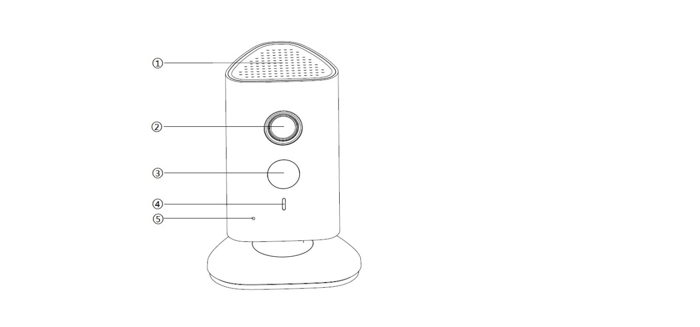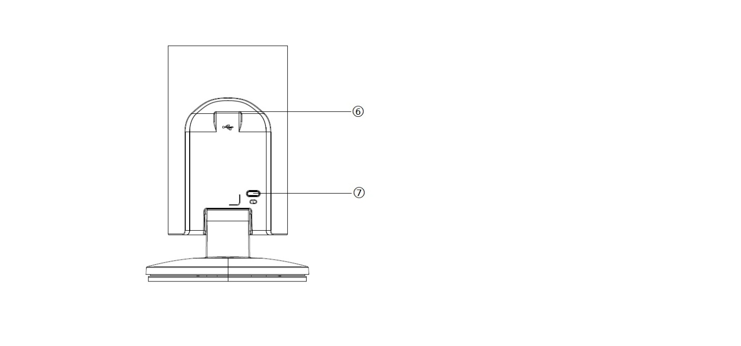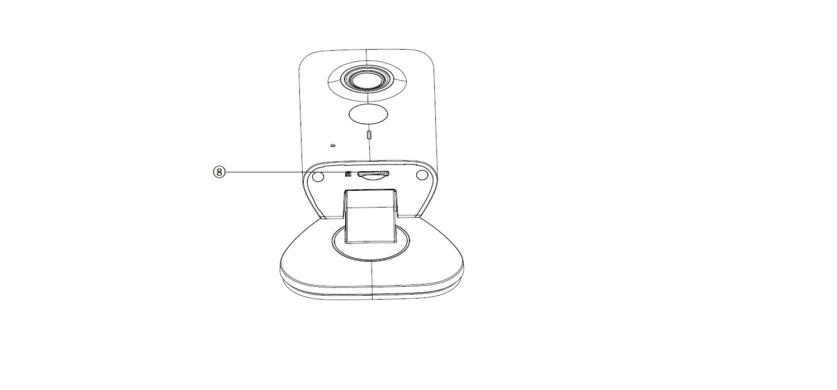

Figure 2-1 Figure 2-2 Figure 2-3

Please refer to the following sheet for more details about each port.

| **SN** | **Name** |
| --- | --- |
| 1 | Speaker |
| 2 | Lens |
| 3 | IR (Infrared Ray) LED |
| 4 | Indicator light |
| 5 | Microphone |
| 6 | USB power slot |
| 7 | Reset/ WPS (Wi-Fi Protected Setup) button |
| 8 | Micro SD Card Slot |

Sheet 2-1

**Note:**

For reset, long press for 8 seconds and then the light off; For WPS (Wi-Fi Protected Setup), one quick press.

Please refer to the following sheet for more details about status of indicator light.

|  |  |
| --- | --- |
| **Indicator light status** | **Device status** |
| Red light stably on | Booting |
| Green light slow flashing | Booting completed, await Wi-Fi config, enter smart config status; |
| Green light quick flashing | Wi-Fi smart config in progress, including WPS (Wi-Fi Protected Setup), management frame, etc. |
| Green light stably on | Wi-Fi connection succeeded, operate normally. |
| Red and green lights flash alternately | Device upgrade |
| Red light slow flashing | Network disconnection |
| Red light quick flashing | Device fail to boot up; alarm or SD card does not work |

Sheet 2-2

# Operate by Easy4ip APP

**Step 1**

Power on the device with power adapter.

**Step 2**

Connect your smart phone to your Wi-Fi network. Scan the “Easy4ip” QR on the packing box, download and install the Easy4ip APP.

**Step 3**

Open Easy4ip APP (take IOS as an example), tap login to login the APP, see Figure 3-1. Please register an account for your first use.

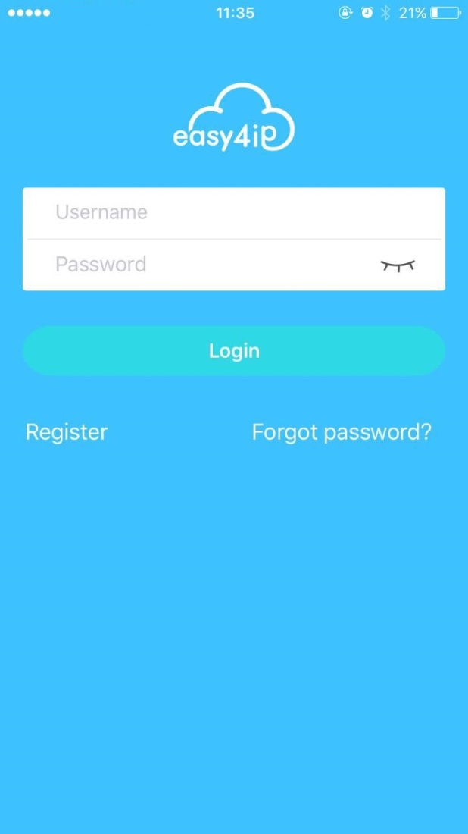

Figure 3-1

**Step 4**

Please tap “+” to add new devices after you log in your account.

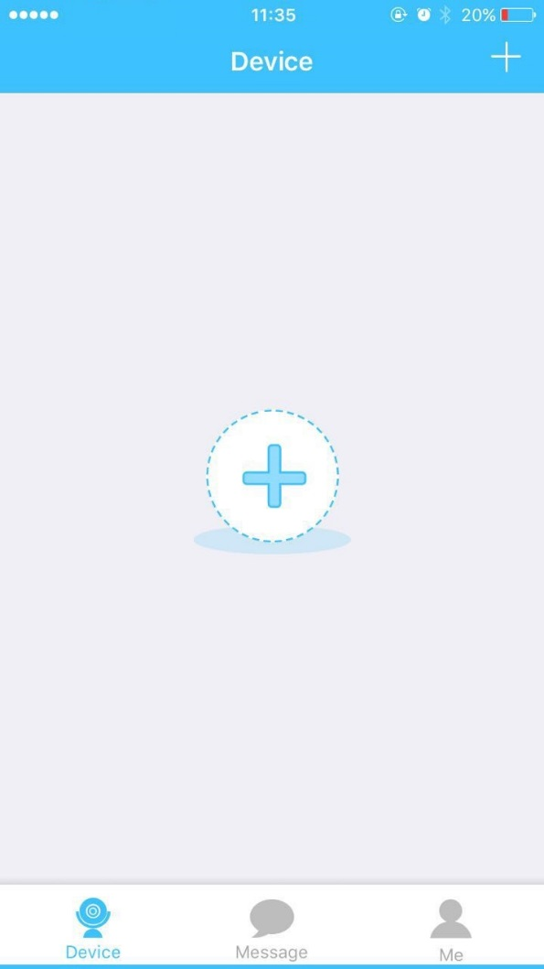

Figure 3-2

**Step 5**

Scan the QR code on the back of the camera to get the SN, you can also tap “Continue without scanning” and manually input the SN number on the next page.

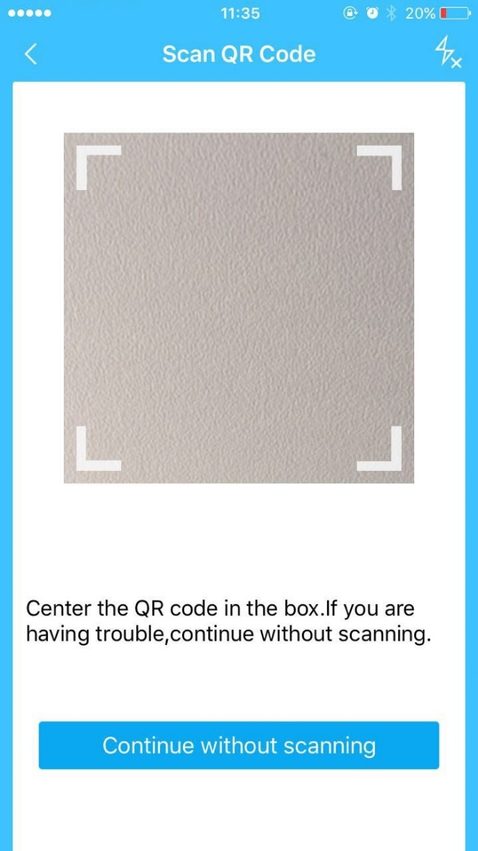

Figure 3-3

**Step 6**

Fill in the Username and Password of the new camera, both of which are admin by default.

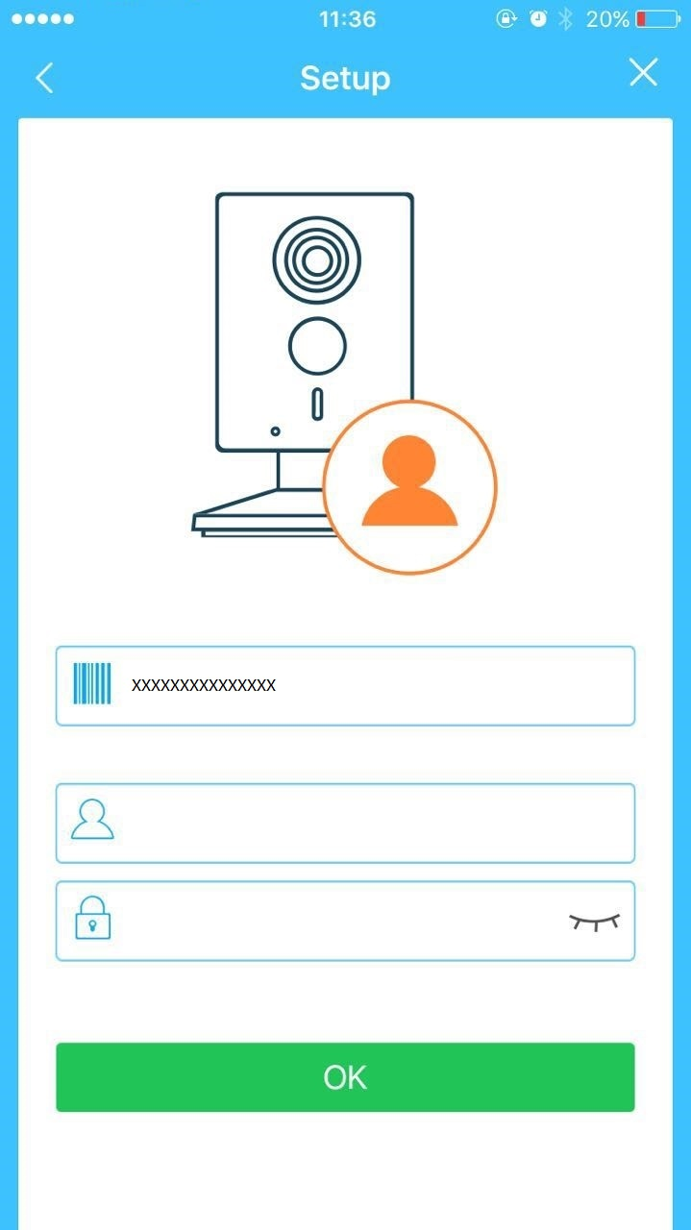

Figure 3-4

**Step 7**

Select “Yes, config Wi-Fi”, and fill in your Wi-Fi password, then tap “Next”. During the Wi-Fi connecting process, please put your smartphone and the camera within 30cm.

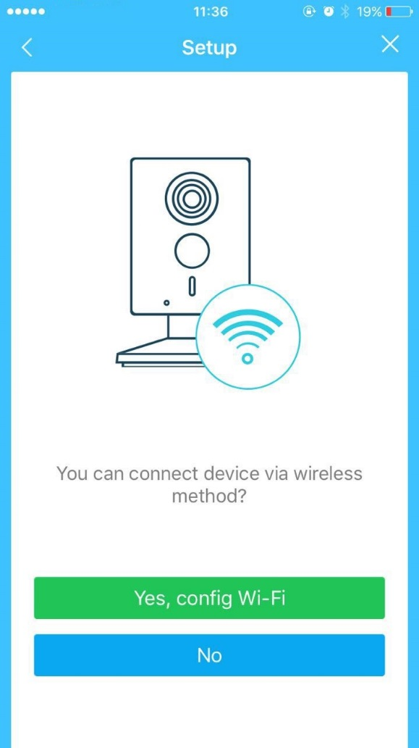 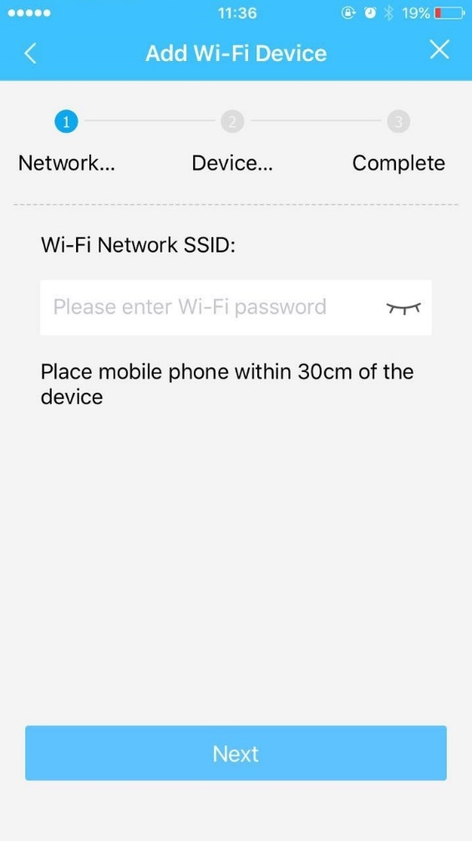

Figure 3-5 Figure 3-6

**Step 8**

Your Camera will be added to your account.

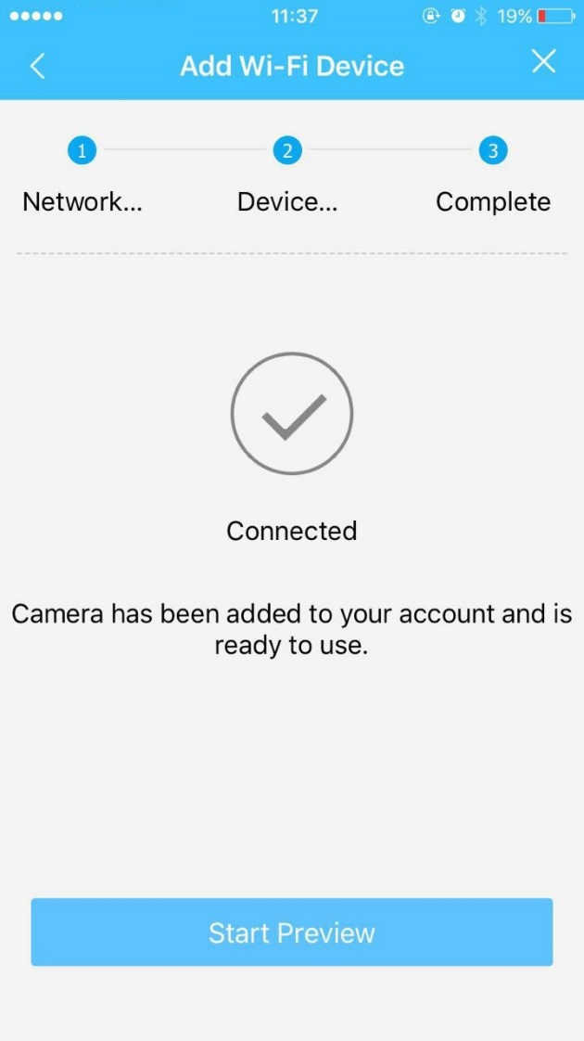

Figure 3-7

**Note:**

* If you have more cameras, please follow steps 4-8 to add them one by one.
* If you want to change the Wi-Fi signal, please reset the camera to factory default and repeat steps 4-8 to add the device.

# Device Installation

**Important**

Before the installation, please make sure the installation environment can at least support 3x weight of the camera.

## Non-metal Surface

Step 1

Fix the metal plate with screws.

Step 2

Stick the camera onto the metal plate.

## Metal Surface

Stick the camera onto the metal surface directly.

**Note:**

* **This quick start guide is for reference only. Slight difference may be found in user interface.**
* **All the designs and software here are subject to change without prior written notice.**
* **All trademarks and registered trademarks mentioned are the properties of their respective   
  owners.**
* **If there is any uncertainty or controversy, please refer to the final explanation of us.**
* **Please visit our website or contact your local service engineer for more information.**



**Dahua Vision Technology Co., Ltd**

Address：No.1199 Bin’an Road, Binjiang District, Hangzhou, PRC.

Postcode: 310053

Tel: +86-571-87688883

Fax: +86-571-87688815

Email:overseas@dahuatech.com

Website: www.dahuasecurity.com