**C Series Home Camera Quick Start Guide**

**V 1.0.1**

# Packing List

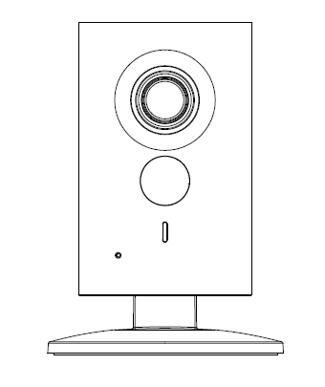 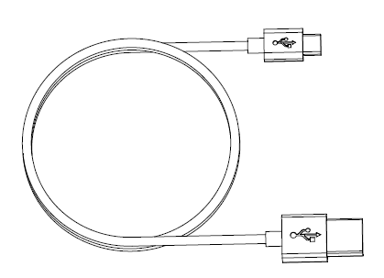

Device × 1 USB ×1

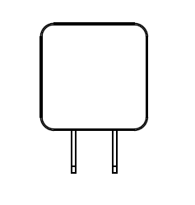 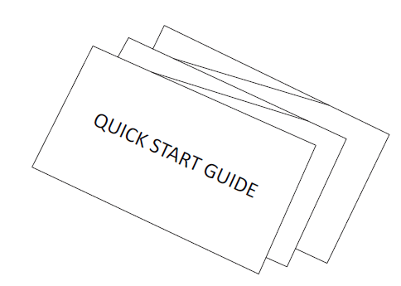

Power Adapter ×1 QSG ×1

 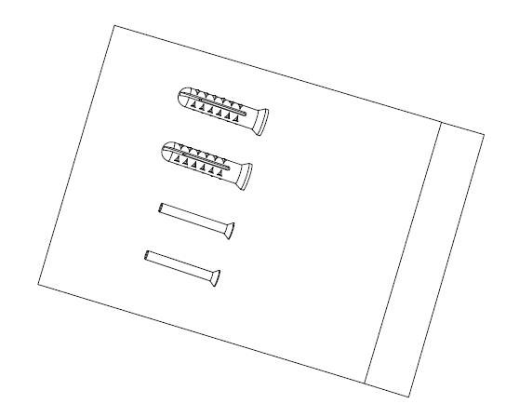

Iron Plate（for magnetic installation）×1 Screw Package ×1

# Product Appearance

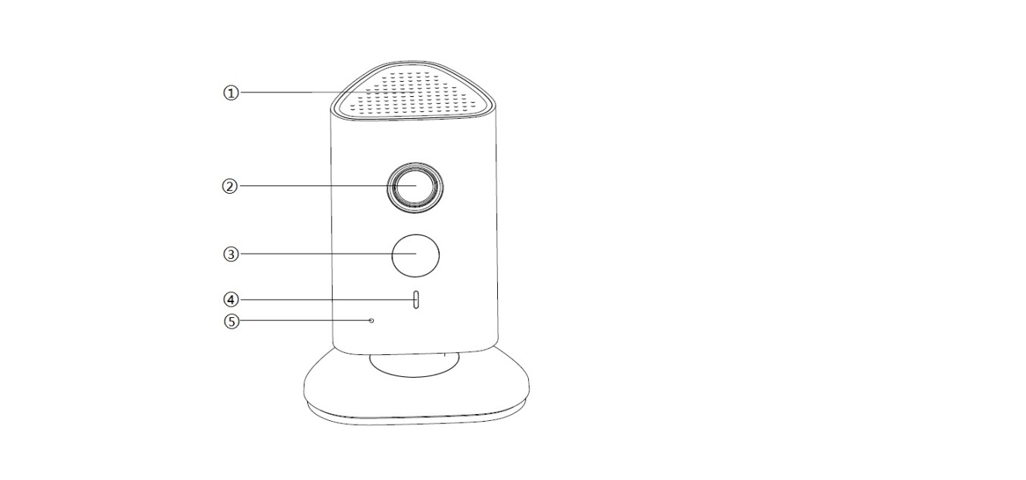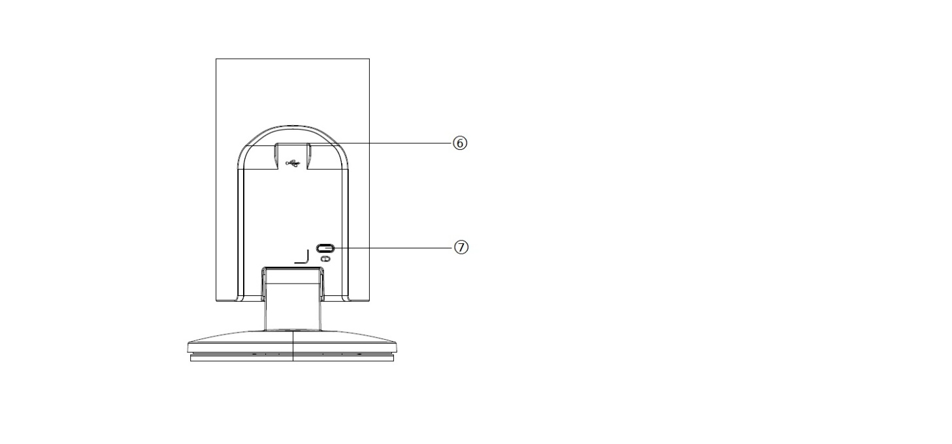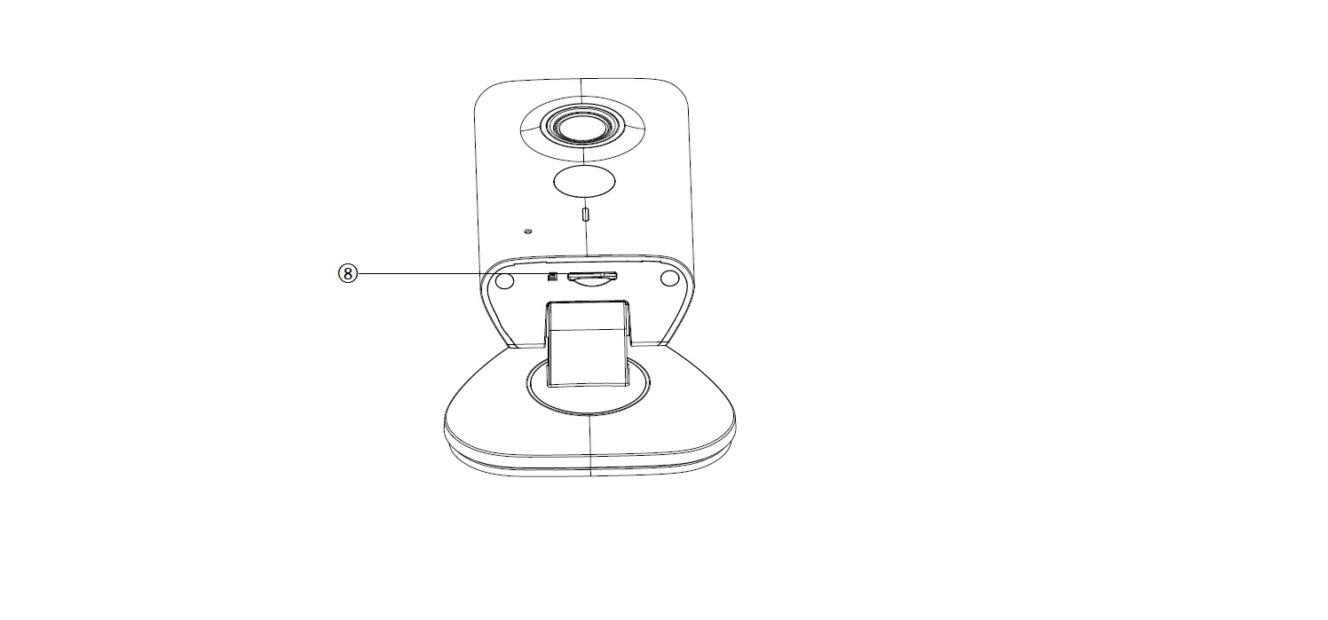

Figure 2-1 Figure 2-2 Figure 2-3

Please refer to the following sheet for more details about each port.

| **SN** | **Name** |
| --- | --- |
| 1 | Speaker |
| 2 | Lens |
| 3 | IR (Infrared Ray) LED |
| 4 | Indicator light |
| 5 | Microphone |
| 6 | USB power supply |
| 7 | Reset/ WPS (Wi-Fi Protected Setup) button |
| 8 | Micro SD Card Slot |

Sheet 2-1

**Note:**

For reset, long press for 8 seconds and then the light off; For WPS (Wi-Fi Protected Setup), one quick press.

Please refer to the following sheet for more details about status of indicator light.

|  |  |
| --- | --- |
| **Indicator light status** | **Device status** |
| Red light normally on | Booting |
| Green light slow flashing | Booting completed, await wifi config, enter smart config status; |
| Green light quick flashing | Wifi smart config in progress, including WPS (Wi-Fi Protected Setup), management frame and etc. |
| Green light normally on | Wifi connection succeeded, operate normally. |
| Red and green lights flash alternately | Device upgrade |
| Red light slow flashing | Network connection failure or disconnection after network connection success. |
| Red light quick flashing | Device malfunction, fail to boot up; alarm or SD card malfunction |

Sheet 2-2

# Operate by EasyViewer

**Step 1**

Power on the camera.

**Step 2**

Connect iphone to a WiFi signal.

**Step 3**

Open EasyViewer (downloaded from APP Store), choose Device Manager.

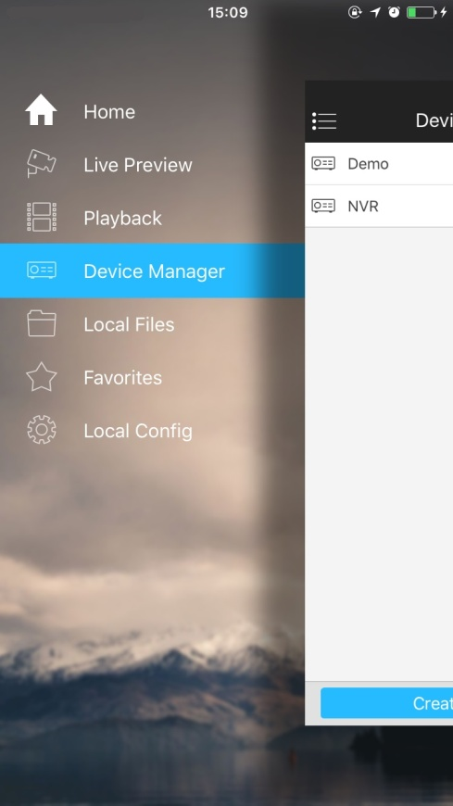

Figure 3-1

**Step 4**

Please select “P2P” when the network cable is connected, select “WiFi configuration” for wireless connection. Here is an example of wireless connection.

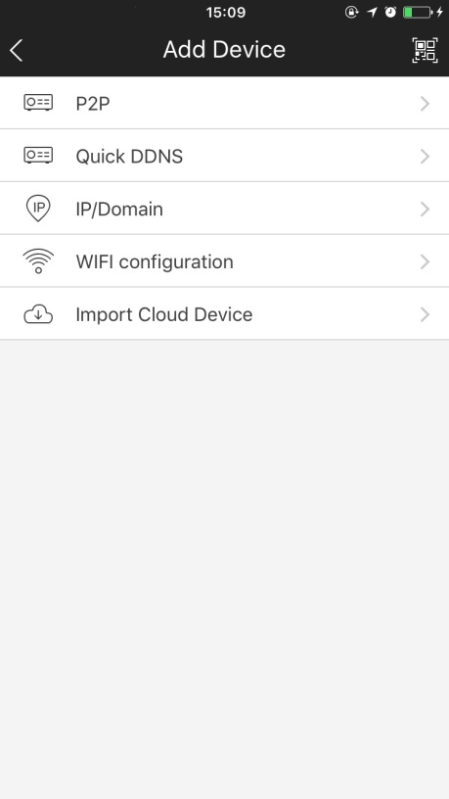

Figure 3-2

**Step 5**

Input a device name and scan the QR code on camera, then “next”.

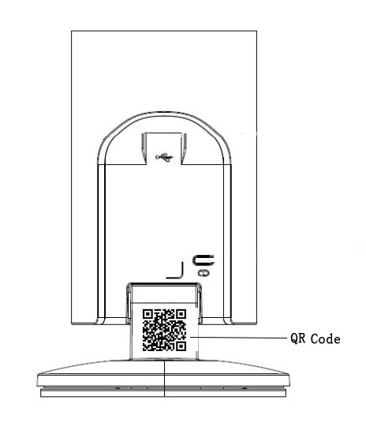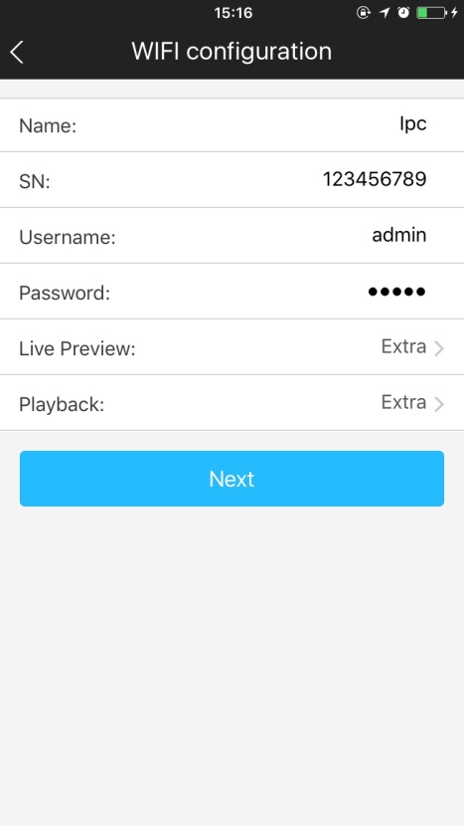

Figure 3-3 Figure 3-4

**Step 6**

Input the WiFi password, then “next”.

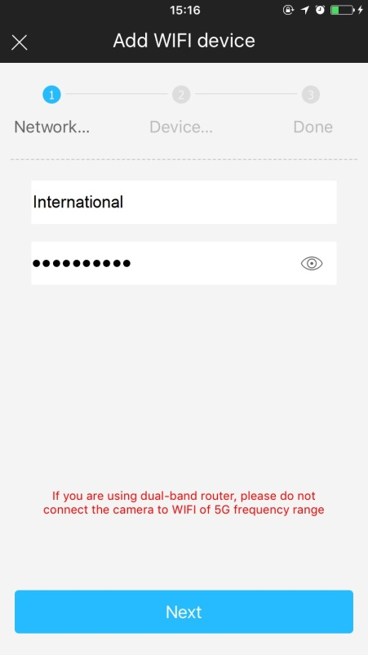

Figure 3-5

Step 7

Connection succeeds.

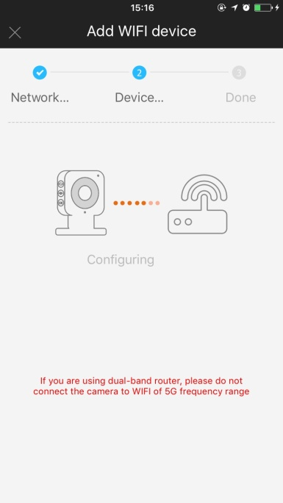 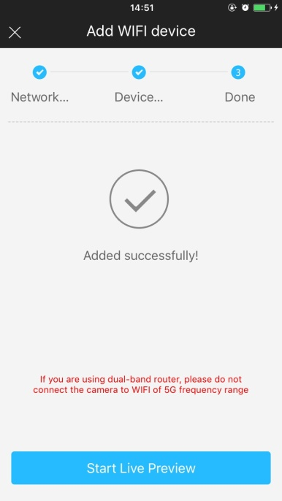 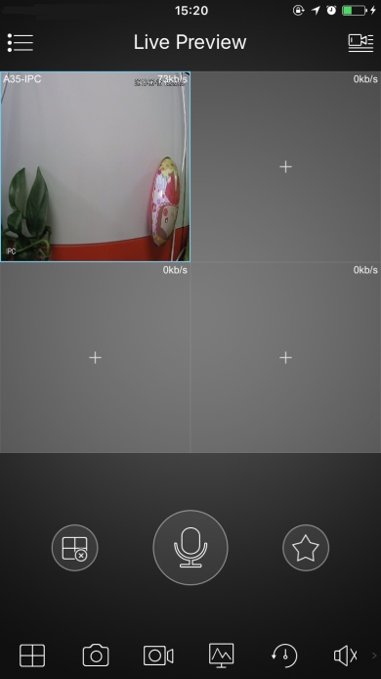

Figure 3-6 Figure 3-7 Figure 3-8

**Note:**

Please try again or check the WiFi password if it failed.

The WiFi configuration will be closed if activating WPS (Wi-Fi Protected Setup) function, please reset the device if you still need to configure WiFi via EasyViewer.

# Device Installation

**Important**

Before the installation, please make sure the installation environment can at least support 3x weight of the camera.

## Non-metal Surface

Step 1

Fix the metal plate with screws.

Step 2

Stick the camera onto the metal plate.

## Metal Surface

Stick the camera onto the metal surface directly.

**Note:**

* **This quick start guide is for reference only. Slight difference may be found in user interface.**
* **All the designs and software here are subject to change without prior written notice.**
* **All trademarks and registered trademarks mentioned are the properties of their respective   
  owners.**
* **If there is any uncertainty or controversy, please refer to the final explanation of us.**
* **Please visit our website or contact your local service engineer for more information.**