1 Megapixel HDCVI Pinhole Camera User's Manual

Version 1.0.0

Table of Contents
1 General Introduction 1
1.1 Overview 1
1.2 Features 1
1.3 Functions 1
1.4 Specifications 2
2 Framework and Dimensions 3
HAC-HUM3100BP/N 3
3 Installation 5
4 Menu 6
4.1 HDCVI Series DVR Settings 6
4.2 Menu List 7
Appendix Toxic or Hazardous Materials or Elements 8

Welcome
Thank you for purchasing our HDCVI camera!
This user’s manual is designed to be a reference tool for your system.
Please read the following safeguard and warnings carefully before you use this series product!
Please keep this user’s manual well for future reference!

Important Safeguards and Warnings
1．Electrical safety
All installation and operation here should conform to your local electrical safety codes.
The power shall conform to the requirement in the SELV (Safety Extra Low Voltage) and the Limited power source is rated 12V DC (24V AC) in the IEC60950-1.
We assume no liability or responsibility for all the fires or electrical shock caused by improper handling or installation.

2．Transportation security
Heavy stress, violent vibration or water splash are not allowed during transportation, storage and installation.

3．Installation
Do not apply power to the camera before completing installation.
Please install the proper power cut-off device during the installation connection.
Always follow the instruction guide the manufacturer recommended.
If this product is installed in the ceiling, please make sure the installation position can sustain the min 50N.

4．Qualified engineers needed
All the examination and repair work should be done by the qualified service engineers.
We are not liable for any problems caused by unauthorized modifications or attempted repair.

5．Environment
This series camera should be installed in a cool, dry place away from direct sunlight or strong light, inflammable, explosive substances and etc.
This series camera shall work on the specified working temperature. Please keep it away from the electromagnetic radiation object and environment.
Please keep the sound ventilation.
Do not allow the water and other liquid falling into the camera.

6. Accessories
Be sure to use all the accessories recommended by manufacturer.
Before installation, please open the package and check all the components are included.
Contact your local retailer ASAP if something is broken in your package.

7. Daily Maintenance
Please shut down the device and then unplug the power cable before you begin daily maintenance work.
Use the dry soft cloth to clean the device.
If there is too much dust, please use the water to dilute the mild detergent first and then use it to clean the device. Finally use the dry cloth to clean the device.
Please put the dustproof cap to protect the CCD (CMOS) component when you do not use the camera.

General Introduction

Overview
This series megapixel HD camera conforms to the HDCVI standard. It supports video signal high-speed long distance transmission without any delay. It can be controlled by the DVR conforming to the HDCVI.

Features
- High-performance CMOS image sensor, megapixel definition.
- Support HDCVI high definition video output.
- Support video, audio, control coaxial transmission.
- Support 75-3 coaxial cable transmission without any loss. Transmission distance is over 500m.
- High speed, long distance real-time transmission.
- Support auto exposure, auto white balance, auto electronic gain function.
- High image color rendition, vivid image.
- Support OSD menu.
- Support DC12V power supplying.

Functions
HDCVI Specification
HDCVI（High Definition Composite Video Interface） is an over-coaxial –cable HD video transmission standard. It’s a kind of HD video which adopts analog modulation technique to transfer with progressive scanning.

OSD (On Screen Display)
Camera supports user-friendly screen menu function, making it convenient for users to select different functions.

Auto gain function
To output the standard video signal in the different illumination environments, the amplifier needs to adjust in a wide range. The system can enhance the camera sensitivity in low illumination and enhance the video signal output to get the clear and high definition video.

Auto white balance
The white balance refers to the camera to restore the white object color. It allows the camera to automatically adjust the color temperature in indoor and outdoor environment. Human eyes see white is still white whether in indoor or outdoor environment because human eyes can adapt to the changes of color temperature, while the camera can’t adapt to the changes as human eyes do. Therefore, white will turn to other colors after the environment is changed, which can be fixed by AWB correctly.

Auto exposure
System can automatically set shutter speed and iris value according to the snapshot video exposure condition.

Specifications
Model  Parameter |  | 1 Megapixel HDCVI Pinhole Camera
 |  | HAC-HUM3100BP/N
Sensor Type |  | 1/2.9" 1.0 Mega Pixels CMOS
Video Format |  | PAL/NTSC
Effective Pixel |  | 1280（H）* 720（V）
Min Illumination |  | 0.01Lux@（F1.2，AGC ON）
Electronic Shutter |  | PAL：1/50s~1/100,000s  NTSC：1/60s~1/100,000s
Video Standard |  | HDCVI compliance
Video Frame Rate |  | PAL：1280×720@25 fps  NTSC：1280×720@30 fps
Lens Port |  | M12
Lens Type |  | 2.8/3.6 mm optional
Day/Night Switch |  | Auto
Video Output |  | 1-channel HDCVI high definition video output
Video Input |  | 1-channel audio input, receive audio signal from device like sound pick-up
Audio Coaxial |  | Support audio and video coaxial transmission
Control Coaxial |  | Support menu control and video coaxial transmission
Menu  Control | Exposure | Shutter/AGC/brightness
Menu  Control | White Balance | Mode/R gain /B gain
Menu  Control | Day/Night Mode | Mode / D→N LEVEL / N→D LEVEL
Menu  Control | Image Setup | Brightness/ contrast/ color gain/sharpness/NR/mirror/language
Menu  Control | Function Setup | Flicker/OSD color/OSD BG
Menu  Control | Reset | -
Menu  Control | Save & Exit | -
Max Transmission Distance |  | Over 500m via 75-3 coaxial cable.
Working Temperature /Humidity |  | -30℃~+60℃. Humidity is less than 95%(no condensation)
Power |  | DC 12V±10%
Power Consumption |  | 1.44W MAX (Input: 12V0.12A)
Dimension(mm) |  | 30*30*15.9
Weight |  | 50g

Framework and Dimensions

HAC-HUM3100BP/N
Please refer to the following figures for dimension information. The unit is mm. See and Figure 2-2.
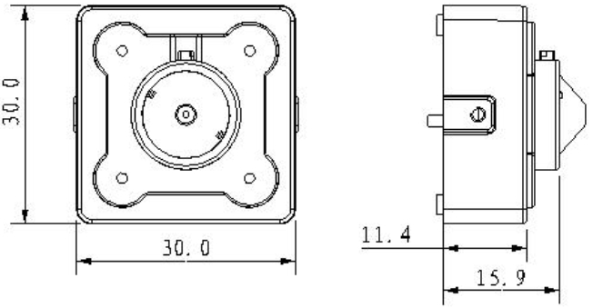

Figure 2-1
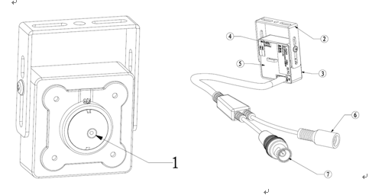

Figure 2-2

SN | Name | Function
1 | Lens | Receive optical signal in the environment
2 | Bracket | Used to fix camera
3 | Front Cover | -
4 | Reserved Audio Input Port | Can be connected to external pick-up
5 | Rear Cover | -
6 | Power Input Port | Connect DC+12V power, input power
7 | Video Output Port | BNC port, output HDCVI HD video signal, rear-end needs to connect HDCVI series DVR to control.

Installation
Important
Please make sure the installation surface can min support the 3X weight of the camera and the bracket.
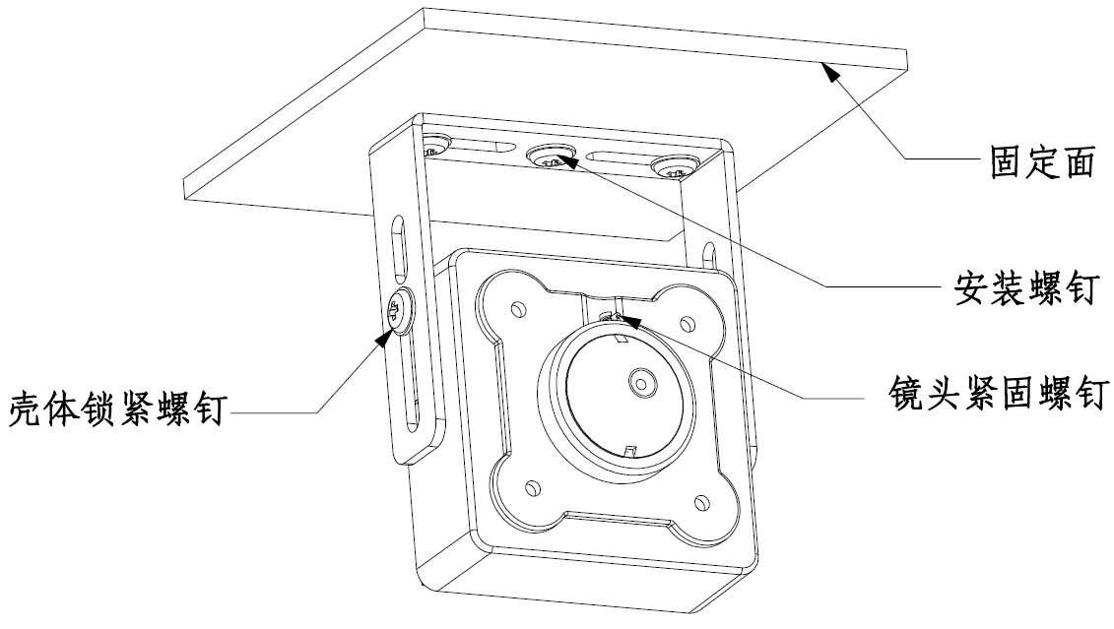
Figure 3-1
壳体锁紧螺钉: Housing Lock Screw
固定面：Fixed Surface
安装螺钉：Installation Screw
镜头紧固螺钉：Lens Fastening Screw

Step1
Install the camera and the bracket on the fixed surface and secure the installation screw.

Step 2
Adjust the camera angle and secure the housing lock screw.

Step 3
Connect the video output port of device cable with rear-end HDVR device and connect the power port of device cable to power supply.

Step 4
Adjust camera’s focal length after the rear-end HCVR displays image and secure the lens fastening screw (Generally it has been set before delivery, can be ignored)

So far, the installation is completed.

Menu

HDCVI Series DVR Settings
Note
The following operation and interfaces for reference only. Please refer to the HDCVI series DVR user’s manual for detailed information.

This HDCVI camera series can adjust OSD menu by coaxial control. After connected the camera to the HDCVI series DVR from” Main Menu-->System->PTZ”, you need to set as follows: select the access channel and select “control mode” as “HDCVI” and the “protocol” as “DH-SD1”.
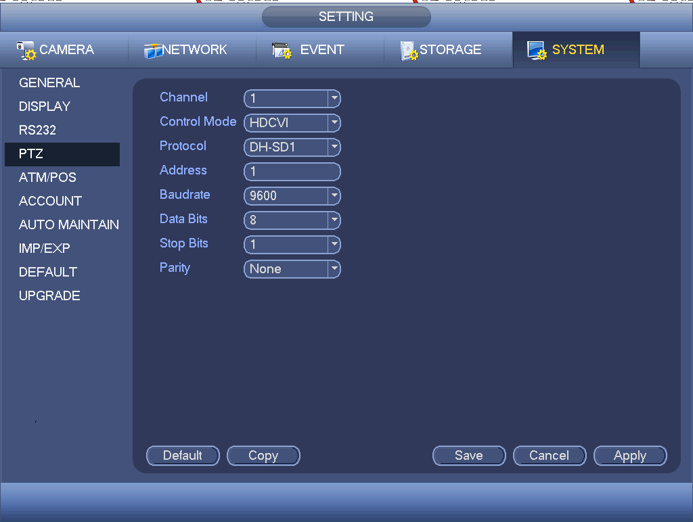
Figure 4-1
After you saved settings, right click mouse and select “PTZ Control”, then click to enter the menu. See Figure 4-2.


Figure 4-2
Single click to enter 4-direction button menu control interface.
Click up/down button to view all the items on the left pane of the following list. Click left/right button to set the corresponding values on the right pane of the following list. If there is “”, click confirm button to go to the 2nd menu. Repeat the previous steps to set detailed value. Click Return button to go back to the previous menu interface.

Menu List
The First Menu | The Second Menu
EXPOSURE | SHUTTER | AUTO，1/100,1/120,1/250，1/500,1/1000,1/2000,1/4000,1/10000,1/100000
EXPOSURE | AGC | OFF/LOW/MIDDLE/HIGH
EXPOSURE | BRIGHTNESS | 1-10
EXPOSURE | RETURN
WHITE BALANCE | MODE | INDOOR/OUTDOOR/USER/AUTO
WHITE BALANCE | R GAIN
WHITE BALANCE | B GAIN
WHITE BALANCE | RETURN
DAY&NIGHT | MODE | AUTO/SMART/COLOR/BW
DAY&NIGHT | D→N LEVEL | 1-5
DAY&NIGHT | N→D LEVEL | 1-5
DAY&NIGHT | RETURN
IMAGE SETUP | BRIGHTNESS | 1-10
IMAGE SETUP | CONTRAST | 1-10
IMAGE SETUP | COLOR GAIN | 1-10
IMAGE SETUP | SHARPNESS | 1-10
IMAGE SETUP | NR | OFF/LOW/MIDDLE/HIGH
IMAGE SETUP | MIRROR | NONE/H/V/HV
IMAGE SETUP | LANGUAGE | ENGLISH
IMAGE SETUP | RETURN
FUNC.SETUP | FLICKER | 50Hz/60Hz
FUNC.SETUP | OSD COLOR | WHITE/YELLOW/RED/GREEN
FUNC.SETUP | OSD BG | OFF/ON
FUNC.SETUP | RETURN
RESET
SAVE&EXIT

Appendix Toxic or Hazardous Materials or Elements
Component Name | Toxic or Hazardous Materials or Elements
Component Name | Pb | Hg | Cd | Cr VI | PBB | PBDE
Circuit Board Component | ○ | ○ | ○ | ○ | ○ | ○
Device Construction Material | ○ | ○ | ○ | ○ | ○ | ○
Wire and Cable | ○ | ○ | ○ | ○ | ○ | ○
Packing Components | ○ | ○ | ○ | ○ | ○ | ○
Accessories | ○ | ○ | ○ | ○ | ○ | ○

O: Indicates that the concentration of the hazardous substance in all homogeneous materials in the parts is below the relevant threshold of the SJ/T11363-2006 standard.

X: Indicates that the concentration of the hazardous substance of at least one of all homogeneous materials in the parts is above the relevant threshold of the SJ/T11363-2006 standard. During the environmental-friendly use period (EFUP) period, the toxic or hazardous substance or elements contained in products will not leak or mutate so that the use of these (substances or elements) will not result in any severe environmental pollution, any bodily injury or damage to any assets. The consumer is not authorized to process such kind of substances or elements, please return to the corresponding local authorities to process according to your local government statutes.

Note
- This manual is for reference only. Slight difference may be found in the user interface.
- All the designs and software here are subject to change without prior written notice.
- All trademarks and registered trademarks mentioned are the properties of their respective owners.
- If there is any uncertainty or controversy, please refer to the final explanation of us.
- Please visit our website or contact your local service engineer for more information.

