2 Megapixel ICR Day/Night WDR
Fixed HDCVI Camera User’s Manual

Version 1.0.0
Table of Contents
1 General Introduction 1
1.1 Overview 1
1.2 Functions 1
1.3 Specifications 1
2 Framework 4
2.1 Rear Panel 4
2.2 Side panel 5
2.3 Front Panel 5
3 Installation 7
3.1 Lens Installation 7
3.2 I/O Port Installation 8
4 Menu 9
Appendix Toxic or Hazardous Materials or Elements 13

Welcome
Thank you for purchasing our HDCVI camera!
This user’s manual is designed to be a reference tool for your system.
Please read the following safeguard and warnings carefully before you use this series product!
Please keep this user’s manual well for future reference!

Important Safeguards and Warnings
1．Electrical safety
All installation and operation here should conform to your local electrical safety codes.
The power shall conform to the requirement in the SELV (Safety Extra Low Voltage) and the Limited power source is rated 12V DC or Ac 24V in the IEC60950-1.
We assume no liability or responsibility for all the fires or electrical shock caused by improper handling or installation.

2．Transportation security
Heavy stress, violent vibration or water splash are not allowed during transportation, storage and installation.

3．Installation
Do not apply power to the camera before completing installation.
Please install the proper power cut-off device during the installation connection.
Always follow the instruction guide the manufacturer recommended.
If this product is installed in the ceiling, please make sure the installation position can sustain the min 50N.

4．Qualified engineers needed
All the examination and repair work should be done by the qualified service engineers.
We are not liable for any problems caused by unauthorized modifications or attempted repair.

5．Environment
This series HDCVI camera should be installed in a cool, dry place away from direct sunlight or strong light, inflammable, explosive substances and etc.
This series camera shall work on the specified working temperature. Please keep it away from the electromagnetic radiation object and environment.
Please make sure the CMOS component is out of the radiation of the laser beam device. Otherwise it may result in CMOS optical component damage.
Please keep the sound ventilation.
Do not allow the water and other liquid falling into the camera.

6. Accessories
Be sure to use all the accessories recommended by manufacturer.
Before installation, please open the package and check all the components are included.
Contact your local retailer ASAP if something is broken in your package.

7. Daily Maintenance
Please shut down the device and then unplug the power cable before you begin daily maintenance work.
Use the dry soft cloth to clean the device. If there is too much dust, please use the water to dilute the mild detergent first and then use it to clean the device. Finally use the dry cloth to clean the device.
Please put the dustproof cap to protect the CMOS component when you do not use the camera.

General Introduction

Overview
This series megapixel HD camera conforms to the HDCVI standard. It supports video signal high-speed long distance transmission without any delay. The HDCVI port adopts coaxial cable and uses BNC port as the standard cable.

This series product has megapixel definition. It supports DC 12V/AC 24V power supplying. It supports HDCVI HD and CVBS standard definition output, and OSD operation.

Functions
Data Transmission
It adopts coaxial cable and use BNC port as the standard cable specifications.

Peripheral Device Control
It can be controlled by the DVR conforming to the HDCVI specifications via the video coaxial cable

Power Supplying
Support external power adapter supplying. Support AC 24V/DC 12V.

Aux Function
- Auto day/night switch (With ICR switch)
- The WDR can max reach 120dB, suitable for the backlight environments.
- Support video/audio/control signal transmission over the same coaxial cable.
- General 75-3 coaxial cable supports over 300m transmission distance without any quality loss.
- Support 1920*1080@25fps, 1920*1080@30fps
- 3D NR function
- Support privacy mask function.
- Support auto iris function.
- Support OSD operation.
- HDCVI HD/standard definition output switch function.

Specifications
Please refer to the following sheet for specification.
Model  Parameter |  |  | 2 Megapixel ICR Day/Nigh WDR Fixed HDCVI Camera
 |  |  | HAC-HF3201P/N
Video | Video Processor |  | 1/3" 3.1M/Full HD CMOS
Video | Video Format |  | PAL/NTSC
Video | Sensor Pixel |  | 2048(H)×1536(V)
Video | Min Illumination |  | Color: 0.05Lux@（F1.2,AGC ON）,  Black and white: 0.001Lux@（F1.2,AGC ON）,
Video | Electronic Shutter |  | 1/1s～1/10000s@ (slow shutter*512）
Video | Video Standard |  | HDCVI/CVBS compliance
Video | Video Frame Rate |  | 1920*1080@25fps ;1920*1080@30fps
Video | Day/Night Switch |  | ICR mechanical auto switch
Video | Lens Port |  | C/CS
Video | Auto Iris |  | DC Drive
Video | WDR Range |  | 120dB
Video | Audio/Video Transmission |  | Support audio/video transmission over the same coaxial cable.
Video | Control Signal Transmission |  | Support OSD control and video transmission over the same coaxial cable.
OSD | SCENE |  | WDR/NORMAL MODE/LOW LUM
OSD | EXPOSURE |  | AUTO/AUTO IRIS/AUTO SHUTTER/MANUAL
OSD | FUNCTION |  | WB/WDR/NR/MIRROR/DAY&NIGHT/HLC/BLC
OSD | IMAGE |  | MODE/HUE CNT/SHARPNESS/SHARP CNT/BRIGHTNESS/SATURATION/HUE/GAMMA
OSD | ADVANCED |  | MOTION DETECT/PRIVACY MASK/FREEZE/ALARM MODE/RS-485/CAMERA ID/LANGUAGE/SYSTEM INFO
OSD | EXIT |  | WDR/RESTART/FORMAT/BACK
AUX Port |  | Video Output | 1-channel BNC HDCVI HD/CVBS standard definition output (Can switch)
 |  | Audio Input | 1-channel audio input port. Connect to devices such as pick up.
 |  | Standard Definition/HD Switch | Hardware button. Press for 5 seconds to switch standard definition/HD definition mode.
 |  | ICR External Trigger | External trigger signal to activate day/night mode switch.
 |  | Alarm Output | 1-channel on-off signal output. Can activate motion alarm.
 |  | RS485 port | Support OSD operation. Software online upgrade.
General |  | Power Supplying | AC 24V±10%/DC 12V±10%
 |  | Power Consumption | 8.3W Max (Input:12V0.69A/24V～0.58A)
 |  | Working Temperature /Humidity | -30℃~+60℃. Humidity is less than 95%(no condensation)
 |  | Dimension(mm) | 70×63.2×136.5
 |  | Weight | 650g
 |  | Installation Mode | Support various installation modes (Housing and bracket is optional)

Framework

Rear Panel
Please refer to the following figure for the rear panel information. See Figure 2-1.
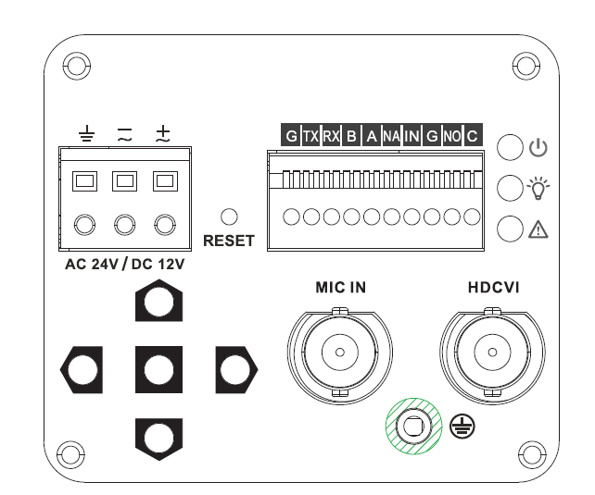
Figure 2-1
Port Name |  | Connector | Port Function
AC 24V/ DC 12V | Power port |  | - Power port.  - Connect to AC 24V/ DC 12V.
Indicator light | Red light |  | Power light. The light is on after system boots up.
Indicator light | Green light |  | Hardware indicator light. The light becomes on after system successfully loads the hardware part.
Indicator light | Yellow light |  | HD/standard definition indicator light. The light is off when system is using the HD output. The light is on when system is using standard definition.
IN | ICR external trigger |  | Connect to external on-off output to control ICR switch to realize day/night mode switch.  Please note: if you want to use this function, you need to go to the OSD menu to set the day/night mode as EXT TRIG-HIGH or EXT TRIG-LOW. The control signal shall connect to the IN and G port. For example, connect the 5V to the IN port and the day/night mode as EXT TRIG-HIGH , the camera can switch from day mode to night mode.
NO | Alarm normal open contact |  | On-off signal alarm output.
C | Alarm output public contact |  | On-off signal alarm output.
G | GND |  | Ground end.
A | RS485 port |  | RS485_A port. Connect to DVR or RS485 configuration tool to set video parameters.
B | RS485 port |  | RS485_B port. Connect to DVR or RS485 configuration tool to set video parameters.
NA | N/A |  | Reserved
RX | Reserved port |  | For R/D use only.
TX | Reserved port |  | For R/D use only.
G | Reserved port |  | For R/D use only.
RESET | Reset button |  | Press it for five seconds, system can reload again and restore factory default setup.
HDCVI | Video/audio/control composite port |  | Send video stream/audio stream/control data stream conforming to HDCVI specifications.  Please connect to the HDCVI DVR series product to control.
MIC IN | Microphone audio input |  | Audio input from the pickup.
5-direction button | OSD button |  | - Press the middle button for five seconds to switch HD/standard definition mode.  - Press the middle button shortly to go to the OSD menu interface.  - After you go to the menu, click the middle button to confirm current operation. Move the up/down button to select menu item and use left/right button to set parameter value.
 | GND port |  | Before you use this series product, please make sure it has been soundly grounded in case there is a risk of thunder strike.

Side panel
Please refer to the following figure for the rear panel information. The unit is mm. See Figure 2-2.
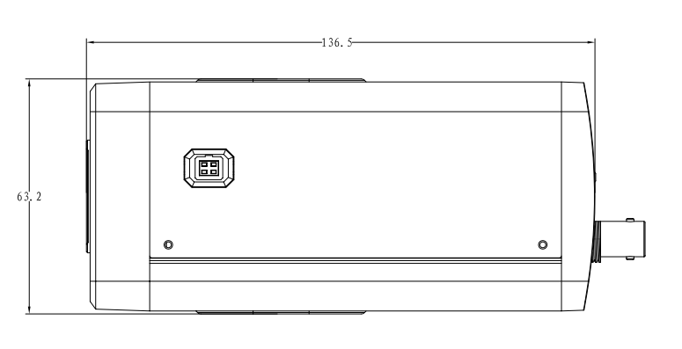
Figure 2-2

Front Panel
Please refer to the following figure for the front panel information. The unit is mm. See Figure 2-3.
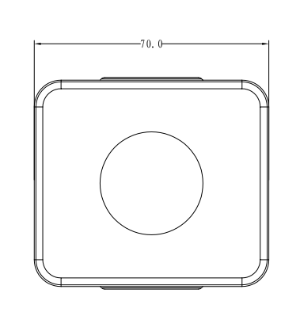
Figure 2-3

Installation
Important
- Before the installation, please make sure the installation surface can sustain at least 3X weight of the bracket and the camera.

Lens Installation
Please refer to the steps listed below for installation information. See Figure 3-4 and Figure 3-5.
- Remove the protection cap from the device. Line up the lens to the lens position of the camera (Install the C/CS adapter ring to the camera if you are using C type lens).Turn clockwise to secure the lens firmly.
- Insert the socket of the lens cable to the auto iris lens connector on the side panel of the device. Skip this step if you are using auto iris lens.
- Fasten the screw near the focusing ring and then turn counter clockwise to move the focusing ring out for several millimeters. Now you can focus manually until you get clear video.
- After you completed the focus setup, fix the screw near the focusing ring firmly. Fasten the focusing ring. Now the installation is complete.
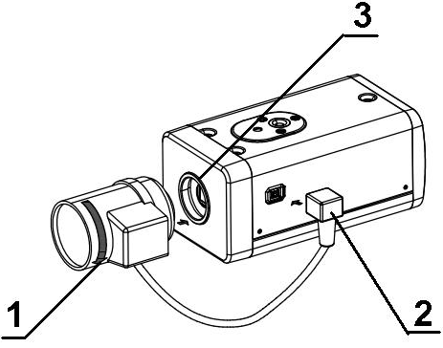
Figure 3-4
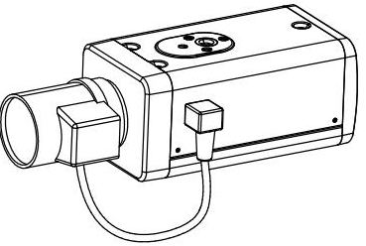
Figure 3-5

I/O Port Installation
Install Cable
Please follow the steps listed below to install the cable. See Figure 3-6.
Use the small slotted screwdriver to press the corresponding button of cable groove. Insert the cable into the groove and then release the screwdriver.
Remove Cable
Please follow the steps listed below to remove the cable.
Use the small slotted screwdriver to press the corresponding button of cable groove. Remove the cable out of the groove and then release the screwdriver.
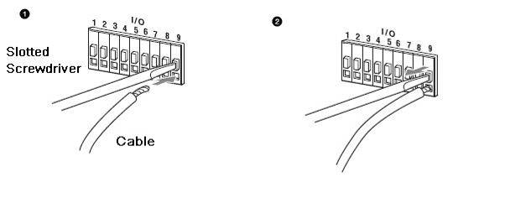
Figure 3-6

Menu
Important
Please check the current video output mode when there is no video output. The yellow light is on when system is outputting standard definition video. The yellow light is off when system is using high definition video.
THE 1ST MENU |  | THE 2ND MENU |  | THE 3RD MENU
SCENE | SCENE WDR
SCENE | SCENE NORMAL MODE
SCENE | SCENE LOW LUM
SCENE | BACK
EXPOSURE | AUTO | SHUTTER AUTO… | MAX SPEED | PAL:  1/25, 1/50, 1/75, 1/100, 1/120, 1/150, 1/215, 1/300, 1/425, 1/600, 1/1000, 1/1250, 1/1750, 1/2500, 1/3500, 1/6000, 1/10000  NTSC: 1/30,1/60,1/90,1/100,1/125,1/180,1/250,1/350,1/500,1/725,1/1000,1/1500,1/2000,1/3000,1/4000,1/6000,1/10000.
EXPOSURE | AUTO | SHUTTER AUTO… | MIN SPEED
EXPOSURE | AUTO | SHUTTER AUTO… | SLOW SHUTTER | PAL:  1/1,1/2,1/3,1/6,1/12,1/25,1/50,1/75,1/100,1/120  NTSC: 1/1, 1/2, 1/4, 1/8, 1/15, 1/30,1/60,1/90,1/100,1/125
EXPOSURE | AUTO | SHUTTER AUTO… | BACK
EXPOSURE | AUTO | GAIN | -1,0,2,4,6,8,10,12,14,16,18,20,22,24,26,28（DB）
EXPOSURE | AUTO | LENS--- | It is read-only on auto mode.
EXPOSURE | AUTO | EC | OFF,+0,+1,+2,+3,+4,+5,+6,+7,-1,-2,-3,-4,-5,-6,-7
EXPOSURE | AUTO | LLC | 0,5,10,15,20,25,30,35,40,45,50,55,60,65,70,75,80,85,90,95,100
EXPOSURE | AUTO | BACK
EXPOSURE | IRIS | SHUTTER | PAL:  1/25, 1/50, 1/75, 1/100, 1/120, 1/150, 1/215, 1/300, 1/425, 1/600, 1/1000, 1/1250, 1/1750, 1/2500, 1/3500, 1/6000, 1/10000  NTSC:  1/30,1/60,1/90,1/100,1/125,1/180,1/250,1/350,1/500,1/725,1/1000,1/1500,1/2000,1/3000,1/4000,1/6000,1/10000.
EXPOSURE | IRIS | GAIN | -1,0,2,4,6,8,10,12,14,16,18,20,22,24,26,28（DB）
EXPOSURE | IRIS | LENS | It is read-only on auto iris mode.
EXPOSURE | IRIS | EC | OFF,+0,+1,+2,+3,+4,+5,+6,+7,-1,-2,-3,-4,-5,-6,-7
EXPOSURE | IRIS | LLC | 0,5,10,15,20,25,30,35,40,45,50,55,60,65,70,75,80,85,90,95,100
EXPOSURE | IRIS | BACK
EXPOSURE | SHUTTER | SHUTTER AUTO… | MAX SPEED | PAL:  1/25, 1/50, 1/75, 1/100, 1/120, 1/150, 1/215, 1/300, 1/425, 1/600, 1/1000, 1/1250, 1/1750, 1/2500, 1/3500, 1/6000, 1/10000  NTSC: 1/30,1/60,1/90,1/100,1/125,1/180,1/250,1/350,1/500,1/725,1/1000,1/1500,1/2000,1/3000,1/4000,1/6000,1/10000.
EXPOSURE | SHUTTER | SHUTTER AUTO… | MIN SPEED
EXPOSURE | SHUTTER | SHUTTER AUTO… | SLOW SHUTTER | PAL:  1/1,1/2,1/3,1/6,1/12,1/25,1/50,1/75,1/100,1/120  NTSC: 1/1, 1/2, 1/4, 1/8, 1/15, 1/30,1/60,1/90,1/100,1/125
EXPOSURE | SHUTTER | SHUTTER AUTO… | BACK
EXPOSURE | SHUTTER | GAIN | -1,0,2,4,6,8,10,12,14,16,18,20,22,24,26,28（DB）
EXPOSURE | SHUTTER | LENS | It is read-only on auto shutter mode.
EXPOSURE | SHUTTER | EC | OFF,+0,+1.+2,+3,+4,+5,+6,+7,-1,-2,-3,-4,-5,-6,-7
EXPOSURE | SHUTTER | LLC | 0,5,10,15,20,25,30,35,40,45,50,55,60,65,70,75,80,85,90,95,100
EXPOSURE | SHUTTER | BACK
EXPOSURE | MANUAL | SHUTTER | PAL:  1/25, 1/50, 1/75, 1/100, 1/120, 1/150, 1/215, 1/300, 1/425, 1/600, 1/1000, 1/1250, 1/1750, 1/2500, 1/3500, 1/6000, 1/10000  NTSC: 1/30,1/60,1/90,1/100,1/125,1/180,1/250,1/350,1/500,1/725,1/1000,1/1500,1/2000,1/3000,1/4000,1/6000,1/10000.
EXPOSURE | MANUAL | GAIN | -1,0,2,4,6,8,10,12,14,16,18,20,22,24,26,28（DB）
EXPOSURE | MANUAL | LENS | MODE OPEN, MODE OFF
EXPOSURE | MANUAL | EC | It is read-only on manual mode.
EXPOSURE | MANUAL | LLC | It is read-only on manual mode.
EXPOSURE | MANUAL | BACK
FUNCTION | WB | AUTO
FUNCTION | WB | INDOOR
FUNCTION | WB | OUTDOOR
FUNCTION | WB | ONE PUSH
FUNCTION | WB | ATW
FUNCTION | WB | MANUAL… | RED GAIN | 000-255
FUNCTION | WB | MANUAL… | BLUE GAIN | 000-255
FUNCTION | WB | OUTDOOR AUTO
FUNCTION | WB | SODIUM AUTO
FUNCTION | WB | SODIUM
FUNCTION | WDR | OFF
FUNCTION | WDR | ON… | INTENSITY | 1-5
FUNCTION | WDR | ON… | MOTION COMP
FUNCTION | WDR | ON… | RETURN
FUNCTION | NR… | 2D-NR | OFF, 1-5
FUNCTION | NR… | 3D-NR | OFF, 1-5
FUNCTION | NR… | BACK
FUNCTION | MIRROR | OFF, V-FLI,H-FLIP, CENTRE
FUNCTION | D/N | AUTO … | SWITCH POINT | 1-7
FUNCTION | D/N | AUTO … | TOLERANCE | 1-6
FUNCTION | D/N | AUTO … | DAYàNIGHT | 2S-30S
FUNCTION | D/N | AUTO … | NIGHT àDAY | 2S-30S
FUNCTION | D/N | AUTO … | BACK
FUNCTION | D/N | DAY
FUNCTION | D/N | NIGHT
FUNCTION | D/N | EXT TRIG-HIGH
FUNCTION | D/N | EXT TRIG-LOW
FUNCTION | HLC | OFF, 1, 2
FUNCTION | BLC | OFF,1, 2
FUNCTION | BACK
IMAGE | MODE | CUSTOM , FLAMBOYANT,SOFT,  Note: For non-custom mode, the rest parameters are read-only.
IMAGE | HUE CNT | 00~15
IMAGE | SHARPNESS | 00~15
IMAGE | SHARP CNT | 00~15
IMAGE | BRIGHT | 000~255
IMAGE | SATURATION | 000~255
IMAGE | HUE | 000~255
IMAGE | GAMMA | 00~15
IMAGE | BACK
ADVANCED | MOTION DETECT… | SN | 1-4
ADVANCED | MOTION DETECT… | ON/OFF | ON/OFF
ADVANCED | MOTION DETECT… | DISPLAY | ON/OFF
ADVANCED | MOTION DETECT… | SENSITIVITY | 00~99
ADVANCED | MOTION DETECT… | AREA LOCATION … | LC | （0-23,0-15）
ADVANCED | MOTION DETECT… | AREA LOCATION … | SZ | （0-23,0-15）
ADVANCED | MOTION DETECT… | BACK
ADVANCED | PRIVACY MASK … | INDEX | 0-7
ADVANCED | PRIVACY MASK … | N/F | ON/OFF
ADVANCED | PRIVACY MASK … | CENTRE SET…
ADVANCED | PRIVACY MASK … | SIZE SET…
ADVANCED | PRIVACY MASK … | COLOR | BLUE
ADVANCED | PRIVACY MASK … | BACK
ADVANCED | FREEZE | ON,OFF
ADVANCED | ALARM MODE… | TYPE | MOTION DETECT
ADVANCED | ALARM MODE… | MODE | ON/OFF
ADVANCED | ALARM MODE… | INTERVAL | CLOSE，1S-255S
ADVANCED | NEXT…
ADVANCED | RS-485… | Support PELCO-D/P, DH-SD protocol.
ADVANCED | RS-485… | BAUD RATE | 1200-9600
ADVANCED | RS-485… | ADDRESS | 001-254
ADVANCED | RS-485… | BACK
ADVANCED | CAMERA ID | OFF
ADVANCED | CAMERA ID | ON… | CAMERA ID | 1-254
ADVANCED | CAMERA ID | BACK
ADVANCED | LANGUAGE | ENGLISH
ADVANCED | SYSTEM INFO… | MANUFACTURER | xxx
ADVANCED | SYSTEM INFO… | HARDWARE | XXX
ADVANCED | SYSTEM INFO… | SOFTWARE | XXX
ADVANCED | SYSTEM INFO… | BACK
ADVANCED | PREVIOUS …
ADVANCED | BACK
EXIT | WDR | CANCEL, SAVE，DEFAULT，RESET
EXIT | RESTART…
EXIT | FORMAT | 1080@25…，1080@30…
EXIT | BACK

Appendix Toxic or Hazardous Materials or Elements
Component Name | Toxic or Hazardous Materials or Elements
Component Name | Pb | Hg | Cd | Cr VI | PBB | PBDE
Circuit Board Component | ○ | ○ | ○ | ○ | ○ | ○
Device Construction Material | ○ | ○ | ○ | ○ | ○ | ○
Wire and Cable | ○ | ○ | ○ | ○ | ○ | ○
Packing Components | ○ | ○ | ○ | ○ | ○ | ○
Accessories | ○ | ○ | ○ | ○ | ○ | ○

O: Indicates that the concentration of the hazardous substance in all homogeneous materials in the parts is below the relevant threshold of the SJ/T11363-2006 standard.

X: Indicates that the concentration of the hazardous substance of at least one of all homogeneous materials in the parts is above the relevant threshold of the SJ/T11363-2006 standard. During the environmental-friendly use period (EFUP) period, the toxic or hazardous substance or elements contained in products will not leak or mutate so that the use of these (substances or elements) will not result in any severe environmental pollution, any bodily injury or damage to any assets. The consumer is not authorized to process such kind of substances or elements, please return to the corresponding local authorities to process according to your local government statutes.

Note
- This manual is for reference only. Slight difference may be found in the user interface.
- All the designs and software here are subject to change without prior written notice.
- All trademarks and registered trademarks mentioned are the properties of their respective owners.
- If there is any uncertainty or controversy, please refer to the final explanation of us.
- Please visit our website or contact your local service engineer for more information.

