2 Megapixel HDCVI (IR) WDR Varifocal Vandal Proof Dome Camera
User’s Manual

Version 1.0.0
Table of Contents
1 General Introduction 1
1.1 Features 1
1.2 Functions 1
2 Device Framework 3
2.1 Dimensions 3
3 Installation 5
4 Menu 7
5 Technical Specifications 10
Appendix Toxic or Hazardous Materials or Elements 12

Welcome
Thank you for purchasing our HDCVI camera!
This user’s manual is designed to be a reference tool for your system.
Please read the following safeguard and warnings carefully before you use this series product!
Please keep this user’s manual well for future reference!

Important Safeguards and Warnings
1．Electrical safety
All installation and operation here should conform to your local electrical safety codes.
The power shall conform to the requirement in the SELV (Safety Extra Low Voltage) and the Limited power source is rated 12V DC in the IEC60950-1.
We assume no liability or responsibility for all the fires or electrical shock caused by improper handling or installation.

2．Transportation security
Heavy stress, violent vibration or water splash are not allowed during transportation, storage and installation.

3．Installation
Do not apply power to the camera before completing installation.
Please install the proper power cut-off device during the installation connection.
Always follow the instruction guide the manufacturer recommended.
If this product is installed in the ceiling, please make sure the installation position can sustain the min 50N.

4．Qualified engineers needed
All the examination and repair work should be done by the qualified service engineers.
We are not liable for any problems caused by unauthorized modifications or attempted repair.

5．Environment
This series HDCVI camera should be installed in a cool, dry place away from direct sunlight or strong light, inflammable, explosive substances and etc.
This series camera shall work on the specified working temperature. Please keep it away from the electromagnetic radiation object and environment.
Please make sure the CMOS component is out of the radiation of the laser beam device. Otherwise it may result in CMOS optical component damage.
Please keep the sound ventilation.
Do not allow the water and other liquid falling into the camera.

6. Accessories
Be sure to use all the accessories recommended by manufacturer.
Before installation, please open the package and check all the components are included.
Contact your local retailer ASAP if something is broken in your package.

7. Daily Maintenance
Please shut down the device and then unplug the power cable before you begin daily maintenance work.
Use the dry soft cloth to clean the device. If there is too much dust, please use the water to dilute the mild detergent first and then use it to clean the device. Finally use the dry cloth to clean the device.
Please put the dustproof cap to protect the CMOS component when you do not use the camera.

General Introduction

Features
This series HDCVI HD coaxial camera conforms to the Dahua HDCVI standard. It supports video signal high-speed long distance transmission without any delay. It can be controlled by the DVR conforming to the HDCVI. This series of camera has the following features:

- High-performance CMOS image sensor, megapixel definition.
- Support manual lens zoom and focus.
- Support HD video, control signal coaxial transmission
- Support 75-3 coaxial cable transmission without any loss. Transmission distance is over 300m.
- Support HDCVI HD and analog standard definition switch output.
- Support 1920×1080@25fps、1920×1080@30fps
- Adopt high performance 3D noise reduction.
- High speed, long distance real-time transmission.
- Support ICR switch to realize surveillance both in the daytime and at night.
- Support privacy masking, motion detect and etc.
- High degree of image color rendition, clear image
- The WDR can max reach 120dB, suitable for the backlight environments.
- Support OSD menu and adjust parameter.
- Support intelligent IR function. Max 20m IR distance. (Not supported by HAC-HDB3201EP/N )
- IP66, IK10 compliance.
- Support AC24V/DC12V power supply.

Functions
HDCVI Specification
HDCVI（High Definition Composite Video Interface） is an over-coaxial –cable HD video transmission standard. The technology renders two HD video formats by progressive scanning.

WDR
When high brightness area under strong light source and relatively low brightness area such as shadow, backlight exist at the same time, the camera output image will appear bright area which will turn to white due to overexposure, but the dark area will turn to black due to insufficient exposure, which seriously affect image quality. WDR is a kind of technology which is applied to make the particularly bright part and particularly dark part in the scenario seen clearly at the same time.

3D NR
Comparing with the general 2D denoise function, the 3D denoise function can not only denoise the brightness of the video separation signal and saturation signal, it can also denoise the original data from CCD. It greatly enhances noise reduction performance and guarantees clear and bright video

Device Framework

Dimensions
Please refer to the following figure for dimension information. The unit is mm. See Figure 2-1.
The following introduction is based on the HAC-HDB（W）3201EP/N series product.
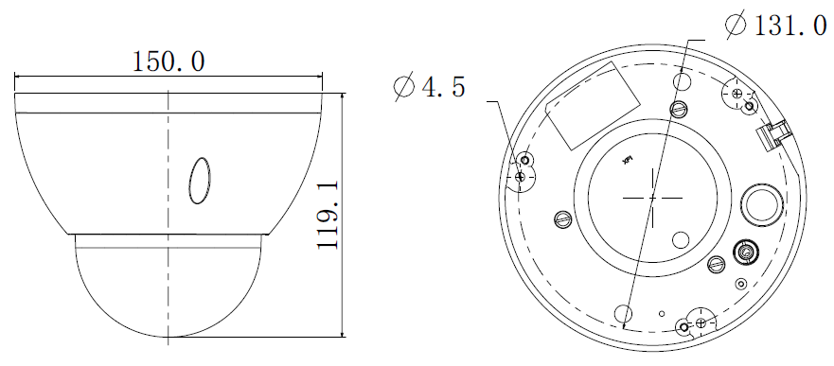
Figure 2-1
Please refer to the following figure for structure information. See Figure 2-2.
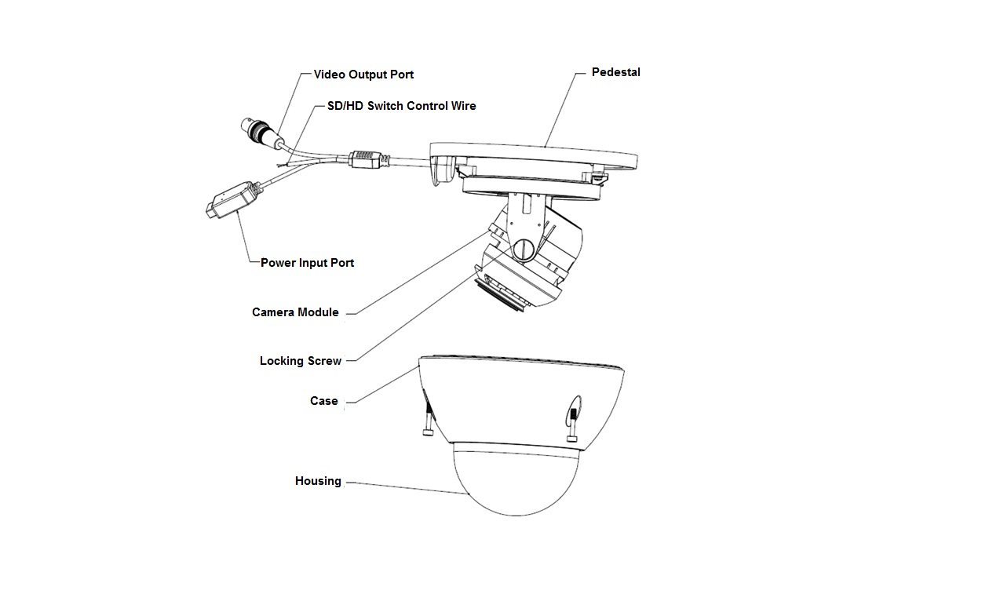
Figure 2-2
When the SD/HD switch control wire is short circuit, the device will switch to SD video output. On the contrary, the device will switch to HD video output when the control wire is open circuit.

Installation
Important
- Before the installation, please make sure the installation surface can sustain at least 3X weight of the bracket and the camera.

The dome camera usually uses the ceiling installation. It can be installed on the ceiling or the wall.
- For side exit cable installation, please make sure the side exit cable direction is the same as shown in the installation position map.
- Before you secure the screws on the pedestal, please put the cable through the cable exit of the pedestal.
- Before you complete the installation and debug, do not remove the electrostatic film. After you remove the film, do not touch the enclosure in case there is any scratch.
All figures listed below are bases on the HAC-HDB（W）3201EP/N series product.

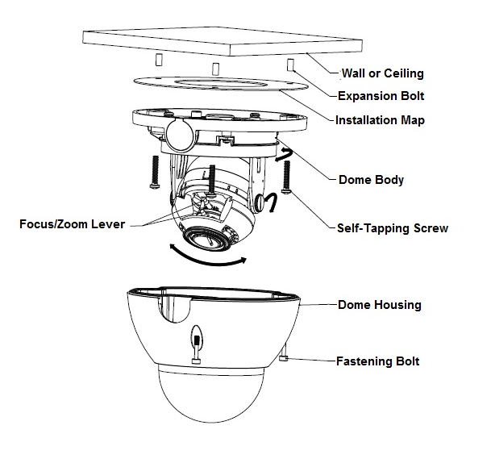
Figure 3-3

Step 1
Take the installation position map from the accessories bag and then put it on the surface of the ceiling or the wall according to the cable exit position. Dig three holes according to the installation position map and then take three expansion bolts from the accessories bag and put them to the holes you just dug.

Step 2
Rive three housing locking screws by socket head wrench, and remove the enclosure.

Step 3
Adjust the pedestal position according to the cable exit mode (ceiling/side). Pull the cable through the cable side exit at the installation surface and the pedestal (Please skip this step if you want to use ceiling exit mode). Line up the screw holes at the bottom of the pedestal to the expansion bolts in the installation surface. Put three self-tapping screws to expansion bolts and then secure firmly. Now the pedestal is on the installation surface.

Step 4
Connect the device video output port to back-end HDCVI series DVR, and then connect the power cable to the device.

Step 5
After you can view the image on the HDCVI series DVR, adjust the focus/zoom lever to set focus to get a clear image, and secure the lever. Adjust the lens angle to a proper position and then fix the screws to fasten the lens. See figure 3-1.

Step 6
Fix the dome housing to the pedestal by three housing locking screws.

Now you have completed the device installation and cable connection, you can use the terminal encode devices to view the monitor video.

Menu

THE 1ST MENU |  | THE 2ND MENU |  | THE 3RD MENU
SCENE | SCENE WDR
SCENE | SCENE NORMAL MODE
SCENE | SCENE LOW LUM
SCENE | BACK
EXPOSURE | AUTO | SHUTTER AUTO… | MAX SPEED | PAL:  1/25, 1/50, 1/75, 1/100, 1/120, 1/150, 1/215, 1/300, 1/425, 1/600, 1/1000, 1/1250, 1/1750, 1/2500, 1/3500, 1/6000, 1/10000  NTSC: 1/30,1/60,1/90,1/100,1/125,1/180,1/250,1/350,1/500,1/725,1/1000,1/1500,1/2000,1/3000,1/4000,1/6000,1/10000.
EXPOSURE | AUTO | SHUTTER AUTO… | MIN SPEED
EXPOSURE | AUTO | SHUTTER AUTO… | SLOW SHUTTER | PAL:  1/1,1/2,1/3,1/6,1/12,1/25,1/50,1/75,1/100,1/120  NTSC: 1/1, 1/2, 1/4, 1/8, 1/15, 1/30,1/60,1/90,1/100,1/125
EXPOSURE | AUTO | SHUTTER AUTO… | BACK
EXPOSURE | AUTO | GAIN | -1,0,2,4,6,8,10,12,14,16,18,20,22,24,26,28（DB）
EXPOSURE | AUTO | LENS--- | It is read-only on auto mode.
EXPOSURE | AUTO | EC | OFF,+0,+1,+2,+3,+4,+5,+6,+7,-1,-2,-3,-4,-5,-6,-7
EXPOSURE | AUTO | LLC | 0,5,10,15,20,25,30,35,40,45,50,55,60,65,70,75,80,85,90,95,100
EXPOSURE | AUTO | BACK
EXPOSURE | IRIS | SHUTTER | PAL:  1/25, 1/50, 1/75, 1/100, 1/120, 1/150, 1/215, 1/300, 1/425, 1/600, 1/1000, 1/1250, 1/1750, 1/2500, 1/3500, 1/6000, 1/10000  NTSC:  1/30,1/60,1/90,1/100,1/125,1/180,1/250,1/350,1/500,1/725,1/1000,1/1500,1/2000,1/3000,1/4000,1/6000,1/10000.
EXPOSURE | IRIS | GAIN | -1,0,2,4,6,8,10,12,14,16,18,20,22,24,26,28（DB）
EXPOSURE | IRIS | LENS | It is read-only on auto iris mode.
EXPOSURE | IRIS | EC | OFF,+0,+1,+2,+3,+4,+5,+6,+7,-1,-2,-3,-4,-5,-6,-7
EXPOSURE | IRIS | LLC | 0,5,10,15,20,25,30,35,40,45,50,55,60,65,70,75,80,85,90,95,100
EXPOSURE | IRIS | BACK
EXPOSURE | SHUTTER | SHUTTER AUTO… | MAX SPEED | PAL:  1/25, 1/50, 1/75, 1/100, 1/120, 1/150, 1/215, 1/300, 1/425, 1/600, 1/1000, 1/1250, 1/1750, 1/2500, 1/3500, 1/6000, 1/10000  NTSC: 1/30,1/60,1/90,1/100,1/125,1/180,1/250,1/350,1/500,1/725,1/1000,1/1500,1/2000,1/3000,1/4000,1/6000,1/10000.
EXPOSURE | SHUTTER | SHUTTER AUTO… | MIN SPEED
EXPOSURE | SHUTTER | SHUTTER AUTO… | SLOW SHUTTER | PAL:  1/1,1/2,1/3,1/6,1/12,1/25,1/50,1/75,1/100,1/120  NTSC: 1/1, 1/2, 1/4, 1/8, 1/15, 1/30,1/60,1/90,1/100,1/125
EXPOSURE | SHUTTER | SHUTTER AUTO… | BACK
EXPOSURE | SHUTTER | GAIN | -1,0,2,4,6,8,10,12,14,16,18,20,22,24,26,28（DB）
EXPOSURE | SHUTTER | LENS | It is read-only on auto shutter mode.
EXPOSURE | SHUTTER | EC | OFF,+0,+1.+2,+3,+4,+5,+6,+7,-1,-2,-3,-4,-5,-6,-7
EXPOSURE | SHUTTER | LLC | 0,5,10,15,20,25,30,35,40,45,50,55,60,65,70,75,80,85,90,95,100
EXPOSURE | SHUTTER | BACK
EXPOSURE | MANUAL | SHUTTER | PAL:  1/25, 1/50, 1/75, 1/100, 1/120, 1/150, 1/215, 1/300, 1/425, 1/600, 1/1000, 1/1250, 1/1750, 1/2500, 1/3500, 1/6000, 1/10000  NTSC: 1/30,1/60,1/90,1/100,1/125,1/180,1/250,1/350,1/500,1/725,1/1000,1/1500,1/2000,1/3000,1/4000,1/6000,1/10000.
EXPOSURE | MANUAL | GAIN | -1,0,2,4,6,8,10,12,14,16,18,20,22,24,26,28（DB）
EXPOSURE | MANUAL | LENS | MODE OPEN, MODE OFF
EXPOSURE | MANUAL | EC | It is read-only on manual mode.
EXPOSURE | MANUAL | LLC | It is read-only on manual mode.
EXPOSURE | MANUAL | BACK
FUNCTION | WB | AUTO
FUNCTION | WB | INDOOR
FUNCTION | WB | OUTDOOR
FUNCTION | WB | ONE PUSH
FUNCTION | WB | ATW
FUNCTION | WB | MANUAL… | RED GAIN | 000-255
FUNCTION | WB | MANUAL… | BLUE GAIN | 000-255
FUNCTION | WB | OUTDOOR AUTO
FUNCTION | WB | SODIUM AUTO
FUNCTION | WB | SODIUM
FUNCTION | WDR | OFF
FUNCTION | WDR | ON… | INTENSITY | 1-5
FUNCTION | WDR | ON… | MOTION COMP
FUNCTION | WDR | ON… | RETURN
FUNCTION | NR… | 2D-NR | OFF, 1-5
FUNCTION | NR… | 3D-NR | OFF, 1-5
FUNCTION | NR… | BACK
FUNCTION | MIRROR | OFF, V-FLI,H-FLIP, CENTRE
FUNCTION | D/N | AUTO … | SWITCH POINT | 1-7
FUNCTION | D/N | AUTO … | TOLERANCE | 1-6
FUNCTION | D/N | AUTO … | DAYàNIGHT | 2S-30S
FUNCTION | D/N | AUTO … | NIGHT àDAY | 2S-30S
FUNCTION | D/N | AUTO … | BACK
FUNCTION | D/N | DAY
FUNCTION | D/N | NIGHT
FUNCTION | D/N | EXT TRIG-HIGH
FUNCTION | D/N | EXT TRIG-LOW
FUNCTION | HLC | OFF, 1, 2
FUNCTION | BLC | OFF,1, 2
FUNCTION | BACK
IMAGE | MODE | CUSTOM , FLAMBOYANT,SOFT,  Note: For non-custom mode, the rest parameters are read-only.
IMAGE | HUE CNT | 00~15
IMAGE | SHARPNESS | 00~15
IMAGE | SHARP CNT | 00~15
IMAGE | BRIGHT | 000~255
IMAGE | SATURATION | 000~255
IMAGE | HUE | 000~255
IMAGE | GAMMA | 00~15
IMAGE | BACK
ADVANCED | MOTION DETECT… | SN | 1-4
ADVANCED | MOTION DETECT… | ON/OFF | ON/OFF
ADVANCED | MOTION DETECT… | DISPLAY | ON/OFF
ADVANCED | MOTION DETECT… | SENSITIVITY | 00~99
ADVANCED | MOTION DETECT… | AREA LOCATION … | LC | （0-23,0-15）
ADVANCED | MOTION DETECT… | AREA LOCATION … | SZ | （0-23,0-15）
ADVANCED | MOTION DETECT… | BACK
ADVANCED | PRIVACY MASK … | INDEX | 0-7
ADVANCED | PRIVACY MASK … | N/F | ON/OFF
ADVANCED | PRIVACY MASK … | CENTRE SET…
ADVANCED | PRIVACY MASK … | SIZE SET…
ADVANCED | PRIVACY MASK … | COLOR | BLUE
ADVANCED | PRIVACY MASK … | BACK
ADVANCED | FREEZE | ON,OFF
ADVANCED | ALARM MODE… | TYPE | MOTION DETECT
ADVANCED | ALARM MODE… | MODE | ON/OFF
ADVANCED | ALARM MODE… | INTERVAL | CLOSE，1S-255S
ADVANCED | NEXT…
ADVANCED | RS-485… | Support PELCO-D/P, DH-SD protocol.
ADVANCED | RS-485… | BAUD RATE | 1200-9600
ADVANCED | RS-485… | ADDRESS | 001-254
ADVANCED | RS-485… | BACK
ADVANCED | CAMERA ID | OFF
ADVANCED | CAMERA ID | ON… | CAMERA ID | 1-254
ADVANCED | CAMERA ID | BACK
ADVANCED | LANGUAGE | ENGLISH
ADVANCED | SYSTEM INFO… | MANUFACTURER | xxx
ADVANCED | SYSTEM INFO… | HARDWARE | XXX
ADVANCED | SYSTEM INFO… | SOFTWARE | XXX
ADVANCED | SYSTEM INFO… | BACK
ADVANCED | PREVIOUS …
ADVANCED | BACK
EXIT | WDR | CANCEL, SAVE，DEFAULT，RESET
EXIT | RESTART…
EXIT | FORMAT | 1080@25…，1080@30…
EXIT | BACK

Technical Specifications
Model  Parameter |  | HAC-HDB3201EP/N | HAC-HDBW3201EP/N
Video Processor |  | 1/3" 3.1M/Full HD CMOS
Video Format |  | PAL/NTSC
Effective Pixel |  | 2048(H) ×1536(V)
Min Illumination |  | Color：0.05Lux@（F1.2，AGC ON）  Black and white:0.001Lux@(F1.2,AGC ON) | 0.05Lux@（F1.2，AGC ON），0 Lux with IR
Electronic Shutter |  | 1/1s～1/10000s@ (slow shutter*512）
Video Standard |  | HDCVI/CVBS compliance
Video Frame Rate |  | 1920×1080@25fps；1920×1080@30fps
Lens Port |  | Φ14
Lens Type |  | 2.8mm～12mm @ F1.4 Auto Iris Manual-focus lens
Day/Night Switch |  | ICR mechanical auto switch
Video Output |  | 1-channel HDCVI high definition video output/ CVBS standard definition video output (Can switch.)
Denoise (Noise Reduction) |  | Support 2D/3D denoise.
OSD Menu Control |  | Support coaxial control
OSD | SCENE | WDR/NORMAL MODE/LOW LUM
OSD | EXPOSURE | AUTO/AUTO IRIS/AUTO SHUTTER/MANUAL
OSD | FUNCTION | WB/WDR/NR/MIRROR/DAY&NIGHT/HLC/BLC
OSD | IMAGE | MODE/HUE CNT/SHARPNESS/SHARP CNT/BRIGHTNESS/SATURATION/HUE/GAMMA
OSD | ADVANCED | MOTION DETECT/PRIVACY MASK/FREEZE/ALARM MODE/RS-485/CAMERA ID/LANGUAGE/SYSTEM INFO
OSD | EXIT | WDR/RESTART/FORMAT/BACK
Max IR Distance |  | N/A | 20m
Transmission Distance |  | Over 300m via 75-3 coaxial cable.
Protection Level |  | IP66
Vandal Proof |  | IK10
Working Temperature /Humidity |  | -30℃~+60℃. Humidity is less than 95%(no condensation)
Power |  | AC 24V±10%/DC 12V±10%
Power Consumption |  | 6.6W MAX（Input：12V0.55A/24V～0.44A） | 10.2W MAX（Input：12V0.85A/24V～0.60A）
Dimension(mm) |  | Φ150.0×119.1
Weight |  | 800g
Angle Adjustment |  | Pan: 0°～360°: Tilt: 0°～90°: Flip: 0°～360°
Installation Mode |  | Wall mount/in ceiling mount

Appendix Toxic or Hazardous Materials or Elements
Component Name | Toxic or Hazardous Materials or Elements
Component Name | Pb | Hg | Cd | Cr VI | PBB | PBDE
Circuit Board Component | ○ | ○ | ○ | ○ | ○ | ○
Device Construction Material | ○ | ○ | ○ | ○ | ○ | ○
Wire and Cable | ○ | ○ | ○ | ○ | ○ | ○
Packing Components | ○ | ○ | ○ | ○ | ○ | ○
Accessories | ○ | ○ | ○ | ○ | ○ | ○

O: Indicates that the concentration of the hazardous substance in all homogeneous materials in the parts is below the relevant threshold of the SJ/T11363-2006 standard.

X: Indicates that the concentration of the hazardous substance of at least one of all homogeneous materials in the parts is above the relevant threshold of the SJ/T11363-2006 standard. During the environmental-friendly use period (EFUP) period, the toxic or hazardous substance or elements contained in products will not leak or mutate so that the use of these (substances or elements) will not result in any severe environmental pollution, any bodily injury or damage to any assets. The consumer is not authorized to process such kind of substances or elements, please return to the corresponding local authorities to process according to your local government statutes.

Note
- This manual is for reference only. Slight difference may be found in the user interface.
- All the designs and software here are subject to change without prior written notice.
- All trademarks and registered trademarks mentioned are the properties of their respective owners.
- If there is any uncertainty or controversy, please refer to the final explanation of us.
- Please visit our website or contact your local service engineer for more information.

