HDCVI HD ICR Varifocal (IR) Vandalproof
Analog Dome Camera
User’s Manual

Version 1.0.0
Table of Contents
1 General Introduction 1
1.1 Overview 1
1.2 Features 1
1.3 Functions 1
1.4 Specifications 1
2 Framework 3
2.1 Dimensions 3
2.2 Structure 3
3 Installation 7
3.1 Device Installation Introduction 7
3.2 Device Installation Steps 8
3.2.1 General Installation 8
3.2.2 Manual Varifocal Lens Operation 11
3.2.3 Side Cable Exit 12
3.2.4 Cable Connection 13
4 Menu 14
Appendix Toxic or Hazardous Materials or Elements 17

Welcome
Thank you for purchasing our analog camera!
This user’s manual is designed to be a reference tool for your system.
Please read the following safeguard and warnings carefully before you use this series product!
Please keep this user’s manual well for future reference!

Important Safeguards and Warnings
1．Electrical safety
All installation and operation here should conform to your local electrical safety codes.
The power shall conform to the requirement in the SELV (Safety Extra Low Voltage) and the Limited power source is rated 12V DC (24V AC) in the IEC60950-1.
We assume no liability or responsibility for all the fires or electrical shock caused by improper handling or installation.

2．Transportation security
Heavy stress, violent vibration or water splash are not allowed during transportation, storage and installation.

3．Installation
Do not apply power to the camera before completing installation.
Please install the proper power cut-off device during the installation connection.
Always follow the instruction guide the manufacturer recommended.
If this product is installed in the ceiling, please make sure the installation position can sustain the min 50N.

4．Qualified engineers needed
All the examination and repair work should be done by the qualified service engineers.
We are not liable for any problems caused by unauthorized modifications or attempted repair.

5．Environment
This series analog camera should be installed in a cool, dry place away from direct sunlight or strong light, inflammable, explosive substances and etc.
The working temperature ranges from -30℃ to +60℃. Please keep it away from the electromagnetic radiation object and environment.
Please make sure the CMOS component is out of the radiation of the laser beam device. Otherwise it may result in CMOS optical component damage.
Please keep the sound ventilation.
Do not allow the water and other liquid falling into the camera.

6. Accessories
Be sure to use all the accessories recommended by manufacturer.
Before installation, please open the package and check all the components are included.
Contact your local retailer ASAP if something is broken in your package.

7. Daily Maintenance
Please shut down the device and then unplug the power cable before you begin daily maintenance work.
Use the dry soft cloth to clean the device. If there is too much dust, please use the water to dilute the mild detergent first and then use it to clean the device. Finally use the dry cloth to clean the device.
Please put the dustproof cap to protect the CMOS component when you do not use the camera.

General Introduction

Overview
This series megapixel analog HD camera conforms to the HDCVI standard. It supports video signal high-speed long distance transmission without any delay. It can be controlled by the DVR conforming to the HDCVI.

Features
- High-performance image sensor, megapixel definition.
- HDCVI analog port, support 75-3 coaxial transmission without any loss. 720P resolution supports over 500m and 1080P supports as long as 300m.
- High speed, long distance real-time transmission.
- Support HD video/audio, 485 control signal coaxial transmission.
- Support OSD (on-screen display), suitable for user self-defined setup.
- Support IO alarm, RS-485 control.
- Support privacy mask, image digital zoom.
- Support DC12V/AC24V power supplying.
- Support 3D noise reduction(denoise),excellent performance in low illumination environment.
- IP66 compliance.
- Support ICR switch to realize surveillance both in the daytime and at night.
- Support IR function. (For IR series product only.)

Functions
HDCVI Specification
HDCVI（High Definition Composite Video Interface） is an over-coaxial –cable analog HD video transmission standard. The technology renders two HD video formats: 1920H (1920*1080) &1280H (1280*720) by progressive scanning.

OSD
User-friendly on-screen display for you to select the different functions.

RS-485
Can connect to peripheral device via 485 serial port. Support various control protocols to realize rear-end device activation.

ICR
The IR cut removal is to filter the IR light in the daytime and then auto switch to the general fitter at night. This function allows the camera to output the high sensitivity and clear video.

Specifications
Please refer to the following sheet for specification.
Model  Parameter |  | HDCVI HD Megapixel ICR Varifocal (IR) Vandalproof Analog Dome Camera
 |  | HAC-HDB3100P/N-2812AI | HAC-HDBW3100P/N-IR2-2812AI | HAC-HDB3200P/N-3312AI | HAC-HDBW3200P/N-IR2-3312AI
Video Processor |  | 1/3"-inch CMOS |  | 1/2.9"-inch CMOS
Video Format |  | PAL/NTSC
Effective Pixel |  | 1280 (H)*720 (V) |  | 1920 (H) *1080 (V)
Resolution |  | 720P |  | 1080P
Min Illumination |  | 0.05Lux/F1.4(Color mode),  0Lux(IR light on) |  | 0.1Lux/F1.4(Color mode),  0Lux(IR light on)
Electronic Shutter |  | Support slow shutter. 1/1s~1/10000s.
Video Frame Rate |  | PAL:1280*720@25fps  NTSC: 1280*720@30fps |  | PAL:1920*1080@25fps  NTSC: 1920*1080@30fps
Lens Type |  | φ14 port 2.8-12mm varifocal auto aperture lens | φ14 port 2.8-12mm varifocal auto aperture lens | φ14 port 3.3-12mm varifocal auto aperture lens | φ14 port 3.3-12mm varifocal auto aperture lens
Day/Night Switch |  | Auto.
Video Output |  | 1-channel BNC analog high definition video output.
Audio Output |  | Reuse video output channel.
SNR |  | Above 50 dB(AGC OFF)
Max IR Distance |  | / | 30m | / | 30m
OSD Menu Control |  | Support
OSD | SCENE | INDOOR/OUTDOOR/WDR
OSD | EXPOSURE | AUTO/AUTO IRIS/AUTO SHUTTER/MANUAL
OSD | FUNCTION | WB/WDR/NR/MIRROR/DAY&NIGHT/HLC/BLC
OSD | IMAGE | MODE/COLOR CNT/SHARPNESS/SHARP CNT/BRIGHTNESS/SATURATION/HUE/GAMMA
OSD | ADVANCED | MOTION DETECT/DIGITAL ZOOM/PRIVACY MASK/FREEZE/RS-485/CAMERA ID/LANGUAGE/SYSTEM INFO
OSD | EXIT | INDOOR/CAMERA RESTART/BACK
Communication Port |  | 1-channel RS485 port (Support PELCOD, PELCOP, and industrial protocol.)
Working Temperature |  | -30℃~+60℃
Working Humidity |  | 20%~90%RH
Power |  | AC24V/DC12V
Power Consumption |  | 7W Max | 10W MAX | 8W MAX | 11W Max
Dimension(mm) |  | ¢151×119
Weight |  | 1000g | 1100g | 1000g | 1100g

Framework

Dimensions
Please refer to the following figures for the dimension information. The unit is mm. See Figure 2-1 and Figure 2-2.
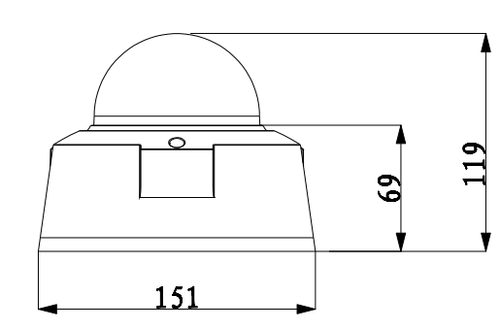
Figure 2-1
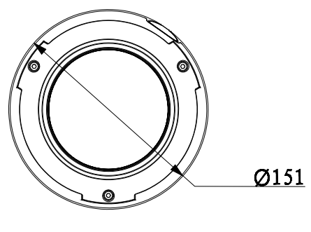
Figure 2-2

Structure
For the non-IR series product, the interface is shown as in Figure 2-3 and Figure 2-4.
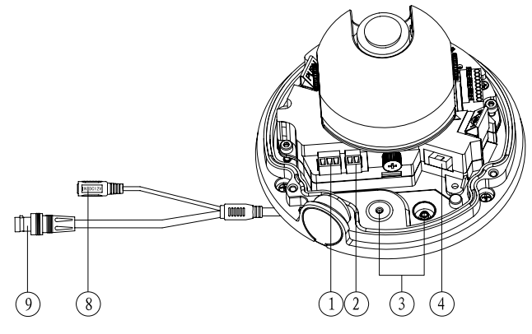
Figure 2-3

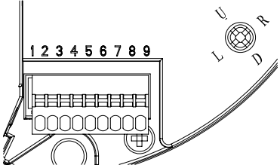
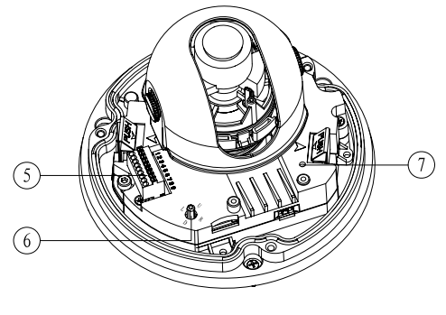
Figure 2-4
For the IR manual varifocal series product, the interface is shown as in Figure 2-5 and Figure 2-6.
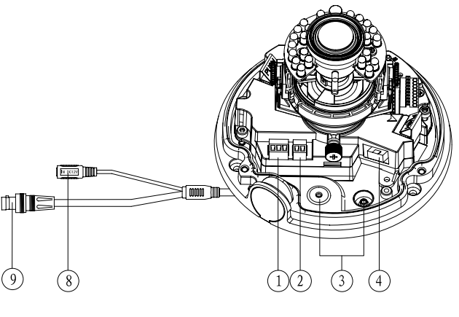
Figure 2-5

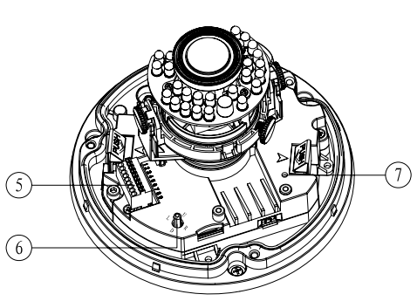
Figure 2-6
Please refer to the following sheet for detailed information.
SN | Component Name | Function
1 | Standard definition video output and 5-direction button input port | /
2 | DC12V/AC24V power port | /
3 | External cable exit | /
4 | High definition video output port | /
5 | I/O port | It includes alarm output, audio input, 485 control signal, standard definition video output.
6 | 5-direction buttons | These five buttons are for OSD menu operation.  Please use the up/down button to select the item and use the left/right button to select the option. The button in the middle is to confirm current operation.
7 | Power and system indicator light | The light becomes yellow when the power supplying is OK.  The light becomes red when system properly loaded.
8 | Power input port | /
9 | High definition video output port | BNC port. Output high definition analog video signal.

Please refer to the following sheet for I/O port cable function information.
Port SN | Port Name | Function Description
1 | ALARM_COM | Alarm output public end.
2 | ALARM_NO | Alarm signal output port. Output alarm signal to alarm device.
3 | GND | Ground end.
4 | AUDIO_IN | Input audio signal. It is to receive analog audio signal from devices such as pickup.
5 | GND | Ground end.
6 | 485_B | RS485 control signal input end B.
7 | 485_A | RS485 control signal input end A.
8 | GND | Ground end.
9 | VIDEO_SD_OUT | Output standard definition video signal.

Installation
Important
- Before you complete the installation and setup, do not remove the electrostatic attraction film on the transparent enclosure. Otherwise it may result in injury.
- After remove electrostatic attraction film, do not touch dome enclosure in case it may leave stain.
- The dome camera mainly uses the in-ceiling installation. Before the installation, please make sure the installation surface can sustain at least 3X weight of the bracket and the camera.

Device Installation Introduction
Please refer to Figure 3-7 and Figure 3-8 for device installation space information. You can use screws (diameter is less than 4.5mm) to secure the device. You can see there are installation position map and installation screws in the accessories bag for you to install the device conveniently.
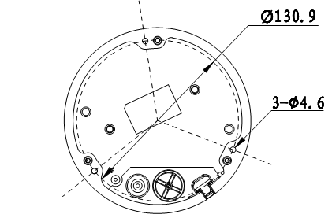
Figure 3-7
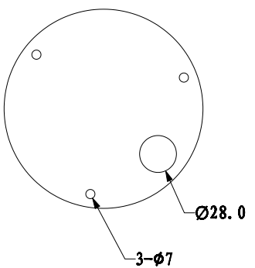
Figure 3-8

Device Installation Steps

General Installation
The general interface is shown as in Figure 3-9.
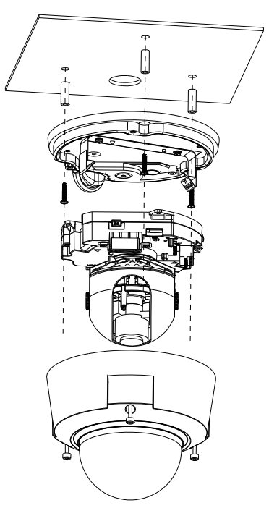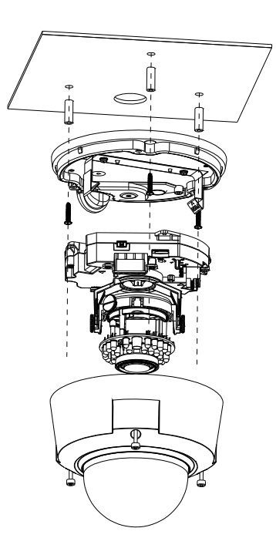
Figure 3-9
Step 1
Take the installation position map from the accessories bag and then paste it on the installation ceiling or the wall according to the monitor area. Please dig three bottom holes of the plastic expansion bolts according to the map. Take three expansion bolts from the accessories bag and then insert them to the holes you just dug and then fix firmly. If you need to dig a hole to pull through the cable, you need to dig a cable exit hole (The diameter is more than 28mm) on the installation surface according to the installation positioning map.

Step 2
Use the inner hex wrench from the accessories bag to unfasten the 3 hex screws on the dome camera enclosure to open it.

Step 3
Please remove the device cable port (Provided) and the power terminal (② and ④ in chapter 2.2.) Use the inner hex wrench (Provided) to remove the 2 inner hex screws from the dome driver module. Then please follow the prompt on the device to push the metal hook to two sides. Remove the dome driver module from the chassis. See Figure 3-10.
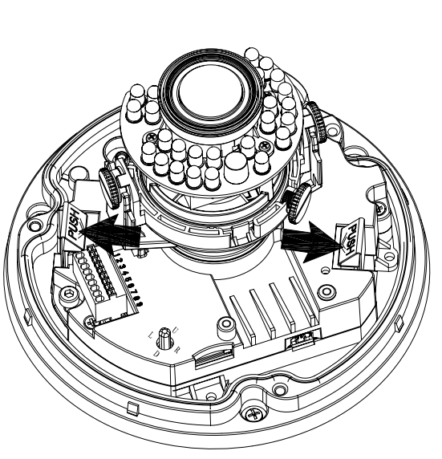

Figure 3-10
Step 4
Adjust the chassis of the device to the proper position and pull the cable to the cable exit of the installation surface. Line up the holes of the chassis to the three expansion bolt holes you dug in Step 1. Take three ST3.0 self-tapping screws and secure them in the three plastic expansion bolts. Now the chassis is secure on the installation surface.

Important
Please earth the device GND hole  (GND) to enhance the reliability of the device. The GND port is near the cable exit of the rear panel. The GND screw thread specification is M3-6mm.
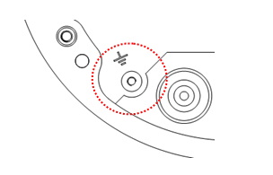
Figure 3-11

Step 5
Please refer to the Step 3 to put the driver module back to the metal hooks of the chassis. Then use the inner hex wrench to secure the two inner hex screws to the chassis. Then connect the network cable and the power terminal.

Step 6
Adjust the lens to the proper angle according to your monitor requirements.

a) For the IR series product, you can skip current step and go the step b) directly. For the non-IR series product, push the port slightly to remove the decoration enclosure from the black plastic enclosure. See Figure 3-12.
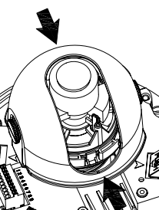
Figure 3-12

b) Lens pan rotation angle setup. Please refer to Figure 3-13 to unfasten the lock screw A and adjust the pan monitor angle to the proper position. Then fix the lock screw A. The pan angle ranges from 0°~+350°.
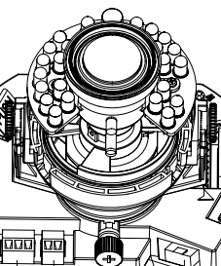
Lock Screw A
Adjust lend pan rotation angle.

Figure 3-13
c). Lens tilt rotation angle. Please refer to Figure 3-14 to unfasten the lock screw B and lock screw C and adjust the tilt monitor angle to the proper position. Then fix the lock screw B and lock screw C. The tilt angle ranges from -23°~+73°.

d). Image pan rotation angle setup. Please refer to Figure 3-14 to turn lock screw D to adjust the video pan angle. Then fix the lock screw B and C. The video pan angle ranges from 0°~+350°.

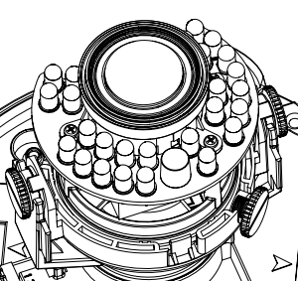
Lock screw B/C
Adjust lens tilt rotation angle.
Lock screw D
Adjust lend pan rotation angle.

Figure 3-14
e) For the manual varifocal series product, please skip current step. Please refer to chapter 3.2.2 for the lens zoom and focus operation of the manual focus series product.

f) For the IR series product, please skip current step and complete the angle setup directly. For the non-IR series product, please put back the black plastic decoration enclosure to complete the angle setup.

Important
Please note Figure 3-13 and Figure 3-14 is based on the IR manual varifocal camera. For the non-IR series product, the lock screw position and the lens angle adjustment are the same.

Step 7
Line up the dome camera protection enclosure to the cable exit on the side panel. Put the enclosure back and then use the inner hex wrench to secure the 3 inner hex screws firmly. Now the installation is complete.

Note
Usually we recommend, after the installation, please take the three white static protection gaskets from the accessories bag and insert them to the screw holes of the protection enclosure. It is to enhance device reliability.

Manual Varifocal Lens Operation
The manual varifocal lens interface is shown as in Figure 3-15.
Step 1
Slightly loosen the adjusting screw E and push the adjust screw E to make it swing. Adjust the lens focus to the proper position according to the displayed video.

Step 2
Slightly loosen the adjusting screw F and push the adjust screw F to make it swing. Adjust the lens to get the clear video and then fix the adjusting screw firmly.

Step 3
When you are securing the adjusting screw F, you can see the video may become blur. Please push the adjusting screw E to adjust the video slightly. Please secure the adjust screw E if you get a clear video.
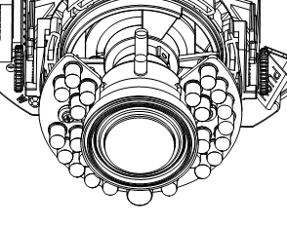
Adjusting Screw E

Adjusting Screw F
Figure 3-15

Side Cable Exit
If you adopt side cable exit when you are installing the device, you need to remove the plastic decoration plug from the side of the chassis. Use the proper tool to dig through the part specified in Figure 3-16 to form a cable exit. Put the plastic decoration plug back to the chassis and then pull the cable through the side panel of the chassis.
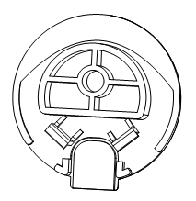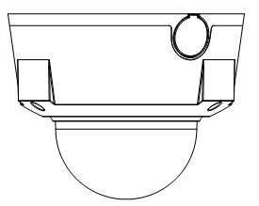
Dig through here
Figure 3-16
For some special user, he may need the metal protection tube to protect when he pulls through the cable from the side cable. There is PG11screw thread port when you pull through the cable from the side panel. Please remove the plastic decoration plug from the side panel of the chassis and pull through the cable to the tunnel of the PG11 screw thread. Now secure the tunnel in the PG11 screw threaded hole of the device.

Cable Connection
The device reserves two cable exits. The pin diameter shall be less than 15mm. One of the cable exits has M22 screw thread and can work with the default combination cable to remove the risk of the dragging and pulling of the cable.

The device has two waterproof airproof plugs (One default position is the cable exit of the chassis of the device and the other is in the accessories bag.). The waterproof airproof plug has two functions. One is to fill in the cable exit and pull through the cable. It supports the cable whose diameter ranges from 4.0~6.0. It is very convenient for you to do the waterproof work when you pull the cable through your own exit. Please refer to the steps listed.
Step 1
Take the waterproof airproof plug out, pull the cable (diameter ranges from 4.0 to 6.0) through the waterproof airproof plug. See Figure 3-17.
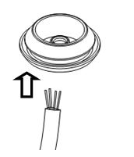
Figure 3-17

Step 2
Before you go to the Step 4 in the chapter 3.2.1 installation steps, please pull through cable with the waterproof airproof plug to the device chassis via the installation hole at the bottom of the chassis and then connect the cable pins.

Step 3
Refer to Step 4 and Step 5 in the chapter 3.2.1 installation steps to install and connect the cable pin to the device and then follow the proper steps to go on the installation.

Important
This series product has the power connection pin and I/O connection pin for you to pull through the signal cable.

Menu
THE 1ST MENU |  | THE 2ND MENU |  | THE 3RD MENU
SCENE | SCENE INDOOR
SCENE | SCENE OUTDOOR
SCENE | SCENE WDR
SCENE | BACK
EXPOSURE | AUTO | SHUTTER AUTO… | PAL:MAX SPEED 1/25  NTSC: MAX SPEED 1/30 | PAL:  1/25, 1/50, 1/75, 1/100, 1/120, 1/150, 1/215, 1/300, 1/425, 1/600, 1/1000, 1/1250, 1/1750, 1/2500, 1/3500, 1/6000, 1/10000  NTSC: 1/30,1/60,1/90,1/100,1/125,1/180,1/250,1/350,1/500,1/725,1/1000,1/1500,1/2000,1/3000,1/4000,1/6000,1/10000.
EXPOSURE | AUTO | SHUTTER AUTO… | MIN SPEED 1/10000
EXPOSURE | AUTO | SHUTTER AUTO… | PAL:SLOW SHUTTER 1/25  NTSC: SLOW SHUTTER 1/30 | PAL:  1/1 ,1/2 ,1/3,1/6,1/12,1/25  NTSC: 1/1, 1/2, 1/4, 1/8, 1/15, 1/30
EXPOSURE | AUTO | SHUTTER AUTO… | BACK
EXPOSURE | AUTO | GAIN 24dB | -1,0,2,4,6,8,10,12,14,16,18,20,22,24,26,28（DB）
EXPOSURE | AUTO | LENS--- | It is read-only on auto mode.
EXPOSURE | AUTO | EC(+0) | OFF,+0,+1,+2,+3,+4,+5,+6,+7,-1,-2,-3,-4,-5,-6,-7
EXPOSURE | AUTO | LLC60 | 0,5,10,15,20,25,30,35,40,45,50,55,60,65,70,75,80,85,90,95,100
EXPOSURE | AUTO | BACK
EXPOSURE | IRIS | PAL: SHUTTER 1/25.  NTSC:SHUTTER 1/30 | PAL:  1/25, 1/50, 1/75, 1/100, 1/120, 1/150, 1/215, 1/300, 1/425, 1/600, 1/1000, 1/1250, 1/1750, 1/2500, 1/3500, 1/6000, 1/10000  NTSC:  1/30,1/60,1/90,1/100,1/125,1/180,1/250,1/350,1/500,1/725,1/1000,1/1500,1/2000,1/3000,1/4000,1/6000,1/10000.
EXPOSURE | IRIS | GAIN 24dB | -1,0,2,4,6,8,10,12,14,16,18,20,22,24,26,28（DB）
EXPOSURE | IRIS | LENS--- | It is read-only on auto iris mode.
EXPOSURE | IRIS | EC(+0) | OFF,+0,+1,+2,+3,+4,+5,+6,+7,-1,-2,-3,-4,-5,-6,-7
EXPOSURE | IRIS | LLC60 | 0,5,10,15,20,25,30,35,40,45,50,55,60,65,70,75,80,85,90,95,100
EXPOSURE | IRIS | BACK
EXPOSURE | SHUTTER | SHUTTER AUTO… | PAL:MAX SPEED 1/25  NTSC: MAX SPEED 1/30 | PAL:  1/25, 1/50, 1/75, 1/100, 1/120, 1/150, 1/215, 1/300, 1/425, 1/600, 1/1000, 1/1250, 1/1750, 1/2500, 1/3500, 1/6000, 1/10000  NTSC: 1/30,1/60,1/90,1/100,1/125,1/180,1/250,1/350,1/500,1/725,1/1000,1/1500,1/2000,1/3000,1/4000,1/6000,1/10000.
EXPOSURE | SHUTTER | SHUTTER AUTO… | MIN SPEED 1/10000
EXPOSURE | SHUTTER | SHUTTER AUTO… | PAL:SLOW SHUTTER 1/25  NTSC: SLOW SHUTTER 1/30 | PAL:  1/1 ,1/2 ,1/3,1/6,1/12,1/25  NTSC: 1/1, 1/2, 1/4, 1/8, 1/15, 1/30
EXPOSURE | SHUTTER | SHUTTER AUTO… | BACK
EXPOSURE | SHUTTER | GAIN 24dB | -1,0,2,4,6,8,10,12,14,16,18,20,22,24,26,28（DB）
EXPOSURE | SHUTTER | LENS--- | It is read-only on auto shutter mode.
EXPOSURE | SHUTTER | EC(+0) | OFF,+0,+1.+2,+3,+4,+5,+6,+7,-1,-2,-3,-4,-5,-6,-7
EXPOSURE | SHUTTER | LLC60 | 0,5,10,15,20,25,30,35,40,45,50,55,60,65,70,75,80,85,90,95,100
EXPOSURE | SHUTTER | BACK
EXPOSURE | MANUAL | SHUTTER | PAL:  1/25, 1/50, 1/75, 1/100, 1/120, 1/150, 1/215, 1/300, 1/425, 1/600, 1/1000, 1/1250, 1/1750, 1/2500, 1/3500, 1/6000, 1/10000  NTSC: 1/30,1/60,1/90,1/100,1/125,1/180,1/250,1/350,1/500,1/725,1/1000,1/1500,1/2000,1/3000,1/4000,1/6000,1/10000.
EXPOSURE | MANUAL | GAIN 24dB | -1,0,2,4,6,8,10,12,14,16,18,20,22,24,26,28（DB）
EXPOSURE | MANUAL | LENS--- | MODE OPEN, MODE OFF
EXPOSURE | MANUAL | EC(+0) | It is read-only on manual mode.
EXPOSURE | MANUAL | LLC60 | It is read-only on manual mode.
EXPOSURE | MANUAL | BACK
FUNCTION | WB | AUTO
FUNCTION | WB | INDOOR
FUNCTION | WB | OUTDOOR
FUNCTION | WB | ONE PUSH
FUNCTION | WB | ATW
FUNCTION | WB | MANUAL… | RED GAIN 087 | 000-255
FUNCTION | WB | MANUAL… | BLUE GAIN 051 | 000-255
FUNCTION | WB | OUTDOOR AUTO
FUNCTION | WB | SODIUM AUTO
FUNCTION | WB | SODIUM
FUNCTION | WDR | OFF
FUNCTION | WDR | ON… | INTENSITY2 | 1-4
FUNCTION | WDR | ON… | MOTION COMP---
FUNCTION | WDR | ON… | RETURN
FUNCTION | NR… | 2D-NR2 | OFF, 1-5
FUNCTION | NR… | 3D-NR2 | OFF, 1-5
FUNCTION | NR… | BACK
FUNCTION | MIRROR | OFF, V-FLI,H-FLIP, CENTRE
FUNCTION | D/N | AUTO … | SWITCH POINT 7 | 1-7
FUNCTION | D/N | AUTO … | TOLERANCE 5 | 1-6
FUNCTION | D/N | AUTO … | DAYàNIGHT 5S | 2S-30S
FUNCTION | D/N | AUTO … | NIGHT àDAY 5S | 2S-30S
FUNCTION | D/N | AUTO … | BACK
FUNCTION | D/N | DAY
FUNCTION | D/N | NIGHT
FUNCTION | HLC | OFF, 1, 2
FUNCTION | BLC | OFF,1, 2
FUNCTION | BACK
IMAGE | MODE | CUSTOM , FLAMBOYANT,SOFT,  Note: For non-custom mode, the rest parameters are read-only.
IMAGE | HUE CNT | 00~15
IMAGE | SHARPNESS | 00~15
IMAGE | SHARP CNT | 00~15
IMAGE | BRIGHT | 000~255
IMAGE | SATURATION | 000~255
IMAGE | HUE | 000~255
IMAGE | GAMMA | 00~15
IMAGE | BACK
ADVANCED | MOTION DETECT… | SN | 1-4
ADVANCED | MOTION DETECT… | ON/OFF | ON/OFF
ADVANCED | MOTION DETECT… | DISPLAY | ON/OFF
ADVANCED | MOTION DETECT… | SENSITIVITY | 00~99
ADVANCED | MOTION DETECT… | AREA LOCATION … | LC | （0-23,0-15）
ADVANCED | MOTION DETECT… | AREA LOCATION … | SZ | （0-23,0-15）
ADVANCED | MOTION DETECT… | BACK
ADVANCED | D-ZOOM | X1-X10
ADVANCED | PRIVACY MASK … | INDEX | 0-7
ADVANCED | PRIVACY MASK … | N/F | ON/OFF
ADVANCED | PRIVACY MASK … | CENTRE SET…
ADVANCED | PRIVACY MASK … | SIZE SET…
ADVANCED | PRIVACY MASK … | COLOR | BLUE
ADVANCED | PRIVACY MASK … | BACK
ADVANCED | FREEZE | ON,OFF
ADVANCED | ALARM MODE… | TYPE | MOTION DETECT
ADVANCED | ALARM MODE… | MODE | ON/OFF
ADVANCED | ALARM MODE… | INTERVAL | CLOSE，1S-255S
ADVANCED | NEXT…
ADVANCED | RS-485… | Support PELCO-D/P, DH-SD protocol.
ADVANCED | RS-485… | BAUD RATE | 1200-9600
ADVANCED | RS-485… | ADDRESS | 001-254
ADVANCED | RS-485… | BACK
ADVANCED | CAMERA ID | OFF
ADVANCED | CAMERA ID | ON… | CAMERA ID | 1-254
ADVANCED | CAMERA ID | BACK
ADVANCED | LANGUAGE | ENGLISH
ADVANCED | SYSTEM INFO… | MANUFACTURER | xxx
ADVANCED | SYSTEM INFO… | HARDWARE | XXX
ADVANCED | SYSTEM INFO… | SOFTWARE | XXX
ADVANCED | SYSTEM INFO… | BACK
ADVANCED | PREVIOUS …
ADVANCED | BACK
EXIT | INDOOR | CANCEL, SAVE，DEFAULT，RESET
EXIT | RESTART…
EXIT | BACK

Appendix Toxic or Hazardous Materials or Elements
Component Name | Toxic or Hazardous Materials or Elements
Component Name | Pb | Hg | Cd | Cr VI | PBB | PBDE
Circuit Board Component | ○ | ○ | ○ | ○ | ○ | ○
Device Construction Material | ○ | ○ | ○ | ○ | ○ | ○
Wire and Cable | ○ | ○ | ○ | ○ | ○ | ○
Packing Components | ○ | ○ | ○ | ○ | ○ | ○
Accessories | ○ | ○ | ○ | ○ | ○ | ○

O: Indicates that the concentration of the hazardous substance in all homogeneous materials in the parts is below the relevant threshold of the SJ/T11363-2006 standard.

X: Indicates that the concentration of the hazardous substance of at least one of all homogeneous materials in the parts is above the relevant threshold of the SJ/T11363-2006 standard. During the environmental-friendly use period (EFUP) period, the toxic or hazardous substance or elements contained in products will not leak or mutate so that the use of these (substances or elements) will not result in any severe environmental pollution, any bodily injury or damage to any assets. The consumer is not authorized to process such kind of substances or elements, please return to the corresponding local authorities to process according to your local government statutes.

Note
- This manual is for reference only. Slight difference may be found in the user interface.
- All the designs and software here are subject to change without prior written notice.
- All trademarks and registered trademarks mentioned are the properties of their respective owners.
- If there is any uncertainty or controversy, please refer to the final explanation of us.
- Please visit our website or contact your local service engineer for more information.

