1 Megapixel HDCVI ICR Sync-Focus Dome Camera
User’s Manual

Version 1.0.0
Table of Contents
1 General Introduction 1
1.1 Overview 1
1.2 Features 1
1.3 Functions 1
1.4 Specifications 2
2 Framework 4
2.1 Dimensions 4
2.2 5-Direction Buttons Settings 5
3 Installation 6
4 Menu 9
4.1 HDCVI Series DVR Settings 9
4.2 Menu List 10
4.3 Note 11
Appendix Toxic or Hazardous Materials or Elements 12

Welcome
Thank you for purchasing our HDCVI camera!
This user’s manual is designed to be a reference tool for your system.
Please read the following safeguard and warnings carefully before you use this series product!
Please keep this user’s manual well for future reference!

Important Safeguards and Warnings
1．Electrical safety
All installation and operation here should conform to your local electrical safety codes.
The power shall conform to the requirement in the SELV (Safety Extra Low Voltage) and the Limited power source is rated 12V DC in the IEC60950-1.
We assume no liability or responsibility for all the fires or electrical shock caused by improper handling or installation.

2．Transportation security
Heavy stress, violent vibration or water splash are not allowed during transportation, storage and installation.

3．Installation
Do not apply power to the camera before completing installation.
Please install the proper power cut-off device during the installation connection.
Always follow the instruction guide the manufacturer recommended.
If this product is installed in the ceiling, please make sure the installation position can sustain the min 50N.

4．Qualified engineers needed
All the examination and repair work should be done by the qualified service engineers.
We are not liable for any problems caused by unauthorized modifications or attempted repair.

5．Environment
This series HDCVI camera should be installed in a cool, dry place away from direct sunlight or strong light, inflammable, explosive substances and etc.
This series camera shall work on the specified working temperature. Please keep it away from the electromagnetic radiation object and environment.
Please make sure the CMOS component is out of the radiation of the laser beam device. Otherwise it may result in CMOS optical component damage.
Please keep the sound ventilation.
Do not allow the water and other liquid falling into the camera.

6. Accessories
Be sure to use all the accessories recommended by manufacturer.
Before installation, please open the package and check all the components are included.
Contact your local retailer ASAP if something is broken in your package.

7. Daily Maintenance
Please shut down the device and then unplug the power cable before you begin daily maintenance work.
Use the dry soft cloth to clean the device. If there is too much dust, please use the water to dilute the mild detergent first and then use it to clean the device. Finally use the dry cloth to clean the device.
Please put the dustproof cap to protect the CMOS component when you do not use the camera.

General Introduction

Overview
This series megapixel HD camera conforms to the HDCVI standard. It supports video signal high-speed long distance transmission without any delay. It can be controlled by the DVR conforming to the HDCVI.

Features
- High-performance CMOS image sensor, megapixel definition.
- Default sync-focus lens, coaxial cable to control lens zoom and focus.
- Support 75-3 coaxial cable transmission without any loss. Transmission distance is over 500m.
- Support HD and standard definition switch.
- Support 720P@25, 720P@30, 720P@50, 720P@60.
- High speed, long distance real-time transmission.
- Support OSD (on-screen display), suitable for user self-defined setup.
- Support DC12V power supplying.
- Support 3D noise reduction(denoise),excellent performance in low illumination environment.
- Support ICR switch to realize surveillance both in the daytime and at night.
- Support intelligent IR function. Max 20m IR distance. (For HAC-HDW3103P/N series only )
- Advanced X-Y-Z axis module design, suitable to monitor various zones.

Functions
HDCVI Specification
HDCVI（High Definition Composite Video Interface） is an over-coaxial –cable HD video transmission standard. The technology renders two HD video formats by progressive scanning.

Sync-focus lens
After set focus distance and get clear video, you can realize zoom and focus at the same time. It can remain clear zoom during the whole focus setup process. You can use the five buttons on the cable to set. Please refer to chapter 2.2.

OSD
User-friendly on-screen display for you to select the different functions.

ICR
The IR cut removal is to filter the IR light in the daytime and then auto switch to the general fitter at night. This function allows the camera to output the high sensitivity and clear video.

Smart IR technology
The sensor controls the IR light on/off via the combination work of the hardware and software, which realizes the automatically IR light compensation according to the environment illumination.

3D NR
Comparing with the general 2D denoise function, the 3D denoise function can not only denoise the brightness of the video separation signal and saturation signal, it can also denoise the original data from CCD. It greatly enhances noise reduction performance and guarantees clear and bright video

Specifications
Please refer to the following sheet for specification.
Model  Parameter |  | 1 Megapixel HDCVI ICR Sync-Focus Dome Camera | 1 Megapixel HDCVI ICR Sync-Focus IR Dome Camera
 |  | HAC-HD3103P/N | HAC-HDW3103P/N
Video Processor |  | 1/3" 1.3 Mega Pixels CMOS
Video Format |  | PAL/NTSC
Effective Pixel |  | 1280（H）×960（V）
Min Illumination |  | 0.01Lux@（F1.2，AGC ON） | 0.01Lux@（F1.2，AGC ON），0 Lux with IR
Electronic Shutter |  | PAL：4/25s～1/45,000s  NTSC：4/30~1/54,000s
Video Standard |  | HDCVI/CVBS compliance
Video Frame Rate |  | 1280×720@25 fps；1280×720@30 fps；  1280×720@50 fps；1280×720@60 fps
Lens Port |  | Φ14
Lens Type |  | 2.7mm～9mm @ F1.4 sync=focus lens
Day/Night Switch |  | ICR mechanical auto switch
Video Output |  | 1-channel HDCVI high definition video output/ CVBS standard definition video output (Can switch.)
Denoise (Noise Reduction) |  | Support 2D/3D denoise.
OSD Menu Control |  | Support coaxial cable control and cable control
OSD | EXPOSURE | Global/BLC/ Front Light/ Distinguish/ Return
OSD | WHITE BALANCE | AWB-GW /AWB-PRO/AWB-TEMPORAL/AWB-AI/ Return
OSD | DAY/NIGHT | Auto/B&W/Color/ Return
OSD | FUNCTION | 3DNR
OSD | ADVANCED | Mirror/Language/RS485/Video/ Version/Return
OSD | IMAGE | Sharpness /Contrast/Saturation/ Brightness / Return
OSD | EXIT | SAVE/CANCEL/RESET
Max IR Distance |  | N/A | 20m
Transmission Distance |  | Over 500m via 75-3 coaxial cable.
Working Temperature /Humidity |  | -30℃~+60℃. Humidity is less than 95%(no condensation)
Power |  | DC 12V±10%
Power Consumption |  | 3.2W MAX (Input：12V0.27A) | 6.5W MAX (Input：12V0.54A)
Dimension(mm) |  | Φ140.3×112.7
Weight |  | 400g
Installation Mode |  | Wall mount/in ceiling mount

Framework

Dimensions
Please refer to the following figure for dimension information. The unit is mm. See Figure 2-1.
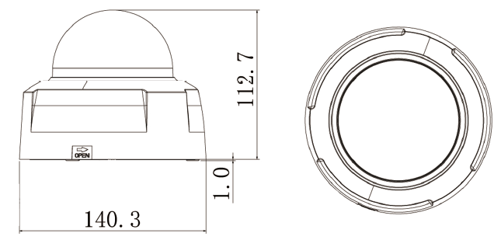
Figure 2-1
Please refer to the following two figures for structure information. See Figure 2-2 and Figure 2-3.
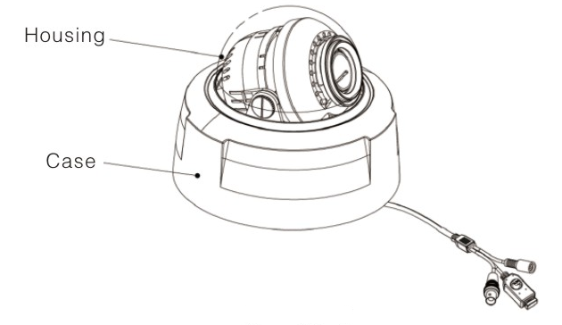
Figure 2-2
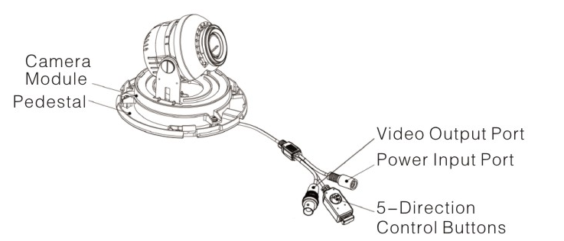
Figure 2-3

Important
- The 5-direction control buttons on the composite cable does not have the waterproof capability. Please make sure you have taken necessary precautions before the operation, otherwise the camera may result in malfunction.
- Disconnect (such as cut off) the composite cable between the 5-direction buttons and the camera, you can not control the camera focus and OSD.

5-Direction Buttons Settings
Important
During the OSD operation process, the left/right button can not realize focus or zoom function. You need to exit OSD and then set.
If there is no video output, please check device output format and make sure you have connected the corresponding encode device.
You can use the left/right button to realize lens focus and zoom function.
Press the middle button for 5 seconds to switch HD/standard video output.
Press the middle button for a short time to go to the OSD menu. After you go to the OSD menu, click the middle button for a short time to confirm current operation, use up/down button to select menu items and use left/right button to set parameters.

Installation
Important
- Before the installation, please make sure the installation surface can sustain at least 3X weight of the bracket and the camera.

The dome camera usually uses the ceiling installation. It can be installed on the ceiling or the wall.
- For side exit cable installation, please make sure the side exit cable direction is the same as shown in the installation position map.
- Before you secure the screws on the pedestal, please put the cable through the cable exit of the pedestal.
- Before you complete the installation and debug, do not remove the electrostatic film. After you remove the film, do not touch the enclosure in case there is any scratch.
All figures listed below are bases on the HAC-HDW3103 series product.

Step 1
Take the installation position map from the accessories bag and then put it on the surface of the ceiling or the wall according to the cable exit position. Dig three holes according to the installation position map and then take three expansion bolts from the accessories bag and put them to the holes you just dug.

Step 2
Turn counter clockwise to remove the enclosure.

Step 3
Adjust the pedestal position according to the cable exit mode (ceiling/side). Pull the cable through the cable side exit at the installation surface and the pedestal (Please skip this step if you want to use ceiling exit mode). Line up the screw holes at the bottom of the pedestal to the expansion bolts in the installation surface. Put three self-tapping screws to expansion bolts and then secure firmly. Now the pedestal is on the installation surface. See Figure 3-4.
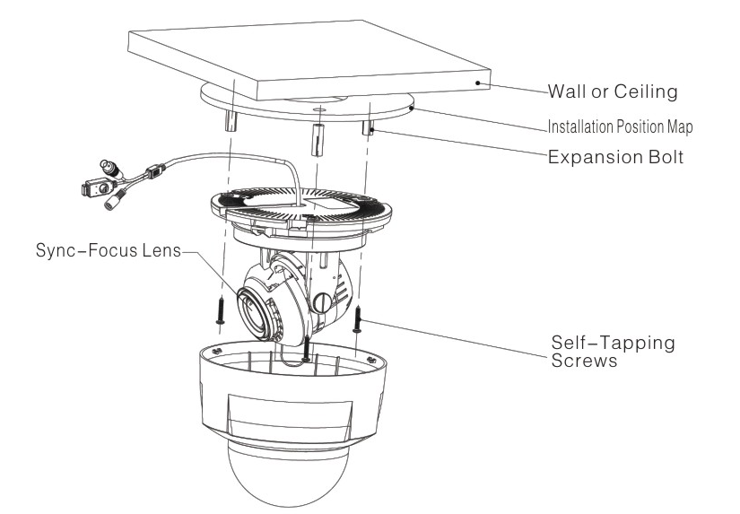
Figure 3-4

Step 4
Adjust the lens angle to a proper position and then fix the screws to fasten the lens.
See Figure 3-5.
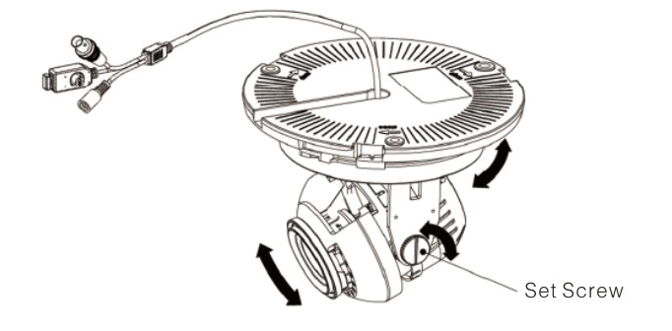
Figure 3-5
Step 5
Turn clockwise to put the enclosure back to the pedestal.

Now you have completed the device installation and cable connection.
You can use the terminal encode devices to view the monitor video.

Menu

HDCVI Series DVR Settings
Note
The following operation and interfaces for reference only. Please refer to the HDCVI series DVR user’s manual for detailed information.

After connected the camera to the HDCVI series DVR, from Main Menu->Setting->System->PTZ, you need to set control mode as HDCVI and the protocol as DH-SD1. Click Save button to save current setup. See Figure 4-6.
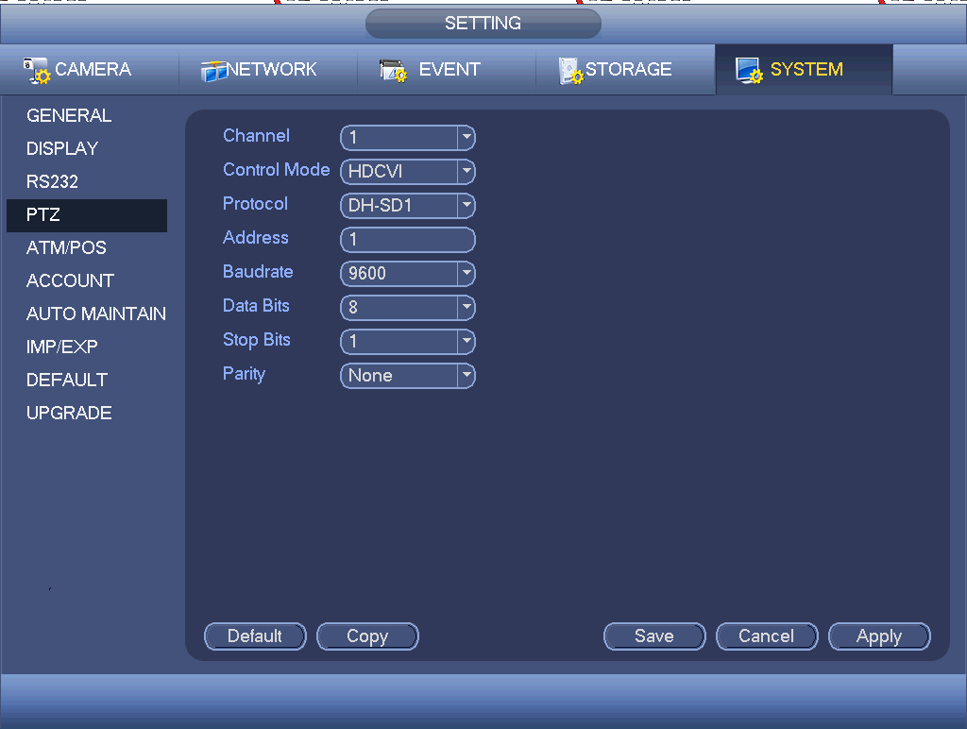
Figure 4-6
On the preview interface, right click mouse and then select PTZ; you can see an interface shown as below. See Figure 4-7.
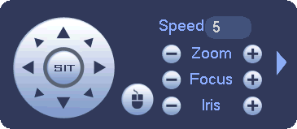
Figure 4-7
Click Iris “+” to open menu or confirm current operation.
Click up/down button to view all the items on the left pane of the following list. Click left/right button to set the corresponding values on the right pane of the following list. If there is “”, click confirm button to go to the 2nd menu. Repeat the previous steps to set detailed value. Click Return button to go back to the previous menu interface.
Click ”+” to zoom in and click ‘-” to zoom out.

Menu List
EXPOSURE |  | AE MODE | GLOBAL
EXPOSURE |  | AE MODE | BLC
EXPOSURE |  | AE MODE | FRONT LIGHT
EXPOSURE |  | AE MODE | DISTINGUISH
EXPOSURE |  | AE MODE | RETURN
WB MODE | AWB-GW
WB MODE | AWB-PRO
WB MODE | AWB-TEMPORAL
WB MODE | AWB-AI
DAY &NIGHT | AUTO | D→N |  | BRIGHTNESS | 0-96
 |  |  |  | RETURN
DAY &NIGHT |  | N→D |  | BRIGHTNESS | 0-192
 |  |  |  | GAIN | 0-63
 |  |  |  | A-REFLECT | 0-13
 |  |  |  | RETURN
DAY &NIGHT |  | RETURN
DAY &NIGHT | B&W
DAY &NIGHT | COLOR
FUNCTION |  | 3D-NR | ON/OFF
FUNCTION |  | RETURN
ADVANCED |  | MIRROR | OFF/HORIZONTAL/VERTICAL/H&V
ADVANCED |  | LANGUAGE | ENGLISH
ADVANCED |  | RS485 |  | ADDRESS | 1-254
 |  |  |  | BAUD RATE | 2400/4800/9600/115200
 |  |  |  | PROTOCOL | PELCOP/PELCOD/DH-SD
ADVANCED |  | VIDEO | 720P@25/  720P@30/ 720P@50/ 720P@60
ADVANCED |  | VERSION | XXXXXXXX
ADVANCED |  | RETURN
IMAGE |  | SHARPNESS |  | DETAIL | AUTO/MANUAL
 |  |  |  | VALUE | 0-15（For manual mode only）
 |  |  |  | EDGE | AUTO/MANUAL
 |  |  |  | VALUE | 0-15（For manual mode only）
 |  |  |  | RETURN
IMAGE |  | CONTRAST | 0-255
IMAGE |  | SATURATION | 0-15
IMAGE |  | BRIGHTNESS | 70-250，+10
IMAGE |  | RETURN
EXIT | SAVE
EXIT | CANCEL
EXIT | RESET

Note
Parameter | Function
3DNR | It is to reduce video noise. The larger the number is, the lower the noise is. The details of the video may disappear if the value here is too large.
Contrast | It is to adjust monitor window contrast.  The larger the number is, the higher the contrast is. You can use this function when the whole video bright is OK but the contrast is not proper. Please note the video may become hazy if the value is too low. If this value is too high, the dark section may lack brightness while the bright section may over exposure.
Saturation | It is to adjust monitor window saturation.  The larger the number, the strong the color is. This value has no effect on the general brightness of the whole video. The video color may become too strong if the value is too high. For the grey part of the video, the distortion may occur if the white balance is not accurate. Please note the video may not be attractive if the value is too low.
Sharpness | The value here is to adjust the edge of the video.  The larger the value is, the clear the edge is and vice versa. Please note there is noise if the value here is too high.

Appendix Toxic or Hazardous Materials or Elements
Component Name | Toxic or Hazardous Materials or Elements
Component Name | Pb | Hg | Cd | Cr VI | PBB | PBDE
Circuit Board Component | ○ | ○ | ○ | ○ | ○ | ○
Device Construction Material | ○ | ○ | ○ | ○ | ○ | ○
Wire and Cable | ○ | ○ | ○ | ○ | ○ | ○
Packing Components | ○ | ○ | ○ | ○ | ○ | ○
Accessories | ○ | ○ | ○ | ○ | ○ | ○

O: Indicates that the concentration of the hazardous substance in all homogeneous materials in the parts is below the relevant threshold of the SJ/T11363-2006 standard.

X: Indicates that the concentration of the hazardous substance of at least one of all homogeneous materials in the parts is above the relevant threshold of the SJ/T11363-2006 standard. During the environmental-friendly use period (EFUP) period, the toxic or hazardous substance or elements contained in products will not leak or mutate so that the use of these (substances or elements) will not result in any severe environmental pollution, any bodily injury or damage to any assets. The consumer is not authorized to process such kind of substances or elements, please return to the corresponding local authorities to process according to your local government statutes.

Note
- This manual is for reference only. Slight difference may be found in the user interface.
- All the designs and software here are subject to change without prior written notice.
- All trademarks and registered trademarks mentioned are the properties of their respective owners.
- If there is any uncertainty or controversy, please refer to the final explanation of us.
- Please visit our website or contact your local service engineer for more information.

