HDCVI IR Motorized Vari-focal Fixed Camera
User’s Manual

Version 1.0.1
Table of Contents
1 General Introduction 1
1.1 Overview 1
1.2 Features 1
1.3 Functions 1
2 Framework and Dimensions 3
2.1 Dimensions 3
2.2 Structure 3
3 Installation 4
4 Menu 6
4.1 HDCVI Series DVR Settings 6
4.2 Note 7
Appendix Toxic or Hazardous Materials or Elements 8

Welcome
Thank you for purchasing our HDCVI camera!
This user’s manual is designed to be a reference tool for your system.
Please read the following safeguard and warnings carefully before you use this series product!
Please keep this user’s manual well for future reference!

Important Safeguards and Warnings
1．Electrical safety
All installation and operation here should conform to your local electrical safety codes.
The power shall conform to the requirement in the SELV (Safety Extra Low Voltage) and the Limited power source is rated 12V DC in the IEC60950-1.
We assume no liability or responsibility for all the fires or electrical shock caused by improper handling or installation.

2．Transportation security
Heavy stress, violent vibration or water splash are not allowed during transportation, storage and installation.

3．Installation
Do not apply power to the camera before completing installation.
Please install the proper power cut-off device during the installation connection.
Always follow the instruction guide the manufacturer recommended.
If this product is installed in the ceiling, please make sure the installation position can sustain the min 50N.

4．Qualified engineers needed
All the examination and repair work should be done by the qualified service engineers.
We are not liable for any problems caused by unauthorized modifications or attempted repair.

5．Environment
This series HDCVI camera should be installed in a cool, dry place away from direct sunlight or strong light, inflammable, explosive substances and etc.
This series camera shall work on the specified working temperature. Please keep it away from the electromagnetic radiation object and environment.
Please make sure the CMOS component is out of the radiation of the laser beam device. Otherwise it may result in CMOS optical component damage.
Please keep the sound ventilation.
Do not allow the water and other liquid falling into the camera.

6. Accessories
Be sure to use all the accessories recommended by manufacturer.
Before installation, please open the package and check all the components are included.
Contact your local retailer ASAP if something is broken in your package.

7. Daily Maintenance
Please shut down the device and then unplug the power cable before you begin daily maintenance work.
Use the dry soft cloth to clean the device. If there is too much dust, please use the water to dilute the mild detergent first and then use it to clean the device. Finally use the dry cloth to clean the device.
Please put the dustproof cap to protect the CMOS component when you do not use the camera.
Applicable model
This manual can be applied to following models:
HAC-HFW2120RP-Z | HAC-HFW2120RN-Z
HAC-HFW2220RP-Z | HAC-HFW2220RN-Z

General Introduction

Overview
This series megapixel HD camera conforms to the HDCVI standard. It supports video signal high-speed long distance transmission without any delay. It can be controlled by the DVR conforming to the HDCVI.

Features
- High-performance CMOS image sensor, megapixel definition.
- Default motorized vari-focal lens, adopt auto focus technology, support coaxial cable to control lens zoom and focus.
- Support HD video and control signal coaxial transmission.
- Support 75-3 coaxial cable transmission without any loss. 720P series transmission distance over 500m, 1080P series transmission distance over 300m.
- High speed, long distance real-time transmission.
- Support HDCVI HD and analog SD switch output.
- 720P series support 720P@25, 720P@30, 720P@50, 720P@60.
1080P series support 1080P@25, 1080P@30, 720P@25, 720P@30, 720P@50, 720P@60.
- Support high performance 3D noise reduction (denoise), excellent performance in low illumination
- Support ICR switch to realize surveillance both in the daytime and at night.
- Support OSD (on-screen display), suitable for user self-defined setup.
- Support DC12V power supplying.
- IP66 compliance.
- Support intelligent IR function, max IR distance 30m.

Functions
HDCVI Specification
HDCVI（High Definition Composite Video Interface） is an over-coaxial –cable HD video transmission standard. The technology renders two HD video formats by progressive scanning.

Auto Focus Technology
Detect the location of main screen by the camera auto focus algorithm, and auto adjust focus motor according to the current focus situation, which would realize zoom control the entire auto focus. The image stays clear during the process of zooming.

OSD
User-friendly on-screen display for you to select the different functions.

ICR
The IR cut removal is to filter the IR light in the daytime and then auto switch to the general fitter at night. This function allows the camera to output the high sensitivity and clear video.

Smart IR technology
The sensor controls the IR light on/off via the combination work of the hardware and software, which realizes the automatically IR light compensation according to the environment illumination.

3D NR
Comparing with the general 2D denoise function, the 3D denoise function can not only denoise the brightness of the video separation signal and saturation signal, it can also denoise the original data from CCD. It greatly enhances noise reduction performance and guarantees clear and bright video.

Framework and Dimensions

Dimensions
Please refer to the following figure for dimension information. The unit is mm. See Figure 2-1.
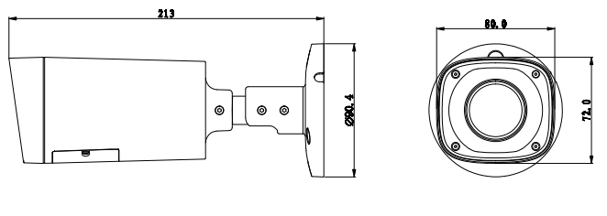
Figure 2-1

Structure
Please refer to the following figure for structure information. See Figure 2-2 .
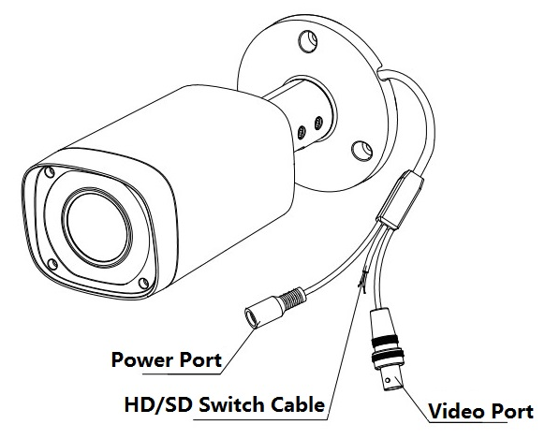
Figure 2-2
When the standard definition/high definition switch control cable is short circuit, system outputs standard definition video. Otherwise, when the circuit is open, system outputs the high definition video.

Installation
Important
- Before the installation, please make sure the installation surface can sustain at least 3X weight of the bracket and the camera.
Please refer to the Figure 3-1 for the chassis hole site of camera bracket
. 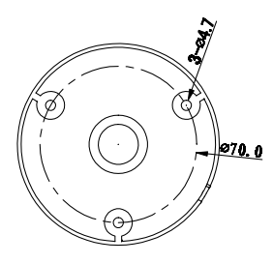
Figure 3-1

Please refer to the steps listed below for installation information, see Figure 3-2 and 3-3.

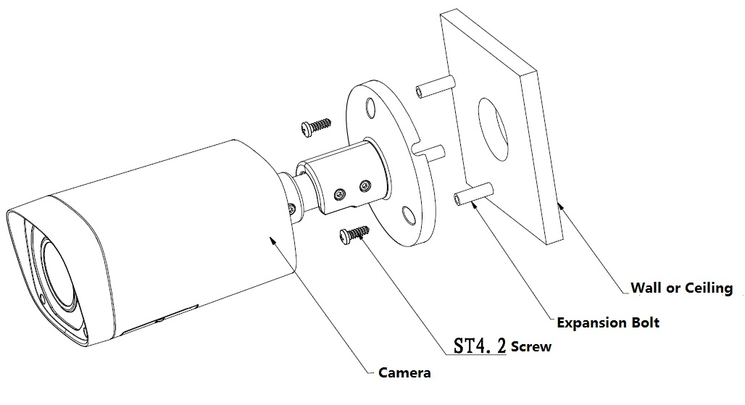

Figure 3-2

Step 1
Before you install the bracket, please pull the cable through the cable exit of the bracket chassis.
- Please install the expansion bolt if you want to install in the cement wall (Please make sure the installation holes of the expansion bolts are the same with the bracket.) Then you can install the bracket. See Figure 3-2.
- If you want to install in the wood surface, please skip the first step and then use the self-tapping screws to install the bracket directly.

Step 2
Unscrew the M3×20 and M3×5 screws on the bracket in the direction shown in Figure 3-3, adjust the camera to an exact location which needs to be monitored by rotating the bracket and camera body, then secure the bolts.
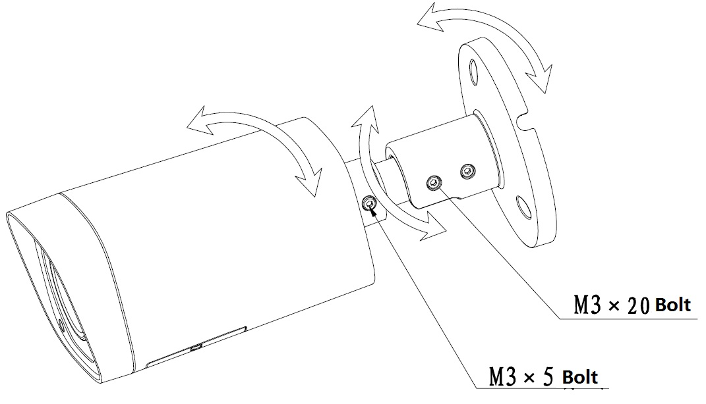

Figure 3-3
Step 3
Connect the video output port of the device cable to the HDCVI DVR, and connect the power port of the device cable to the power.

Step 4
After the image is shown on the HDCVI DVR, control the interface by HDCVI series DVR PTZ, adjust lens zoom by using coaxial control, and the camera will auto focus to the best position which makes the image clear. So far the camera installation is completed.

Menu

HDCVI Series DVR Settings
Note
The following operation and interfaces for reference only. Please refer to the HDCVI series DVR user’s manual for detailed information.

After connected the camera to the HDCVI series DVR, from Main Menu->Setting->System->PTZ, you need to set control mode as HDCVI and the protocol as DH-SD1. Click Save button to save current setup. See Figure 4-3.
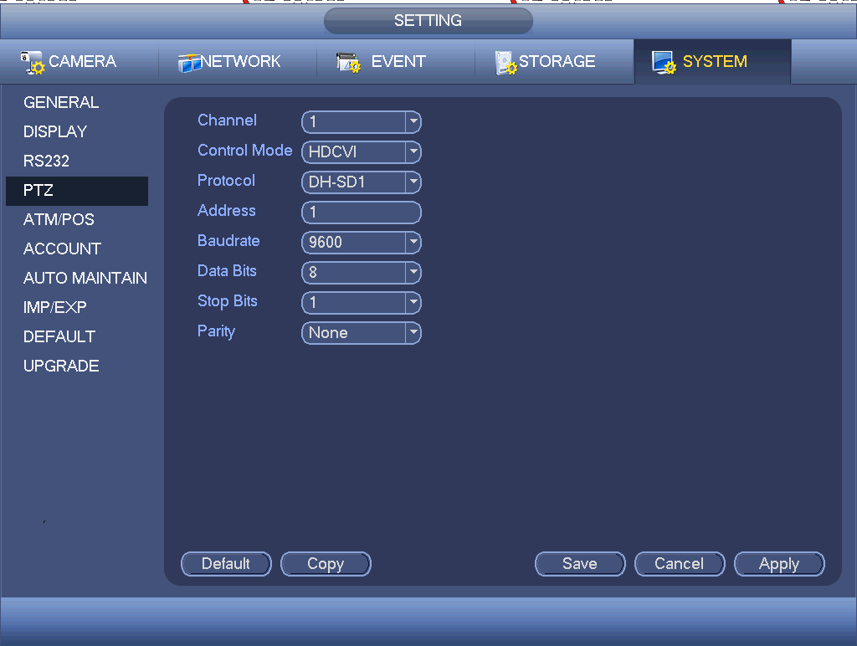
Figure 4-3
On the preview interface, right click mouse and then select PTZ; you can see an interface shown as below. See Figure 4-4.
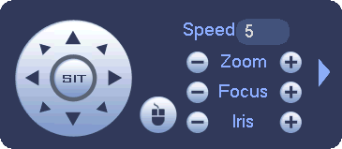
Figure 4-4
Click Iris “+” to open menu or confirm current operation.
Click Iris “-” to realize auto focus.
Click up/down button to view all the items on the left pane of the following list. Click left/right button to set the corresponding values on the right pane of the following list. If there is “”, click confirm button to go to the 2nd menu. Repeat the previous steps to set detailed value. Click Return button to go back to the previous menu interface.
Click Zoom “+” to zoom in and click Zoom “-” to zoom out.

Note
Parameter | Function
Brightness | It is to adjust monitor window bright. The value ranges from 0 to 100. The default value is 50.  The larger the number is, the bright the video is. When you input the value here, the bright section and the dark section of the video will be adjusted accordingly. You can use this function when the whole video is too dark or too bright. Please note the video may become hazy if the value is too high. The recommended value ranges from 40 to 60.
Contrast | It is to adjust monitor window contrast. The value ranges from 0 to 100. The default value is 50.  The larger the number is, the higher the contrast is. You can use this function when the whole video bright is OK but the contrast is not proper. Please note the video may become hazy if the value is too low. If this value is too high, the dark section may lack brightness while the bright section may over exposure .The recommended value ranges from 40 to 60.
Saturation | It is to adjust monitor window saturation. The value ranges from 0 to 100. The default value is 50.  The larger the number, the strong the color is. This value has no effect on the general brightness of the whole video. The video color may become too strong if the value is too high. For the grey part of the video, the distortion may occur if the white balance is not accurate. Please note the video may not be attractive if the value is too low. The recommended value ranges from 40 to 60.
Sharpness | The value here is to adjust the edge of the video. The value ranges from 0 to 100. The larger the value is, the clear the edge is and vice versa. Please note there is noise if the value here is too high. The default value is 50 and the recommended value ranges from 40 to 60.
3DNR | It is to reduce video noise. The larger the number is, the lower the noise is. The details of the video may disappear if the value here is too large.
Anti-flicker | - Outdoor: In this mode, you can switch exposure mode to get the effect under the corresponding exposure mode.  - 50Hz: When the current is 50Hz, system can auto adjust the exposure according to the environment brightness in case there is any strip.  - 60Hz: When the current is 60Hz, system can auto adjust the exposure according to the environment brightness in case there is any strip.

Appendix Toxic or Hazardous Materials or Elements
Component Name | Toxic or Hazardous Materials or Elements
Component Name | Pb | Hg | Cd | Cr VI | PBB | PBDE
Circuit Board Component | ○ | ○ | ○ | ○ | ○ | ○
Device Construction Material | ○ | ○ | ○ | ○ | ○ | ○
Wire and Cable | ○ | ○ | ○ | ○ | ○ | ○
Packing Components | ○ | ○ | ○ | ○ | ○ | ○
Accessories | ○ | ○ | ○ | ○ | ○ | ○

O: Indicates that the concentration of the hazardous substance in all homogeneous materials in the parts is below the relevant threshold of the SJ/T11363-2006 standard.

X: Indicates that the concentration of the hazardous substance of at least one of all homogeneous materials in the parts is above the relevant threshold of the SJ/T11363-2006 standard. During the environmental-friendly use period (EFUP) period, the toxic or hazardous substance or elements contained in products will not leak or mutate so that the use of these (substances or elements) will not result in any severe environmental pollution, any bodily injury or damage to any assets. The consumer is not authorized to process such kind of substances or elements, please return to the corresponding local authorities to process according to your local government statutes.

Note
- This manual is for reference only. Slight difference may be found in the user interface.
- All the designs and software here are subject to change without prior written notice.
- All trademarks and registered trademarks mentioned are the properties of their respective owners.
- If there is any uncertainty or controversy, please refer to the final explanation of us.
- Please visit our website or contact your local service engineer for more information.

