HDCVI IR Vari-focal Waterproof Fixed Camera
User’s Manual

Version 1.0.0
Table of Contents
1 General Introduction 1
1.1 Overview 1
1.2 Features 1
1.3 Functions 1
1.4 Specifications 2
2 Framework and Dimensions 4
2.1 Dimensions 4
2.2 Structure 4
2.3 5-Direction Buttons Settings 5
3 Installation 6
4 Menu 8
4.1 HDCVI Series DVR Settings 8
4.2 Menu List 9
4.3 Note 10
Appendix Toxic or Hazardous Materials or Elements 11

Welcome
Thank you for purchasing our HDCVI camera!
This user’s manual is designed to be a reference tool for your system.
Please read the following safeguard and warnings carefully before you use this series product!
Please keep this user’s manual well for future reference!

Important Safeguards and Warnings
1．Electrical safety
All installation and operation here should conform to your local electrical safety codes.
The power shall conform to the requirement in the SELV (Safety Extra Low Voltage) and the Limited power source is rated 12V DC in the IEC60950-1.
We assume no liability or responsibility for all the fires or electrical shock caused by improper handling or installation.

2．Transportation security
Heavy stress, violent vibration or water splash are not allowed during transportation, storage and installation.

3．Installation
Do not apply power to the camera before completing installation.
Please install the proper power cut-off device during the installation connection.
Always follow the instruction guide the manufacturer recommended.
If this product is installed in the ceiling, please make sure the installation position can sustain the min 50N.

4．Qualified engineers needed
All the examination and repair work should be done by the qualified service engineers.
We are not liable for any problems caused by unauthorized modifications or attempted repair.

5．Environment
This series HDCVI camera should be installed in a cool, dry place away from direct sunlight or strong light, inflammable, explosive substances and etc.
This series camera shall work on the specified working temperature. Please keep it away from the electromagnetic radiation object and environment.
Please make sure the CMOS component is out of the radiation of the laser beam device. Otherwise it may result in CMOS optical component damage.
Please keep the sound ventilation.
Do not allow the water and other liquid falling into the camera.

6. Accessories
Be sure to use all the accessories recommended by manufacturer.
Before installation, please open the package and check all the components are included.
Contact your local retailer ASAP if something is broken in your package.

7. Daily Maintenance
Please shut down the device and then unplug the power cable before you begin daily maintenance work.
Use the dry soft cloth to clean the device. If there is too much dust, please use the water to dilute the mild detergent first and then use it to clean the device. Finally use the dry cloth to clean the device.
Please put the dustproof cap to protect the CMOS component when you do not use the camera.

Applicable model
This manual can be applied to following models:
HAC-HFW2120RP-VF | HAC-HFW2120RN-VF
HAC-HFW2220RP-VF | HAC-HFW2220RN-VF

General Introduction

Overview
This series megapixel HD camera conforms to the HDCVI standard. It supports video signal high-speed long distance transmission without any delay. It can be controlled by the DVR conforming to the HDCVI.

Features
- High-performance CMOS image sensor, megapixel definition.
- Support manual adjustment of lens zoom and focus, conduct lens focus and zoom by opening the lower cover of the camera body, which is convenient to install for clients.
- Support HD video and control signal coaxial transmission.
- Support 75-3 coaxial cable transmission without any loss. 720P series transmission distance over 500m, 1080P series transmission distance over 300m.
- High speed, long distance real-time transmission.
- Support HDCVI HD and analog SD switch output.
- 720P series support 720P@25, 720P@30, 720P@50, 720P@60.
1080P series support 1080P@25, 1080P@30, 720P@25, 720P@30, 720P@50, 720P@60.
- Support high performance 3D noise reduction (denoise), excellent performance in low illumination
- Support ICR switch to realize surveillance both in the daytime and at night.
- Support OSD (on-screen display), suitable for user self-defined setup.
- Support DC12V power supplying.
- IP66 compliance.
- Support intelligent IR function, max IR distance 30m.

Functions
HDCVI Specification
HDCVI（High Definition Composite Video Interface） is an over-coaxial –cable HD video transmission standard. The technology renders two HD video formats by progressive scanning.

OSD
User-friendly on-screen display for you to select the different functions.

ICR
The IR cut removal is to filter the IR light in the daytime and then auto switch to the general fitter at night. This function allows the camera to output the high sensitivity and clear video.

Smart IR technology
The sensor controls the IR light on/off via the combination work of the hardware and software, which realizes the automatically IR light compensation according to the environment illumination.

3D NR
Comparing with the general 2D denoise function, the 3D denoise function can not only denoise the brightness of the video separation signal and saturation signal, it can also denoise the original data from CCD. It greatly enhances noise reduction performance and guarantees clear and bright video.

Specifications
Please refer to the following sheet for specification.
Model  Parameter |  | 1 Megapixel HDCVI IR Vari-focal Waterproof Fixed Camera | 2 Megapixel HDCVI IR Vari-focal Waterproof Fixed Camera
 |  | HAC-HFW2100RP/N-VF | HAC-HFW2200RP/N-VF
Video Processor |  | 1/3" 1.37 Mega Pixels CMOS | 1/2.8" 2.43 Mega Pixels CMOS
Video Format |  | PAL/NTSC
Effective Pixel |  | 1305(H) × 1049(V) | 1984(H) × 1225(V)
Min Illumination |  | 0.01Lux@（F1.2,AGC ON），0 Lux with IR | 0.05Lux@（F1.2，AGCON），0 Lux with IR
Electronic Shutter |  | Support slow shutter，1/3s～1/1000,000s
Video Standard |  | HDCVI/CVBS compliance
Video Frame Rate |  | 1280×720@25 fps；1280×720@30 fps；1280×720@50 fps；1280×720@60 fps | 1920×1080@25fps；1920×1080@30fps；1280×720@25 fps；1280×720@30 fps；1280×720@50 fps；1280×720@60 fps；
Lens Port |  | Φ14
Lens Type |  | 2.7-12mm@F1.4 fixed iris manual vari-focal lens
Day/Night Switch |  | ICR auto switch
Video Output |  | 1-channel HDCVI high definition video output/ CVBS standard definition video output (Can switch.)
Denoise (Noise Reduction) |  | Support 2D/3D denoise.
OSD Menu Control |  | Support coaxial cable control
OSD | EXPOSURE | Exposure Mode/ Exp Level/ Exp Speed/ Anti-flicker/BLC
OSD | WHITE BALANCE | Auto/ Manual/ Day/ Night/Indoor/Outdoor
OSD | DAY/NIGHT | Auto/B&W/Color
OSD | Function | 2DNR/3DNR/ D-Zoom/ Lens/Lens Reset
OSD | Advanced | CAM Title/ Mirror&Flip/ Privacy Mask/ Language/Com setup/System Info
OSD | IMAGE | Sharpness /Brightness/Contrastness/Saturation/ Sharp Suppress/ Chroma suppress/ Gamma/ Video Format
OSD | RESET | ----
OSD | EXIT | ----
Max IR Distance |  | 30m
Transmission Distance |  | Over 500m via 75-3 coaxial cable. | Over 300m via 75-3 coaxial cable.
Protection Level |  | IP66
Working Temperature /Humidity |  | -30℃~+60℃. Humidity is less than 95%(no condensation)
Power |  | DC 12V±10%
Power Consumption
Dimension(mm) |  | 213×80×72
Angle Adjustment |  | Pan: 0°～360°: Tilt: 0°～90°: Flip: 0°～360°
Weight |  | 550g
Installation Mode |  | Wall mount

Framework and Dimensions

Dimensions
Please refer to the following figure for dimension information. The unit is mm. See Figure 2-1.
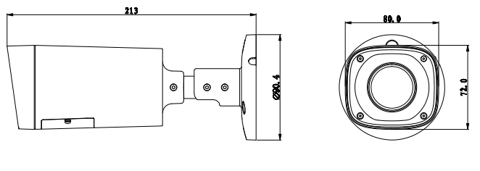
Figure 2-1

Structure
Please refer to the following figures for structure information. See Figure 2-2 and Figure 2-3.
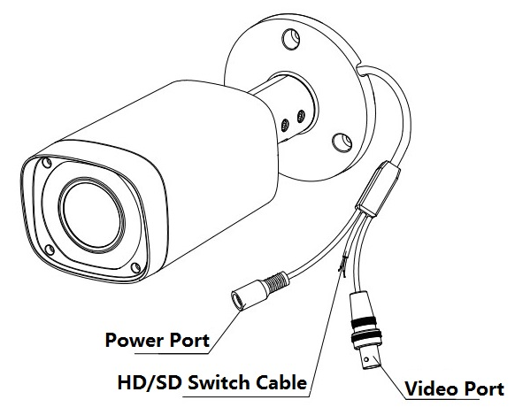
Figure 2-2
When the standard definition/high definition switch control cable is short circuit, system outputs standard definition video. Otherwise, when the circuit is open, system outputs the high definition video.

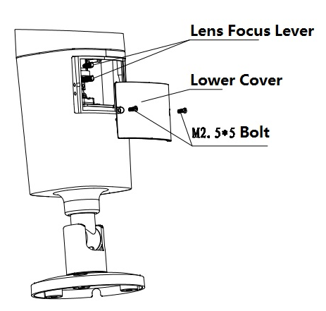
Figure 2-3

3 Installation
Important
Please make sure the installation surface can min support the 3X weight of the camera and the bracket.
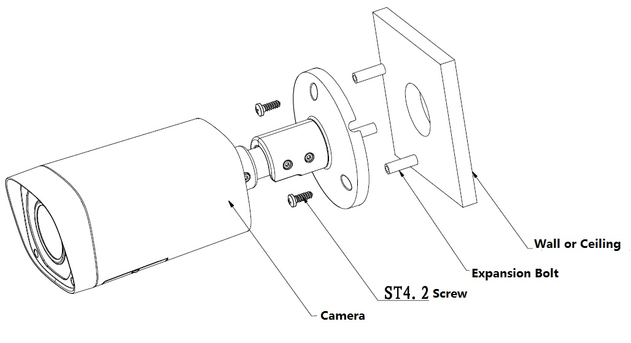
Figure 3-1
Step1
Take out the camera cable through cable exit of the bracket chassis and install camera bracket.
If it is cement wall, you need to install expansion bolt first (the installation hole of expansion bolt need to be in accordance with the bracket), then use self-tapping bolt to install bracket, which is shown in Figure 3-1.

If it is wooden wall, you can skip the first step and use self-tapping bolt to install bracket directly.

Step 2
Unscrew the M3×20 and M3×5 screws on the bracket in the direction shown in Figure 3-2, adjust the camera to an exact location which needs to be monitored by rotating the bracket and camera body, then secure the bolts.
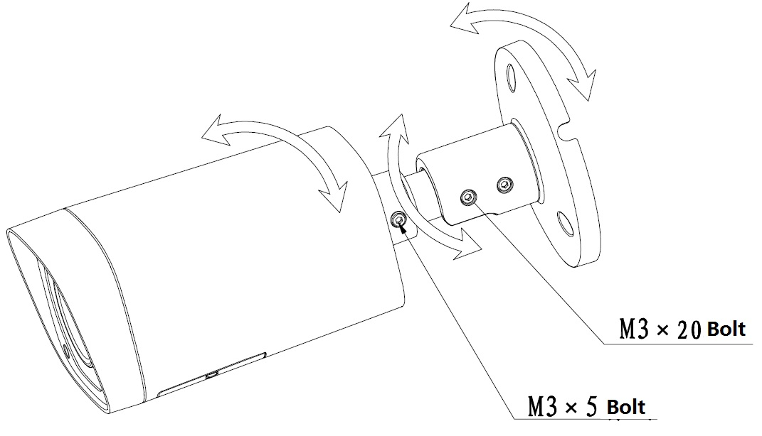
Figure 3-2

Step 3
Connect the video output port of the device cable to the HDCVI DVR, and connect the power port of the device cable to the power.

Step 4
After the image is shown on the HDCVI DVR, open the lower cover of the camera and adjust lens focal length by focus/zoom lever to make the image clear and secure the lever. Retighten the camera lower cover and complete the installation.

Menu

HDCVI Series DVR Settings
Note
The following operation and interfaces for reference only. Please refer to the HDCVI series DVR user’s manual for detailed information.

After connected the camera to the HDCVI series DVR, from Main Menu->Setting->System->PTZ, you need to set control mode as HDCVI and the protocol as DH-SD1. Click Save button to save current setup. See Figure 4-4.
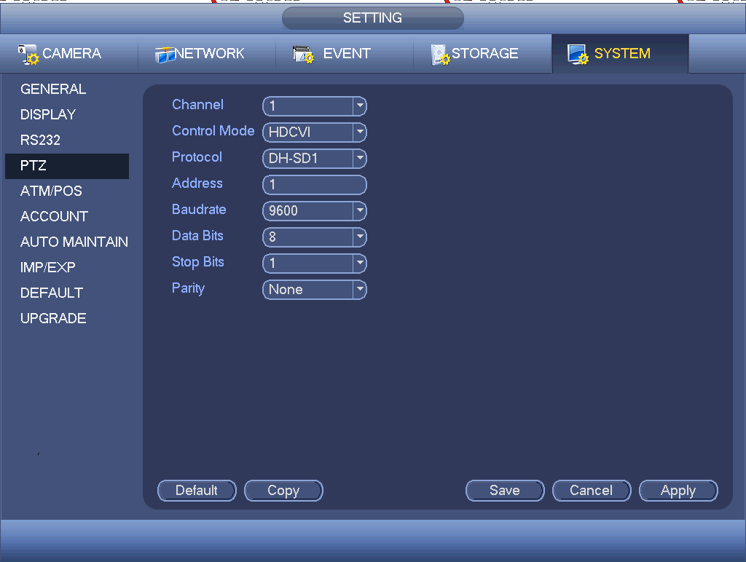
Figure 4-4
On the preview interface, right click mouse and then select PTZ; you can see an interface shown as below. See Figure 4-5.
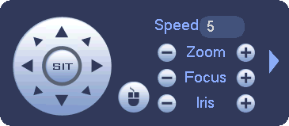
Figure 4-5
Click Iris “+” to open menu or confirm current operation.
Click up/down button to view all the items on the left pane of the following list. Click left/right button to set the corresponding values on the right pane of the following list. If there is “”, click confirm button to go to the 2nd menu. Repeat the previous steps to set detailed value. Click Return button to go back to the previous menu interface.

Menu List
The 1st |  | The 2nd |  | The 3rd
Exposure |  | Exposure Mode | Auto | Gain Max | 0～100
 |  |  |  | Gain Min | 0～100
Exposure |  | Exposure Mode | Low Noise | Gain Max | 0～100
 |  |  |  | Gain Min | 0～100
 |  |  |  | Return&Exit | For the 2nd and the 3rd menu, when you click Exit button to exit, system saves current setup by default.
Exposure |  | Exposure Mode | Low Motion Blur | Shutter Max | - PAL: 0ms～40ms  - NTSC: 0ms～33ms
 |  |  |  | Shutter Min | - PAL: 0ms～40ms  - NTSC: 0ms～33ms
 |  |  |  | Return&Exit
Exposure |  | Exposure Mode | Manual | Shutter | 1/100000, 1/10000, 1/4000,1/2000,1/1000,1/500,1/250,1/120,1/100,1/60,1/50,1/30,1/25,1/15,1/12,1/10,1/8,1/6,1/5,1/4,1/3  Customized
 |  |  |  | Gain Max | 0～100
 |  |  |  | Gain Min | 0～100
 |  |  |  | Return&Exit
Exposure |  | Exp Level | 0～14
Exposure |  | Exp Speed | 0～7
Exposure |  | Anti-flicker | Outoodr/50HZ/60HZ |  | - 50HZ: 1/50, 1/100, 1/25, 1/10, 1/5, 1/4.  - 60HZ: 1/60, 1/120, 1/30, 1/4, 1/12, 1/6.  The 50HZ and 60HZ mode have different manual exposure mode and there is no low motion blur and low noise exposure mode.
Exposure |  | BLC |  | BLC | OFF/ON
 |  |  |  | WDR | 0～100
 |  |  |  | HLC | 0～100  The HLC is valid when auto exposure and outdoor anti-flicker mode are both valid.
 |  |  |  | Return&Exit
White Balance | Auto
White Balance | Manual | Blue | 1～100
White Balance |  | Red | 1～100
White Balance |  | Return&Exit
White Balance | Day
White Balance | Night
White Balance | Indoor
White Balance | Outdoor
Day/Night | Auto | Day→ Night | 1～100
Day/Night |  | Return&Exit
Day/Night | B/W
Day/Night | Color
Function |  | 2DNR | 0～100
Function |  | 3DNR | 0～100
Function |  | D-Zoom | 1～10
Function |  | Lens | Manual/DC
Function |  | Return&Exit
Advanced |  | CAM Title
Advanced |  | Mirror/Flip | Mirror | OFF/ON
Advanced |  |  | Flip | OFF/ON
Advanced |  |  | Return&Exit
Advanced |  | Privacy  Mask | OFF
Advanced |  | Privacy  Mask | ON | Area Sel | 0～7  There are eight privacy mask zones ranging from 0 to 7. You need to set parameters for each zone.
 |  |  |  | Area state | OFF/ON
 |  |  |  | Area setup | Position
Size
Use direction buttons to set position and zone size.
 |  |  |  | Default
 |  |  |  | Return&Exit
Advanced |  | Language | EN
Advanced |  | COM Setup |  | Address | 1～254
 |  |  |  | Apply
 |  |  |  | Return&Exit
Advanced |  | System Info |  | Version | XXXXXXXXX
 |  |  |  | Return&Exit
Image |  | Sharpness | 0～100
Image |  | Brightness | 0～100
Image |  | Contrastness | 0～100
Image |  | Saturation | 0～100
Image |  | Sharp Suppress | 0～100
Image |  | Chroma suppress | 0～100
Image |  | Gamma | 0～15
Image |  | Video Format | /720P@25/720P@30/720P@50/720P@60 | OK/CANCEL | 1080P series support 1080P@25, 1080P@30, 720P@25, 720P@30, 720P@50, 720P@60
Image |  | Return&Exit
Reset
Exit

Note
Parameter | Function
Brightness | It is to adjust monitor window bright. The value ranges from 0 to 100. The default value is 50.  The larger the number is, the bright the video is. When you input the value here, the bright section and the dark section of the video will be adjusted accordingly. You can use this function when the whole video is too dark or too bright. Please note the video may become hazy if the value is too high. The recommended value ranges from 40 to 60.
Contrast | It is to adjust monitor window contrast. The value ranges from 0 to 100. The default value is 50.  The larger the number is, the higher the contrast is. You can use this function when the whole video bright is OK but the contrast is not proper. Please note the video may become hazy if the value is too low. If this value is too high, the dark section may lack brightness while the bright section may over exposure .The recommended value ranges from 40 to 60.
Saturation | It is to adjust monitor window saturation. The value ranges from 0 to 100. The default value is 50.  The larger the number, the strong the color is. This value has no effect on the general brightness of the whole video. The video color may become too strong if the value is too high. For the grey part of the video, the distortion may occur if the white balance is not accurate. Please note the video may not be attractive if the value is too low. The recommended value ranges from 40 to 60.
Sharpness | The value here is to adjust the edge of the video. The value ranges from 0 to 100. The larger the value is, the clear the edge is and vice versa. Please note there is noise if the value here is too high. The default value is 50 and the recommended value ranges from 40 to 60.
3DNR | It is to reduce video noise. The larger the number is, the lower the noise is. The details of the video may disappear if the value here is too large.
Anti-flicker | - Outdoor: In this mode, you can switch exposure mode to get the effect under the corresponding exposure mode.  - 50Hz: When the current is 50Hz, system can auto adjust the exposure according to the environment brightness in case there is any strip.  - 60Hz: When the current is 60Hz, system can auto adjust the exposure according to the environment brightness in case there is any strip.

Appendix Toxic or Hazardous Materials or Elements
Component Name | Toxic or Hazardous Materials or Elements
Component Name | Pb | Hg | Cd | Cr VI | PBB | PBDE
Circuit Board Component | ○ | ○ | ○ | ○ | ○ | ○
Device Construction Material | ○ | ○ | ○ | ○ | ○ | ○
Wire and Cable | ○ | ○ | ○ | ○ | ○ | ○
Packing Components | ○ | ○ | ○ | ○ | ○ | ○
Accessories | ○ | ○ | ○ | ○ | ○ | ○

O: Indicates that the concentration of the hazardous substance in all homogeneous materials in the parts is below the relevant threshold of the SJ/T11363-2006 standard.

X: Indicates that the concentration of the hazardous substance of at least one of all homogeneous materials in the parts is above the relevant threshold of the SJ/T11363-2006 standard. During the environmental-friendly use period (EFUP) period, the toxic or hazardous substance or elements contained in products will not leak or mutate so that the use of these (substances or elements) will not result in any severe environmental pollution, any bodily injury or damage to any assets. The consumer is not authorized to process such kind of substances or elements, please return to the corresponding local authorities to process according to your local government statutes.

Note
- This manual is for reference only. Slight difference may be found in the user interface.
- All the designs and software here are subject to change without prior written notice.
- All trademarks and registered trademarks mentioned are the properties of their respective owners.
- If there is any uncertainty or controversy, please refer to the final explanation of us.
- Please visit our website or contact your local service engineer for more information.

