2 Megapixel HDCVI Dome Camera User's Manual

Version 1.0.0

Table of Contents
1 General Introduction 1
1.1 Overview 1
1.2 Features 1
1.3 Functions 1
1.4 Specifications 1
2 Framework and Dimensions 3
3 Installation 5
4 Menu 7
4.1 HDCVI Series DVR Settings 7
4.2 Menu List 8
4.3 Note 10
Appendix Toxic or Hazardous Materials or Elements 11

Welcome
Thank you for purchasing our HDCVI camera!
This user’s manual is designed to be a reference tool for your system.
Please read the following safeguard and warnings carefully before you use this series product!
Please keep this user’s manual well for future reference!

Important Safeguards and Warnings
1．Electrical safety
All installation and operation here should conform to your local electrical safety codes.
The power shall conform to the requirement in the SELV (Safety Extra Low Voltage) and the Limited power source is rated 12V DC in the IEC60950-1.
We assume no liability or responsibility for all the fires or electrical shock caused by improper handling or installation.

2．Transportation security
Heavy stress, violent vibration or water splash are not allowed during transportation, storage and installation.

3．Installation
Do not apply power to the camera before completing installation.
Please install the proper power cut-off device during the installation connection.
Always follow the instruction guide the manufacturer recommended.
If this product is installed in the ceiling, please make sure the installation position can sustain the min 50N.

4．Qualified engineers needed
All the examination and repair work should be done by the qualified service engineers.
We are not liable for any problems caused by unauthorized modifications or attempted repair.

5．Environment
This series HDCVI camera should be installed in a cool, dry place away from direct sunlight or strong light, inflammable, explosive substances and etc.
This series camera shall work on the specified working temperature. Please keep it away from the electromagnetic radiation object and environment.
Please make sure the CMOS component is out of the radiation of the laser beam device. Otherwise it may result in CMOS optical component damage.
Please keep the sound ventilation.
Do not allow the water and other liquid falling into the camera.

6. Accessories
Be sure to use all the accessories recommended by manufacturer.
Before installation, please open the package and check all the components are included.
Contact your local retailer ASAP if something is broken in your package.

7. Daily Maintenance
Please shut down the device and then unplug the power cable before you begin daily maintenance work.
Use the dry soft cloth to clean the device. If there is too much dust, please use the water to dilute the mild detergent first and then use it to clean the device. Finally use the dry cloth to clean the device.
Please put the dustproof cap to protect the CMOS component when you do not use the camera.

General Introduction

Overview
This series megapixel HD camera conforms to the HDCVI standard. It supports video signal high-speed long distance transmission without any delay. It can be controlled by the DVR conforming to the HDCVI.

Features
- High-performance CMOS image sensor, megapixel definition.
- HD video, coaxial cable to transmit the control signal.
- Support 75-3 coaxial cable transmission without any loss. Transmission distance is over 300m.
- Support HD and standard definition switch.
- Support 1080P@25, 1080P@30, 720P@25, 720P@30, 720P@50, 720P@60.
- High speed, long distance real-time transmission.
- Support OSD (on-screen display), suitable for user self-defined setup.
- Support privacy mask, image digital zoom.
- Support DC12V power supplying.
- Support 3D noise reduction(denoise),excellent performance in low illumination environment.
- IP66 compliance.
- Support ICR switch to realize surveillance both in the daytime and at night.
- Support intelligent IR function.

Functions
HDCVI Specification
HDCVI（High Definition Composite Video Interface） is an over-coaxial –cable HD video transmission standard. The technology renders two HD video formats by progressive scanning.

OSD
User-friendly on-screen display for you to select the different functions.

ICR
The IR cut removal is to filter the IR light in the daytime and then auto switch to the general fitter at night. This function allows the camera to output the high sensitivity and clear video.

Smart IR technology
The sensor controls the IR light on/off via the combination work of the hardware and software, which realizes the automatically IR light compensation according to the environment illumination.

Specifications
Model  Parameter |  | 2 Megapixel HDCVI IR Waterproof Dome Camera Series
 |  | HAC-HDW2200MP/N
Video Processor |  | 1/3" 2 Megapixel CMOS
Video Format |  | PAL/NTSC
Effective Pixel |  | 1920 (H) *1080 (V)
Min Illumination |  | 0.05Lux@（F1.2，AGC ON），0 Lux with IR
Electronic Shutter |  | 1/3s～1/100,000s@（slow shutter*512）
Video Standard |  | HDCVI/CVBS compliance
Video Frame Rate |  | 1920×1080@25fps；1920×1080@30fps；1280×720@25 fps；  1280×720@30 fps；1280×720@50 fps；1280×720@60 fps
Lens Port |  | M12
Lens Type |  | 2.8/3.6/6/8mm optional
Day/Night Switch |  | ICR mechanical auto switch
Video Output |  | 1-channel HDCVI high definition video output/ CVBS standard definition video output (Can switch.)
Denoise (Noise Reduction) |  | Support 2D/3D denoise.
OSD Menu Control |  | Support coaxial cable control
OSD | EXPOSURE | Exposure Mode/Exposure Level/Exposure Speed/Anti Flicker/BLC/Return
OSD | WHITE BALANCE | Auto/Manual/Day/Night/Return&Exit
OSD | DAY/NIGHT | Auto/B&W/Color/ Return&Exit
OSD | FUNCTION | 2DNR/3DNR/D-zoom/Lens/ Return&Exit
OSD | ADVANCED | Cam Title/Mirror&Flip/Motion Detect/Privacy Mask/Language/COM Setup/System Info/ Return&Exit
OSD | IMAGE | Sharpness/Brightness/Contrastness/Saturation/Sharp Suppress/ Chroma Suppress/Gamma/Video Format/ Return&Exit
OSD | RESET | /
OSD | EXIT | /
Max IR Distance |  | 20m
IR Light Control Plan |  | Advanced non-photosensor control plan
Transmission Distance |  | Over 300m via 75-3 coaxial cable.
Protection Level |  | IP66
Working Temperature /Humidity |  | -30℃~+60℃. Humidity is less than 95%(no condensation)
Power |  | DC 12V±10%
Power Consumption |  | 3.5W MAX (Input: 12V0.29A)
Dimension(mm) |  | φ94.0×98.0
Weight |  | 350g
Installation Mode |  | Wall mount/In-ceiling mount

Framework and Dimensions
Please refer to the following figures for dimension information. The unit is mm. See Figure 2-1 and Figure 2-2.
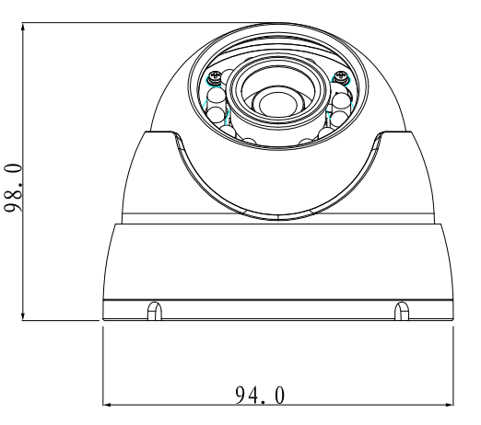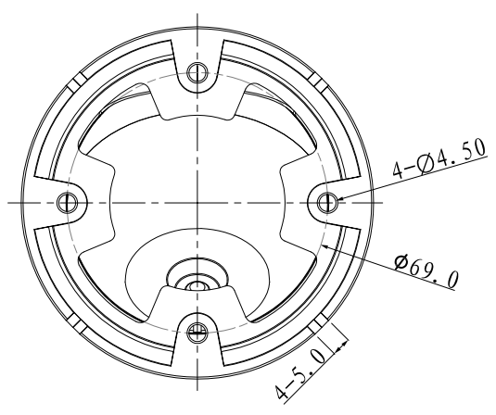
Figure 2-1
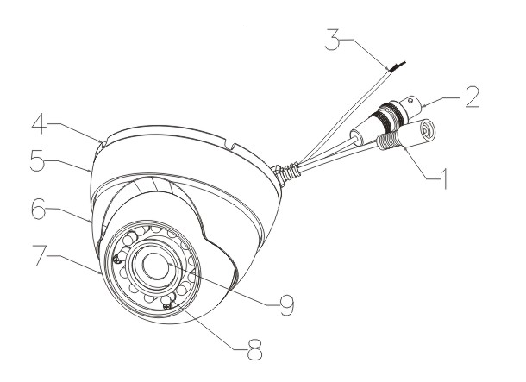
Figure 2-2
Please refer to the following sheet for detailed information.
SN | Name | Function
1 | Power input port | Connect to the DC 12V power to input the power.
2 | Video output port | BNC port is to output HDCVI/CVBS video signal.  You can connect to the devices such as the DVR or the NVS conforming to the HDCVI specifications.
3 | Standard definition/high definition switch control cable | When the standard definition/high definition switch control cable is short circuit, system outputs standard definition video. Otherwise, when the circuit is open, system outputs the high definition video.
4 | Installation base | Device installation base
5 | Pan base | Adjust the pan base to adjust the monitor angle.
6 | Rotate base | Adjust the rotate base to adjust the monitor angle.
7 | Dome Body | Adjust the dome body to adjust monitor angle.
8 | IR light | It is to send out the IR compensation light to enhance the night vision.
9 | Lens | It is to receive the optical signal from the environments.

Installation
Important
Please make sure the installation surface can min support the 3X weight of the camera and the bracket.

The dome camera usually uses the ceiling installation. It can be installed on the ceiling or the wall.

Step1 Device Installation
Take the wrench from the accessories bag and use it to loosen the three set screws on the side of the camera body. See Figure 3-3.
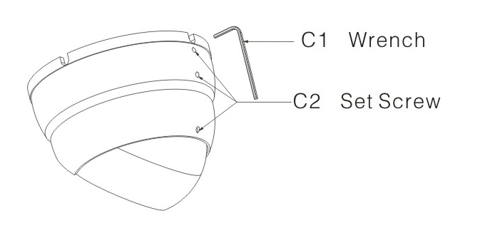
Figure 3-3

Step 2 Pedestal Installation
Turn the pedestal of the device and then pull the cable through it. Use four screws to secure the pedestal to the proper position. See Figure 3-4.
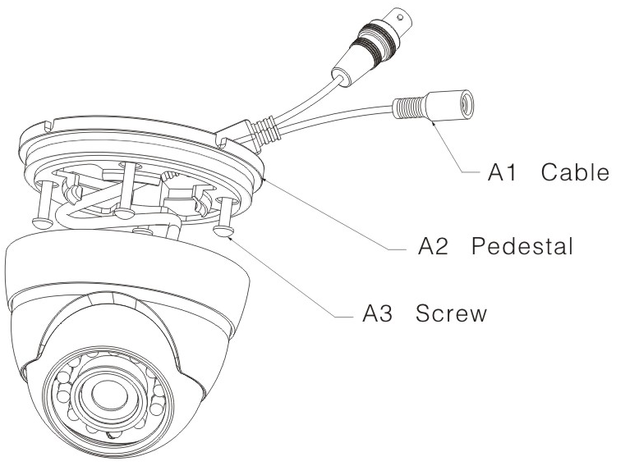
Figure 3-4
Step 3 Adjust Monitor Angle
Turn the pan base to the pedestal and secure firmly. Adjust rotate base and the dome body to get the lens to the proper monitor angle. See Figure 3-5.
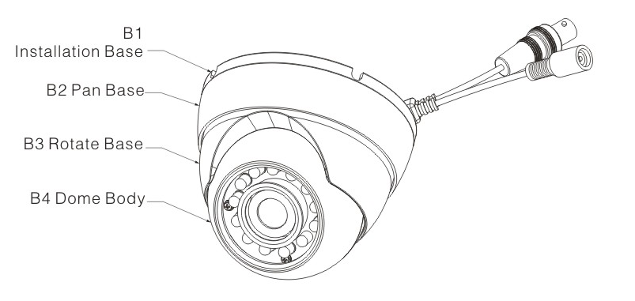
Figure 3-5

Step 4 Fix Monitor Angle
To prevent the dome from moving, use wrench to secure the three set screws to secure the monitor angle position.

Menu

HDCVI Series DVR Settings
Note
The following operation and interfaces for reference only. Please refer to the HDCVI series DVR user’s manual for detailed information.

After connected the camera to the HDCVI series DVR, from Main Menu->Setting->System->PTZ, you need to set control mode as HDCVI and the protocol as DH-SD1. Click Save button to save current setup. See Figure 4-6.
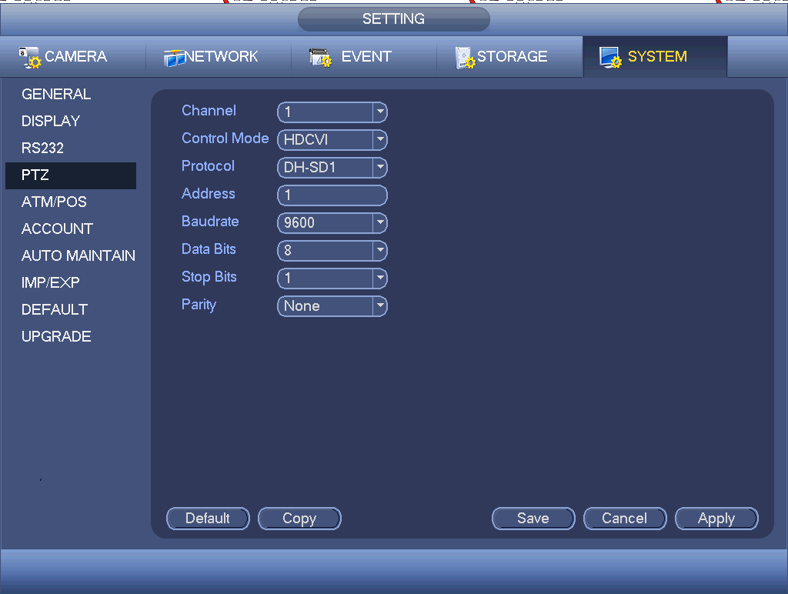
Figure 4-6
On the preview interface, right click mouse and then select PTZ; you can see an interface shown as below. See Figure 4-7.
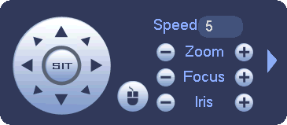
Figure 4-7
Click Iris “+” to open menu or confirm current operation.
Click up/down button to view all the items on the left pane of the following list. Click left/right button to set the corresponding values on the right pane of the following list. If there is “”, click confirm button to go to the 2nd menu. Repeat the previous steps to set detailed value. Click Return button to go back to the previous menu interface.

Menu List
The 1st |  | The 2nd |  | The 3rd
Exposure |  | Exposure Mode | Auto
Exposure |  | Exposure Mode | Low Noise | Gain Max | 0～100
 |  |  |  | Gain Min | 0～100
 |  |  |  | Return&Exit | For the 2nd and the 3rd menu, when you click Exit button to exit, system saves current setup by default.
Exposure |  | Exposure Mode | Low Motion Blur | Shutter Max | - PAL: 0ms～40ms  - NTSC: 0ms～33ms
 |  |  |  | Shutter Min | - PAL: 0ms～40ms  - NTSC: 0ms～33ms
 |  |  |  | Return&Exit
Exposure |  | Exposure Mode | Manual | Shutter | 1/100000, 1/10000, 1/4000,1/2000,1/1000,1/500,1/250,1/120,1/100,1/60,1/50,1/30,1/25,1/15,1/12,1/10,1/8,1/6,1/5,1/4,1/3  Customized
 |  |  |  | Gain Max | 0～100
 |  |  |  | Gain Min | 0～100
 |  |  |  | Return&Exit
Exposure |  | Exp Level | 0～14
Exposure |  | Exp Speed | 0～7
Exposure |  | Anti-flicker | Outoodr/50HZ/60HZ |  | - 50HZ: 1/50, 1/100, 1/25, 1/10, 1/5, 1/4.  - 60HZ: 1/60, 1/120, 1/30, 1/4, 1/12, 1/6.  The 50HZ and 60HZ mode have different manual exposure mode and there is no low motion blur and low noise exposure mode.
Exposure |  | BLC |  | BLC | OFF/ON
 |  |  |  | WDR | 0～100
 |  |  |  | HLC | 0～100  The HLC is valid when auto exposure and outdoor anti-flicker mode are both valid.
 |  |  |  | Return&Exit
White Balance | Auto
White Balance | Manual | Blue | 1～100
White Balance |  | Red | 1～100
White Balance |  | Return&Exit
White Balance | Day
White Balance | Night
Day/Night | Auto
Day/Night | B/W
Day/Night | Color
Function |  | 2DNR | 0～100
Function |  | 3DNR | 0～100
Function |  | D-Zoom | 1～10
Function |  | Lens | Manual/DC
Function |  | Return&Exit
Advanced |  | CAM Title
Advanced |  | Mirror/Flip | Mirror | OFF/ON
Advanced |  |  | Flip | OFF/ON
Advanced |  |  | Return&Exit
Advanced |  | Motion Detect | OFF
Advanced |  | Motion Detect | ON | Area Sel | 0～3  There are four motion detect zones ranging from 0 to 3. You need to set parameters for each zone.
 |  |  |  | Area State | OFF/ON
 |  |  |  | Sensitivity | 0～100
 |  |  |  | Threshold | 0～100
 |  |  |  | Area Setup | Position
Size
Use direction buttons to set position and zone size.
 |  |  |  | Default
 |  |  |  | Return&Exit
Advanced |  | Privacy  Mask | OFF
Advanced |  | Privacy  Mask | ON | Area Sel | 0～7  There are eight privacy mask zones ranging from 0 to 7. You need to set parameters for each zone.
 |  |  |  | Area state | OFF/ON
 |  |  |  | Area setup | Position
Size
Use direction buttons to set position and zone size.
 |  |  |  | Default
 |  |  |  | Return&Exit
Advanced |  | Language | EN
Advanced |  | COM Setup |  | Address | 1～254
 |  |  |  | Apply
 |  |  |  | Return&Exit
Advanced |  | System Info |  | Version | XXXXXXXXX
 |  |  |  | Return&Exit
Image |  | Sharpness | 0～100
Image |  | Brightness | 0～100
Image |  | Contrastness | 0～100
Image |  | Saturation | 0～100
Image |  | Sharp Suppress | 0～100
Image |  | Chroma suppress | 0～100
Image |  | Gamma | 0～5
Image |  | Video Format | 1080P@25/1080P@30/720P@25/720P@30/720P@50/720P@60 | OK/CANCEL
Image |  | Return&Exit
Reset
Exit

Note
Parameter | Function
Brightness | It is to adjust monitor window bright. The value ranges from 0 to 100. The default value is 50.  The larger the number is, the bright the video is. When you input the value here, the bright section and the dark section of the video will be adjusted accordingly. You can use this function when the whole video is too dark or too bright. Please note the video may become hazy if the value is too high. The recommended value ranges from 40 to 60.
Contrast | It is to adjust monitor window contrast. The value ranges from 0 to 100. The default value is 50.  The larger the number is, the higher the contrast is. You can use this function when the whole video bright is OK but the contrast is not proper. Please note the video may become hazy if the value is too low. If this value is too high, the dark section may lack brightness while the bright section may over exposure .The recommended value ranges from 40 to 60.
Saturation | It is to adjust monitor window saturation. The value ranges from 0 to 100. The default value is 50.  The larger the number, the strong the color is. This value has no effect on the general brightness of the whole video. The video color may become too strong if the value is too high. For the grey part of the video, the distortion may occur if the white balance is not accurate. Please note the video may not be attractive if the value is too low. The recommended value ranges from 40 to 60.
Sharpness | The value here is to adjust the edge of the video. The value ranges from 0 to 100. The larger the value is, the clear the edge is and vice versa. Please note there is noise if the value here is too high. The default value is 50 and the recommended value ranges from 40 to 60.
3DNR | It is to reduce video noise. The larger the number is, the lower the noise is. The details of the video may disappear if the value here is too large.
Anti-flicker | - Outdoor: In this mode, you can switch exposure mode to get the effect under the corresponding exposure mode.  - 50Hz: When the current is 50Hz, system can auto adjust the exposure according to the environment brightness in case there is any strip.  - 60Hz: When the current is 60Hz, system can auto adjust the exposure according to the environment brightness in case there is any strip.

Appendix Toxic or Hazardous Materials or Elements
Component Name | Toxic or Hazardous Materials or Elements
Component Name | Pb | Hg | Cd | Cr VI | PBB | PBDE
Circuit Board Component | ○ | ○ | ○ | ○ | ○ | ○
Device Construction Material | ○ | ○ | ○ | ○ | ○ | ○
Wire and Cable | ○ | ○ | ○ | ○ | ○ | ○
Packing Components | ○ | ○ | ○ | ○ | ○ | ○
Accessories | ○ | ○ | ○ | ○ | ○ | ○

O: Indicates that the concentration of the hazardous substance in all homogeneous materials in the parts is below the relevant threshold of the SJ/T11363-2006 standard.

X: Indicates that the concentration of the hazardous substance of at least one of all homogeneous materials in the parts is above the relevant threshold of the SJ/T11363-2006 standard. During the environmental-friendly use period (EFUP) period, the toxic or hazardous substance or elements contained in products will not leak or mutate so that the use of these (substances or elements) will not result in any severe environmental pollution, any bodily injury or damage to any assets. The consumer is not authorized to process such kind of substances or elements, please return to the corresponding local authorities to process according to your local government statutes.

Note
- This manual is for reference only. Slight difference may be found in the user interface.
- All the designs and software here are subject to change without prior written notice.
- All trademarks and registered trademarks mentioned are the properties of their respective owners.
- If there is any uncertainty or controversy, please refer to the final explanation of us.
- Please visit our website or contact your local service engineer for more information.

