HDCVI Dome Camera
User's Manual

Version 1.0.0

Table of Contents
1 General Introduction 1
1.1 Overview 1
1.2 Features 1
2 Framework and Dimensions 2
2.1 HAC-HDBW2120EP/N and HAC-HDBW2220EP/N 2
2.2 HAC-HDW2120SP/N and HAC-HDW2220SP/N 2
2.3 HAC-HDW2120MP/N and HAC-HDW2220MP/N 3
3 Installation 5
3.1 HAC-HDBW2120EP/N and HAC-HDBW2220EP/N 5
3.2 HAC-HDW2120SP/N and HAC-HDW2220SP/N 6
3.3 HAC-HDW2120MP/N and HAC-HDW2220MP/N 8
4 Menu 10
4.1 HDCVI Series DVR Settings 10
Appendix Toxic or Hazardous Materials or Elements 12

Welcome
Thank you for purchasing our HDCVI camera!
This user’s manual is designed to be a reference tool for your system.
Please read the following safeguard and warnings carefully before you use this series product!
Please keep this user’s manual well for future reference!

Important Safeguards and Warnings
1．Electrical safety
All installation and operation here should conform to your local electrical safety codes.
The power shall conform to the requirement in the SELV (Safety Extra Low Voltage) and the Limited power source is rated 12V DC (24V AC) in the IEC60950-1.
We assume no liability or responsibility for all the fires or electrical shock caused by improper handling or installation.

2．Transportation security
Heavy stress, violent vibration or water splash are not allowed during transportation, storage and installation.

3．Installation
Do not apply power to the camera before completing installation.
Please install the proper power cut-off device during the installation connection.
Always follow the instruction guide the manufacturer recommended.
If this product is installed in the ceiling, please make sure the installation position can sustain the min 50N.

4．Qualified engineers needed
All the examination and repair work should be done by the qualified service engineers.
We are not liable for any problems caused by unauthorized modifications or attempted repair.

5．Environment
This series camera should be installed in a cool, dry place away from direct sunlight or strong light, inflammable, explosive substances and etc.
This series camera shall work on the specified working temperature. Please keep it away from the electromagnetic radiation object and environment.
Please keep the sound ventilation.
Do not allow the water and other liquid falling into the camera.

6. Accessories
Be sure to use all the accessories recommended by manufacturer.
Before installation, please open the package and check all the components are included.
Contact your local retailer ASAP if something is broken in your package.

7. Daily Maintenance
Please shut down the device and then unplug the power cable before you begin daily maintenance work.
Use the dry soft cloth to clean the device.
If there is too much dust, please use the water to dilute the mild detergent first and then use it to clean the device. Finally use the dry cloth to clean the device.
Please put the dustproof cap to protect the CCD (CMOS) component when you do not use the camera.
Applicable model
This manual can be applied to following models:
1 Megapixel 720P Vandal-proof IR HDCVI Dome Camera
HAC-HDBW2120EP | HAC-HDBW2120EN
1 Megapixel 720P IR HDCVI Dome Camera
HAC-HDW2120SP | HAC-HDW2120SN
HAC-HDW2120MP | HAC-HDW2120MN
2 Megapixel 1080P Vandal-proof IR HDCVI Dome Camera
HAC-HDBW2220EP | HAC-HDBW2220EN
2 Megapixel 1080P IR HDCVI Dome Camera
HAC-HDW2220SP | HAC-HDW2220SN
HAC-HDW2220MP | HAC-HDW2220MN

General Introduction

Overview
This series megapixel HD camera conforms to the HDCVI standard. It supports video signal high-speed long distance transmission without any delay. It can be controlled by the DVR conforming to the HDCVI.

Features
- High-performance CMOS image sensor, megapixel definition.
- Support HD video and control signal coaxial transmission.
- Support 75-3 coaxial cable transmission without any loss. 720P series transmission distance over 500m, 1080P series transmission distance over 300m.
- High speed, long distance real-time transmission.
- Support HDCVI HD and analog SD switch output.
- 720P series support 720P@25, 720P@30, 720P@50, 720P@60.
1080P series support 1080P@25, 1080P@30, 720P@25, 720P@30, 720P@50, 720P@60.
- Support high performance 3D noise reduction (denoise), excellent performance in low illumination
- Support ICR switch to realize surveillance both in the daytime and at night.
- 3.6mm fixed lens (2.8mm, 6mm, 8mm optional).
- Support OSD (on-screen display), suitable for user self-defined setup.
- Support DC12V power supplying.
- IP66 compliance.
- Support intelligent IR function, max IR distance 20m.

Framework and Dimensions

HAC-HDBW2120EP/N and HAC-HDBW2220EP/N
Please refer to the following figures for dimension information. The unit is mm. See Figure 2-1 to Figure 2-3.
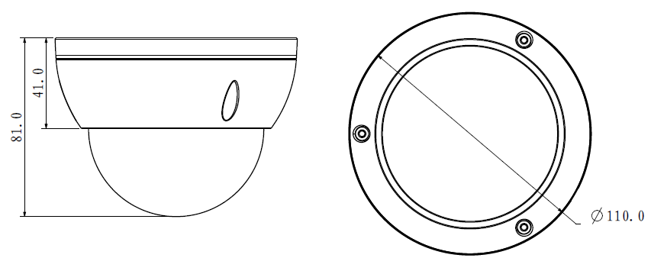
Figure 2-1
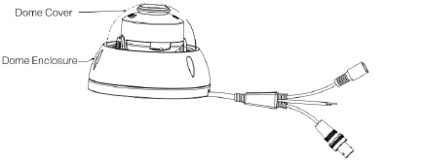
Figure 2-2
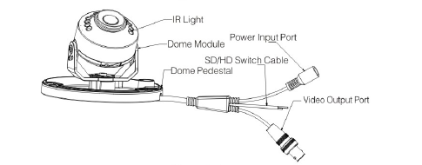
Figure 2-3

HAC-HDW2120SP/N and HAC-HDW2220SP/N
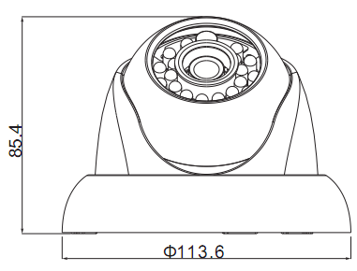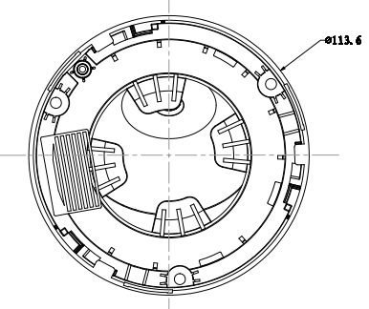
Figure 2-4
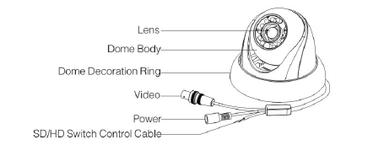
Figure 2-5

HAC-HDW2120MP/N and HAC-HDW2220MP/N
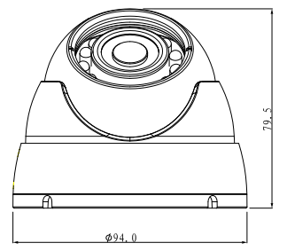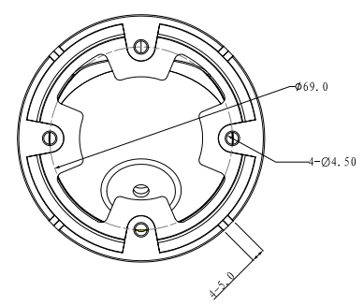
Figure 2-6
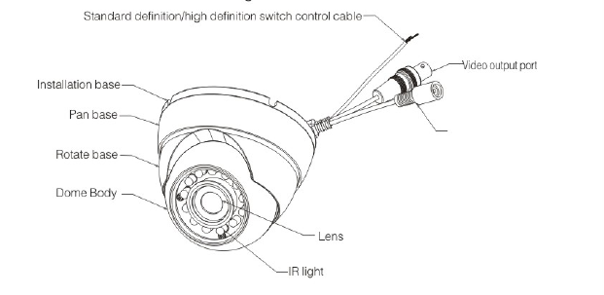
Figure 2-7

When the standard definition/high definition switch control cable is short circuit, system outputs standard definition video. Otherwise, when the circuit is open, system outputs the high definition video.

Installation
Important
- Before the installation, please make sure the installation surface can sustain at least 3X weight of the bracket and the camera.

HAC-HDBW2120EP/N and HAC-HDBW2220EP/N
The dome camera usually uses the ceiling installation. It can be installed on the ceiling or the wall.
- For side exit cable installation, please make sure the side exit cable direction is the same as shown in the installation position map.
- Before you secure the screws on the pedestal, please put the cable through the cable exit of the pedestal.
- Before you complete the installation and debug, do not remove the electrostatic film. After you remove the film, do not touch the enclosure in case there is any scratch.
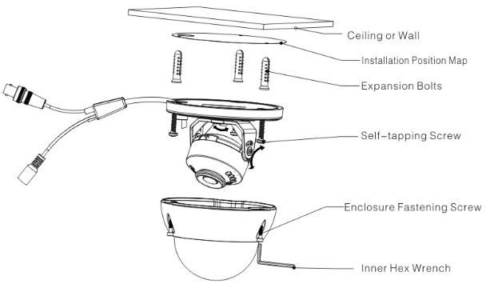
Figure 3-1
Step 1
Take the installation position map from the accessories bag and then put it on the surface of the ceiling or the wall according to the cable exit position. Dig three holes according to the installation position map and then take three expansion bolts from the accessories bag and put them to the holes you just dug.

Step 2
Use inner hex wrench to remove the three enclosure fastening screws and then remove the dome enclosure.

Step 3
Adjust the pedestal position according to the cable exit mode (ceiling/side). Pull the cable through the cable side exit at the installation surface and the pedestal (Please skip this step if you want to use ceiling exit mode). Line up the screw holes at the bottom of the pedestal to the expansion bolts in the installation surface. Put three self-tapping screws to expansion bolts and then secure firmly. Now the pedestal is on the installation surface.
Step 4
Adjust the camera module angle to a proper position and then fix the screws to fasten.

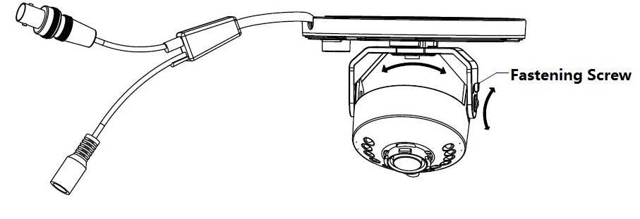
Figure 3-2
Step 5
Use three enclosure fastening screws to secure the dome housing on the pedestal.

HAC-HDW2120SP/N and HAC-HDW2220SP/N
Step1
Please take the installation position map in the accessories bag, and then paste it on the ceiling or the wall according to your monitor area requirements. Draw and then dig three holes in the installation surface and then insert three expansion bolts in the holes. Secure these three bolts firmly.

Step 2
Turn counter clockwise to remove the decoration ring. Please dig a “cable exit hole” in the surface according to the installation position map if you want to draw out the cable from the top of the installation surface. You need to draw out the cable from the cable channel side port of the pedestal if you want to draw out the cable from the side port of the cable channel. Adjust the device installation pedestal to the proper position and then draw the cable through the cable exit. Line up the three screw holes in the device pedestal to the three plastic expansion bolt holes in the installation position. Put the three self-tapping screws in the three plastic expansion bolts firmly. Now the dome camera is secure in the installation surface. See Figure 3-3.

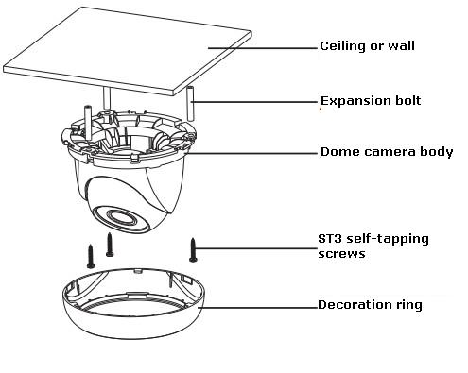
Figure 3-3

Step 3
Adjust the lens to get the clear monitor video. See Figure 3-4.Use crosshead screwdriver to loosen the screw and the turn the camera body to the proper position manually. Fix the screw again.
Important
Do not remove the screw. Loosen a little bit will be OK. Please secure after you completed the setup.
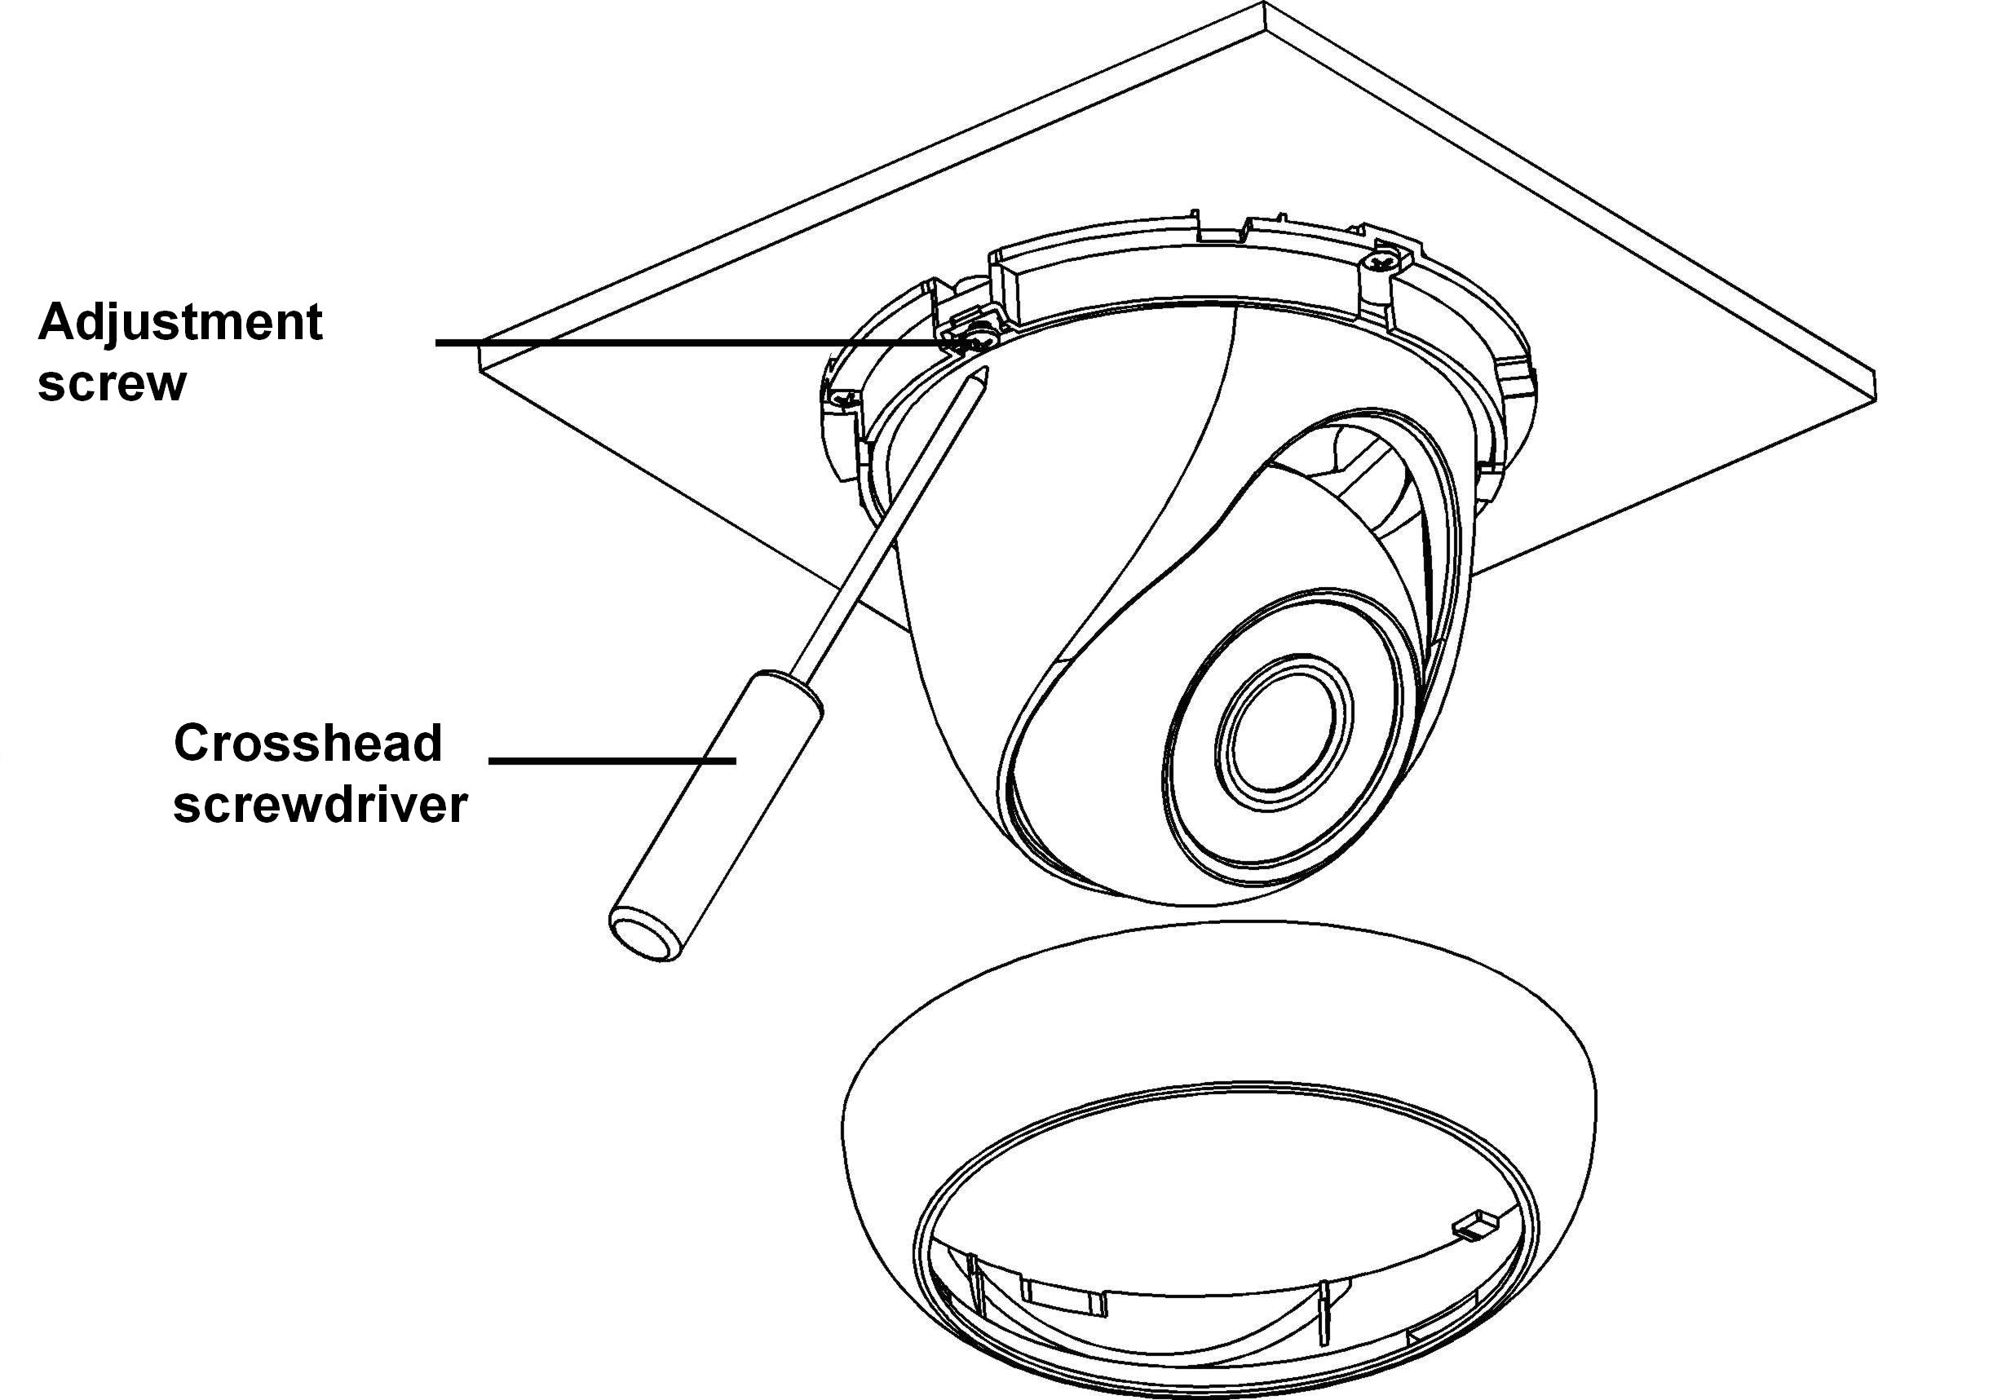
Figure 3-4
Step 4
Line up the bulge of the decoration ring to the nick of the camera body and install along the tilt installation. Push and then turn decoration ring clockwise. The installation completed after you secure the decoration ring. You need to use the proper tool to open up the side port of the U-cable channel of the decoration ring if you want to draw out the cable from the side port of the cable channel when you are installing the device cable. And then you can draw out the cable from the cable channel of the pedestal. Finally you can install the decoration ring to complete the installation.

HAC-HDW2120MP/N and HAC-HDW2220MP/N
Step1 Device Installation
Take the wrench from the accessories bag and use it to loosen the three set screws on the side of the camera body. See Figure 3-5.
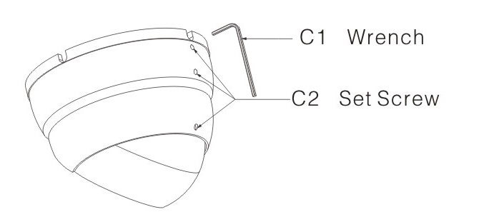
Figure 3-5

Step 2 Pedestal Installation
Turn the pedestal of the device and then pull the cable through it. Use four screws to secure the pedestal to the proper position. See Figure 3-6.
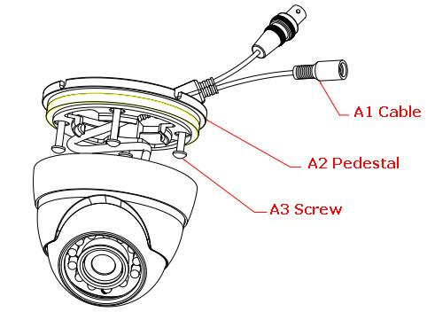
Figure 3-6
Step 3 Adjust Monitor Angle
Turn the pan base to the pedestal and secure firmly. Adjust rotate base and the dome body to get the lens to the proper monitor angle. See Figure 3-7.
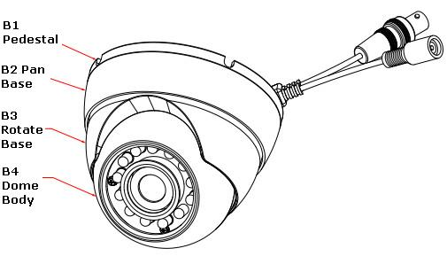
Figure 3-7
Step 4 Fix Monitor Angle
To prevent the dome from moving, use wrench to secure the three set screws to secure the monitor angle position.

Menu

HDCVI Series DVR Settings
Note
The following operation and interfaces for reference only. Please refer to the HDCVI series DVR user’s manual for detailed information.

After connected the camera to the HDCVI series DVR, from Main Menu->Setting->System->PTZ, you need to set control mode as HDCVI and the protocol as DH-SD1. Click Save button to save current setup. See Figure 4-2.
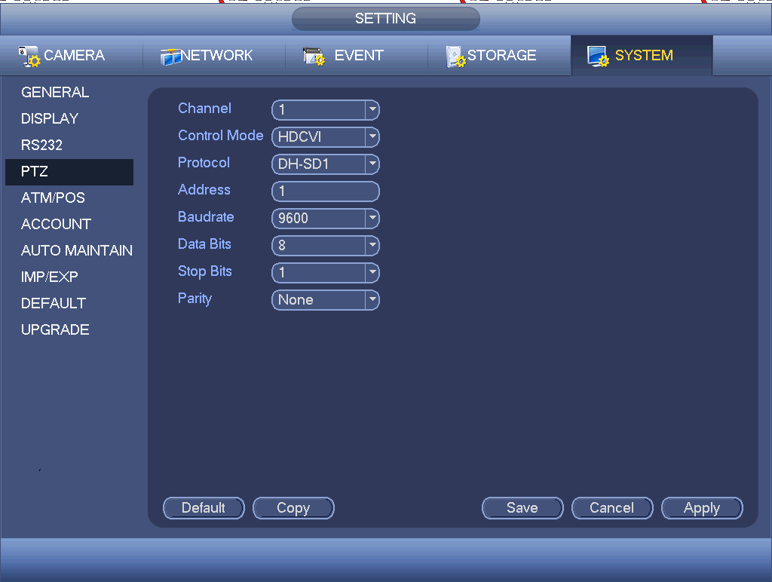
Figure 4-2
On the preview interface, right click mouse and then select PTZ; you can see an interface shown as below. See Figure 4-3.
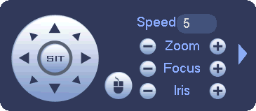
Figure 4-3
Click Iris “+” to open menu or confirm current operation.
Click up/down button to view all the items on the left pane of the following list. Click left/right button to set the corresponding values on the right pane of the following list. If there is “”, click confirm button to go to the 2nd menu. Repeat the previous steps to set detailed value. Click Return button to go back to the previous menu interface.

Appendix Toxic or Hazardous Materials or Elements
Component Name | Toxic or Hazardous Materials or Elements
Component Name | Pb | Hg | Cd | Cr VI | PBB | PBDE
Circuit Board Component | ○ | ○ | ○ | ○ | ○ | ○
Device Construction Material | ○ | ○ | ○ | ○ | ○ | ○
Wire and Cable | ○ | ○ | ○ | ○ | ○ | ○
Packing Components | ○ | ○ | ○ | ○ | ○ | ○
Accessories | ○ | ○ | ○ | ○ | ○ | ○

O: Indicates that the concentration of the hazardous substance in all homogeneous materials in the parts is below the relevant threshold of the SJ/T11363-2006 standard.

X: Indicates that the concentration of the hazardous substance of at least one of all homogeneous materials in the parts is above the relevant threshold of the SJ/T11363-2006 standard. During the environmental-friendly use period (EFUP) period, the toxic or hazardous substance or elements contained in products will not leak or mutate so that the use of these (substances or elements) will not result in any severe environmental pollution, any bodily injury or damage to any assets. The consumer is not authorized to process such kind of substances or elements, please return to the corresponding local authorities to process according to your local government statutes.

Note
- This manual is for reference only. Slight difference may be found in the user interface.
- All the designs and software here are subject to change without prior written notice.
- All trademarks and registered trademarks mentioned are the properties of their respective owners.
- If there is any uncertainty or controversy, please refer to the final explanation of us.
- Please visit our website or contact your local service engineer for more information.

