1 Megapixel HDCVI Fixed and Dome Camera User's Manual

Version 1.0.0

Table of Contents
1 General Introduction 1
1.1 Overview 1
1.2 Features 1
1.3 Functions 1
1.4 Specifications 2
2 Framework and Dimensions 4
2.1 HAC-HDW1100DP/N 4
2.2 HAC-HFW1100BP/N 5
2.3 HAC-HFW1100DP/N 5
3 Installation 7
3.1 Dome Camera 7
3.2 Fixed Camera 7
Appendix Toxic or Hazardous Materials or Elements 10

Welcome
Thank you for purchasing our HDCVI camera!
This user’s manual is designed to be a reference tool for your system.
Please read the following safeguard and warnings carefully before you use this series product!
Please keep this user’s manual well for future reference!

Important Safeguards and Warnings
1．Electrical safety
All installation and operation here should conform to your local electrical safety codes.
The power shall conform to the requirement in the SELV (Safety Extra Low Voltage) and the Limited power source is rated 12V DC (24V AC) in the IEC60950-1.
We assume no liability or responsibility for all the fires or electrical shock caused by improper handling or installation.

2．Transportation security
Heavy stress, violent vibration or water splash are not allowed during transportation, storage and installation.

3．Installation
Do not apply power to the camera before completing installation.
Please install the proper power cut-off device during the installation connection.
Always follow the instruction guide the manufacturer recommended.
If this product is installed in the ceiling, please make sure the installation position can sustain the min 50N.

4．Qualified engineers needed
All the examination and repair work should be done by the qualified service engineers.
We are not liable for any problems caused by unauthorized modifications or attempted repair.

5．Environment
This series camera should be installed in a cool, dry place away from direct sunlight or strong light, inflammable, explosive substances and etc.
This series camera shall work on the specified working temperature. Please keep it away from the electromagnetic radiation object and environment.
Please keep the sound ventilation.
Do not allow the water and other liquid falling into the camera.

6. Accessories
Be sure to use all the accessories recommended by manufacturer.
Before installation, please open the package and check all the components are included.
Contact your local retailer ASAP if something is broken in your package.

7. Daily Maintenance
Please shut down the device and then unplug the power cable before you begin daily maintenance work.
Use the dry soft cloth to clean the device.
If there is too much dust, please use the water to dilute the mild detergent first and then use it to clean the device. Finally use the dry cloth to clean the device.
Please put the dustproof cap to protect the CCD (CMOS) component when you do not use the camera.

General Introduction

Overview
This series megapixel HD camera conforms to the HDCVI standard. It supports video signal high-speed long distance transmission without any delay. It can be controlled by the DVR conforming to the HDCVI.

Features
- High-performance CMOS image sensor, megapixel definition.
- HD video, coaxial cable to transmit the control signal.
- Support 75-3 coaxial cable transmission without any loss. Transmission distance is over 500m.
- High speed, long distance real-time transmission.
- Support ICR switch to realize surveillance both in the daytime and at night.
- Support auto exposure, auto white balance, auto electronic shutter and auto gain function.
- Restore clear and vivid video, high signal to noise ratio (SNR).
- Support DC12V power supplying.
- IP66 compliance. (For HAC-HFW1100BP/N and HAC-HFW1100DP/N series only.)
- Support intelligent IR function.

Functions
HDCVI Specification
HDCVI（High Definition Composite Video Interface） is an over-coaxial –cable HD video transmission standard. The technology renders two HD video formats by progressive scanning.

ICR
The IR cut removal is to filter the IR light in the daytime and then auto switch to the general fitter at night. This function allows the camera to output the high sensitivity and clear video.

Smart IR technology
The sensor controls the IR light on/off via the combination work of the hardware and software, which realizes the automatically IR light compensation according to the environment illumination.

Auto gain function
To output the standard video signal in the different illumination environments, the amplifier needs to adjust in a wide range. The system can enhance the camera sensitivity in low illumination and enhance the video signal output to get the clear and high definition video.

SNR
It is the ratio value between the signal voltage and the noise voltage. The higher the SNR value, the lower the adverse effect. It is to guarantee the clear video.

Auto white balance
The white balance refers to the camera to restore the white object color. It allows the camera to automatically adjust the color temperature in indoor and outdoor environment, just like our human eyes does.

Auto exposure
System can automatically set shutter speed and iris value according to the snapshot video exposure condition.

Auto electronic shutter
The system can automatically adjust the electronic shutter when the environment light changes.

Specifications
Model  Parameter | 1 Megapixel HDCVI Mini IR Dome Camera Series | 1 Megapixel HDCVI IR Waterproof Fixed Camera Series | 1 Megapixel HDCVI IR Waterproof Fixed Camera Series
Model  Parameter | HAC-HDW1100DP/N | HAC-HFW1100BP/N | HAC-HFW1100DP/N
Video Processor | 1/2.9" 1.0 Mega Pixels CMOS
Video Format | PAL/NTSC
Effective Pixel | 1280（H）* 720（V）
Min Illumination | 0.01Lux @（F1.2,AGC ON），0Lux with IR
Electronic Shutter | PAL：1/50s~1/100,000s  NTSC：1/60s~1/100,000s
Video Standard | HDCVI compliance
Video Frame Rate | PAL：1280×720@25 fps  NTSC：1280×720@30 fps
Lens Port | M12
Lens Type | 2.8/3.6/6/8mm optional | 2.8/3.6/6/8mm optional | 3.6/6/8/12/16mm optional
Day/Night Switch | ICR auto switch
Sync Mode | INT
Video Output | 1-channel HDCVI high definition video output
White Balance | Auto
Gain Control | Auto
BLC | Auto
IR Light Control Plan | Advanced non-photosensor control plan
Transmission Distance | Over 500m via 75-3 coaxial cable.
Smart IR | Support
Max IR Distance | 20m | 30m | 50m
Protection Level | N/A | IP66 | IP66
Working Temperature /Humidity | -30℃~+60℃. Humidity is less than 95%(no condensation)
Power | DC 12V±10%
Power Consumption | 2.5W MAX  (Input: 12V0.21A) | 4.9W MAX  (Input: 12V0.41A) | 7W MAX  (Input: 12V0.58A)
Dimension(mm) | φ108×86.5 | 185.3×87.6×82.0 | 185.3×87.6×82.0
Weight | 150g | 450g | 450g
Installation Mode | Wall mount/In-ceiling mount | Wall mount | Wall mount

Framework and Dimensions

HAC-HDW1100DP/N
Please refer to the following figures for dimension information. The unit is mm. See Figure 2-1 and Figure 2-2.
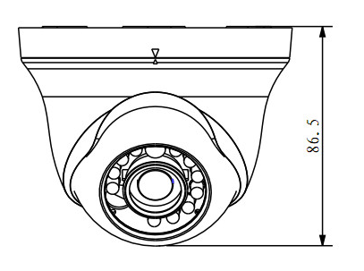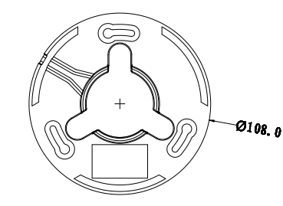
Figure 2-1
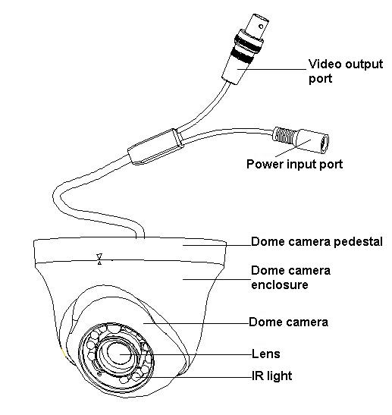
Figure 2-2

HAC-HFW1100BP/N
Please refer to the following figure for dimension information. The unit is mm. See Figure 2-3 and Figure 2-4.
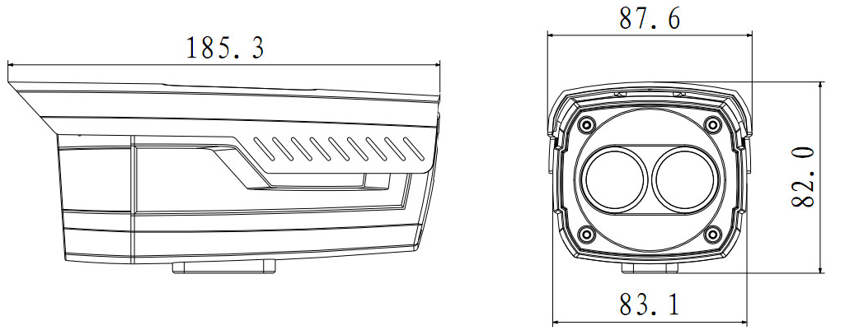

Figure 2-3
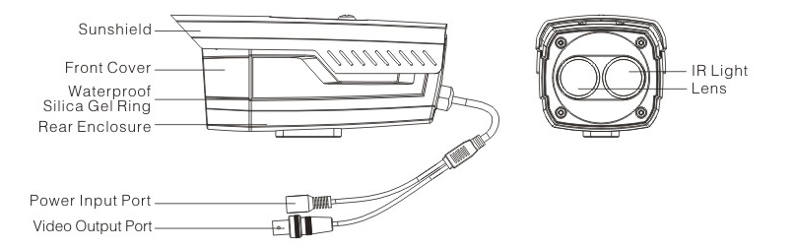
Figure 2-4

HAC-HFW1100DP/N
Please refer to the following figure for dimension information. The unit is mm. See Figure 2-5 and Figure 2-6.
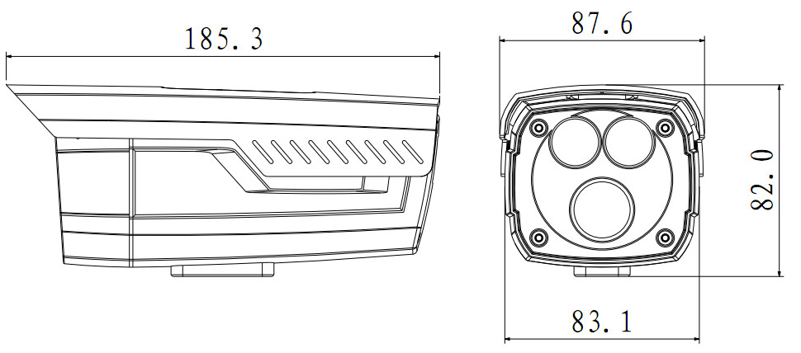

Figure 2-5
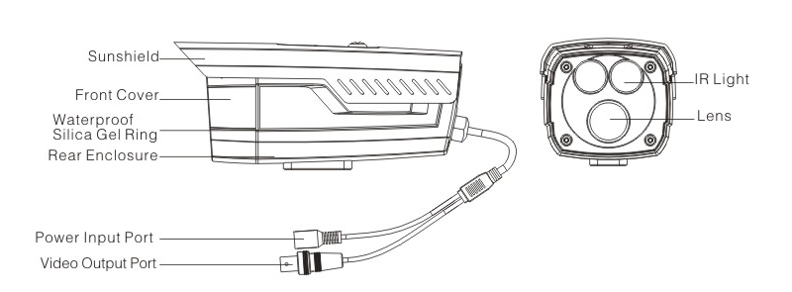
Figure 2-6

Installation
Important
Please make sure the installation surface can min support the 3X weight of the camera and the bracket.

Dome Camera
The dome camera usually mainly uses the in-ceiling installation. It can be installed on the ceiling or the wall.
For side exit cable installation, please make sure the side exit cable direction is the same as shown in the installation position map. Before you secure the screws on the pedestal, please put the cable through the cable exit of the pedestal.

Step1
Please take the installation position map (6) in the accessories bag, and then paste it on the ceiling or the wall (7) according to your cable exit position. Draw and then dig three holes in the installation surface and then insert three expansion bolts (provided) in the holes. Secure these three bolts firmly.

Step 2
Take the device out, use your left hand to hold the device pedestal and then right hand to turn the external enclosure (A) to the corresponding position of the arrow in the pedestal (B). Use your right hand to push the both sides of the external enclosure to remove the buckle (C) and then pull the external enclosure (D) from the pedestal. See Figure 3-7.
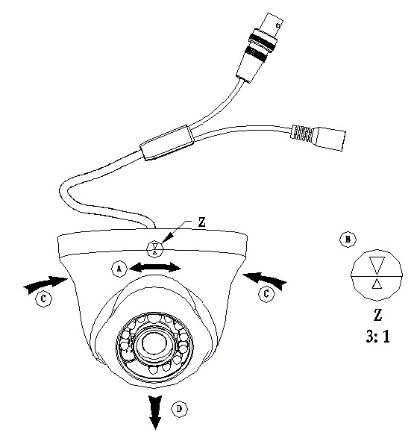
Figure 3-7

Step 3
Adjust the device pedestal position (4) according to your cable exit requirements (top cable exit/side cable exit), pull the cable (8) through the side cable exit from the installation surface (7) and the pedestal (4) (You can skip current operation if you want to use top cable exit mode). Line up the screw hole of the pedestal (4) to the plastic expansion bolt fix hole of the installation surface (7). Use three self-captive screws to the plastic expansion bolts (5) firmly and the secure the pedestal (4) to the installation surface.
See Figure 3-8.
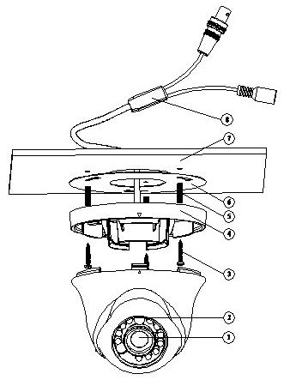
Figure 3-8
Step 4
Line up the external enclosure (2) with the device body to the pedestal (4), and then pull the cable (8) through the cable exit of the installation surface (7)( You can skip current operation if you want to use side cable exit mode). Put the buckle of the external enclosure back to the pedestal. Turn the external enclosure and the dome body to adjust to a proper monitor position. Now the dome camera installation is complete.

Fixed Camera
This series product supports wall-mount. Please refer to the steps listed below for installation information. See Figure 3-9. The follow figure is for reference only.
Step 1
Install the camera bracket. Please install the expansion bolt if you want to install in the cement wall (Please make sure the installation holes of the expansion bolts are the same with the bracket.) Then you can install the bracket. If you want to install in the wood surface, please skip the first step and then use the self-tapping screws to install the bracket directly.
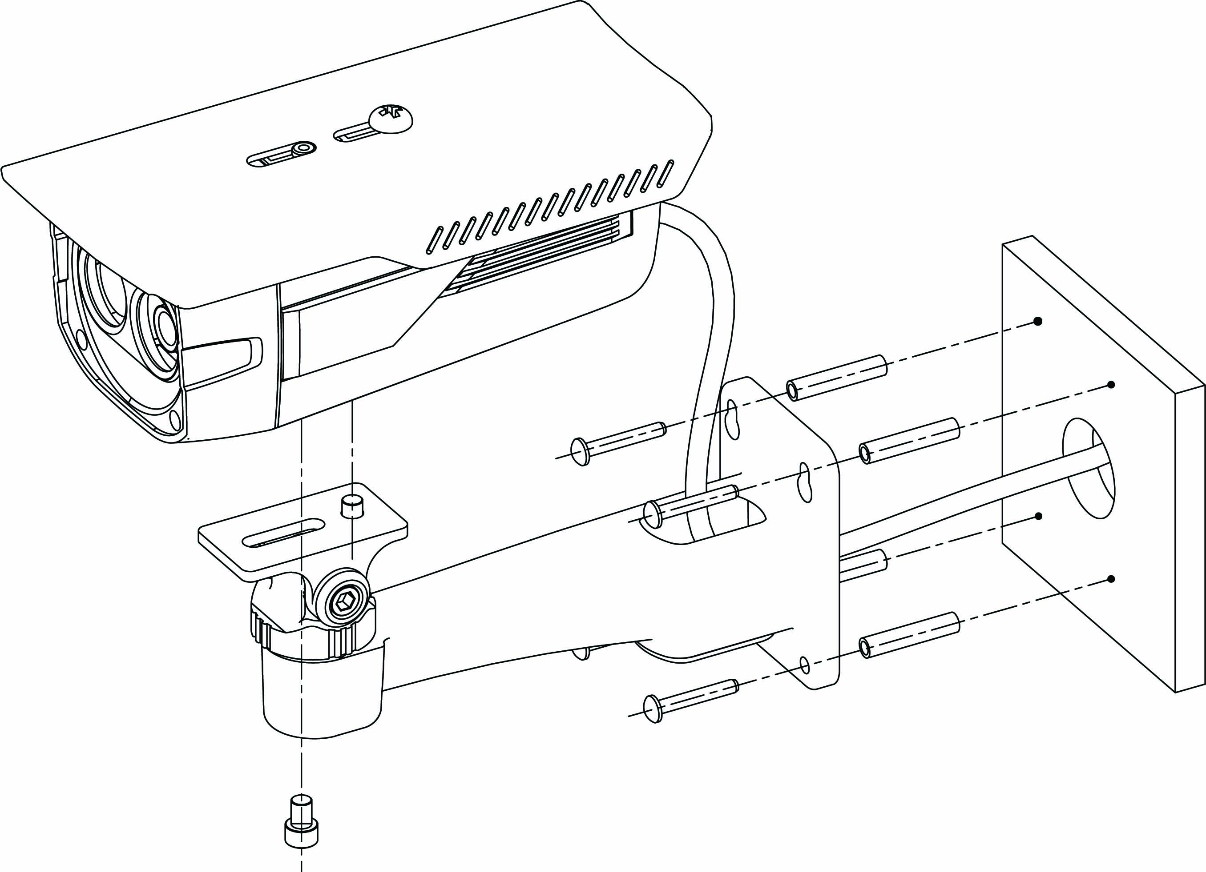
Figure 3-9
Step 2
Install the camera. Use the screws to install the camera to the bracket via the installation pedestal of the bottom of the camera.

Step 3
Adjust the camera to the proper monitor area and then secure the button of the bracket to fasten the camera.

Appendix Toxic or Hazardous Materials or Elements
Component Name | Toxic or Hazardous Materials or Elements
Component Name | Pb | Hg | Cd | Cr VI | PBB | PBDE
Circuit Board Component | ○ | ○ | ○ | ○ | ○ | ○
Device Construction Material | ○ | ○ | ○ | ○ | ○ | ○
Wire and Cable | ○ | ○ | ○ | ○ | ○ | ○
Packing Components | ○ | ○ | ○ | ○ | ○ | ○
Accessories | ○ | ○ | ○ | ○ | ○ | ○

O: Indicates that the concentration of the hazardous substance in all homogeneous materials in the parts is below the relevant threshold of the SJ/T11363-2006 standard.

X: Indicates that the concentration of the hazardous substance of at least one of all homogeneous materials in the parts is above the relevant threshold of the SJ/T11363-2006 standard. During the environmental-friendly use period (EFUP) period, the toxic or hazardous substance or elements contained in products will not leak or mutate so that the use of these (substances or elements) will not result in any severe environmental pollution, any bodily injury or damage to any assets. The consumer is not authorized to process such kind of substances or elements, please return to the corresponding local authorities to process according to your local government statutes.

Note
- This manual is for reference only. Slight difference may be found in the user interface.
- All the designs and software here are subject to change without prior written notice.
- All trademarks and registered trademarks mentioned are the properties of their respective owners.
- If there is any uncertainty or controversy, please refer to the final explanation of us.
- Please visit our website or contact your local service engineer for more information.

