1 Megapixel HDCVI Mini Dome Camera User's Manual

Version 1.0.0

Table of Contents
1 General Introduction 1
1.1 Overview 1
1.2 Features 1
1.3 Functions 1
1.4 Specifications 1
2 Framework and Dimensions 3
3 Installation 5
Appendix Toxic or Hazardous Materials or Elements 9

Welcome
Thank you for purchasing our HDCVI camera!
This user’s manual is designed to be a reference tool for your system.
Please read the following safeguard and warnings carefully before you use this series product!
Please keep this user’s manual well for future reference!

Important Safeguards and Warnings
1．Electrical safety
All installation and operation here should conform to your local electrical safety codes.
The power shall conform to the requirement in the SELV (Safety Extra Low Voltage) and the Limited power source is rated 12V DC (24V AC) in the IEC60950-1.
We assume no liability or responsibility for all the fires or electrical shock caused by improper handling or installation.

2．Transportation security
Heavy stress, violent vibration or water splash are not allowed during transportation, storage and installation.

3．Installation
Do not apply power to the camera before completing installation.
Please install the proper power cut-off device during the installation connection.
Always follow the instruction guide the manufacturer recommended.
If this product is installed in the ceiling, please make sure the installation position can sustain the min 50N.

4．Qualified engineers needed
All the examination and repair work should be done by the qualified service engineers.
We are not liable for any problems caused by unauthorized modifications or attempted repair.

5．Environment
This series camera should be installed in a cool, dry place away from direct sunlight or strong light, inflammable, explosive substances and etc.
This series camera shall work on the specified working temperature. Please keep it away from the electromagnetic radiation object and environment.
Please keep the sound ventilation.
Do not allow the water and other liquid falling into the camera.

6. Accessories
Be sure to use all the accessories recommended by manufacturer.
Before installation, please open the package and check all the components are included.
Contact your local retailer ASAP if something is broken in your package.

7. Daily Maintenance
Please shut down the device and then unplug the power cable before you begin daily maintenance work.
Use the dry soft cloth to clean the device.
If there is too much dust, please use the water to dilute the mild detergent first and then use it to clean the device. Finally use the dry cloth to clean the device.
Please put the dustproof cap to protect the CCD (CMOS) component when you do not use the camera.

General Introduction

Overview
This series megapixel HD camera conforms to the HDCVI standard. It supports video signal high-speed long distance transmission without any delay. It can be controlled by the DVR conforming to the HDCVI.

Features
- High-performance CMOS image sensor, megapixel definition.
- Support HDCVI video output.
- Support 75-3 coaxial cable transmission without any loss. Transmission distance is over 500m.
- High speed, long distance real-time transmission.
- Support auto exposure, auto white balance, auto electronic shutter and auto gain function.
- Support DC12V power supplying.

Functions
HDCVI Specification
HDCVI（High Definition Composite Video Interface） is an over-coaxial –cable HD video transmission standard. The technology renders two HD video formats by progressive scanning.

Auto gain function
To output the standard video signal in the different illumination environments, the amplifier needs to adjust in a wide range. The system can enhance the camera sensitivity in low illumination and enhance the video signal output to get the clear and high definition video.

Auto white balance
The white balance refers to the camera to restore the white object color. It allows the camera to automatically adjust the color temperature in indoor and outdoor environment, just like our human eyes does.

Auto exposure
System can automatically set shutter speed and iris value according to the snapshot video exposure condition.

Auto electronic shutter
The system can automatically adjust the electronic shutter when the environment light changes.

Specifications
Model  Parameter | 1 Megapixel HDCVI Mini Dome Camera Series
Model  Parameter | HAC-HD1100BP/N
Video Processor | 1/2.9" 1.0 Mega Pixels CMOS
Video Format | PAL/NTSC
Effective Pixel | 1280（H）* 720（V）
Min Illumination | 0.01Lux @（F1.2,AGC ON）
Electronic Shutter | PAL：1/50s~1/100,000s  NTSC：1/60s~1/100,000s
Video Standard | HDCVI compliance
Video Frame Rate | PAL：1280×720@25 fps  NTSC：1280×720@30 fps
Lens Port | M12
Lens Type | 2.8/3.6/6/8mm optional
Day/Night Switch | Auto
Sync Mode | INT
Video Output | 1-channel HDCVI high definition video output
White Balance | Auto
Gain Control | Auto
BLC | Auto
Transmission Distance | Over 500m via 75-3 coaxial cable.
Max IR Distance | N/A
Protection Level | N/A
Working Temperature /Humidity | -30℃~+60℃. Humidity is less than 95%(no condensation)
Power | DC 12V±10%
Power Consumption | 1W MAX(Input: 12V0.08A)
Dimension(mm) | φ108.2×86.3
Weight | 300g
Installation Mode | Wall mount/In-ceiling mount

Framework and Dimensions
Please refer to the following figures for dimension information. The unit is mm. See Figure 2-1 and Figure 2-2.
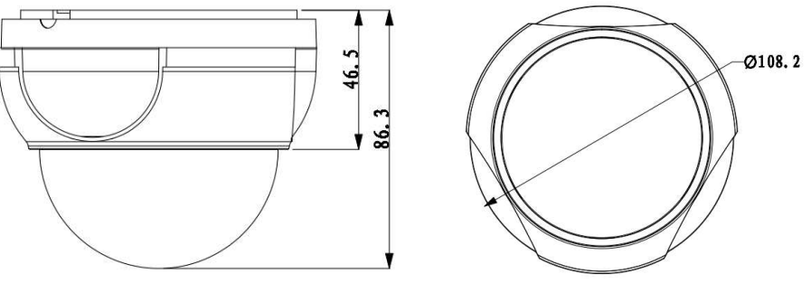
Figure 2-1
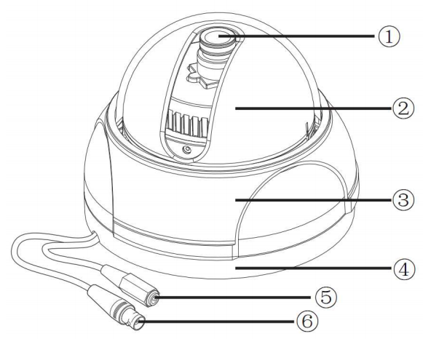
Figure 2-2
Please refer to the following sheet for detailed information.

SN | Name
1 | Device lens | It is to receive the optical signal from the environment.
2 | Dome camera enclosure | ／
3 | Dome camera side enclosure | ／
4 | Dome camera pedestal | ／
5 | Power input port | Connect to the DC 12V power to input the power.
6 | Video output port | BNC port is to output HDCVI video signal.  You can connect to the devices such as the DVR or the NVS conforming to the HDCVI specifications.

Important
- For the dome camera, there are two cable exits, one is at the bottom and one is at the side. Please use the rubber dustproof plug to secure the idle exit.
- The power cable and the video output cable both pull through the cable exit.

Installation
Important
Please make sure the installation surface can min support the 3X weight of the camera and the bracket.

The dome camera usually uses the ceiling installation. It can be installed on the ceiling or the wall.
For side exit cable installation, please make sure the side exit cable direction is the same as shown in the installation position map. Before you secure the screws on the pedestal, please put the cable through the cable exit of the pedestal.

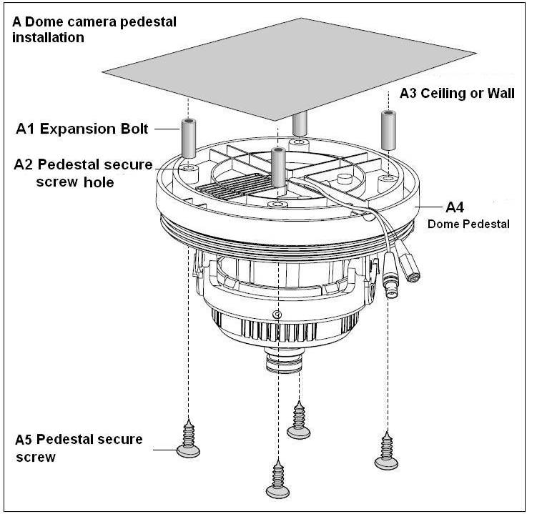
Figure 3-3
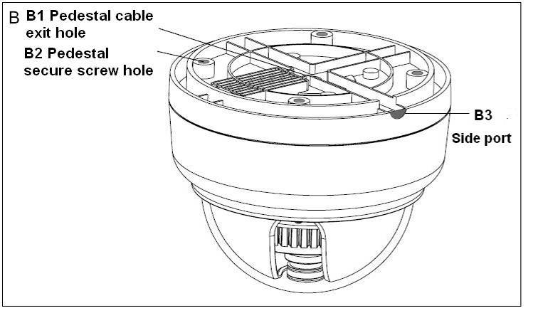
Figure 3-4
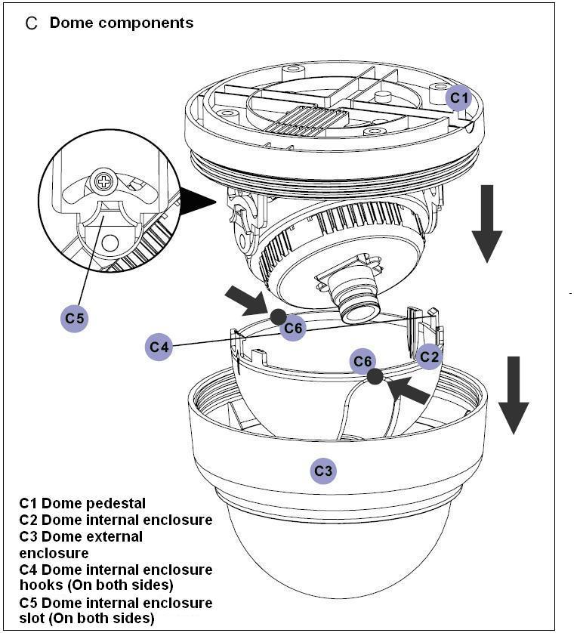
Figure 3-5
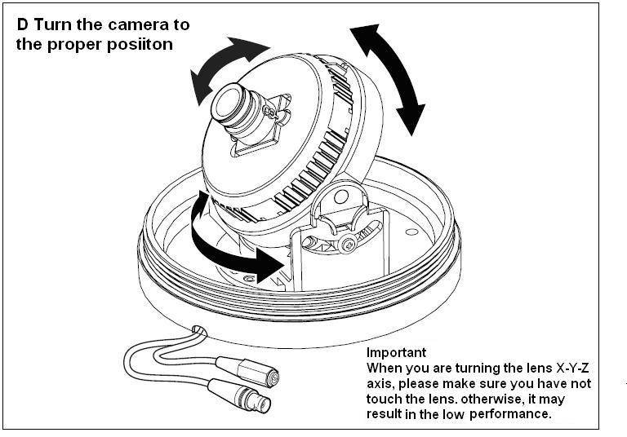
Figure 3-6
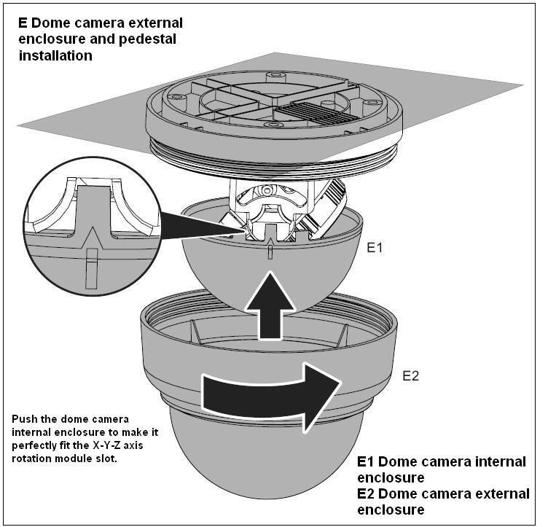
Figure 3-7
Step1
Please take the installation position map in the accessories bag, and then paste it on the ceiling or the wall you want to install the dome camera. Dig four holes in the installation surface and then insert four expansion bolts in the hole. Secure these four bolts firmly.
Step 2
Turn the dome camera external enclosure counter clockwise and the remove. Push the two sides of the dome camera internal enclosure (Please refer to C6 in Figure 3-5) so that the hook drops from the X-Y-Z axis module. Remove the dome camera internal enclosure. Please refer to Figure 3-5.
Step 3
Use the proper tool to open the cable exit side hole in the pedestal (Please refer to B2 in Figure 3-4), and then draw the cable from the cable exit (Please refer to B2 in Figure 3-4) and fix the cable in the pedestal cable channel. Draw the cable port out of the cable channel side hole of the pedestal (Please refer to the B2 in Figure 3-4 ).
Step 4
Line up the four screw holes in the pedestal to the holes you just dug in the ceiling (wall), then input the four secure screws in the pedestal screw secure holes. Fix the screws firmly to secure the dome camera in the ceiling (wall).
Step 5
Turn the lens or the ring to adjust the camera to the proper direction. Adjust the X-Y-Z axis to turn the camera lens to the proper monitor angle. Please refer to the Figure 3-6.
Step 6
Push the hooks (Please refer to C4 in Figure 3-5) of two sides of the internal enclosure to the slot (Please refer to C5 in Figure 3-5) of the X-Y-Z axis to make the internal enclosure perfectly fit the X-Y-Z axis. After the installation, please make sure the lens port of the internal enclosure is fit the camera lens. Please refer to Figure 3-7 for proper adjustment if necessary.
Step 7
Turn dome camera enclosure clockwise to fasten it on the pedestal.
Step 8
Connect the device video output port to the terminal devices such as the DVR, NVS and etc. Then connect the power cable to the device.

Now you have completed the dome camera installation and cable connection.
You can use the terminal devices such as the DVR, NVS and etc to view the monitor video.

Appendix Toxic or Hazardous Materials or Elements
Component Name | Toxic or Hazardous Materials or Elements
Component Name | Pb | Hg | Cd | Cr VI | PBB | PBDE
Circuit Board Component | ○ | ○ | ○ | ○ | ○ | ○
Device Construction Material | ○ | ○ | ○ | ○ | ○ | ○
Wire and Cable | ○ | ○ | ○ | ○ | ○ | ○
Packing Components | ○ | ○ | ○ | ○ | ○ | ○
Accessories | ○ | ○ | ○ | ○ | ○ | ○

O: Indicates that the concentration of the hazardous substance in all homogeneous materials in the parts is below the relevant threshold of the SJ/T11363-2006 standard.

X: Indicates that the concentration of the hazardous substance of at least one of all homogeneous materials in the parts is above the relevant threshold of the SJ/T11363-2006 standard. During the environmental-friendly use period (EFUP) period, the toxic or hazardous substance or elements contained in products will not leak or mutate so that the use of these (substances or elements) will not result in any severe environmental pollution, any bodily injury or damage to any assets. The consumer is not authorized to process such kind of substances or elements, please return to the corresponding local authorities to process according to your local government statutes.

Note
- This manual is for reference only. Slight difference may be found in the user interface.
- All the designs and software here are subject to change without prior written notice.
- All trademarks and registered trademarks mentioned are the properties of their respective owners.
- If there is any uncertainty or controversy, please refer to the final explanation of us.
- Please visit our website or contact your local service engineer for more information.

