**Single, 4, 8-Port Fiber Transceiver User’s Manual**

**V1.0.0**

Important Safeguards and Warnings

Please read the following safeguards and warnings carefully before using the product in order to avoid

damages and losses.

**Attention:**

Do not expose the device to lampblack, steam or dust. Otherwise it may cause fire or electric shock.

Do not install the device at position exposed to sunlight or in high temperature. Temperature rise in device may cause fire.

Do not expose the device to humid environment. Otherwise it may cause fire.

The device must be installed on solid and flat surface in order to guarantee safety under load and earthquake. Otherwise, it may cause device to fall off or turnover.

Do not place the device on carpet or quilt.

Do not block air vent of the device or ventilation around the device. Otherwise, temperature in

device will rise and may cause fire.

Do not place any object on the device.

Do not disassemble the device without professional instruction.

**Warning:**

Please use battery properly to avoid fire, explosion and other dangers.

Please replace used battery with battery of the same type.

Do not use power line other than the one specified. Please use it properly. Otherwise, it may cause fire or electric shock.

**Special Announcement:**

This manual is for reference only.

All the designs and software here are subject to change without prior written notice.

All trademarks and registered trademarks are the properties of their respective owners.

If there is any uncertainty or controversy, please refer to the final explanation of us.

Please visit our website for more information.

Table of Contents

1 Product Overview - 1 -

1.1 Features - 1 -

1.2 Typical Application - 1 -

2 Device Structure - 3 -

2.1 Single-port 1000M Fiber Transceiver - 3 -

2.1.1 Front panel - 3 -

2.1.2 Upper Cover - 4 -

2.2 4-Port 1000M Fiber Transceiver - 4 -

2.2.1 Front panel - 4 -

2.2.2 Upper Cover - 6 -

2.3 8-Port 1000M Fiber Transceiver - 6 -

2.3.1 Front panel - 6 -

2.3.2 Upper Cover - 7 -

3 Installation Guide - 9 -

Appendix 1 Technical Specifications - 10 -

# Product Overview

## Features

### Common Features:

* + 2-layer industrial level switch.
  + Conform IEEE802.3, IEEE802.3u, IEEE802.3ab/z and IEEE802.3X standards
  + MAC automatic learning and aging, MAC address list capacity is up to 8K.
  + All ports automatic adapt to MDI/MDIX mode.
  + Industrial level wide temperature design.
  + Adopt metal structure.
  + Support DC 12V power supply.

### Individual Features:

* + Single-port fiber switch supports 1 100M/1000M self-adaptive SFP fiber port and 1 10/100M/1000M self-adaptive RJ 45 port.
  + 4-port fiber switch supports 1 100M/1000M self-adaptive SFP fiber port, 1 10/100M/1000M self-adaptive RJ 45 port and 4 10/100M self-adaptive RJ 45 ports.
  + 8-port fiber switch supports 1 100M/1000M self-adaptive SFP fiber port, 1 10/100M/1000M self-adaptive RJ 45 port and 8 10/100M self-adaptive RJ 45 ports.

## Typical Application

See Figure 1-1 for the typical networking scene.

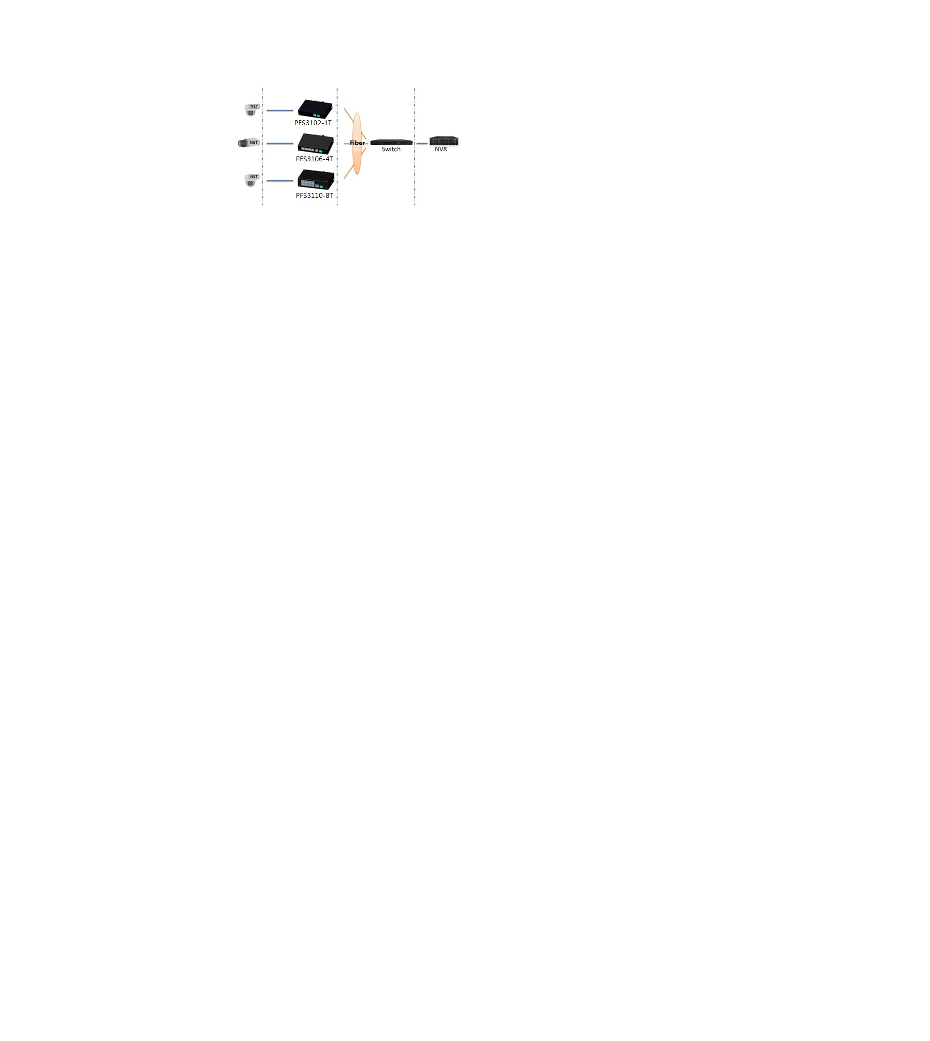

Figure 1-1

# Device Structure

## Single-port 1000M Fiber Transceiver

### Front panel

The front panel is shown in .

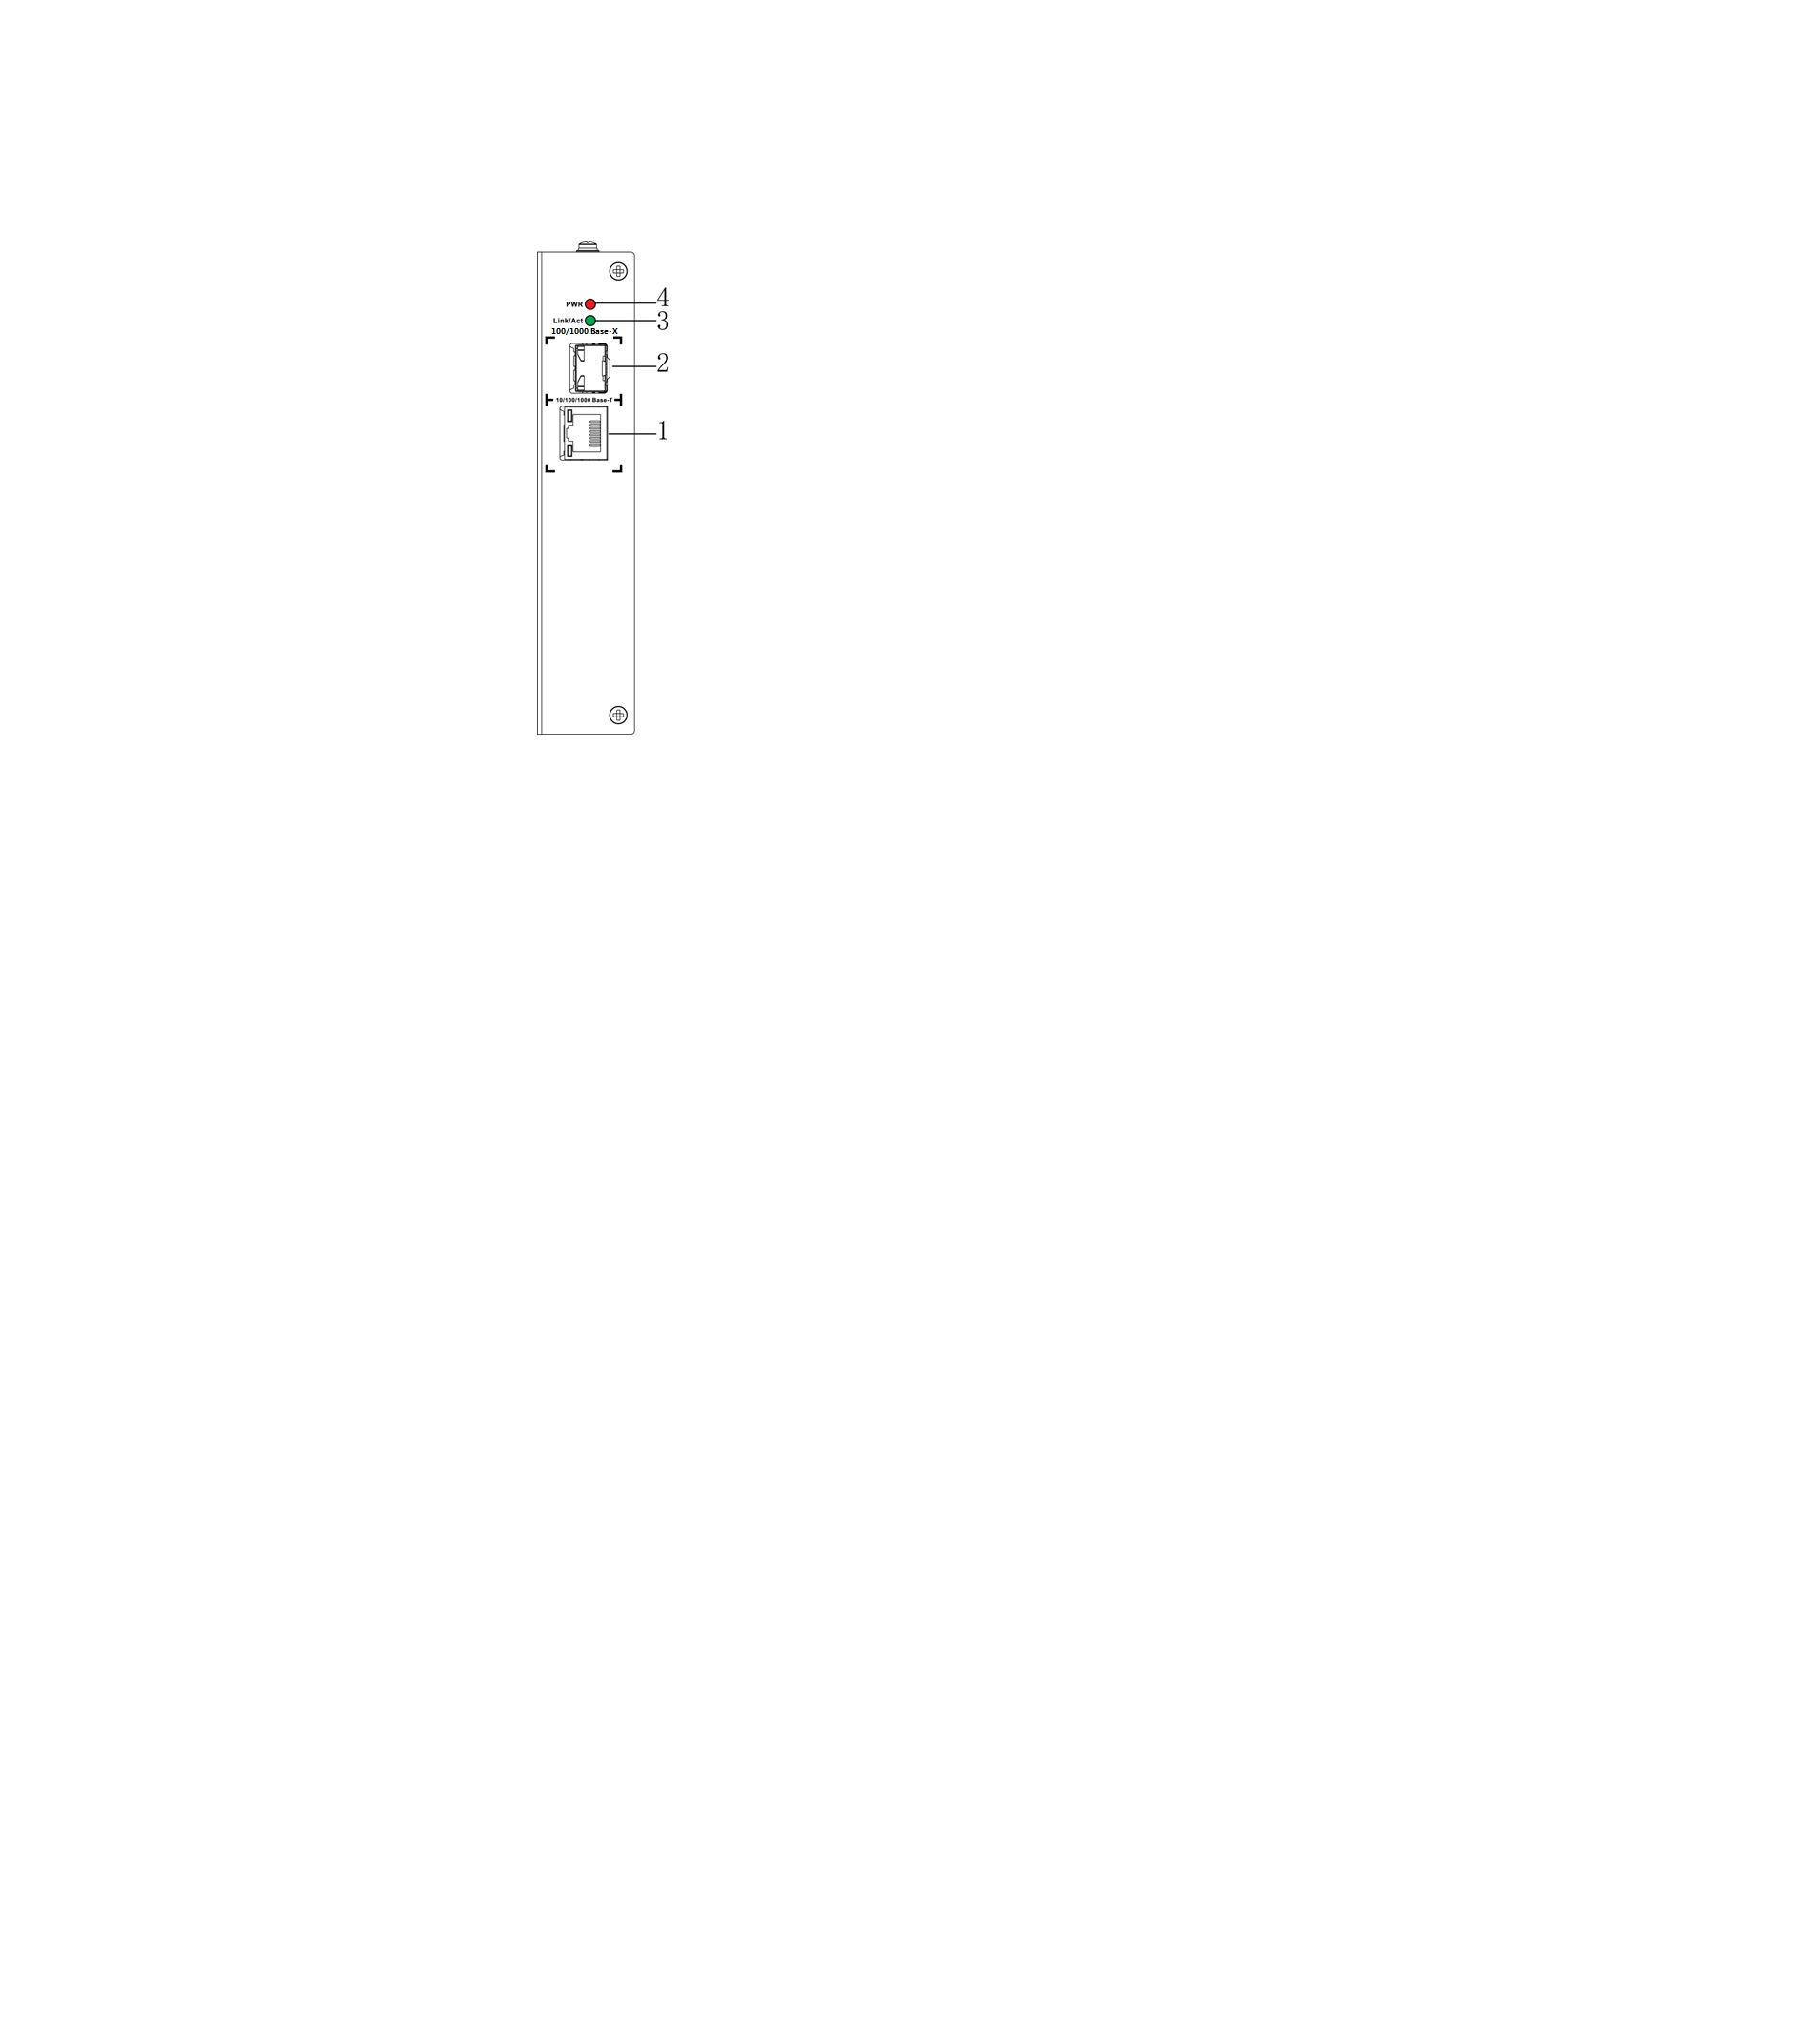

Figure 2- 1

Refer to Sheet 2-1 for more details.

| SN | Name | Note |
| --- | --- | --- |
| 1 | 10/100/1000 Base-T | 10/100/1000M self-adaptive RJ 45 port |
| 2 | 100/1000 Base-X | 100/1000M self-adaptive SFP fiber port |
| 3 | Link/Act | Fiber port status indicator light |
| 4 | PWR | Power indicator light |

Sheet 2-1

### Upper Cover

See Figure 2-2 for the device power port, which supports DC 12V power supply.

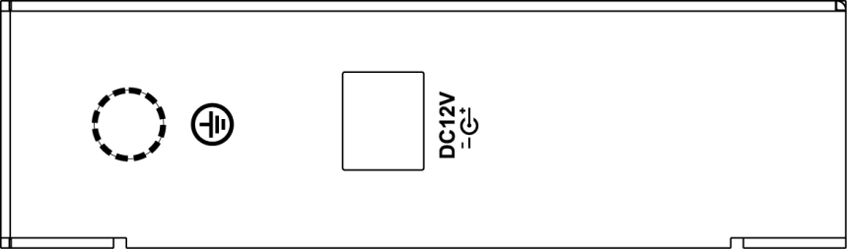

Figure 2-2

## 4-Port 1000M Fiber Transceiver

### Front panel

The front panel is shown in Figure 2-3.

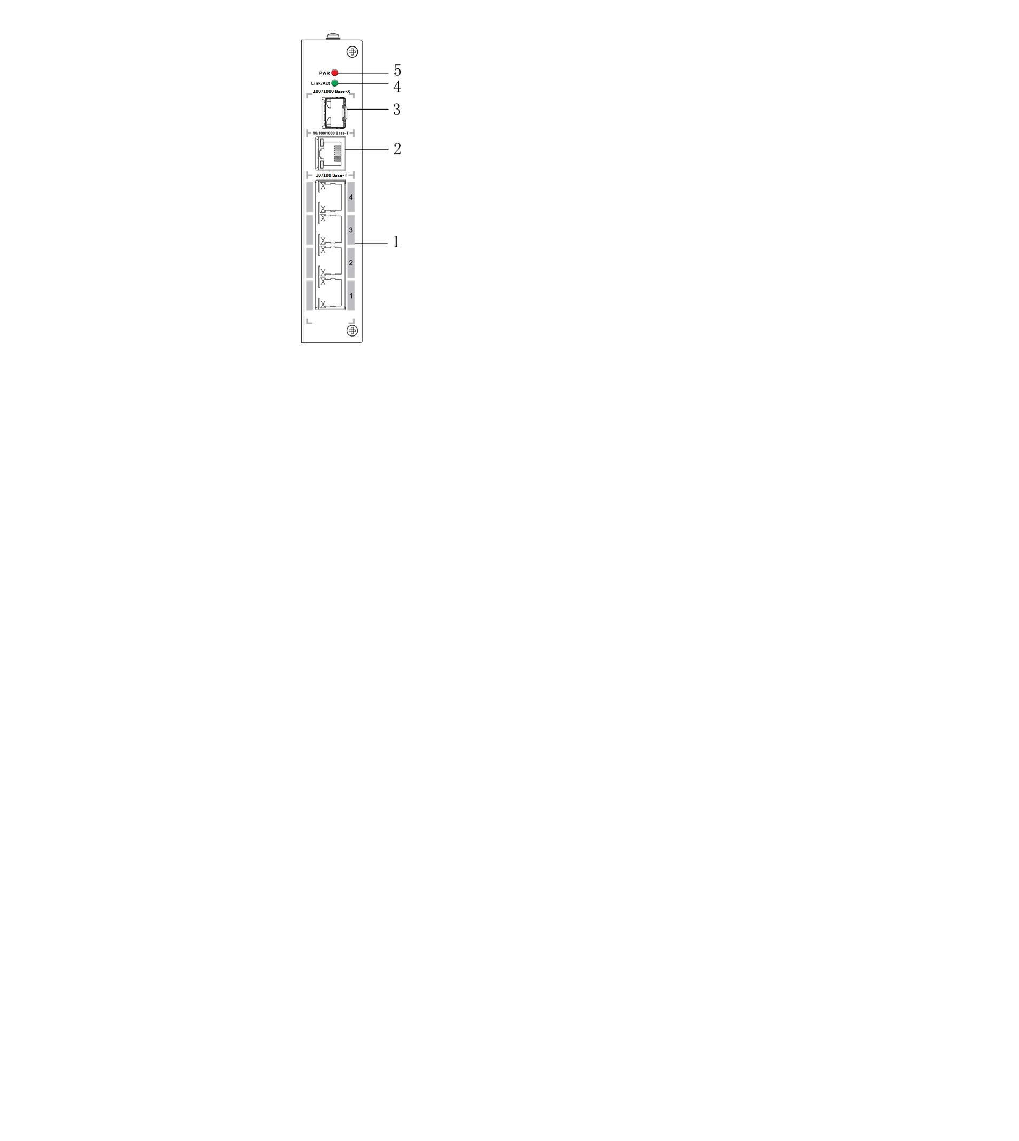

Figure 2- 3

Refer to Sheet 2-2 for more details.

| SN | Name | Note |
| --- | --- | --- |
| 1 | 10/100 Base-T | 4 10/100M self-adaptive RJ 45 ports |
| 2 | 10/100/1000 Base-T | 10/100/1000M self-adaptive RJ 45 port |
| 3 | 100/1000 Base-X | 100/1000M self-adaptive SFP fiber port |
| 4 | Link/Act | Fiber port status indicator light |
| 5 | PWR | Power indicator |

Sheet 2-2

### Upper Cover

See Figure 2-4 for the device power port, which supports DC 12V power supply.



Figure 2-4

## 8-Port 1000M Fiber Transceiver

### Front panel

The front panel is shown in Figure 2-5.

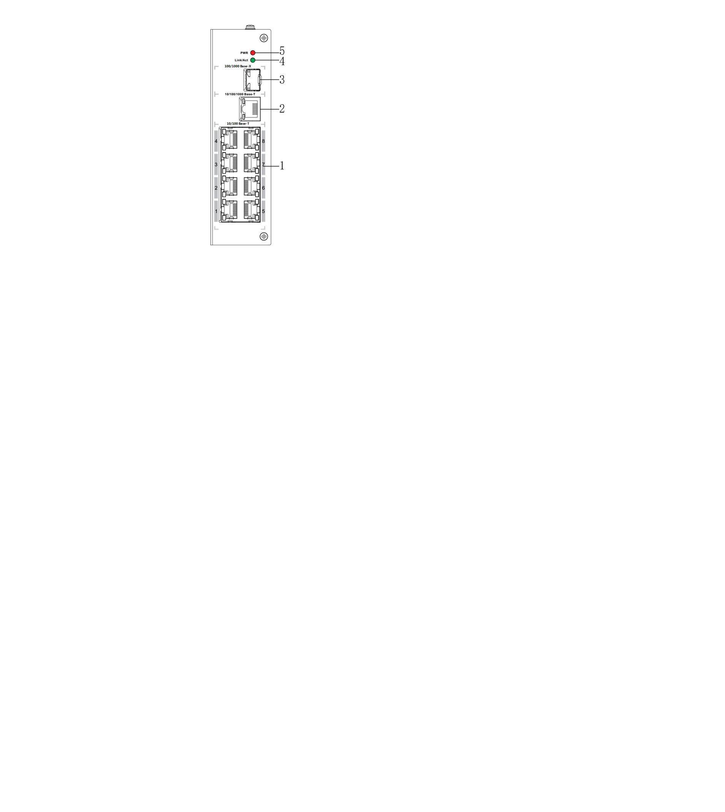

Figure 2-5

See Sheet 2-3 for more details.

| SN | Name | Note |
| --- | --- | --- |
| 1 | 10/100 Base-T | 8 10/100M self-adaptive RJ 45 ports |
| 2 | 10/100/1000 Base-T | 10/100/1000M self-adaptive RJ 45 port |
| 3 | 100/1000 Base-X | 100/1000M self-adaptive SFP fiber port |
| 4 | Link/Act | Fiber port status indicator light |
| 5 | PWR | Power indicator light |

Sheet 2-3

### Upper Cover

See Figure 2-6 for the device power port, which supports DC 12V power supply.

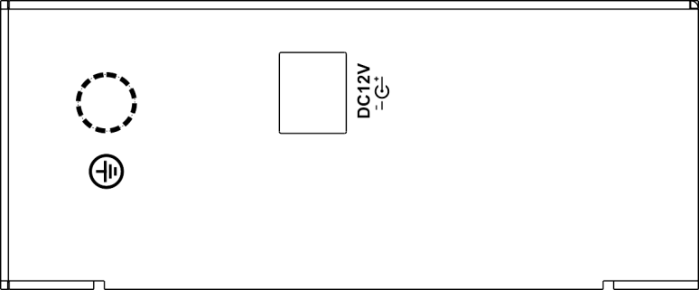

Figure 2-6

# Installation Guide

The fiber transceiver supports guide rail installation.

Hang the hook of fiber transceiver on the slider, press the fiber transceiver to make the buckle stuck into the slider, see Figure 3-1 for more details.

Note:

* Both single-port 1000M fiber transceiver and 4-port 1000M fiber transceiver support the slider with the width of 28mm.
* 8-port 1000M fiber transceiver supports the slider with the width of 38mm.

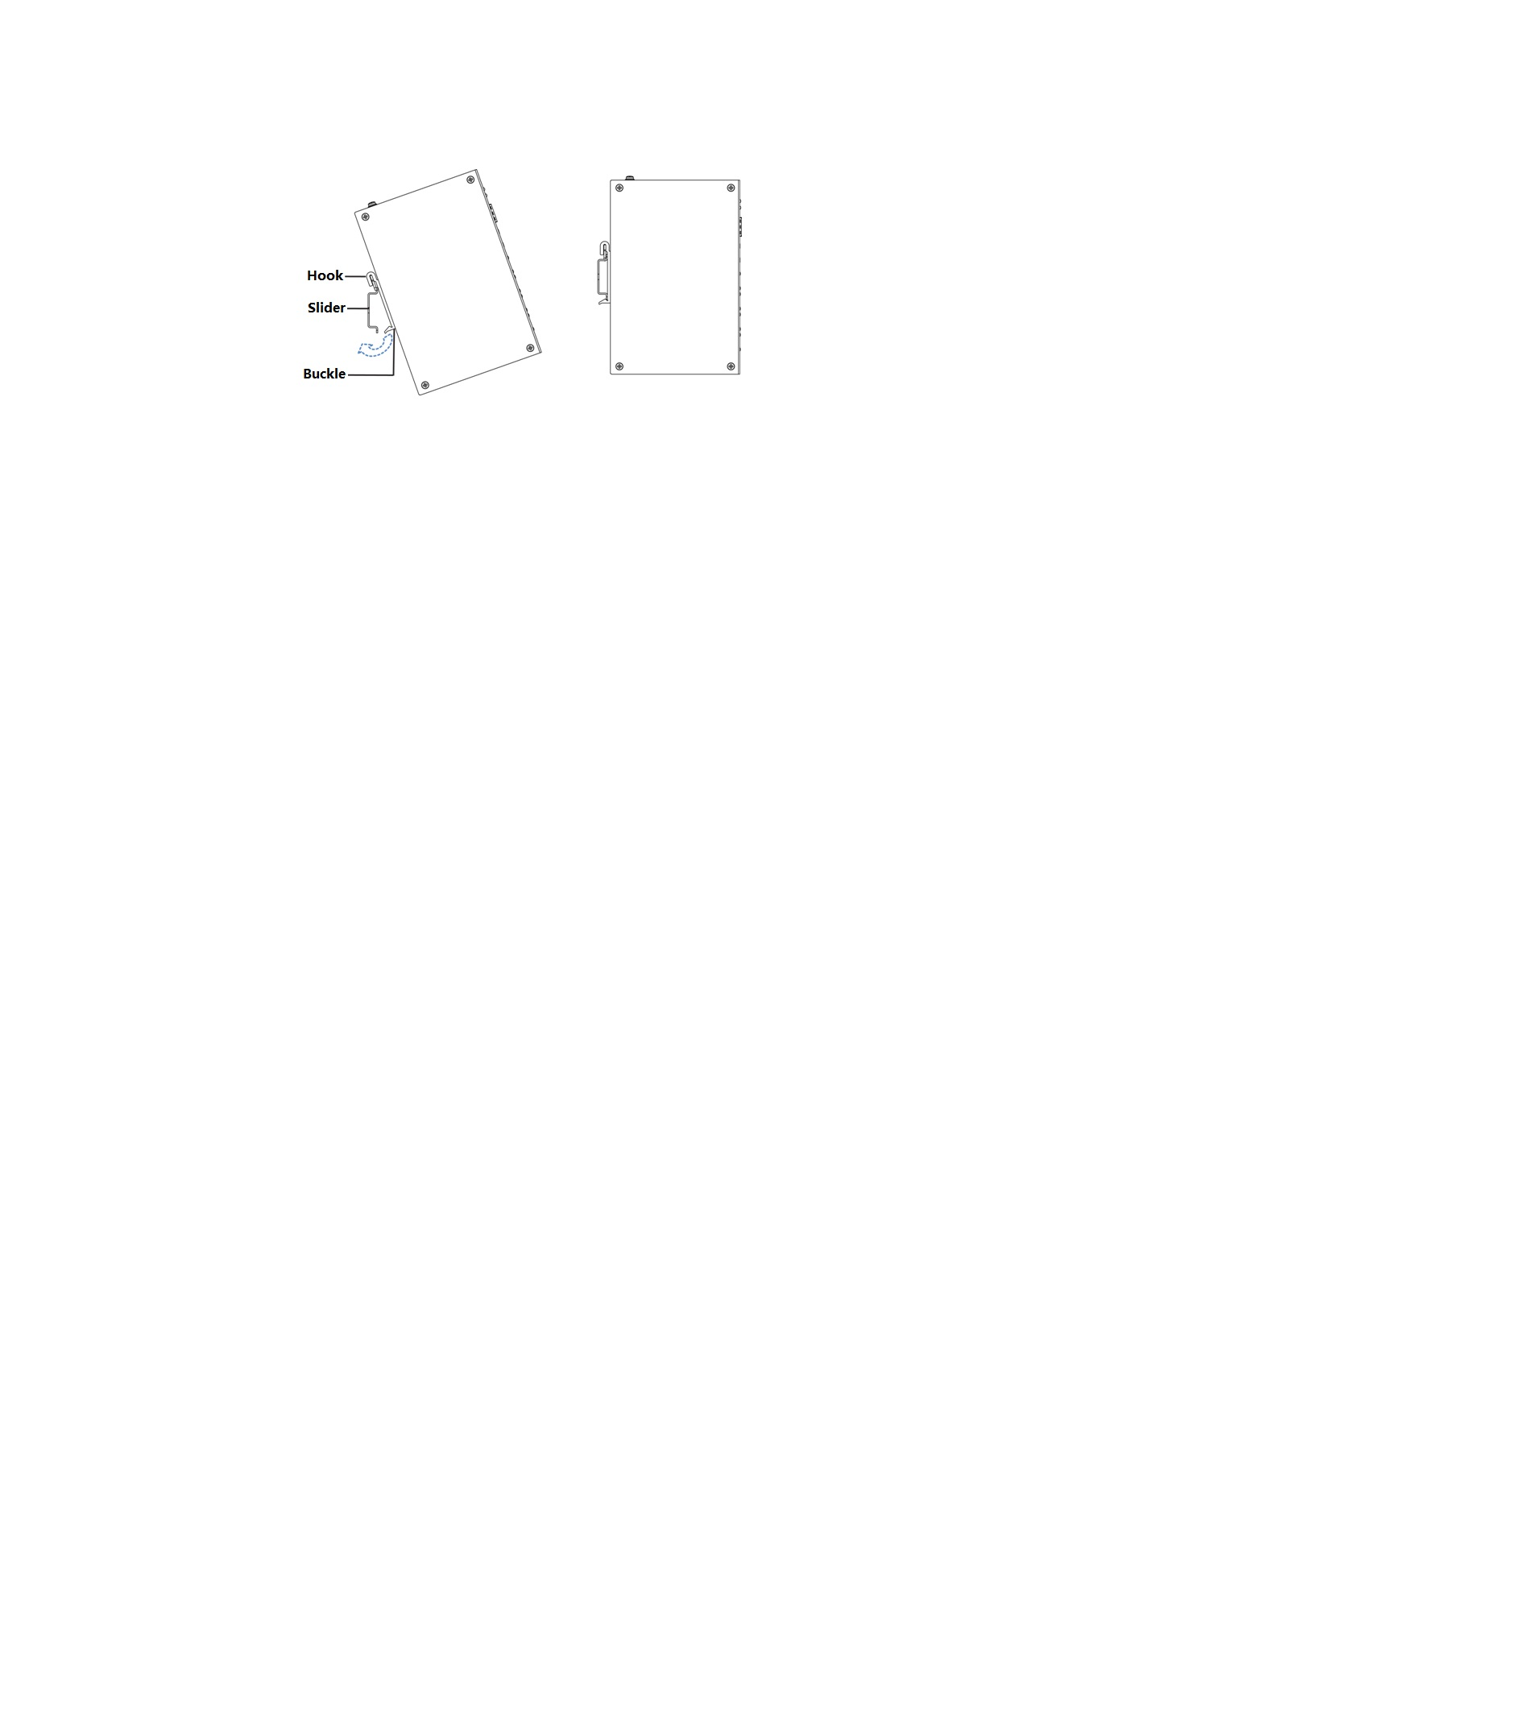

Figure 3-1

# Appendix 1 Technical Specifications

|  |  |  |  |
| --- | --- | --- | --- |
| Technical parameters | IS2002 | IS1106 | IS1110 |
| Physical port | | | |
| Business port | 1*100/1000 Base-X、  1*10/100/1000 Base-T | 1*100/1000 Base-X、  1*10/100/1000 Base-T、4*10/100 Base-T | 1*100/1000 Base-X、  1*10/100/1000 Base-T、8*10/100 Base-T |
| Technical index | | | |
| Exchange capacity | 2.20Gbps | 4.80Gbps | 5.60Gbps |
| Packet forwarding rate | 1.64Mpps | 3.57Mpps | 4.17Mpps |
| Exchange mode | Store & forward | Store & forward | Store & forward |
| MAC study | MAC auto study, address  list capacity 8K | MAC auto study, address list capacity 8K | MAC auto study, address list capacity 8K |
| Common parameters | | | |
| Indicator light | Power indicator, fiber port status indicator | Power indicator, fiber port status indicator | Power indicator, fiber port status indicator |
| Power | DC12V | DC12V | DC12V |
| Power consumption | ≤3W | ≤3W | ≤3W |
| Application humidity | 10%～90% | 10%～90% | 10%～90% |
| High & low temperature | ﹣40℃～70℃ | ﹣40℃～70℃ | ﹣40℃～70℃ |
| Weight | 420g | 480g | 540g |
| Dimension | 150mm×100mm×30mm | 150mm×100mm×30mm | 150mm×100mm×42mm |

**Note**

* **This user’s manual is for reference only.**
* **Slight difference may be found in user interface.**
* **All the designs and software here are subject to change without prior written notice.**
* [**All trademarks and registered trademarks are the properties of their respective owners.**](http://www.affordablelaundry.com/all-trademarks-and-registered-trademarks-are-the-property-of-their-respective-owners)
* **If there is any uncertainty or controversy, please refer to the final explanation of us.**
* **Please visit our website for more information.**