Mobile 4-Port PoE Network Switch Quick Start Guide

V1.0.0

Important Safeguards and Warnings

Please read the following safeguards and warnings carefully before using the product in order to avoid damages and losses.
Note
- Do not expose the device to lampblack, steam or dust. Otherwise it may cause fire or electric shock.
- Do not install the device at position exposed to sunlight or in high temperature. Temperature rise in device may cause fire.
- Do not expose the device to humid environment. Otherwise it may cause fire.
- The device must be installed on solid and flat surface in order to guarantee safety under load and earthquake. Otherwise, it may cause device to fall off or turnover.
- Do not place the device on carpet or quilt.
- Do not block air vent of the device or ventilation around the device. Otherwise, temperature in device will rise and may cause fire.
- Do not place any object on the device.
- Do not disassemble the device without professional instruction.

Warning
- Please use battery properly to avoid fire, explosion and other dangers.
- Please replace used battery with battery of the same type.
- Do not use power line other than the one specified. Please use it properly. Otherwise, it may cause fire or electric shock.

Special Announcement
- This manual is for reference only.
- All the designs and software here are subject to change without prior written notice.
- All trademarks and registered trademarks are the properties of their respective owners.
- If there is any uncertainty or controversy, please refer to the final explanation of us.
- Please visit our website for more information.
Table of Contents
1 Product Overview - 1 -
1.1 Specifications and parameters - 1 -
1.2 Front Panel - 2 -
1.3 Rear Panel - 2 -
1.4 Aviation Port - 3 -
1.5 Installation and Connection - 4 -
2 Quick Configuration - 5 -
2.1 Software Setting - 5 -
2.1.1 Network Setting - 5 -
2.1.2 IPC Configuration - 5 -
2.2 WEB Setting - 7 -
2.2.1 Network Setting - 7 -
2.2.2 IPC Configuration - 7 -

Product Overview

Specifications and parameters
Product name: 4-port PoE Network Switch
Product dimension: 159*100*30mm (Length*Width*Height)
Application environment: Mobile HD surveillance transmission and power supply
Working environment: Temperature: -30℃~65℃, humidity: 0~95% (no condensation)
Power supply: Aviation port power supply >60W
Port description: Aviation port power supply, five 10/100 Mbps self-adaption RJ 45 ports, 4 channels with PoE power supply network port while 1 channel main network port supports port auto reverse (Auto MDI/MDIX)
Network medium: category 5 and above unshielded twisted pair (≦100m)
Forward mode: Store & forward
Support protocol: IEEE 802.3, IEEE 802. 3u, IEEE802. 3x
Network delay: Max delay within 20 microseconds
Flow control mode: Full duplex adopts IEEE 802.3x standard, half duplex adopts Back pressure standard
PoE total power consumption: 48W
PoE port: 1-4 port support IEEE 802.3af (15.4W) network power supply.
PoE power supply wire: 1/2﹢、3/6- wire pair
Weight: 1.5KG/piece
Heat dissipation: Fanless, natural heat dissipation
Working height: Altitude 3000m (10,000ft)

Front Panel
The front panel is shown in Figure 1-1.
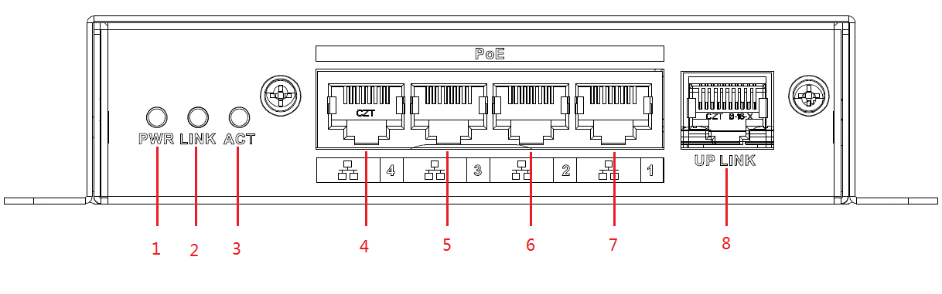
Figure 1-1
SN | Mark | Name | Note
1 | PWR | Power indicator light | Normally on when power is enabled
2 | LINK | Network indicator light | Normally on when network port connects to LINK
3 | ACT | Network indicator light | ACT flashes when data transmitting
4 | 4 | LAN 4 | IPC port
5 | 5 | LAN 3 | IPC port
6 | 6 | LAN 2 | IPC port
7 | 7 | LAN 1 | IPC port
8 | UPLINK | Main network port | Device mainframe connector

Rear Panel
The rear panel is shown in Figure 1-2.
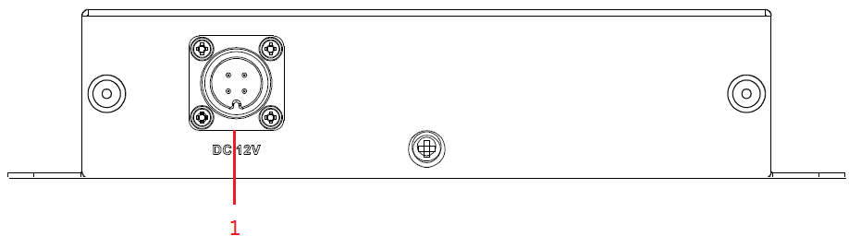
Figure 1-2

SN | Name | Note
1 | Aviation port | Power supply port

Aviation Port

See Figure 1-3 for more details about the aviation port.

Figure 1-3

DC 12V pin definition
Terminal Number | Definition
1 | DC12V+
2 | GND
3 | NULL
4 | NULL

Installation and Connection

See Figure 1-4 for more details about the installation and connection.
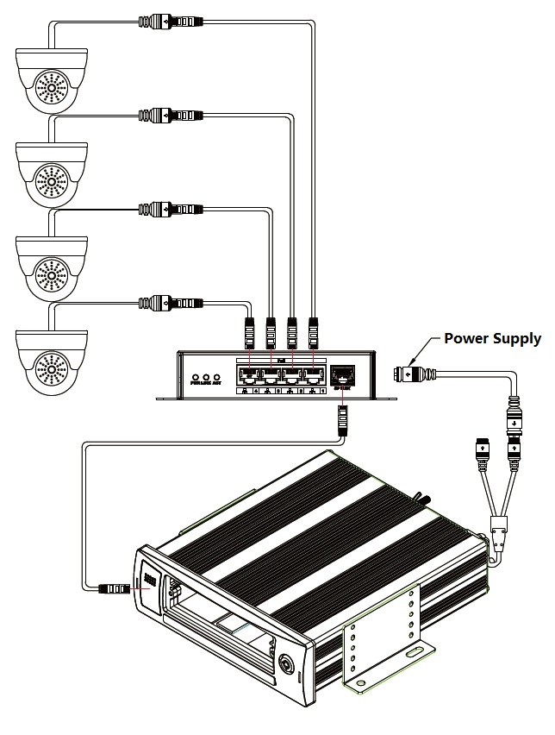
Figure1-4
Note:
Network cable, camera and other accessories are not included in the accessories bag, users have to prepare by themselves.
The network cable cover should be installed when accessing network cable, which is to prevent the network cable from being loose during vibration.

Quick Configuration

Software Setting
IPC needs to configure IP address which should be the same as the IP address of NVR during use.

Network Setting
Step 1 Enter “Main Menu”> “System Setting”> “Network Setting”interface, as shown in Figure 2-1.

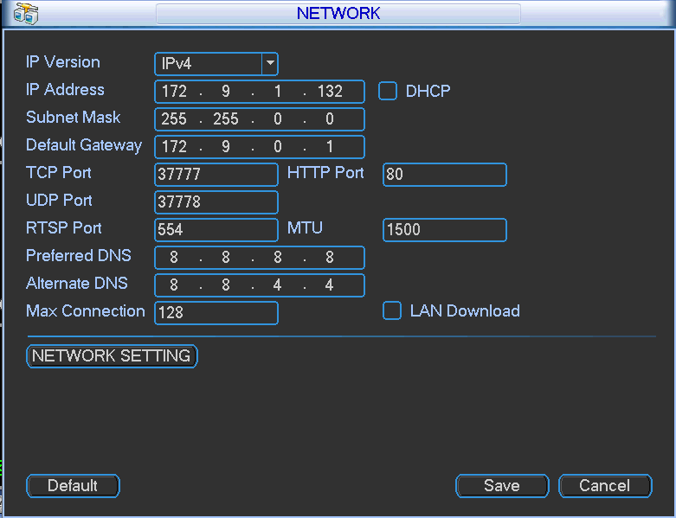
Figure 2-1

Step 2
Set corresponding IP address to the '' IP Address'', ''Subnet Mask'' and ''Default gateway'', click ''Save''.

IPC Configuration
The IP address of IPC and the IP address of ''Network Setting'' should be kept in the same network segment.

Step 1
Enter “Main Menu”> “Remote Device”or “Main Menu”> “IPC”configuration interface, as shown in Figure 2-2:
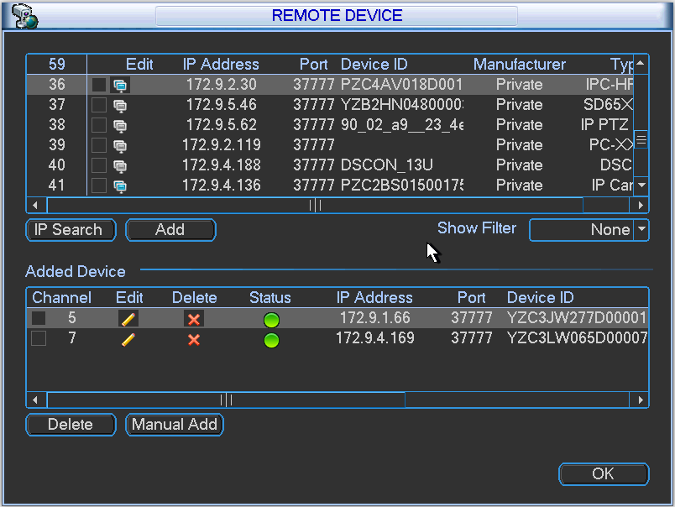
Figure 2-2
Step 2
Click ''Device Search'' and corresponding IPC can be searched. Attention: It will fail to search corresponding IPC if the IP address of IPC and the IP address of NVR are not in the same network segment.

Step 3
Click the icon under ''Edit'', enter ''Modify IP'' configuration interface, as shown in Figure 2-3:

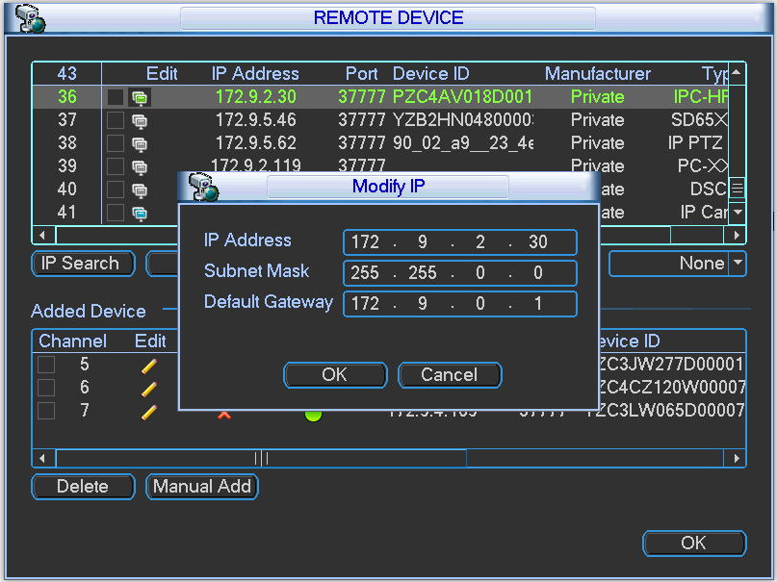
Figure 2-3
Step 4
Click ''Confirm'' after configuring corresponding IP address, the IP address of IPC is successfully saved. Attention: NVR products from some manufacturers may not support modifying device IP online if the “”in front of “Onvif” displays gray. It needs to login the WEB interface of IPC to modify IP address via PC under this circumstance, refer to IPC operation manual for more details.

Step 5
Click ''Add'' to add corresponding IPC into the NVR device channel, check if it is well connected via the icon color of ''Connection Status''. It means successful connection for the system when the color of the circle turns from red to green.

Note:
Differences may exist to the configuration interface for different NVR devices.

It will fail to search corresponding IPC if the IP address of IPC and the IP address of NVR are not in the same network segment.

WEB Setting

Users can configure the IP address of IPC and the IP address of NVR via WEB.

Network Setting
Select ''System Setting > Network Setting'', the system enter ''Network Setting'' interface, and users can set IP address of NVR on this interface.

IPC Configuration
Select ''System Setting > Advanced Options > Remote Device'', system enter ''Remote Device Setting'' interface, and users can set IP address of IPC.

Auto Registration

Select ‘’Extended Configuration > Auto Registration’’, the system enters “Auto Registration” interface. Then it can configure “Server IP”, “Port Number” and other parameters, after the device is registered to the server, it can visit the device after the successful connection between client and server.

