HDMI-HDCVI Converter User’s Manual

V1.0.0
Important Safeguards and Warnings

Please read the following safeguards and warnings carefully before using the product in order to avoid damages and losses.
Note
- Do not expose the device to lampblack, steam or dust. Otherwise it may cause fire or electric shock.
- Do not install the device at position exposed to sunlight or in high temperature. Temperature rise in device may cause fire.
- Do not expose the device to humid environment. Otherwise it may cause fire.
- The device must be installed on solid and flat surface in order to guarantee safety under load and earthquake. Otherwise, it may cause device to fall off or turnover.
- Do not place the device on carpet or quilt.
- Do not block air vent of the device or ventilation around the device. Otherwise, temperature in device will rise and may cause fire.
- Do not place any object on the device.
- Do not disassemble the device without professional instruction.

Warning
- Please use battery properly to avoid fire, explosion and other dangers.
- Please replace used battery with battery of the same type.
- Do not use power line other than the one specified. Please use it properly. Otherwise, it may cause fire or electric shock.

Special Announcement
- This manual is for reference only.
- All the designs and software here are subject to change without prior written notice.
- All trademarks and registered trademarks are the properties of their respective owners.
- If there is any uncertainty or controversy, please refer to the final explanation of us.
- Please visit our website for more information.
Table of Contents
1 Product Overview - 1 -
1.1 Product Features - 1 -
1.2 Typical Application - 1 -
2 Device Structure - 2 -
2.1 Front Panel - 2 -
2.2 Rear Panel - 2 -
Appendix 1 Technical Specifications - 3 -

Product Overview

Product Features
  - Input HDMI video signal, self-adaptive output HDCVI signal.
  - HDMI support mode：1024*768@60Hz, 1280*720@50/60Hz, 1280*1024@60Hz,
1600*1200@60Hz,1920*1080@50/60Hz.
- HDCVI output format：720P/50, 720P/60, 1080P/25, 1080P/30.
- LED status indicator shows the working condition of video converter.
- Fully enclosed dustproof design.

Typical Application
The typical application of HDMI-HDCVI Converter is shown in Figure 1-1.
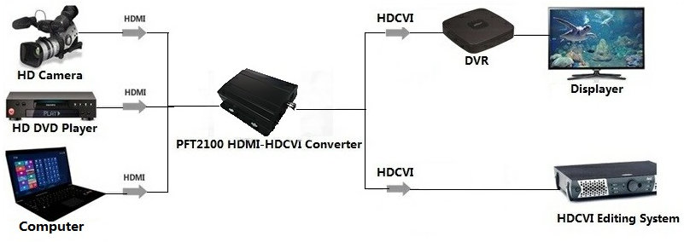
Figure 1-1
Note:
- When input HDMI video format is 1280*720@50Hz, output HDCVI format is 720P/50.
- When input HDMI video format is 1024*768@60Hz, 1280*720@60Hz or
1280*1024@ 60Hz, output HDCVI format is 720P/60.
- When input HDMI video format is 1920*1080@50Hz, output HDCVI format is 1080P/25.
- When input HDMI video format is 1600*1200@60Hz or 1920*1080@60Hz,output HDCVI format is 1080P/30.

Device Structure

Front Panel
The front panel of HDMI-HDCVI Converter is shown in Figure 2-1.

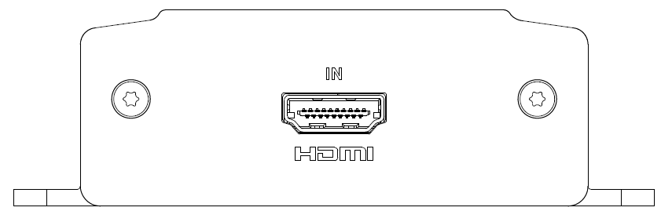
Figure 2-1
Please refer to sheet 2-1 for more details about port.
Port | Note
HDMI | HDMI video input
Sheet 2-1

Rear Panel
The rear panel of HDMI-HDCVI Converter is shown in Figure 2-2.
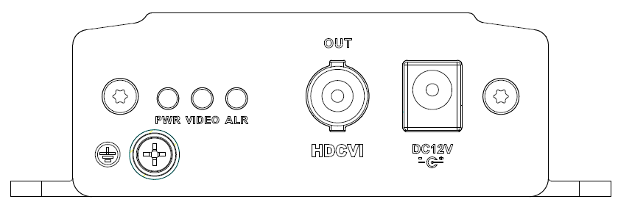
Figure 2-2
Please refer to Sheet 2-2 for more details about indicator light.
Indicator light | Note | Color | Device status
PWR | Power status indicator | Green | Normal power connection
VIDEO | Video source indicator | Green | Normal video access
ALR | Alarm indicator | Red light flashing | Video format which is not supported

Sheet 2-2
Please refer to Sheet 2-3 for more details about port.
Port | Note
HDCVI | HDCVI video output
Sheet 2-3

Appendix 1 Technical Specifications
Product model | PFT2100
Input HDMI Specifications
Physical port | HDMI
Port specification | HDMI A Type
HDMI version | HDMI 1.3,backward compatibility HDMI1.2 HDMI1.1 and etc.
HDCP version | HDCP1.2
HDMI signal format | EIA/CEA-861D standard
HDMI resolution | 1024*768@60Hz,1280*720@50/60Hz, 1280*1024@60Hz,1600*1200@60Hz,  1920*1080@50/60Hz
Max transmission rate | 10.2Gbps
Input output TMDS signal | 0.5~1.5Vp-p（TDMS）
Input output DDC signal | 5Vp-p（TTL）
Input cable length | ≤5m（AWG26 HDMI1.3 Cable Standard）
Output HDCVI Specifications
Physical port | BNC
HDCVI format | 720P/50、720P/60、1080P/25、1080P/30
Output level | 1Vp-p
Output cable length | 1080P：75-5 coaxial cable support 300m  720P：75-5 coaxial cable support 500m
Output impedance | 75Ω
Video bandwidth | 45MHz
Other Specifications
Indicator light | Power indicator, video source indicator, alarm indicator
Power | DC12V 1A
Power consumption | <5W
Application humidity | 10%～90%
High and low temperature | ﹣10℃～55℃
Weight | 315g
Dimension | 104.6mm×96.2mm×29.5mm
Installation mode | Wall-mounted

Note
- This user’s manual is for reference only.
- Slight difference may be found in user interface.
- All the designs and software here are subject to change without prior written notice.
- All trademarks and registered trademarks are the properties of their respective owners.
- If there is any uncertainty or controversy, please refer to the final explanation of us.
- Please visit our website for more information.

