Dahua HDMI-HDCVI Converter User’s Manual

V1.0.0
Dahua Technology CO., LTD

Important Safeguards and Warnings

Please read the following safeguards and warnings carefully before using the product in order to avoid damages and losses.
Note
- Do not expose the device to lampblack, steam or dust. Otherwise it may cause fire or electric shock.
- Do not install the device at position exposed to sunlight or in high temperature. Temperature rise in device may cause fire.
- Do not expose the device to humid environment. Otherwise it may cause fire.
- The device must be installed on solid and flat surface in order to guarantee safety under load and earthquake. Otherwise, it may cause device to fall off or turnover.
- Do not place the device on carpet or quilt.
- Do not block air vent of the device or ventilation around the device. Otherwise, temperature in device will rise and may cause fire.
- Do not place any object on the device.
- Do not disassemble the device without professional instruction.

Warning
- Please use battery properly to avoid fire, explosion and other dangers.
- Please replace used battery with battery of the same type.
- Do not use power line other than the one specified. Please use it properly. Otherwise, it may cause fire or electric shock.

Special Announcement
- This manual is for reference only.
- All the designs and software here are subject to change without prior written notice.
- All trademarks and registered trademarks are the properties of their respective owners.
- If there is any uncertainty or controversy, please refer to the final explanation of us.
- Please visit our website for more information.
Table of Contents
1 Product Overview - 1 -
1.1 Product Features - 1 -
1.2 Typical Application - 1 -
2 Device Structure - 2 -
2.1 Front Panel - 2 -
2.2 Rear Panel - 2 -
Appendix 1 Technical Specifications - 3 -

Product Overview

Product Features
  - Input HDMI video signal, self-adaptive output HDCVI signal.
  - HDMI support mode：1024*768@60Hz, 1280*720@50/60Hz, 1280*1024@60Hz,
1600*1200@60Hz,1920*1080@50/60Hz.
- HDCVI output format：720P/50, 720P/60, 1080P/25, 1080P/30.
- LED status indicator shows the working condition of video converter.
- Fully enclosed dustproof design.

Typical Application
The typical application of HDMI-HDCVI Converter is shown in Figure 1-1.
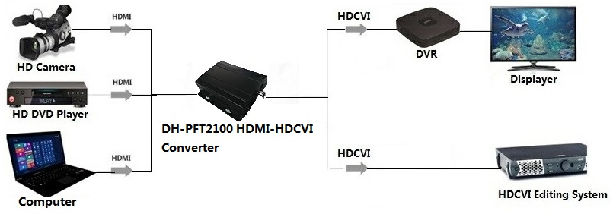
Figure 1-1
Note:
- When input HDMI video format is 1280*720@50Hz, output HDCVI format is 720P/50.
- When input HDMI video format is 1024*768@60Hz, 1280*720@60Hz or
1280*1024@ 60Hz, output HDCVI format is 720P/60.
- When input HDMI video format is 1920*1080@50Hz, output HDCVI format is 1080P/25.
- When input HDMI video format is 1600*1200@60Hz or 1920*1080@60Hz, output HDCVI format is 1080P/30.

Device Structure

Front Panel
The front panel of HDMI-HDCVI Converter is shown in Figure 2-1.

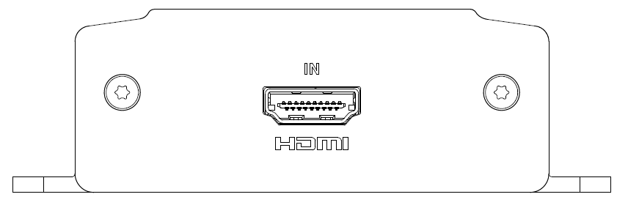
Figure 2-1
Please refer to Sheet 2-1 for more details about port.
Port | Note
HDMI | HDMI video input
Sheet 2-1

Rear Panel
The rear panel of HDMI-HDCVI Converter is shown in Figure 2-2.
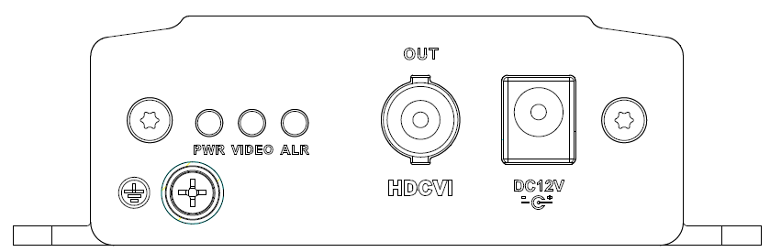
Figure 2-2
Please refer to Sheet 2-2 for more details about indicator light.
Indicator light | Note | Color | Device status
PWR | Power status indicator | Green | Normal power connection
VIDEO | Video source indicator | Green | Normal video access
ALR | Alarm indicator | Red light flashing | Video format which is not supported

Sheet 2-2
Please refer to Sheet 2-3 for more details about port.
Port | Note
HDCVI | HDCVI video output
Sheet 2-3

Appendix 1 Technical Specifications
Product model | DH-PFT2100
Input HDMI Specifications
Physical port | HDMI
Port specification | HDMI A Type
HDMI version | HDMI 1.3,backward compatibility HDMI1.2 HDMI1.1 and etc.
HDCP version | HDCP1.2
HDMI signal format | EIA/CEA-861D standard
HDMI resolution | 1024*768@60Hz、1280*720@50/60Hz、  1280*1024@60Hz、1600*1200@60Hz、  1920*1080@50/60Hz
Max transmission rate | 10.2Gbps
Input output TMDS signal | 0.5~1.5Vp-p（TDMS）
Input output DDC signal | 5Vp-p（TTL）
Input cable length | ≤5m（AWG26 HDMI1.3 Cable Standard）
Output HDCVI Specifications
Physical port | BNC
HDCVI format | 720P/50、720P/60、1080P/25、1080P/30
Output level | 1Vp-p
Output cable length | 1080P：75-5 coaxial cable support 300m  720P：75-5 coaxial cable support 500m
Output impedance | 75Ω
Video bandwidth | 45MHz
Other Specifications
Indicator light | Power indicator, video source indicator, alarm indicator
Power | DC12V 1A
Power consumption | <5W
Application humidity | 10%～90%
High and low temperature | ﹣10℃～55℃
Weight | 315g
Dimension | 104.6mm×96.2mm×29.5mm
Installation mode | Wall-mounted

Note
- This user’s manual is for reference only.
- Slight difference may be found in user interface.
- All the designs and software here are subject to change without prior written notice.
- All trademarks and registered trademarks are the properties of their respective owners.
- If there is any uncertainty or controversy, please refer to the final explanation of us.
- Please visit our website for more information.



Dahua Technology Co., Ltd
Address：No.1199 Bin’an Road, Binjiang District, Hangzhou, PRC.
Postcode: 310053
Tel: +86-571-87688883
Fax: +86-571-87688815
Email:overseas@dahuatech.com
Website: www.dahuatech.com

