HDCVI Video Converter
User’s Manual

V1.0.0
Important Safeguards and Warnings

Please read the following safeguards and warnings carefully before using the product in order to avoid damages and losses.
Note
- Do not expose the device to lampblack, steam or dust. Otherwise it may cause fire or electric shock.
- Do not install the device at position exposed to sunlight or in high temperature. Temperature rise in device may cause fire.
- Do not expose the device to humid environment. Otherwise it may cause fire.
- The device must be installed on solid and flat surface in order to guarantee safety under load and earthquake. Otherwise, it may cause device to fall off or turnover.
- Do not place the device on carpet or quilt.
- Do not block air vent of the device or ventilation around the device. Otherwise, temperature in device will rise and may cause fire.
- Do not place any object on the device.
- Do not disassemble the device without professional instruction.

Warning
- Please use battery properly to avoid fire, explosion and other dangers.
- Please replace used battery with battery of the same type.
- Do not use power line other than the one specified. Please use it properly. Otherwise, it may cause fire or electric shock.

Special Announcement
- This manual is for reference only.
- All the designs and software here are subject to change without prior written notice.
- All trademarks and registered trademarks are the properties of their respective owners.
- If there is any uncertainty or controversy, please refer to the final explanation of us.
- Please visit our website for more information.
Table of Contents
1 Product Overview - 1 -
1.1 Product Features - 1 -
1.2 Typical Application - 1 -
2 Device Structure - 2 -
2.1 Front Panel - 2 -
2.2 Rear Panel - 3 -
Appendix 1 Technical Specifications - 4 -
Appendix 2 Toxic or Hazardous Materials or Elements - 6 -

Product Overview

Product Features
  - Self-adaptive output HDCVI, HDMI, VGA, CVBS signal.
  - Lossless, real time, non-compression.
  - Support 2 dial switches and indicate 4 Baud rate 2400b/s, 4800b/s, 9600b/s and 115200b/s.
  - LED status indicator shows the working condition of video converter.
  - Fully enclosed dustproof design

Typical Application
The typical application of HDCVI video converter is shown in Figure 1-1
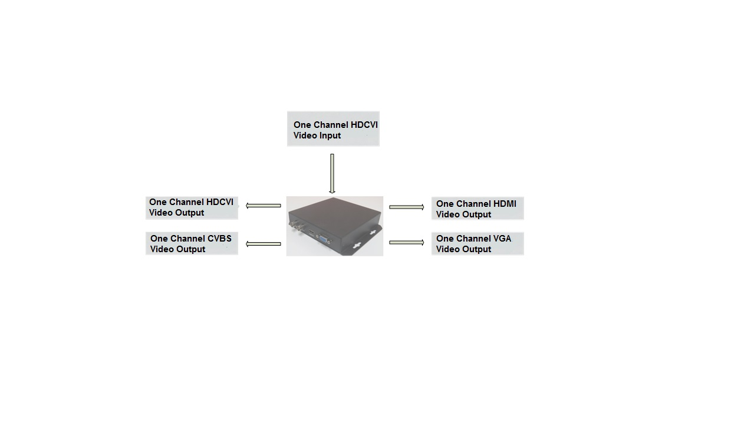
Figure 1-1
Note:
- VGA, HDMI Port ：
When input CVI video format is 720P, output is 720P/60.
When input CVI video format is 1080P, output is 1080P/60.
- CVBS Port ：
When input CVI is 25frame, 50frame, output is PAL format.
When input CVI is 30frame, 60frame, output is NTSC format.
Fixed aspect ratio, output according to 4:3.

Device Structure

Front Panel
The front panel of HDCVI video converter is shown in Figure 2-1.

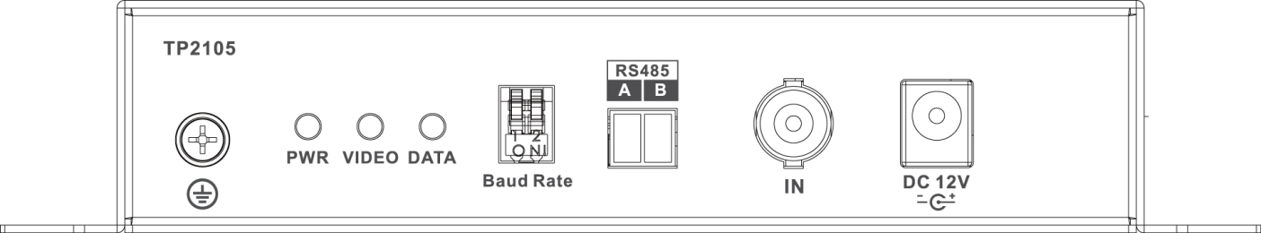
Figure 2-1
For indicator, please refer to sheet 2-1. For ports, please refer to sheet 2-2. For Baud rate, please refer to sheet 2-3.

Indicator | Description | Color | Status
PWR | Power status indicator | Green | Power connection is normal
VIDEO | BNC video output indicator | Green | Video input is normal
DATA | RS485 data transmission indicator | Flashing Green | Transmitting data
Sheet 2-1
Port | Description
Baud Rate | Baud rate dial switch
RS485 | RS485 control data
IN | HDCVI video input port
DC 12V | Power port，DC12V 1A
Sheet 2-2
Dial switch | Baud rate | Dial switch | Baud rate
 | 9600b/s |  | 4800b/s
 | 2400b/s |  | 115200b/s
Sheet 2-3

Rear Panel
The rear panel of HDCVI video converter is shown in Figure 2-2
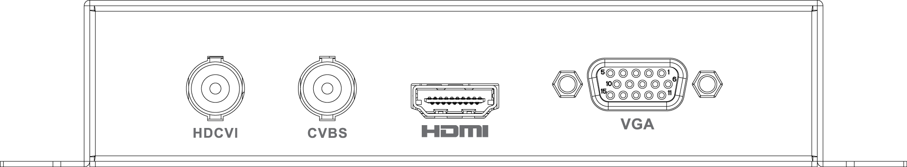
Figure 2-2

For ports, please refer to sheet 2-4.

Port | Description
HDCV1 | HDCVI video output
CVBS | CVBS video output
HDMI | HDMI video output
VGA | VGA video output
Sheet 2-4

Appendix 1 Technical Specifications
Technical Parameter | TP2105
Physical Port
Function Port | 1*BNC input, 2*BNC output（1*HDCVI, 1*CVBS）, 1*HDMI, 1*VGA, 1*RS485
Dial Switch | 2 dial switch indicate 4 Baud rate 2400b/s、4800b/s、9600b/s、115200b/s
General Parameter
Indicator | Power, data, video source indicator
Power | DC12V 1A
Power Consumption | ≤8W
Working Humidity | 10%～90%
Working Temperature | ﹣10℃～55℃
Unit Weight | 200g
Dimension | 162mm×136.4mm×30mm

Appendix 2 Toxic or Hazardous Materials or Elements
Component Name | Toxic or Hazardous Materials or Elements
Component Name | Pb | Hg | Cd | Cr VI | PBB | PBDE
Circuit Board Component | ○ | ○ | ○ | ○ | ○ | ○
Device Case | ○ | ○ | ○ | ○ | ○ | ○
Wire and Cable | ○ | ○ | ○ | ○ | ○ | ○
Packing Components | ○ | ○ | ○ | ○ | ○ | ○
Accessories | ○ | ○ | ○ | ○ | ○ | ○

O: Indicates that the concentration of the hazardous substance in all homogeneous materials in the parts is below the relevant threshold of the SJ/T11363-2006 standard.

X: Indicates that the concentration of the hazardous substance of at least one of all homogeneous materials in the parts is above the relevant threshold of the SJ/T11363-2006 standard. During the environmental-friendly use period (EFUP) period, the toxic or hazardous substance or elements contained in products will not leak or mutate so that the use of these (substances or elements) will not result in any severe environmental pollution, any bodily injury or damage to any assets. The consumer is not authorized to process such kind of substances or elements, please return to the corresponding local authorities to process according to your local government statute.
Note
- This user’s manual is for reference only.
- Slight difference may be found in user interface.
- All the designs and software here are subject to change without prior written notice.
- All trademarks and registered trademarks are the properties of their respective owners.
- If there is any uncertainty or controversy, please refer to the final explanation of us.
- Please visit our website for more information.

