HDCVI Distributor User’s Manual

V1.0.0
Important Safeguards and Warnings

Please read the following safeguards and warnings carefully before using the product in order to avoid damages and losses.
Note:
- Do not expose the device to lampblack, steam or dust. Otherwise it may cause fire or electric shock.
- Do not install the device at position exposed to sunlight or in high temperature. Temperature rise in device may cause fire.
- Do not expose the device to humid environment. Otherwise it may cause fire.
- The device must be installed on solid and flat surface in order to guarantee safety under load and earthquake. Otherwise, it may cause device to fall off or turnover.
- Do not place the device on carpet or quilt.
- Do not block air vent of the device or ventilation around the device. Otherwise, temperature in device will rise and may cause fire.
- Do not place any object on the device.
- Do not disassemble the device without professional instruction.

Warning:
- Please use battery properly to avoid fire, explosion and other dangers.
- Please replace used battery with battery of the same type.
- Do not use power line other than the one specified. Please use it properly. Otherwise, it may cause fire or electric shock.

Special Announcement
- This manual is for reference only.
- All the designs and software here are subject to change without prior written notice.
-  All trademarks and registered trademarks are the properties of their respective owners.
- If there is any uncertainty or controversy, please refer to the final explanation of us.
-  Please visit our website for more information.
Table of Contents
1 Product Overview - 1 -
1.1 Features - 1 -
1.2 Typical Application - 1 -
2 Device Structure - 3 -
2.1 Port - 3 -
Appendix 1 Technical Specification - 5 -
Appendix A Toxic or Hazardous Materials or Elements - 6 -

Product Overview
HDCVI distributor is mainly used to connect front-end and rear-end devices for long distance transmission without data loss. Meantime, it separates 1-ch HDCVI HD video into three channels.

Features
  - Support 1-ch HDCVI HD video output to three channels
  - Lossless non-compression transmission.
  - Support DC 12V power.
  - Port: BNC.
  - Appearance dimension: metal plate or section, brand new appearance and structure.
  - Working temperature: -10℃～55℃, max consumption 5W.
  - HDCVI data input is normal or not, power indicator and data transmission indicator.

Typical Application
The typical application of HDCVI distributor is shown in Figure 1-

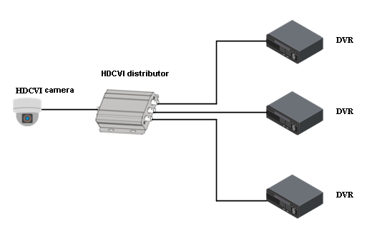
Figure 1-

Device Structure

Port
Front Panel

The front panel is shown in Figure 2- .
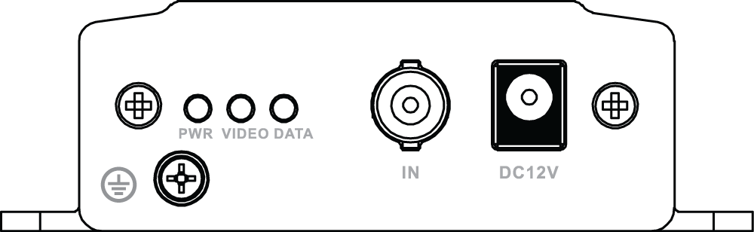
Figure 2- TP2600

Indicator | Note | Color | Device Status
PWR | Power status indicator | Green | Means power connection is normal
VIDEO | BNC video output indicator | Green | Means video input is normal
DATA | RS485 data transmission indicator | Green light flashes | Means transmitting data

Port Name | Note
IN | 1-ch HDCVI video input. Port type: BNC port.
DC 12V | Power port, connect to DC12V power.

Rear Panel
The rear panel is shown in Figure 2- .
1-ch HDCVI HD video is inputted from IN port, and output into three channels (OUT1, OUT2, OUT3).
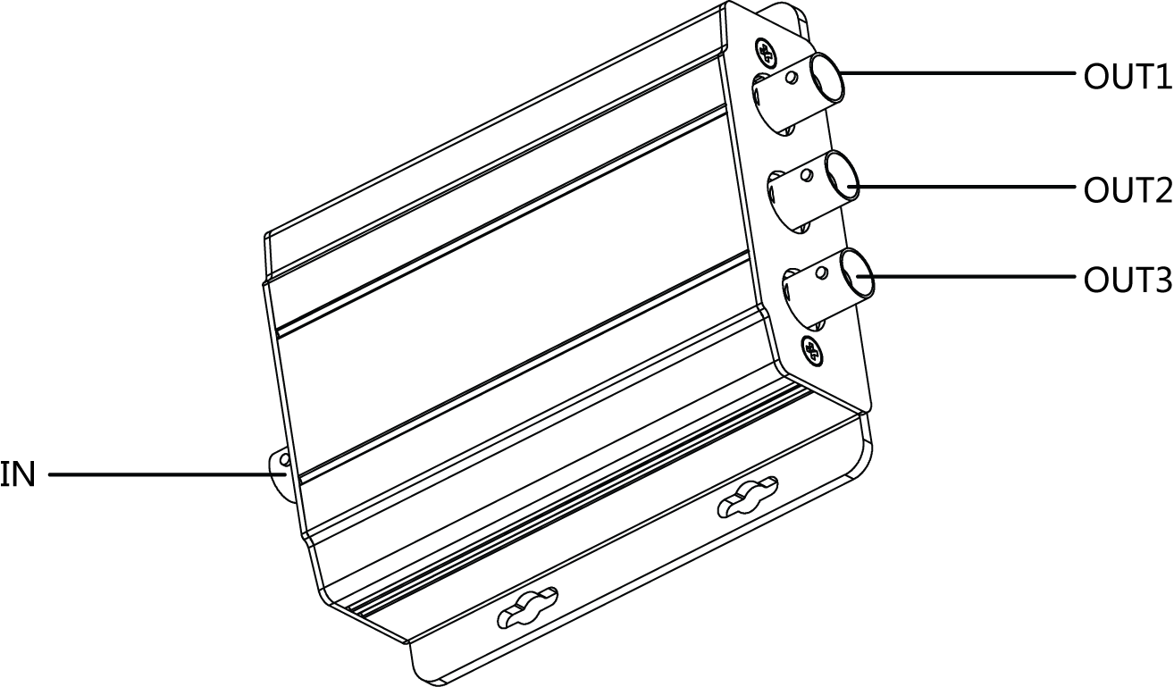
Figure 2- TP2600
Appendix 1 Technical Specification
Product Model | TP2600
Power | DC12V、1A
Power Consumption | ≤5W
Working Temperature | -10℃～＋55℃
Working Humidity | 10%～90%
Weight | 200g
Dimension | 104.6mm×96.2mm×29.5mm
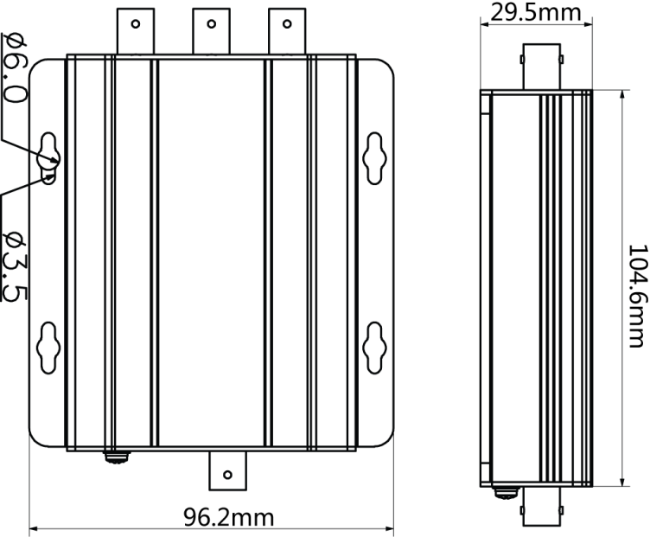
Appendix 1- Dimension

Appendix A Toxic or Hazardous Materials or Elements
Component Name | Toxic or Hazardous Materials or Elements
Component Name | Pb | Hg | Cd | Cr VI | PBB | PBDE
Circuit Board Component | ○ | ○ | ○ | ○ | ○ | ○
Device Case | ○ | ○ | ○ | ○ | ○ | ○
Wire and Cable | ○ | ○ | ○ | ○ | ○ | ○
Packing Components | ○ | ○ | ○ | ○ | ○ | ○
Accessories | ○ | ○ | ○ | ○ | ○ | ○
O: Indicates that the concentration of the hazardous substance in all homogeneous materials in the parts is below the relevant threshold of the SJ/T11363-2006 standard.

X: Indicates that the concentration of the hazardous substance of at least one of all homogeneous materials in the parts is above the relevant threshold of the SJ/T11363-2006 standard. During the environmental-friendly use period (EFUP) period, the toxic or hazardous substance or elements contained in products will not leak or mutate so that the use of these (substances or elements) will not result in any severe environmental pollution, any bodily injury or damage to any assets. The consumer is not authorized to process such kind of substances or elements, please return to the corresponding local authorities to process according to your local government statutes

Note
- This user’s manual is for reference only.
- Slight difference may be found in user interface.
- All the designs and software here are subject to change without prior written notice.
- All trademarks and registered trademarks are the properties of their respective owners.
- If there is any uncertainty or controversy, please refer to the final explanation of us.
- Please visit our website for more information.

