HDSDI Fiber Transceiver
User’s Manual

V1.0.0
Important Safeguards and Warnings

Please read the following safeguards and warnings carefully before using the product in order to avoid damages and losses.
Note:
- Do not expose the device to lampblack, steam or dust. Otherwise it may cause fire or electric shock.
- Do not install the device at position exposed to sunlight or in high temperature. Temperature rise in device may cause fire.
- Do not expose the device to humid environment. Otherwise it may cause fire.
- The device must be installed on solid and flat surface in order to guarantee safety under load and earthquake. Otherwise, it may cause device to fall off or turnover.
- Do not place the device on carpet or quilt.
- Do not block air vent of the device or ventilation around the device. Otherwise, temperature in device will rise and may cause fire.
- Do not place any object on the device.
- Do not disassemble the device without professional instruction.

Warning:
- Please use battery properly to avoid fire, explosion and other dangers.
- Please replace used battery with battery of the same type.
- Do not use power line other than the one specified. Please use it properly. Otherwise, it may cause fire or electric shock.

Special Announcement
- This manual is for reference only.
- All the designs and software here are subject to change without prior written notice.
-  All trademarks and registered trademarks are the properties of their respective owners.
- If there is any uncertainty or controversy, please refer to the final explanation of us.
-  Please visit our website for more information.
Table of Contents
1 Product Overview - 1 -
1.1 Introduction - 1 -
1.2 Features - 1 -
1.3 Typical Application - 1 -
2 Device Structure - 3 -
2.1 Front Panel - 3 -
2.2 Rear Panel - 3 -
2.3 Indicator and Other Ports - 4 -
3 Technical Standard - 6 -
4 FAQ - 7 -
Appendix A Toxic or Hazardous Materials or Elements - 8 -

Product Overview

Introduction
SDI fiber transceiver adopts the advanced non-compression digital HD video and high-speed digital optical fiber transmission technology which converts SDI digital signal to optical signal via fiber-optical and it can transmit up to 20 km. It is used in public security, school, residence and office environments.

Features
  - Digital non-compression encoding technology.
  - Auto recognition of video input format.
  - Support 1-ch SDI and RS485 control data transmission on single fiber.
  - RS485 speed support 115200bit/s and below.
  - Support DC12V power supply.
  - Support video format of 720p/25, 720p/30, 720p/50, 720p/60, 1080p/25, 1080p/30 and 1080i/60.
  - LED status indicator display fiber transceiver’s working status.

Typical Application
The typical application of SDI fiber transceiver is shown in Figure 1-

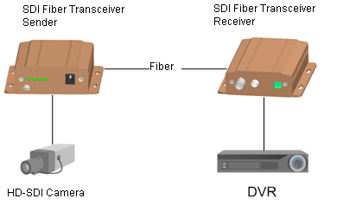
Figure 1-

Device Structure

Front Panel
The front panel is shown in Figure 2- .
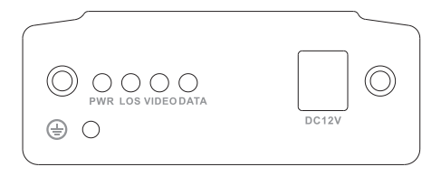
Figure 2-

Rear Panel
The rear panel is shown in Figure 2- .
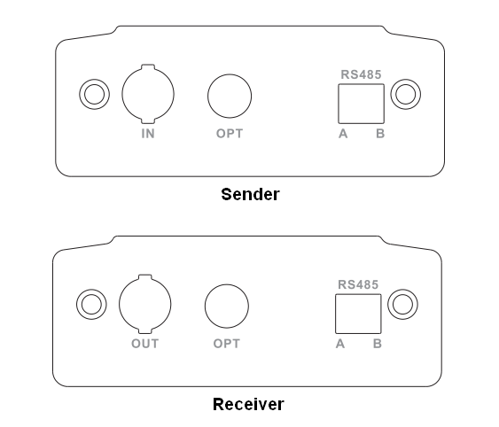
Figure 2-

Indicator and Other Ports

For indicator, please refer to Chart 2- . For other ports, please refer to Chart 2-

Indicator | Description | Color | Status
PWR | Power status indicator | Green | Means power connection is normal
LOS | Fiber status indicator | Green | Means fiber connection is normal
VIDEO | BNC video output indicator | Green | Means video input is normal
DATA | RS485 data transmission indicator | Flashing green | Means transmitting data
Chart 2-

Port | Description
DC12V | Power port, DC12V 1A
IN | Video input port
OUT | Video output port
OPT | Fiber port
RS485 | RS485 data port
Chart 2-

Technical Standard
Parameter |  | Description
Model |  | OTS102T  OTS102R
Optical Standard | Fiber type | Single fiber
Optical Standard | Fiber port | FC port
Optical Standard | Transmission distance | 0km～20km
Optical Standard | Send/Receive wavelength | Sending end: 1310nm send, 1550nm receive  Receiving end: 1550nm send, 1310nm receive
SDI Standard (sending end) | Input electrical level | ＞380 mVp-p
SDI Standard (sending end) | Input/output impedance | 75 ohm
SDI Standard (receiving end) | Receiving end output electrical level | 800mVp-p ±10%
SDI Standard (receiving end) | Receiving end up and down time | ＜0.8ns
SDI Standard (receiving end) | Receiving end max jitter | ＜0.2 UI
SDI Standard (receiving end) | Input/output impedance | 75 ohm
Data Standard | Input/output port number | 1
Data Standard | Baud rate | ≤115200bit/s
Data Standard | Bit error rate | ≤10⁻⁹
Data Standard | Working mode | Half-duplex auto-negotiation
Data Standard | Data format | RS485
Data Standard | Indicator | Optical link indicator, power indicator, data indicator, video source indicator
Data Standard | MTBF | >100,000 hours
General | Power supply | DC12V 1A
General | Working temperature | -40℃～75℃
General | Power consumption | ≤6W
General | Working humidity | 10%～90%
General | Dimension | 104.6mm×96.2mm×29.5mm

FAQ
Problem | Possible Cause | Solution
Video signal blanking | Fiber cable, video line connection are abnormal. | Properly connect fiber cable, and may judge according to device indicator.
Video signal blanking | Video line is too long. | Use better cable, and make 75-5 line > 100m
Video signal blanking | Sending end and receiving end are connected inversely. | Make sure sending end is OTS102T and receiving end is OTS102R.
RS485 does not work | Connecting terminal’s positive and negative ends are connected inversely. | Switch them.

Appendix A Toxic or Hazardous Materials or Elements
Component Name | Toxic or Hazardous Materials or Elements
Component Name | Pb | Hg | Cd | Cr VI | PBB | PBDE
Circuit Board Component | ○ | ○ | ○ | ○ | ○ | ○
Device Case | ○ | ○ | ○ | ○ | ○ | ○
Wire and Cable | ○ | ○ | ○ | ○ | ○ | ○
Packing Components | ○ | ○ | ○ | ○ | ○ | ○
Accessories | ○ | ○ | ○ | ○ | ○ | ○
O: Indicates that the concentration of the hazardous substance in all homogeneous materials in the parts is below the relevant threshold of the SJ/T11363-2006 standard.

X: Indicates that the concentration of the hazardous substance of at least one of all homogeneous materials in the parts is above the relevant threshold of the SJ/T11363-2006 standard. During the environmental-friendly use period (EFUP) period, the toxic or hazardous substance or elements contained in products will not leak or mutate so that the use of these (substances or elements) will not result in any severe environmental pollution, any bodily injury or damage to any assets. The consumer is not authorized to process such kind of substances or elements, please return to the corresponding local authorities to process according to your local government statutes

Note
- This user’s manual is for reference only.
- Slight difference may be found in user interface.
- All the designs and software here are subject to change without prior written notice.
- All trademarks and registered trademarks are the properties of their respective owners.
- If there is any uncertainty or controversy, please refer to the final explanation of us.
- Please visit our website for more information.

