Ethernet Fiber Transceiver
User’s Manual

V1.0.0

Important Safeguards and Warnings
Please read the following safeguards and warnings carefully before using the product in order to avoid damages and losses.
Note:
- Do not expose the device to lampblack, steam or dust. Otherwise it may cause fire or electric shock.
- Do not install the device at position exposed to sunlight or in high temperature. Temperature rise in device may cause fire.
- Do not expose the device to humid environment. Otherwise it may cause fire.
- The device must be installed on solid and flat surface in order to guarantee safety under load and earthquake. Otherwise, it may cause device to fall off or turnover.
- Do not place the device on carpet or quilt.
- Do not block air vent of the device or ventilation around the device. Otherwise, temperature in device will rise and may cause fire.
- Do not place any object on the device.
- Do not disassemble the device without professional instruction.

Warning:
- Please use battery properly to avoid fire, explosion and other dangers.
- Please replace used battery with battery of the same type.
- Do not use power line other than the one specified. Please use it properly. Otherwise, it may cause fire or electric shock.

Special Announcement
- This manual is for reference only.
- All the designs and software here are subject to change without prior written notice.
-  All trademarks and registered trademarks are the properties of their respective owners.
- If there is any uncertainty or controversy, please refer to the final explanation of us.
-  Please visit our website for more information.

Table of Contents
1 Product Overview - 1 -
1.1 Introduction - 1 -
1.2 Features - 1 -
1.3 Typical Application - 1 -
2 Device Structure - 3 -
2.1 Front Panel - 3 -
2.2 Real Panel - 3 -
2.3 Indicator and Other Ports - 3 -
3 Technical Standard - 5 -
4 FAQ - 6 -
Appendix A Toxic or Hazardous Materials or Elements - 7 -

Product Overview

Introduction
Ethernet fiber transceiver is an Ethernet transmission media converting unit that switch short-distance twisted-pair electrical signal with long-distance optical signal. It is reliable and applied in public security, traffic and factory.

Features
  - Support 1-ch 100M Ethernet data transmission on single fiber.
  - Support DC12V power.
  - Support IEEE802.3U, IEEE802.3X network standard.
  - Support 10/100Mbps auto-negotiation network signal transmission.
  - Support full/half duplex.
  - Industrial design, simple installation, UPnP.
  - Fiber default distance is 20km, and 40km, 80km are optional.
  - LED status indicator displays fiber transceiver’s working status.

Typical Application
Typical application of Ethernet fiber transceiver is shown in Figure 1- .
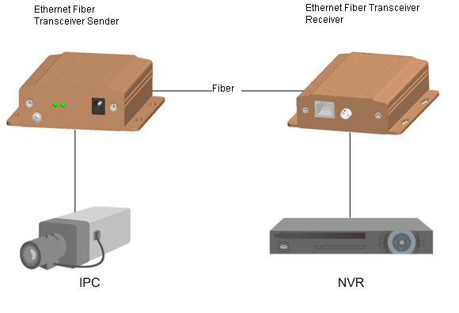
Figure 1-

Device Structure

Front Panel
The front panel is shown in Figure 2- .
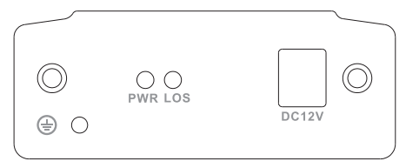
Figure 2-

Real Panel
The real panel is shown as in Figure 2- .
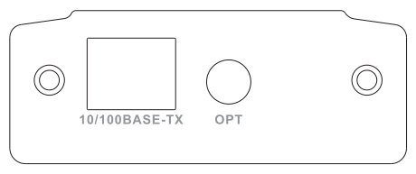
Figure 2-

Indicator and Other Ports
For indicator, please refer to Chart 2- . For other ports, please refer to Chart 2- .

Indicator | Description | Color | Status
PWR | Power status indicator | Green | Means power connection is normal.
LOS | Fiber status indicator | Green | Means fiber connection is normal.
Chart 2-

Port | Description
DC12V | Power port, DC12V 1A
OPT | Fiber port
Chart 2-

Technical Standard
Parameter |  | Description
Model |  | OTE103R  OTE103T
Optical Standard | Fiber type | Single fiber
Optical Standard | Fiber port | FC port
Optical Standard | Transmission distance | Single module 0km～20km
Optical Standard | Send/Receive wavelength | Send end(OTE103T)：1310nm send 1550nm receive  Receive end (OTE103R)：1550nm send 1310nm receive
Network Standard | Port type | 1 RJ45
Network Standard | Working mode | 10M/100M auto-negotiation Ethernet
Network Standard | Indicator | Optical link indicator, power indicator
Network Standard | MTBF | >100,000 hours
General | Power supply | DC12V 1A
General | Working temperature | ﹣40℃～75℃
General | Power consumption | ≤6W
General | Working humidity | 10%～90%
General | Dimension | 104.6mm×96.2mm×29.5mm

FAQ
Problem | Possible Cause | Solution
Network disconnection | Optical port connection error | Re-connect optical port. When LOS indicator is green, the device is normal.
Network disconnection | Sending/receiving devices are not used as pair. | Confirm if send end (OTE103T) and receive end (OTE103R) are correct.
Network disconnection or network packet loss | Cable is too long. | Change to better cable, or add relay to cables.

Appendix A Toxic or Hazardous Materials or Elements
Component Name | Toxic or Hazardous Materials or Elements
Component Name | Pb | Hg | Cd | Cr VI | PBB | PBDE
Circuit Board Component | ○ | ○ | ○ | ○ | ○ | ○
Device Case | ○ | ○ | ○ | ○ | ○ | ○
Wire and Cable | ○ | ○ | ○ | ○ | ○ | ○
Packing Components | ○ | ○ | ○ | ○ | ○ | ○
Accessories | ○ | ○ | ○ | ○ | ○ | ○
O: Indicates that the concentration of the hazardous substance in all homogeneous materials in the parts is below the relevant threshold of the SJ/T11363-2006 standard.

X: Indicates that the concentration of the hazardous substance of at least one of all homogeneous materials in the parts is above the relevant threshold of the SJ/T11363-2006 standard. During the environmental-friendly use period (EFUP) period, the toxic or hazardous substance or elements contained in products will not leak or mutate so that the use of these (substances or elements) will not result in any severe environmental pollution, any bodily injury or damage to any assets. The consumer is not authorized to process such kind of substances or elements, please return to the corresponding local authorities to process according to your local government statutes
Note
- This user’s manual is for reference only.
- Slight difference may be found in user interface.
- All the designs and software here are subject to change without prior written notice.
- All trademarks and registered trademarks are the properties of their respective owners.
- If there is any uncertainty or controversy, please refer to the final explanation of us.
- Please visit our website for more information.

