**8-Port PoE Switch**

**User’s Manual**

**V1.0.0**

Important Safeguards and Warnings

Please read the following safeguards and warnings carefully before using the product in order to avoid damages and losses.

Note:

Do not expose the device to lampblack, steam or dust. Otherwise it may cause fire or electric shock.

Do not install the device at position exposed to sunlight or in high temperature. Temperature rise in device may cause fire.

Do not expose the device to humid environment. Otherwise it may cause fire.

The device must be installed on solid and flat surface in order to guarantee safety under load and earthquake. Otherwise, it may cause device to fall off or turnover.

Do not place the device on carpet or quilt.

Do not block air vent of the device or ventilation around the device. Otherwise, temperature in device will rise and may cause fire.

Do not place any object on the device.

Do not disassemble the device without professional instruction.

**Warning:**

Please use battery properly to avoid fire, explosion and other dangers.

Please replace used battery with battery of the same type.

Do not use power line other than the one specified. Please use it properly. Otherwise, it may cause fire or electric shock.

Special Announcement:

* + - This manual is for reference only.
    - All the designs and software here are subject to change without prior written notice.
    -  All trademarks and registered trademarks are the properties of their respective owners.
    - If there is any uncertainty or controversy, please refer to the final explanation of us.
    -  Please visit our website for more information.

Table of Contents

1 Product Overview - 1 -

1.1 Features - 1 -

1.2 Typical Application - 1 -

2 Device Structure - 3 -

2.1 Port - 3 -

2.2 PoE - 3 -

2.3 Install Ear - 4 -

● Appendix 1 Technical Specification - 5 -

● Appendix 2 Toxic or Hazardous Materials or Elements - 6 -

# Product Overview

8-port PoE switch is a lay 2 switch which supports Power over Ethernet. It is widely applied in school, community, office and other environment where fewer wiring is preferred

## Features

* + 1*1000Mbps SFP optical port, 1*10/100/1000Mbps electrical port, and 8*10/100Mbps PoE electrical ports.
  + Switch capacity 5.6Gbps, including transmission rate 8.3 Mbps.
  + IEEE802.3af, IEEE802.3at, and PoE total power of 120W.
  + Up to 8K MAC address entries with automatic learning and aging.
  + Port self-adaptive MDI/MDIX modes.
  + Metal plate, brand new design.
  + AC 110V, AC 220V power supply.

## Typical Application

The typical application of fiber transceiver is shown in

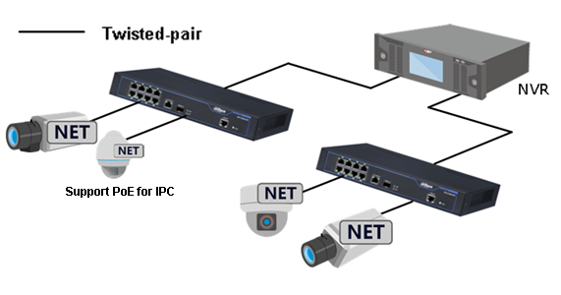

Figure 1- 1

# Device Structure

## Port

The front panel is shown in .

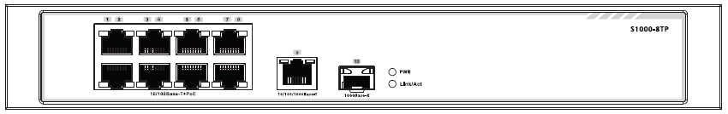

Figure 2- 1 S1000-8TP

| No. | Name | Function |
| --- | --- | --- |
| **1** | No. 1~8 | 8*10/100Mbps electrical ports. |
| **2** | 10/100/1000Base-T | 1*10/100/1000Mbps electrical port. |
| **3** | 1000Base-X | 1*1000Mbps SFP port. |
| **4** | PWR, Link/Act | PWR: power indicator.  Link/Act: optical link indicator. |

The rear panel is shown in .

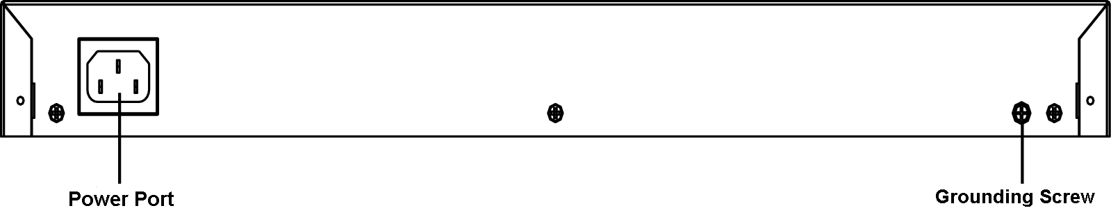

Figure 2- 2 S1000-8TP

## PoE

8-port PoE switch has a total of 8 100Mbps electrical ports all supporting PoE. Please be careful with the following:

* Electrical port 1, electrical port 2 support 60W, IEEE802.3af, IEEE802.3at.
* Electrical port 3 electrical port 4 support IEEE802.3af, IEEE802.3at.
* Electrical port 5, electrical port 6, electrical port 7, electrical port 8 support IEEE802.3af.

## Install Ear

8-port PoE switch supports installation in rack or on surface. For installation in rack, please refer to the following instruction.

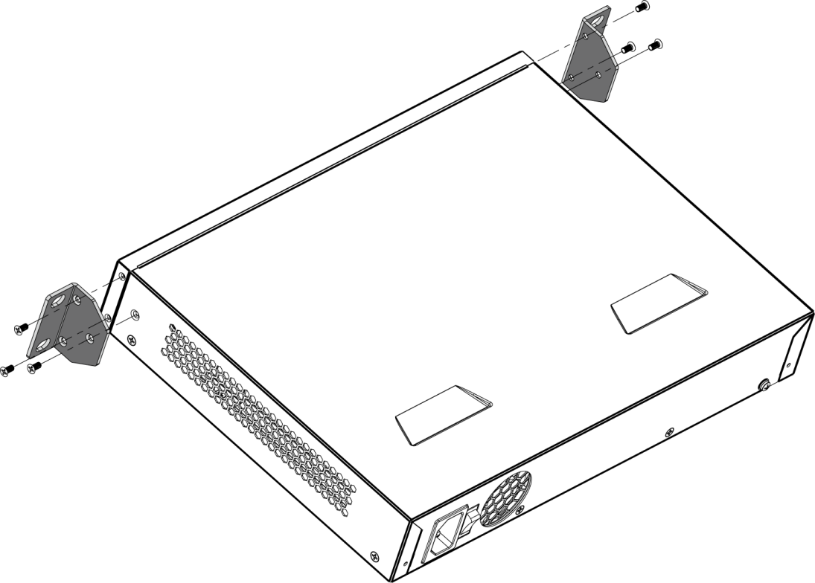

Figure 2- 3 Ear installation

Appendix 1 Technical Specification

| **Product Model** | **S1000-8TP** |
| --- | --- |
| Physical Port | |
| Network Port | 1 10*100Mbps SFP optical port, 1 10*100Mbps electrical port, 8 100Mbps electrical ports. |
| **Technical Specification** | |
| Switch Capacity | 5.6Gbps |
| Transmission Rate | 8.3Mpps |
| Switch Mode | Storage and transmission |
| MAC Learning | MAC auto learning and aging, MAC address list capacity is 8K. |
| POE Standard | IEEE802.3af, IEEE802.3at |
| **General** | |
| Power | AC 220V |
| Consumption | ≤150W |
| Temperature | -10℃～＋55℃ |
| Humidity | 10%～90% |
| Weight | ＜3kg |
| Dimension | 300mm×220mm×44.4mm |
| Installation | In rack, on surface |

Appendix 2 Toxic or Hazardous Materials or Elements

|  |  |  |  |  |  |  |
| --- | --- | --- | --- | --- | --- | --- |
| **Component Name** | **Toxic or Hazardous Materials or Elements** | | | | | |
| **Pb** | **Hg** | **Cd** | **Cr VI** | **PBB** | **PBDE** |
| Circuit Board Component | ○ | ○ | ○ | ○ | ○ | ○ |
| Device Case | ○ | ○ | ○ | ○ | ○ | ○ |
| Wire and Cable | ○ | ○ | ○ | ○ | ○ | ○ |
| Packing Components | ○ | ○ | ○ | ○ | ○ | ○ |
| Accessories | ○ | ○ | ○ | ○ | ○ | ○ |

O: Indicates that the concentration of the hazardous substance in all homogeneous materials in the parts is below the relevant threshold of the SJ/T11363-2006 standard.

X: Indicates that the concentration of the hazardous substance of at least one of all homogeneous materials in the parts is above the relevant threshold of the SJ/T11363-2006 standard. During the environmental-friendly use period (EFUP) period, the toxic or hazardous substance or elements contained in products will not leak or mutate so that the use of these (substances or elements) will not result in any severe environmental pollution, any bodily injury or damage to any assets. The consumer is not authorized to process such kind of substances or elements, please return to the corresponding local authorities to process according to your local government statutes

**Note**

* **This user’s manual is for reference only.**
* **Slight difference may be found in user interface.**
* **All the designs and software here are subject to change without prior written notice.**
* [**All trademarks and registered trademarks are the properties of their respective owners.**](http://www.affordablelaundry.com/all-trademarks-and-registered-trademarks-are-the-property-of-their-respective-owners)
* **If there is any uncertainty or controversy, please refer to the final explanation of us.**
* **Please visit our website for more information.**