5-Port Access Switch (5 RJ45 ports)
User’s Manual

V1.0.0

Important Safeguards and Warnings

Please read the following safeguards and warnings carefully before using the product in order to avoid damages and losses.
Note
- Do not expose the device to lampblack, steam or dust. Otherwise it may cause fire or electric shock.
- Do not install the device at position exposed to sunlight or in high temperature. Temperature rise in device may cause fire.
- Do not expose the device to humid environment. Otherwise it may cause fire.
- The device must be installed on solid and flat surface in order to guarantee safety under load and earthquake. Otherwise, it may cause device to fall off or turnover.
- Do not place the device on carpet or quilt.
- Do not block air vent of the device or ventilation around the device. Otherwise, temperature in device will rise and may cause fire.
- Do not place any object on the device.
- Do not disassemble the device without professional instruction.

Warning
- Please use battery properly to avoid fire, explosion and other dangers.
- Please replace used battery with battery of the same type.
- Do not use power line other than the one specified. Please use it properly. Otherwise, it may cause fire or electric shock.

Special Announcement
- This manual is for reference only.
- All the designs and software here are subject to change without prior written notice.
- All trademarks and registered trademarks are the properties of their respective owners.
- If there is any uncertainty or controversy, please refer to the final explanation of us.
- Please visit our website for more information.
Table of Contents
1 Product Overview - 1 -
1.1 Features - 1 -
1.2 Typical Application - 1 -
2 Device Structure - 3 -
2.1 Front Panel - 3 -
2.2 Rear Panel - 3 -
Appendix 1 Technical Specifications - 4 -
Appendix 2 Toxic or Hazardous Materials or Elements - 5 -

Product Overview

Features
Common features are as follows:
- Two-layer Business Switch.
- Switch capacity 2.8Gbps，forwarding rate 4.166Mpps.
- Support one 10/100/1000M self-adaptive RJ45 port，four 10/100M self-adaptive RJ45 ports.
- Conform IEEE802.3,IEEE802.3u,IEEE802.3ab/z and IEEE802.3X standards.
- MAC auto study and aging, MAC address list capacity is 8K.
- All ports self-adaptive MDI/MDIX modes.
- Indicator displays data transmission status and power status.
- Industrial Wide Temperature Design
- Adopt metal structure.
- Support DC12V/DC24V/AC24V power supply.

Typical Application
The typical application of 5-Port Access Switch is shown in Figure 1-1.
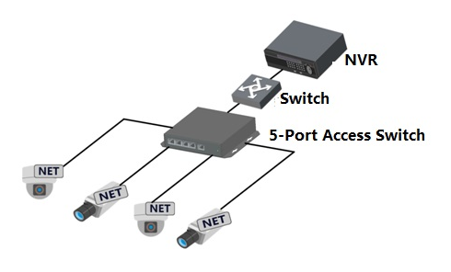
Figure 1-

Device Structure

Front Panel

The front panel is shown in Figure 2- .

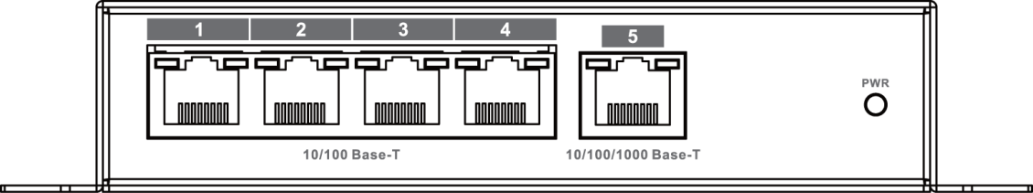
Figure 2-

Please refer to Sheet 2-1 for more information.

Number | Name | Description
1～4 | 10/100Base-T | 10/100M self-adaptive RJ45 ports
5 | 10/100/1000Base-T | 10/100/1000M self-adaptive RJ45 port
- | PWR | Power indicator

Sheet 2-1

Rear Panel
  - The device power ports are shown in Figure 2- . Support DC12V/DC24V/AC24V power supply.

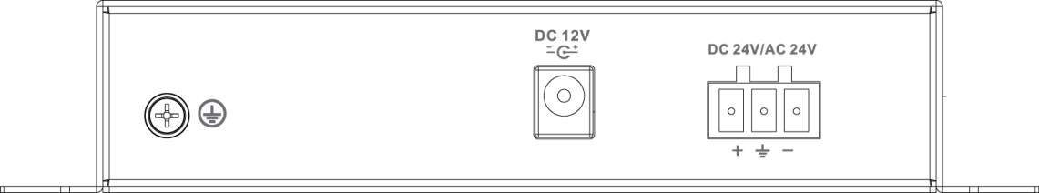
Figure 2- 2

Appendix 1 Technical Specifications
Technical Parameters | S3100-5T
Physical Port
Function Port | 1*10/100/1000 Base-T, 4*10/100 Base-T
Technical Index
Switch Capacity | 2.8Gbps
Forwarding Rate | 4.166Mpps
Switch Mode | Storage forwarding
MAC Study | MAC auto study, address list capacity is 8K
General Parameters
Indicator | Power indicator
Power | DC12V、DC24V、AC24V
Power Consumption | ≤3W
Humidity | 10%～90%
Temperature | ﹣40℃～75℃
Unit Weight | 200g
Dimension | 162mm×136.4mm×30mm

Appendix 2 Toxic or Hazardous Materials or Elements
Component Name | Toxic or Hazardous Materials or Elements
Component Name | Pb | Hg | Cd | Cr VI | PBB | PBDE
Circuit Board Component | ○ | ○ | ○ | ○ | ○ | ○
Device Case | ○ | ○ | ○ | ○ | ○ | ○
Wire and Cable | ○ | ○ | ○ | ○ | ○ | ○
Packing Components | ○ | ○ | ○ | ○ | ○ | ○
Accessories | ○ | ○ | ○ | ○ | ○ | ○

O: Indicates that the concentration of the hazardous substance in all homogeneous materials in the parts is below the relevant threshold of the SJ/T11363-2006 standard.

X: Indicates that the concentration of the hazardous substance of at least one of all homogeneous materials in the parts is above the relevant threshold of the SJ/T11363-2006 standard. During the environmental-friendly use period (EFUP) period, the toxic or hazardous substance or elements contained in products will not leak or mutate so that the use of these (substances or elements) will not result in any severe environmental pollution, any bodily injury or damage to any assets. The consumer is not authorized to process such kind of substances or elements, please return to the corresponding local authorities to process according to your local government statute.
Note
- This user’s manual is for reference only.
- Slight difference may be found in user interface.
- All the designs and software here are subject to change without prior written notice.
- All trademarks and registered trademarks are the properties of their respective owners.
- If there is any uncertainty or controversy, please refer to the final explanation of us.
- Please visit our website for more information.

