4-CH HDCVI Fiber Transceiver
User’s Manual

V1.0.0
Important Safeguards and Warnings

Please read the following safeguards and warnings carefully before using the product in order to avoid damages and losses.
Note
- Do not expose the device to lampblack, steam or dust. Otherwise it may cause fire or electric shock.
- Do not install the device at position exposed to sunlight or in high temperature. Temperature rise in device may cause fire.
- Do not expose the device to humid environment. Otherwise it may cause fire.
- The device must be installed on solid and flat surface in order to guarantee safety under load and earthquake. Otherwise, it may cause device to fall off or turnover.
- Do not place the device on carpet or quilt.
- Do not block air vent of the device or ventilation around the device. Otherwise, temperature in device will rise and may cause fire.
- Do not place any object on the device.
- Do not disassemble the device without professional instruction.

Warning
- Please use battery properly to avoid fire, explosion and other dangers.
- Please replace used battery with battery of the same type.
- Do not use power line other than the one specified. Please use it properly. Otherwise, it may cause fire or electric shock.

Special Announcement
- This manual is for reference only.
- All the designs and software here are subject to change without prior written notice.
- All trademarks and registered trademarks are the properties of their respective owners.
- If there is any uncertainty or controversy, please refer to the final explanation of us.
- Please visit our website for more information.
Table of Contents
1 Product Overview - 1 -
1.1 Product Model - 1 -
1.2 Features - 1 -
1.3 Typical Application - 2 -
2 Device Structure - 3 -
2.1 Front Panel - 3 -
2.1.1 Sender - 3 -
2.1.2 Receiver - 4 -
2.2 Rear Panel - 5 -
2.2.1 Sender - 5 -
2.2.2 Receiver - 6 -
Appendix 1 Technical Specifications - 8 -
Appendix 2 Toxic or Hazardous Materials or Elements - 10 -

Product Overview

Product Model
The manual is designed for two products which are four-channel standard HDCVI fiber transceiver and four-channel multi-function HDCVI fiber transceiver.

Features
Common features are as follows:
- High definition, lossless, real time, non-compression.
- Metal plate or proximate matter is used for the structure, fully enclosed dustproof design.
- Temperature design：﹣40℃-75℃
- UPnP with simple installation.
- LED status indicator shows the working condition of optical transceiver.
- Support video format720p/25, 720p/30, 720p/50, 720p/60, 1080p/25, and 1080p/30.

Unique features for four-channel multi-function HDCVI fiber transceiver:
- Support audio input/output.
- Support on-off signal input/output.
- Support 1*10/100Mbps RJ 45 port.

Typical Application
The typical application of HDCVI fiber transceiver is shown in Figure 1-1.

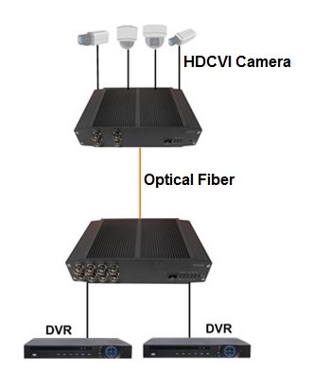
Figure 1-

Device Structure

Front Panel
This section will take four-channel standard HDCVI fiber transceiver as an example to introduce the front panel. Both four-channel multi-service HDCVI fiber transceiver and four-channel standard HDCVI fiber transceiver have the same front panel. The only difference is the product model; please refer to the sheet 2-1 for more information.

Silk Print | Device
OTC402T | 4-CH Standard HDCVI Fiber Transceiver Sender
OTC402R | 4-CH Standard HDCVI Fiber Transceiver Receiver
OTC405T | 4-CH Multi-Function HDCVI Fiber Transceiver Sender
OTC405R | 4-CH Multi-Function HDCVI Fiber Transceiver Receiver

Sheet 2-1

2.1.1 Sender

The front panel of sender is shown in Figure 2- .

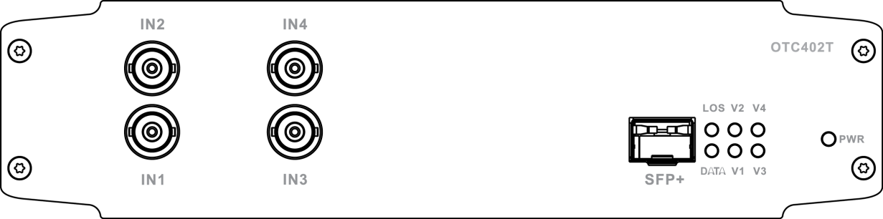
Figure 2-

For indicator, please refer to Sheet 2-2. For other ports, please refer to Sheet 2-3.

Indicator | Description | Color | Status
PWR | Power status indicator | Green | Power connection is normal
V1/V2/V3/V4 | BNC video input indicator | Green | Video input is normal
LOS | Optical link status indicator | Green | Fiber connection is normal
DATA | RS485 data transmission indicator | Flashing green | Transmitting RS485 data

Sheet 2-2

Port | Description
IN1/IN2/IN3/IN4 | Video input port
SFP+ | SFP+ optical module port

Sheet 2-3

2.1.2 Receiver

The front panel of receiver is shown in Figure 2-

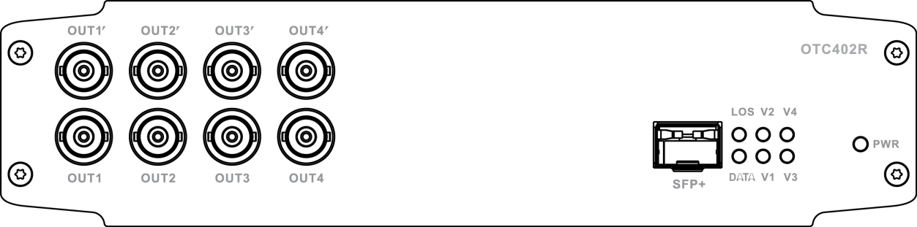

Figure 2-

For indicator, please refer to Sheet 2-4. For other ports, please refer to Sheet 2-5.

Indicator | Description | Color | Status
PWR | Power status indicator | Green | Power connection is normal
LOS | Fiber status indicator | Green | Fiber connection is normal
V1/V2/V3/V4 | Fiber video signal indicator | Green | Fiber video signal is normal, that is to say sender IN1/IN2/IN3/IN4 video signal is normal.
DATA | RS485 data transmission indicator | Flashing green | Transmitting RS485 data

Sheet 2-4

Port | Description
SFP+ | SFP+ optical module port
OUT1/OUT2/OUT3/OUT4 | HDCVIV video output port
OUT1ˊ/OUT2ˊ/OUT3ˊ/OUT4ˊ | HDCVI video loop output port

Sheet 2-5

Rear Panel
The rear panel of four-channel standard/multi-function HDCVI fiber transceiver sender and receiver is shown in figure 2-3 and 2-4.

2.2.1 Sender
The rear panel of standard HDCVI fiber transceiver sender is shown in Figure 2- .
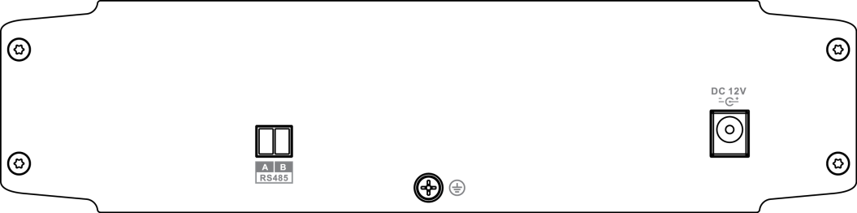
Figure 2- 3

For ports, please refer to sheet 2-6

Port | Description
DC12V | Power port，DC12V 1A
RS485 | RS485 control data

Sheet 2-6

The rear panel of four-channel multi-function HDCVI fiber transceiver sender is shown in Figure 2- .

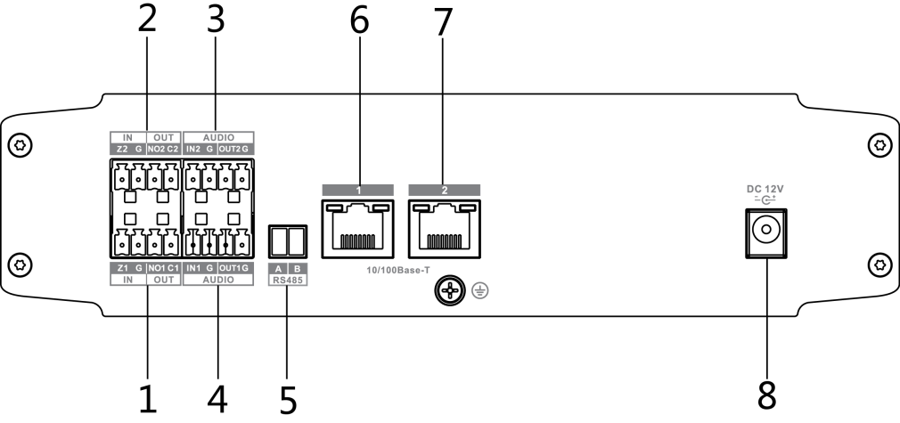

Figure 2-

For ports, please refer to sheet 2-7

SN | Name | Description
1 | IN/OUT | On-off in/out
2 | IN/OUT | On-off in/out
3 | AUDIO | Audio in/out
4 | AUDIO | Audio in/out
5 | RS485 | RS485 control data
6 | 10/100 Base-T | One 100Mbps RJ45 port
7 | 10/100 Base-T | One 100Mbps RJ45 port
8 | DC 12V | Power port，DC12V 1A

Sheet 2-7

2.2.2 Receiver
The rear panel of four-channel standard HDCVI fiber transceiver receiver is shown in Figure 2-5.

Figure 2-5

For ports, please refer to sheet 2-8

Port | Description
DC12V | Power port，DC12V 1A
RS485 | RS485 control data

Sheet 2-8

The rear panel of four-channel multi-function HDCVI fiber transceiver receiver is shown in Figure 2-6.

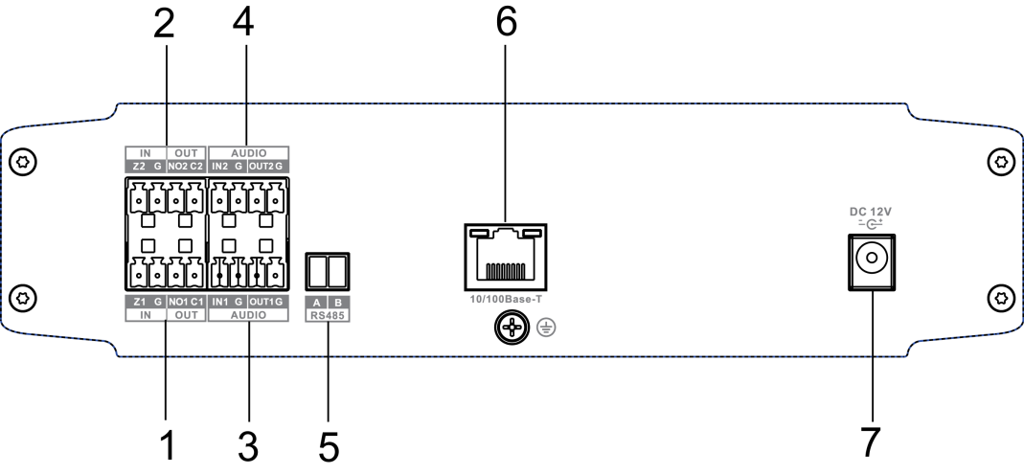
Figure 2-6

For ports, please refer to sheet 2-9

SN | Name | Description
1 | IN/OUT | On-off in/out
2 | IN/OUT | On-off in/out
3 | AUDIO | Audio in/out
4 | AUDIO | Audio in/out
5 | RS485 | RS485 control data
6 | 10/100 Base-T | One 100Mbps RJ45 port
7 | DC 12V | Power port，DC12V 1A

Sheet 2-9

Appendix 1 Technical Specifications
Product Model | OTC402T/R(Standard version) | OTC405T/R（Multi-function）
Optical Index
Physical Port | SFP+ Port
Transmission Distance | 0km～20km
Input/output Wave Length | Sender（OTC402T/OTC405T）：1550nm send1310nm receive；  Receiver（OTC402R/OTC405R）：1310nm send 1550nm receive
HDCVI Video Index
Physical Port | Sender（OTC402T）：4*BNC, 1*RS485  Receiver（OTC402R）：8*BNC,1*RS485 | Sender（OTC405T）：4*BNC, 1*RS485, 2* audio input, 2* audio output, two- channel on-off signal input, two- channel on-off signal output, 2*RJ45 10/100Mbps  Receiver（OTC405R）：8*BNC、1*RS485、1* audio input, 2*audio output, two- channel on-off signal input, two- channel on-off signal output, 1*RJ45 10/100Mbps
Sender Input Electrical Level | >500mVp-p
Receiver Output Electrical Level | 1Vp-p
Input Auto  Cable  Balance | 1080p：75-5 coaxial cable support 300m  720p ：75-5coaxial cable support 500m
Sender Input Reflection Loss | >15dB
Input/Output Impedance | 75Ohm
Video Bandwidth | 45MHz
Sampling Bandwidth | 10bit
Sampling Frequency | 108MHz
HDCVI Audio Index
Sampling Bandwidth | N/A | 16bit
Audio Sampling Frequency | N/A | 48KHz
HDCVI Coaxial Control Data Index
Work Mode | Half-duplex
Error Rate | <10⁻⁹
Baud Rate | 1200-9600bps
Other
Indicator | Light linker indicator, power indicator, RS485 data transmission indicator, video indicator
Power | DC12V 1A
Power Consumption | Sender <7.5W，receiver <8W
Humidity | 10%～90%
Temperature | ﹣40℃～75℃
Unit Weight | 500g
Dimension | 210mm×142.15mm×52mm
Installation | Wall mount

Appendix 2 Toxic or Hazardous Materials or Elements
Component Name | Toxic or Hazardous Materials or Elements
Component Name | Pb | Hg | Cd | Cr VI | PBB | PBDE
Circuit Board Component | ○ | ○ | ○ | ○ | ○ | ○
Device Case | ○ | ○ | ○ | ○ | ○ | ○
Wire and Cable | ○ | ○ | ○ | ○ | ○ | ○
Packing Components | ○ | ○ | ○ | ○ | ○ | ○
Accessories | ○ | ○ | ○ | ○ | ○ | ○

O: Indicates that the concentration of the hazardous substance in all homogeneous materials in the parts is below the relevant threshold of the SJ/T11363-2006 standard.

X: Indicates that the concentration of the hazardous substance of at least one of all homogeneous materials in the parts is above the relevant threshold of the SJ/T11363-2006 standard. During the environmental-friendly use period (EFUP) period, the toxic or hazardous substance or elements contained in products will not leak or mutate so that the use of these (substances or elements) will not result in any severe environmental pollution, any bodily injury or damage to any assets. The consumer is not authorized to process such kind of substances or elements, please return to the corresponding local authorities to process according to your local government statute.
Note
- This user’s manual is for reference only.
- Slight difference may be found in user interface.
- All the designs and software here are subject to change without prior written notice.
- All trademarks and registered trademarks are the properties of their respective owners.
- If there is any uncertainty or controversy, please refer to the final explanation of us.
- Please visit our website for more information.

