**Dahua 4/8-Port PoE Switch User’s Manual**

**V1.0.0**

**Dahua Technology CO., LTD**

Important Safeguards and Warnings

**Attention:**

Please read the following safeguards and warnings carefully before using the product in order to avoid damages and losses.

Note:

* + - Do not expose the device to lampblack, steam or dust. Otherwise it may cause fire or electric shock.
    - Do not install the device at position exposed to sunlight or in high temperature. Temperature rise in

device may cause fire.

* + - Do not expose the device to humid environment. Otherwise it may cause fire.
    - The device must be installed on solid and flat surface in order to guarantee safety under load and earthquake. Otherwise, it may cause device to fall off or turnover.
    - Do not place the device on carpet or quilt.
    - Do not block air vent of the device or ventilation around the device. Otherwise, temperature in

device will rise and may cause fire.

* + - Do not place any object on the device.
    - Do not disassemble the device without professional instruction.

**Warning:**

* + - Please use battery properly to avoid fire, explosion and other dangers.
    - Please replace used battery with battery of the same type.
    - Do not use power line other than the one specified. Please use it properly. Otherwise, it may cause fire or electric shock.

**Special Announcement:**

* + - This manual is for reference only.
    - All the designs and software here are subject to change without prior written notice.
    - All trademarks and registered trademarks are the properties of their respective owners.
    - If there is any uncertainty or controversy, please refer to the final explanation of us.
    - Please visit our website for more information.

**Applicable Models:**

The manual can be applied to the following models:

DH-PFS3106-4P-60, DH-PFS3110-8P-96

Table of Contents

1 Product Overview - 1 -

1.1 Features - 1 -

1.2 Typical Application - 1 -

2 Device Structure - 3 -

2.1 4-Port PoE Switch - 3 -

2.1.1 Front Panel - 3 -

2.1.2 Upper Cover - 5 -

2.1.3 PoE Power Supply - 6 -

2.2 8-Port PoE Switch - 7 -

2.2.1 Front Panel - 7 -

2.2.2 Upper Cover - 8 -

2.2.3 PoE Power Supply - 9 -

3 Installation Guide - 10 -

● Appendix 1 Technical Specification - 11 -

# Product Overview

## Features

### Common Features:

* + Two-layer industrial POE switch.
  + Conform IEEE802.3, IEEE802.3u, IEEE802.3ab/z and IEEE802.3X standards.
  + MAC auto study and aging, MAC address list capacity is 8K.
  + All ports self-adapt MDI/MDIX mode.
  + All the10/100M self-adaptive RJ45 ports support IEEE802.3af, IEEE802.3at standard power supply.
  + Industrial wide temperature design.
  + Adopt metal structure.
  + Support DC 53V power supply.

### Individual Features:

* + 4-port PoE switch 1 100/1000M self-adaptive SFP fiber port, 1 10/100/1000M self-adaptive RJ45 port and 4 10/100M self-adaptive RJ 45 ports.
  + 4-port PoE switch with 60W power adapter.
  + 8-port PoE switch supports 1 1000M SFP fiber port, 1 10/100/1000M self-adaptive RJ45 port and 8 10/100M self-adaptive RJ 45 ports.
  + 8-port PoE switch with 96W power adapter.

## Typical Application

The typical application of the device is shown in

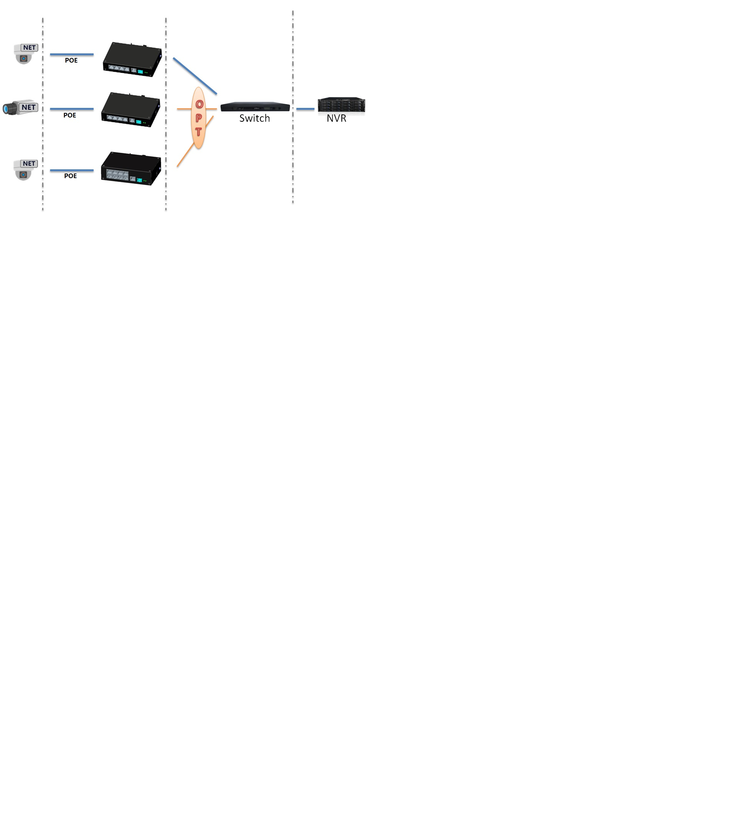

Figure 1- 1

# Device Structure

## 4-Port PoE Switch

### Front Panel

The front panel is shown in .

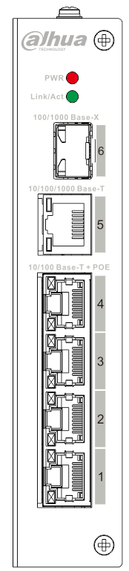

Figure 2-1

| SN | Name | Note |
| --- | --- | --- |
| 1 | 10/100 Base-T | 4 10/100M self-adaptive PoE power supply ports. |
| 2 | 10/100/1000 Base-T | 10/100/1000M self-adaptive RJ45 port. |
| 3 | 100/1000 Base-X | 100/1000M self-adaptive SFP fiber port. |
| 4 | Link/Act | Fiber port status indicator |
| 5 | PWR | Power indicator |

Sheet 2-1

### Upper Cover

The device power port is shown in Figure 2-2, support DC53V power supply.



Figure 2-2

### PoE Power Supply

* 4 10/100M RJ45 ports support IEEE802.3af, IEEE802.3at standard power supply.
* Support 4 10/100M RJ45 Ports IEEE802.3af standard power supply simultaneously.
* Support 2 10/100M RJ45 ports IEEE802.3at standard power supply simultaneously.

## 8-Port PoE Switch

### Front Panel

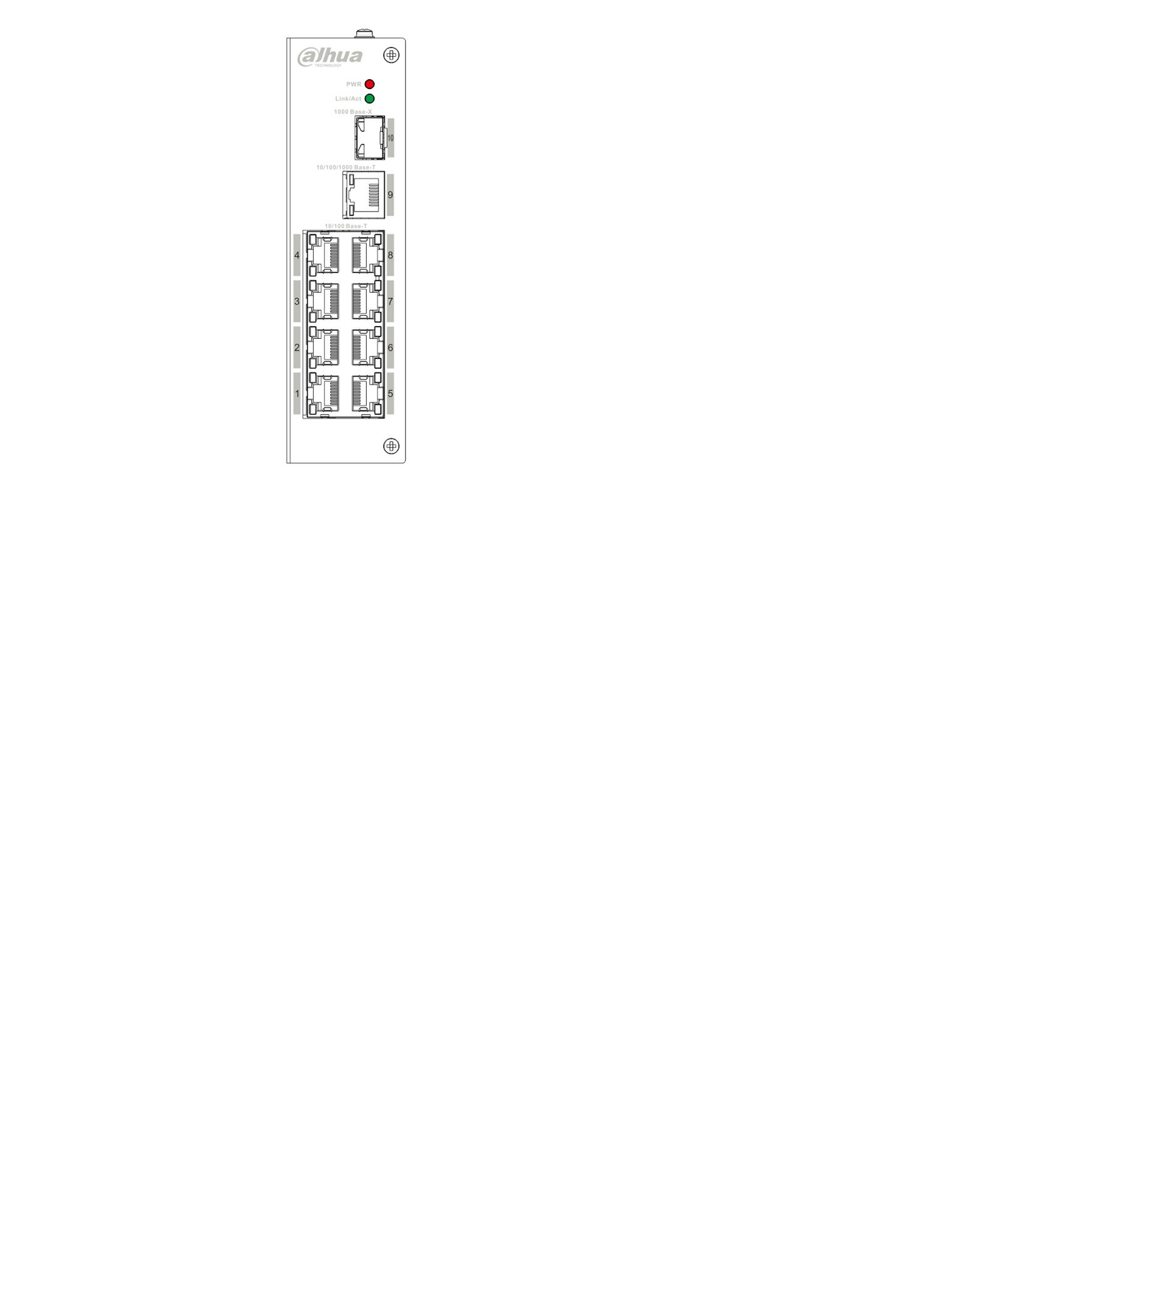

Figure 2-3

| SN | Name | Note |
| --- | --- | --- |
| 1 | 10/100 Base-T | 8 10/100M self-adaptive RJ45 ports, which are used for PoE power supply. |
| 2 | 10/100/1000 Base-T | 10/100/1000M self-adaptive RJ45 port. |
| 3 | 1000 Base-X | 1000M self-adaptive SFP fiber port. |
| 4 | Link/Act | Fiber port status indicator. |
| 5 | PWR | Power indicator. |

Sheet 2-2

### Upper Cover

The device power port is shown in Figure 2-4, support DC53V power supply.



Figure 2-4

### PoE Power Supply

* 8 10/100M RJ45 ports support IEEE802.3af, IEEE802.3at standard power supply.
* Support several RJ45 Ports IEEE802.3af and IEEE802.3at standard power supply simultaneously,

total power consumption of PoE power supply is less than 93W.

# Installation Guide

PoE switch supports DIN rail mounting. Lay the switch hook on the rail, press the PoE switch to make

the buckle get into the slide, see Figure 3-1.

Note:

4-port PoE switch supports the slide width of 28mm.

8-port PoE switch supports the slide width of 38mm.



Figure 3-1

Appendix 1 Technical Specification

|  |  |  |
| --- | --- | --- |
| Technical Parameters | DH-PFS3106-4P-60 | DH-PFS3110-8P-96 |
| Physical Port | | |
| Business Port | 1*100/1000 Base-X、  1*10/100/1000 Base-T、  4*10/100 Base-T（POE power supply） | 1*1000 Base-X、  1*10/100/1000 Base-T、  8*10/100 Base-T（POE power supply） |
| Technical Index | | |
| Exchange Capacity | 4.80Gbps | 5.60Gbps |
| Packet Forwarding Rate | 3.57Mpps | 4.17Mpps |
| Exchange Mode | Store & forward | Store & forward |
| MAC Study | MAC auto study, address list capacity 8K | MAC auto study, address list capacity 8K |
| Common Parameters | | |
| Lightning Protection Level | Lightning protection level 3 | Lightning protection level 3 |
| Indicator | Power indicator, fiber port status  indicator | Power indicator, fiber port status indicator |
| Power | Default DC53V power adapter | Default DC53V power adapter |
| Power Consumption | ≤60W | ≤96W |
| Application Humidity | 10%～90% | 10%～90% |
| High &Low Temperature | ﹣30℃～65℃ | ﹣30℃～65℃ |
| Weight | 480g | 540g |
| Dimension | 150mm×100mm×30mm | 150mm×100mm×42mm |

**Note**

* **This user’s manual is for reference only.**
* **Slight difference may be found in user interface.**
* **All the designs and software here are subject to change without prior written notice.**
* [**All trademarks and registered trademarks are the properties of their respective owners.**](http://www.affordablelaundry.com/all-trademarks-and-registered-trademarks-are-the-property-of-their-respective-owners)
* **If there is any uncertainty or controversy, please refer to the final explanation of us.**
* **Please visit our website for more information.**



**Dahua Technology Co., Ltd**

**Address：No.1199 Bin’an Road, Binjiang District, Hangzhou, China.**

**Postcode: 310053**

**Tel: +86-571-87688883**

**Fax: +86-571-87688815**

**Email:overseas@dahuatech.com**

**Website: www.dahuatech.com**