**16-Port Fiber Switch**

**User’s Manual**

**V1.0.1**

Important Safeguards and Warnings

Please read the following safeguards and warnings carefully before using the product in order to avoid damages and losses.

Note:

Do not expose the device to lampblack, steam or dust. Otherwise it may cause fire or electric shock.

Do not install the device at position exposed to sunlight or in high temperature. Temperature rise in device may cause fire.

Do not expose the device to humid environment. Otherwise it may cause fire.

The device must be installed on solid and flat surface in order to guarantee safety under load and earthquake. Otherwise, it may cause device to fall off or turnover.

Do not place the device on carpet or quilt.

Do not block air vent of the device or ventilation around the device. Otherwise, temperature in device will rise and may cause fire.

Do not place any object on the device.

Do not disassemble the device without professional instruction.

Warning:

Please use battery properly to avoid fire, explosion and other dangers.

Please replace used battery with battery of the same type.

Do not use power line other than the one specified. Please use it properly. Otherwise, it may cause fire or electric shock.

Special Announcement

This manual is for reference only.

All the designs and software here are subject to change without prior written notice.

 All trademarks and registered trademarks are the properties of their respective owners.

If there is any uncertainty or controversy, please refer to the final explanation of us.

 Please visit our website for more information.

Table of Contents

1 Product Overview - 1 -

1.1 Introduction - 1 -

1.2 Features - 1 -

1.3 Typical Application - 1 -

2 Device Structure - 3 -

2.1 Front Panel - 3 -

2.2 Rear Panel - 3 -

3 WEB Operation - 4 -

3.1 Login - 4 -

3.2 Device Info - 4 -

3.3 System Settings - 5 -

3.3.1 System Info - 5 -

3.3.2 Network Config - 6 -

3.3.3 Software Upgrade - 7 -

3.3.4 Change Password - 8 -

3.3.5 Restore Default - 8 -

3.3.6 Reboot - 9 -

3.4 Device Management - 9 -

3.4.1 802.1Q VLAN Config - 10 -

3.4.2 MAC Security - 10 -

3.4.3 Link Aggregation - 11 -

3.5 Port Management - 12 -

3.5.1 Port Config - 12 -

3.5.2 Port Mirroring Config - 12 -

3.5.3 Port Speed Limit - 13 -

4 FAQ - 14 -

● Appendix A Technical Specification - 15 -

● Appendix B Toxic or Hazardous Materials or Elements - 16 -

# Product Overview

## Introduction

16-port fiber switch is a lay 2 switch which supports WEB, SNMP and integration functions. It provides 16*100Mbps SFP fiber ports and 2*1000Mbps Combo ports via fiber transmission. It is used in safe city, high way and other environments.

## Features

16*100Mbps SFP fiber ports and 2*1000Mbps Combo ports.

Switch capacity 7.2Gbps, including transmission rate 10.7 Mbps.

IEEE802.3, IEEE802.3u, IEEE802.3ab/z and IEEE802.3X standards.

High performance lookup engine with support for up to 8K MAC address entries with automatic learning and aging.

Port self-adaptive MDI/MDIX modes.

Support WEB, SNMP (v1/v2c).

IEEE802.3X dual flow control and Backpressure half-dual flow control.

Indicator displays Link/Act status.

Support port isolation, speed limit, mirroring, 802.1Q VLAN, link aggregation.

802.1p and the port’s default priority.

Anti-MAC address flooding.

Metal plate, brand new design.

AC 220 power supply.

## Typical Application

The typical application of fiber transceiver is shown in

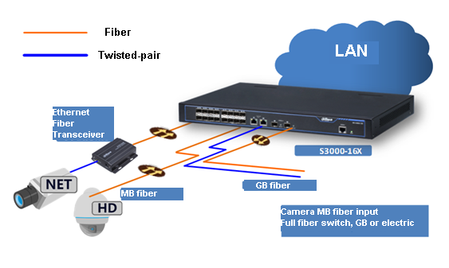

Figure 1- 1

# Device Structure

## Front Panel

The front panel is shown in .

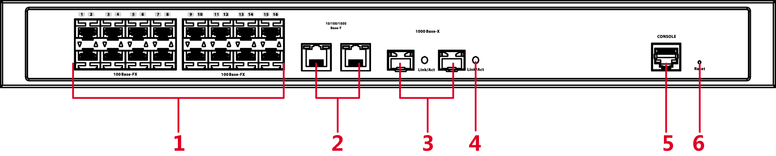

Figure 2- 1

| No. | Name | Function |
| --- | --- | --- |
| **1** | 100Base-FX | 16*100Mbps SFP ports. |
| **2** | 10/100/1000Base-T | 2*1000Mbps Combo electrical ports. |
| **3** | 1000Base-X | 2*1000Mbps Combo fiber ports. |
| **4** | Link/Act | Fiber port indicator. |
| **5** | CONSOLE | Device debug port. |
| **6** | Reset | Long press the button to reset which restores default settings. |

## Rear Panel

The rear panel is shown in .

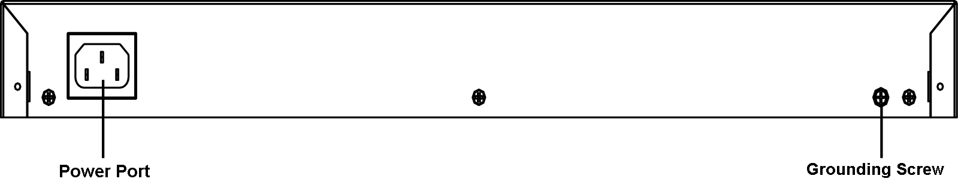

Figure 2- 2

Device port supports AC 220V.

# WEB Operation

You can login device via PC and config system settings, device management and port management.

## Login

Before logging in web, please make sure PC and device network are connected and are in same network segment. To login web:

1. In Internet Explorer, input device IP address (default is 192.168.1.110). Press Enter. You will see .

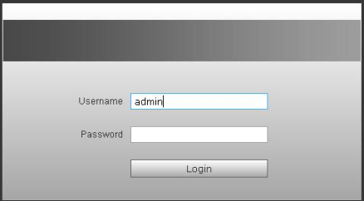

Figure 3- 1

1. Input username and password, click on Login. System enters web client main interface.

Note:

Device default password is null, so at first login, do not input any character in password field.

## Device Info

WAN: up port; LAN: down port

符号3: link is normal.

符号2: abnormal.

符号1: seriously abnormal.  
See for device info.

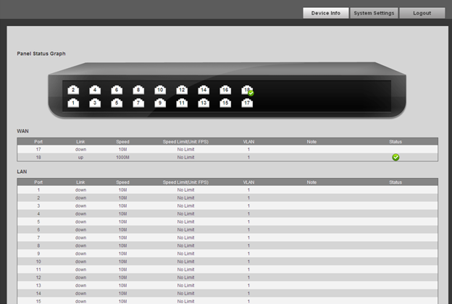

Figure 3- 2

## System Settings

You can view system info, set network config, upgrade software version, change password, restore default setting and reboot system.

### System Info

Select System Settings>System Info, you can view device model, SN and software version. See .

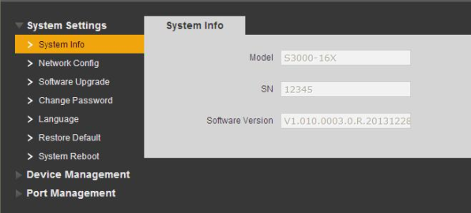

Figure 3- 3

### Network Config

**DHCP Mode**

Select DHCP mode, you only need to config DNS server. Device will automatically get IP address.

**Static Mode**

You can config device IP address, subnet mask, default gateway and etc.

1. Select System Settings>Network Config, see .

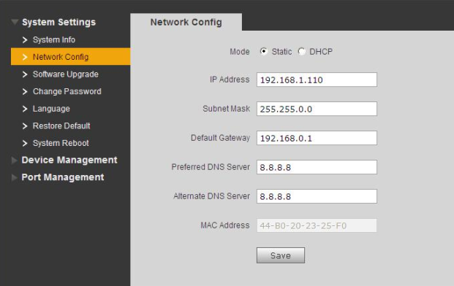

Figure 3- 4

1. Config IP address, subnet mask, default gateway and DNS server.
2. Click on save.

### Software Upgrade

You can upgrade software to the latest version.

1. Select System Settings>Software Upgrade, see .

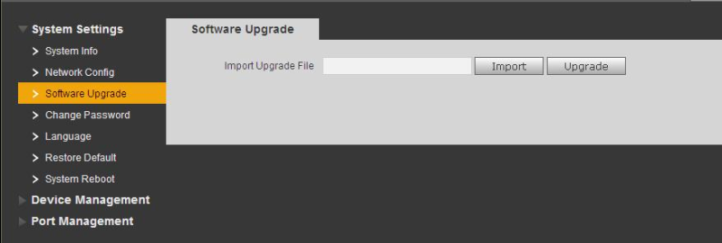

Figure 3- 5

1. Click on Import and select file.
2. Click on upgrade.

### Change Password

There is no default password, so you do not need to input original password when you change password. See .

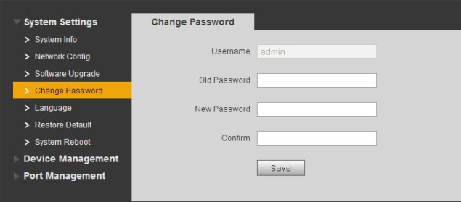

Figure 3- 6

### Restore Default

Click on Restore Default Config, system will restore to default settings. See .

Note:

IP address will not change during restoring.

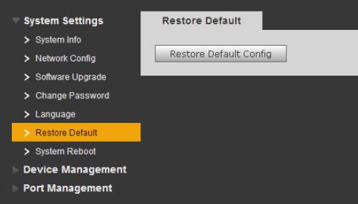

Figure 3- 7

### Reboot

You can reboot system remotely via reboot function. See .

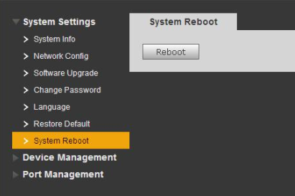

Figure 3- 8

## Device Management

You can set 802.1Q VLAN config, PORT VLAN config, mac security, link aggregation via device management.

### 802.1Q VLAN Config

IEEE802.1Q is certified by IEEE with VLAN protocol, and is also known as VLAN (Tagging VLAN). It can max identify 4096 VLANs. Current config range is 1~4094.

* Default VLAN ID

When port receives report without VLAN Tag, system will add port default VLAN ID and send report to port of default VLAN ID.

* Allowed VLAN ID

Allowed VLAN range is 1~4094. When port sends report, if report VLAN ID matched default VLAN ID, then system will remove report VLAN Tag and send it.

1. Select Device Management>802.1Q VLAN Config. See .
2. Check Enable 802.1Q VLAN Config.
3. Set default VLAN ID, if not, port default VLAN ID will be 1.
4. Set allowed VLAN ID.
5. Click on save.

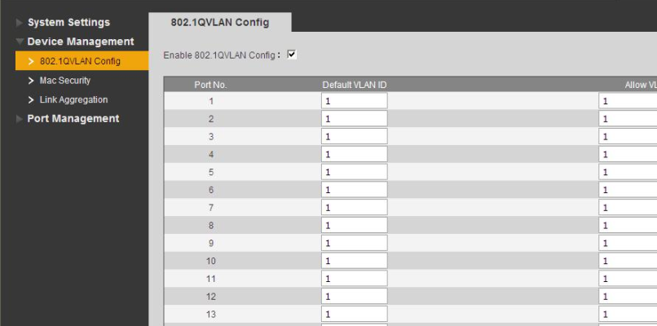

Figure 3- 9

### MAC Security

MAC security controls max MAC number learned by each port, thus eliminates problem caused by overload at switch. ( Set 0 means no limit, max is 255. See .

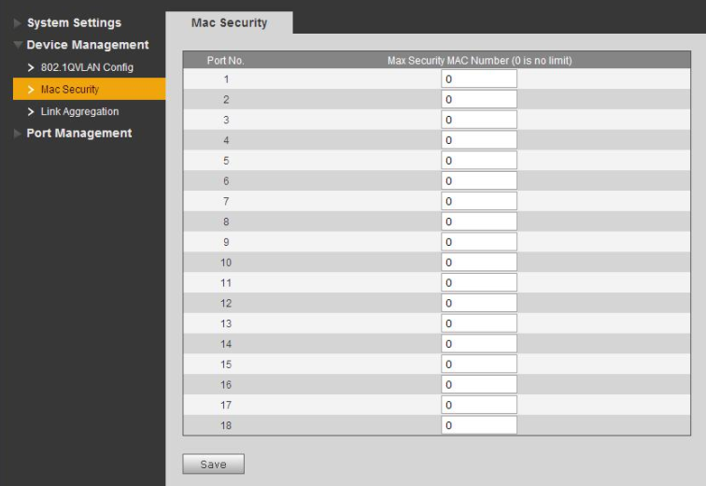

Figure 3- 10

### Link Aggregation

Link Aggregation as a logic link combination of multiple Ethernet links.

See .

http://www.h3c.com.cn/res/201105/03/20110503_1190328_image001_605861_30003_0.png

Figure 3- 11

See .

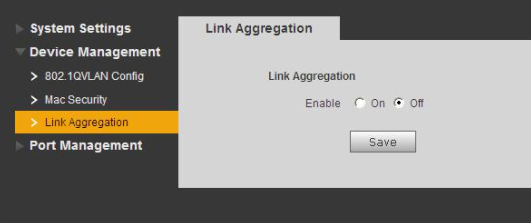

Figure 3- 12

## Port Management

You can set port config, port mirroring, port statistics and port speed limit in port management.

### Port Config

You can set priority level of each port. When port load is high, port with high priority can be processed earlier.

Enable flow control means when network flow is busy, system will sends flow control signal to source port thus adjusts sending rate. See .

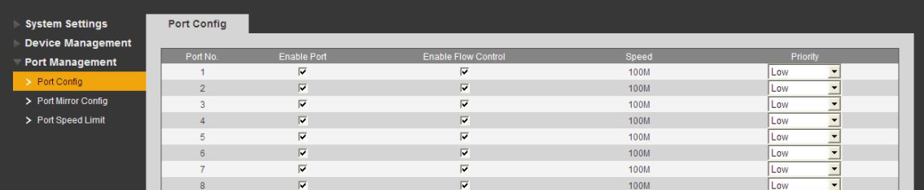

Figure 3- 13

### Port Mirroring Config

You can send data from one port to another via port mirroring for positioning by repair staff. See .

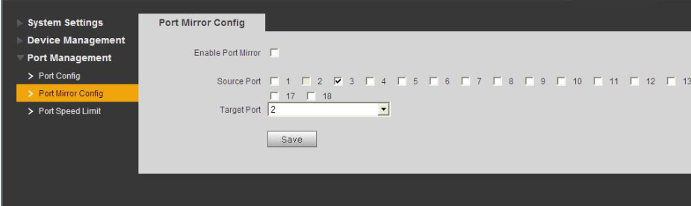

Figure 3- 14

### Port Speed Limit

You can control port speed of each port. See .

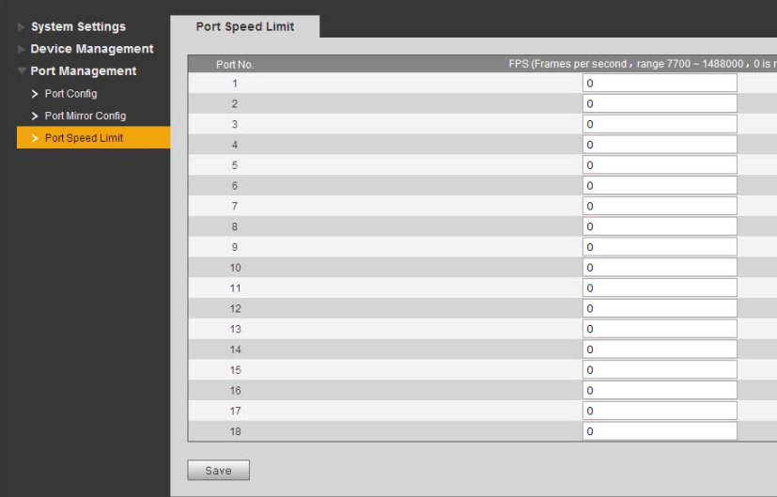

Figure 3- 15

# FAQ

| Problem | Possible Cause | Solution |
| --- | --- | --- |
| Device power supply failure | External power source is unstable or power line is damaged. | Replace power supply. |
| Link/Act not on | Fiber module, fiber selections are poor; fiber connection error | Select right module, check fiber connection. |
| Network operation is normal, but certain device does not work. | Port cable is loosened or port is dirty. | Check port cable connection and keep the environment clean. |
| No network connection | System software version and device does not match. | Upgrade system software. |
| Switch indicator flashes quickly. Unplug it and replug it to power, problem is still. | * Network ring network   In general, it connects two ends of the same physical network cable to one network device.   * Network virus attack   Due to virus attack, bandwidth is insufficient. | * Check if it is ring network. If it is, please cut corresponding link. * Check received virus attack, please install firewall. |

Appendix A Technical Specification

| **Technical Specification** | **Specification** |
| --- | --- |
| Network Port | 16*100Mbps SFP fiber port and 2*1000Mbps combo ports |
| Switch Capacity | 7.2Gbps |
| Transmission Rate | 10.7Mpps |
| MAC Learning | MAC auto learning and aging, MAC address list capacity is 8K |
| VLAN | Support 802.1Q VLAN |
| Security | Support MAC security, port separation. |
| Priority | Support QoS port default priority setup. |
| Network Function | Support WEB, SNMP management（v1/v2c） |
| **General** | |
| Power | AC 90～264V 50 Hz/60Hz |
| Consumption | ≤30W |
| Temperature | ﹣10℃～55℃ |
| Dimension（W×H×D） | 440mm×43.5mm×300mm |
| Weight | 3.5kg |
| Installation | 19" 1U standard bracket installation. |

Appendix B Toxic or Hazardous Materials or Elements

|  |  |  |  |  |  |  |
| --- | --- | --- | --- | --- | --- | --- |
| **Component Name** | **Toxic or Hazardous Materials or Elements** | | | | | |
| **Pb** | **Hg** | **Cd** | **Cr VI** | **PBB** | **PBDE** |
| Circuit Board Component | ○ | ○ | ○ | ○ | ○ | ○ |
| Device Case | ○ | ○ | ○ | ○ | ○ | ○ |
| Wire and Cable | ○ | ○ | ○ | ○ | ○ | ○ |
| Packing Components | ○ | ○ | ○ | ○ | ○ | ○ |
| Accessories | ○ | ○ | ○ | ○ | ○ | ○ |

O: Indicates that the concentration of the hazardous substance in all homogeneous materials in the parts is below the relevant threshold of the SJ/T11363-2006 standard.

X: Indicates that the concentration of the hazardous substance of at least one of all homogeneous materials in the parts is above the relevant threshold of the SJ/T11363-2006 standard. During the environmental-friendly use period (EFUP) period, the toxic or hazardous substance or elements contained in products will not leak or mutate so that the use of these (substances or elements) will not result in any severe environmental pollution, any bodily injury or damage to any assets. The consumer is not authorized to process such kind of substances or elements, please return to the corresponding local authorities to process according to your local government statutes

**Note**

* **This user’s manual is for reference only.**
* **Slight difference may be found in user interface.**
* **All the designs and software here are subject to change without prior written notice.**
* [**All trademarks and registered trademarks are the properties of their respective owners.**](http://www.affordablelaundry.com/all-trademarks-and-registered-trademarks-are-the-property-of-their-respective-owners)
* **If there is any uncertainty or controversy, please refer to the final explanation of us.**
* **Please visit our website for more information.**