Dahua 16-Ch HD Video Distributor User’s Manual

V1.0.0
Dahua Technology CO., LTD

Important Safeguards and Warnings

Please read the following safeguards and warnings carefully before using the product in order to avoid damages and losses.
Note
- Do not expose the device to lampblack, steam or dust. Otherwise it may cause fire or electric shock.
- Do not install the device at position exposed to sunlight or in high temperature. Temperature rise in device may cause fire.
- Do not expose the device to humid environment. Otherwise it may cause fire.
- The device must be installed on solid and flat surface in order to guarantee safety under load and earthquake. Otherwise, it may cause device to fall off or turnover.
- Do not place the device on carpet or quilt.
- Do not block air vent of the device or ventilation around the device. Otherwise, temperature in device will rise and may cause fire.
- Do not place any object on the device.
- Do not disassemble the device without professional instruction.

Warning
- Please use battery properly to avoid fire, explosion and other dangers.
- Please replace used battery with battery of the same type.
- Do not use power line other than the one specified. Please use it properly. Otherwise, it may cause fire or electric shock.

Special Announcement
- This manual is for reference only.
- All the designs and software here are subject to change without prior written notice.
- All trademarks and registered trademarks are the properties of their respective owners.
- If there is any uncertainty or controversy, please refer to the final explanation of us.
- Please visit our website for more information.
Table of Contents
1 Product Overview - 3 -
1.1 Product Features - 3 -
1.2 Typical Application - 3 -
2 Device Structure - 4 -
2.1 Front Panel - 4 -
2.2 Rear Panel - 4 -
Appendix 1 Technical Specifications - 6 -

Product Overview

16-Ch HD Video Distributor realizes 16-ch coaxial HD video input into 32-ch output, which guarantees lossless, real-time transmission for the HD video signal, which is mainly applied in the device room.

Product Features
  - Support 16-ch HDCVI Input, 32-ch output, each input is corresponding to 2 outputs.
  - Support HDCVI video format: 720P/25, 720P/30, 720P/50, 720P/60, 1080P/25 and 1080P/30.
  - Support positive video, coaxial positive data, coaxial positive audio and coaxial reverse control.
  - Lossless, real-time transmission.
  - Compatible CVBS, AHD, HDTVI signal distribution.
  - Appearance dimension: enterprise-level metal structure design, 19-inch 1U chassis.
  - Working temperature: -10℃～55℃, max power consumption: 2W.
  - Video access indicator and power indicator.

Typical Application
The typical application of the device is shown in Figure 1-1.
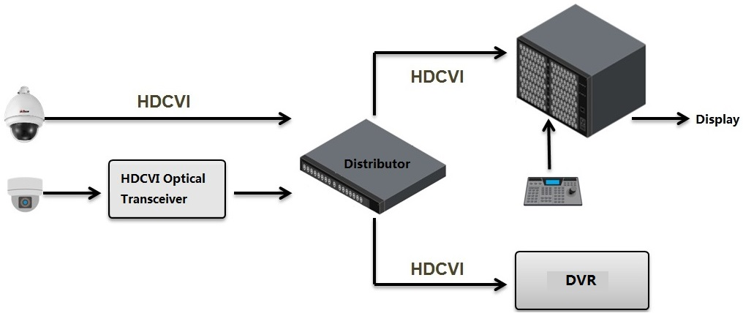
Figure 1-1

Device Structure

Front Panel
The front panel of the device is shown in Figure 2-1.

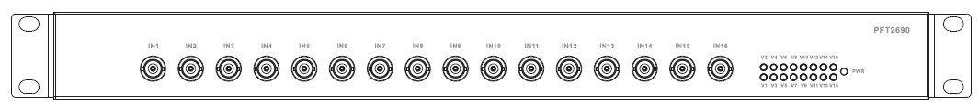
Figure 2-1
Refer to Sheet 2-1 for more details about indicators.
Indicator | Note | Color | Device status
PWR | Power indicator | Green | Power connection normal
V1/V2/V3/V4/V5/  V6/V7/V8/V9/V10/  V11/V12/V13/V14/  V15/V16 | Video access indicator | Green | Video access normal

Sheet 2-1
Refer to Sheet 2-2 for more details about ports.
Port name | Note
IN1/IN2/IN3/IN4/  IN5/IN6/IN7/IN8/  IN9/IN10/IN11/  IN12/IN13/IN14/  IN15/IN16 | 16-ch HD video input. Interface type: BNC.
Sheet 2-2

Rear Panel
16-ch HD video input through IN port and output with 32 channels. The rear panel of the device is shown in Figure 2-2.

Figure 2-2

Please refer to Sheet 2-3 for more details about the ports.

Port Name | Note
OUT1/OUT2/OUT3/OUT4/  OUT5/OUT6/OUT7/OUT8/  OUT9/OUT10/OUT11/  OUT12/OUT13/OUT14/  OUT15/OUT16 | 16-ch HD video output port. Port type: BNC.
OUT1ˊ/OUT2ˊ/OUT3ˊ/OUT4ˊ/  OUT5ˊ/OUT6ˊ/OUT7ˊ/OUT8ˊ/  OUT9ˊ/OUT10ˊ/OUT11ˊ/OUT12ˊ  /OUT13ˊ/OUT14ˊ/OUT15ˊ/OUT16ˊ | 16-ch HD video loop output. Port type: BNC.
100-240V AC | Power port
Sheet 2-3

Appendix 1 Technical Specifications
Product model | DH-PFT2690
Input
Physical port | 16*BNC
Input impedance | 75Ω
Output
Physical port | 32*BNC
Output impedance | 75Ω
Functions and Features
Video format | HDCVI 720P/25、720P/30、720P/50、720P/60、1080P/25、1080P/30
HDCVI signal | Positive video, coaxial positive data, coaxial positive audio, coaxial reverse control.
Video compatibility | CVBS、AHD、HDTVI
Signal features | Lossless, real-time
Other
Lightning protection level | Level 3
Indicator | Power indicator, video access indicator
Power | 100-240V AC
Power consumption | ≤2W
Application humidity | 10%～90%
High and low temperature | ﹣10℃～55℃
Weight | 2.78kg
Dimension | 440mm×200mm×43.65mm
Installation | 19-inch standard rack

Note
- This user’s manual is for reference only.
- Slight difference may be found in user interface.
- All the designs and software here are subject to change without prior written notice.
- All trademarks and registered trademarks are the properties of their respective owners.
- If there is any uncertainty or controversy, please refer to the final explanation of us.
- Please visit our website for more information.



Dahua Technology Co., Ltd
Address：No.1199 Bin’an Road, Binjiang District, Hangzhou, PRC.
Postcode: 310053
Tel: +86-571-87688883
Fax: +86-571-87688815
Email:overseas@dahuatech.com
Website: www.dahuatech.com

