16-Ch HD Video Distributor User’s Manual

V1.0.0
Important Safeguards and Warnings

Please read the following safeguards and warnings carefully before using the product in order to avoid damages and losses.
Note
- Do not expose the device to lampblack, steam or dust. Otherwise it may cause fire or electric shock.
- Do not install the device at position exposed to sunlight or in high temperature. Temperature rise in device may cause fire.
- Do not expose the device to humid environment. Otherwise it may cause fire.
- The device must be installed on solid and flat surface in order to guarantee safety under load and earthquake. Otherwise, it may cause device to fall off or turnover.
- Do not place the device on carpet or quilt.
- Do not block air vent of the device or ventilation around the device. Otherwise, temperature in device will rise and may cause fire.
- Do not place any object on the device.
- Do not disassemble the device without professional instruction.

Warning
- Please use battery properly to avoid fire, explosion and other dangers.
- Please replace used battery with battery of the same type.
- Do not use power line other than the one specified. Please use it properly. Otherwise, it may cause fire or electric shock.

Special Announcement
- This manual is for reference only.
- All the designs and software here are subject to change without prior written notice.
- All trademarks and registered trademarks are the properties of their respective owners.
- If there is any uncertainty or controversy, please refer to the final explanation of us.
- Please visit our website for more information.
Table of Contents
1 Product Overview - 3 -
1.1 Product Features - 3 -
1.2 Typical Application - 3 -
2 Device Structure - 4 -
2.1 Front Panel - 4 -
2.2 Rear Panel - 4 -
Appendix 1 Technical Specifications - 6 -

Product Overview

16-Ch HD Video Distributor realizes 16-ch coaxial HD video input into 32-ch output, which guarantees lossless real-time transmission for the HD video signal, which is mainly applied in the device room.

Product Features
  - Support 16-ch HDCVI Input, 32-ch output, each input is corresponding to 2 outputs.
  - Support HDCVI video format: 720P/25, 720P/30, 720P/50, 720P/60, 1080P/25 and 1080P/30.
  - Support positive video, coaxial positive data, coaxial positive audio and coaxial reverse control.
  - Lossless, real-time transmission.
  - Compatible CVBS, AHD, HDTVI signal distribution.
  - Appearance dimension: enterprise-level metal structure design, 19-inch 1U chassis.
  - Working temperature: -10℃～55℃, max power consumption: 2W.
  - Video access indicator and power indicator.

Typical Application
The typical application of the device is shown in Figure 1-1.
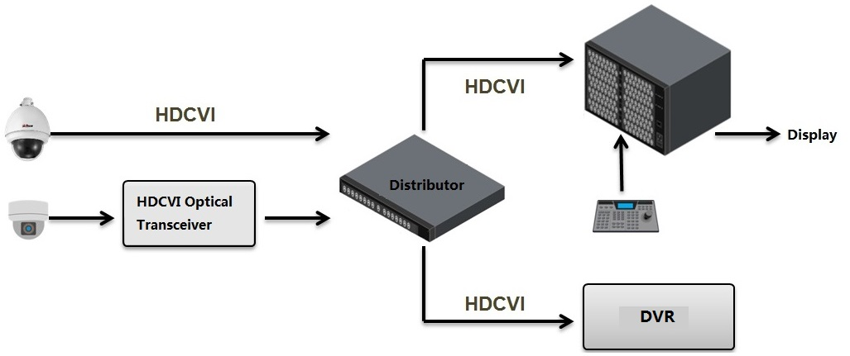
Figure 1-1

Device Structure

Front Panel
The front panel of the device is shown in Figure 2-1.

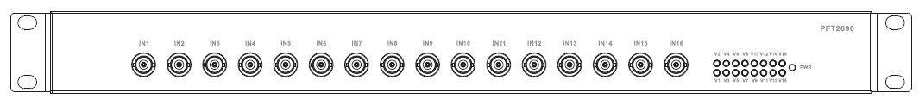
Figure 2-1
Refer to Sheet 2-1 for more details about indicators.
Indicator | Note | Color | Device status
PWR | Power indicator | Green | Power connection normal
V1/V2/V3/V4/V5/  V6/V7/V8/V9/V10/  V11/V12/V13/V14/  V15/V16 | Video access indicator | Green | Video access normal

Sheet 2-1
Refer to Sheet 2-2 for more details about ports.
Port name | Note
IN1/IN2/IN3/IN4/  IN5/IN6/IN7/IN8/  IN9/IN10/IN11/  IN12/IN13/IN14/  IN15/IN16 | 16-ch HD video input. Interface type: BNC.
Sheet 2-2

Rear Panel
16-ch HD video input through IN port and output with 32 channels. The rear panel of the device is shown in Figure 2-2.

Figure 2-2

Please refer to Sheet 2-3 for more details about the ports.

Port Name | Note
OUT1/OUT2/OUT3/OUT4/  OUT5/OUT6/OUT7/OUT8/  OUT9/OUT10/OUT11/  OUT12/OUT13/OUT14/  OUT15/OUT16 | 16-ch HD video output port. Port type: BNC.
OUT1ˊ/OUT2ˊ/OUT3ˊ/OUT4ˊ/  OUT5ˊ/OUT6ˊ/OUT7ˊ/OUT8ˊ/  OUT9ˊ/OUT10ˊ/OUT11ˊ/OUT12ˊ  /OUT13ˊ/OUT14ˊ/OUT15ˊ/OUT16ˊ | 16-ch HD video loop output. Port type: BNC.
100-240V AC | Power port
Sheet 2-3

Appendix 1 Technical Specifications
Product model | PFT2690
Input
Physical port | 16*BNC
Input impedance | 75Ω
Output
Physical port | 32*BNC
Output impedance | 75Ω
Functions and Features
Video format | HDCVI 720P/25、720P/30、720P/50、720P/60、1080P/25、1080P/30
HDCVI signal | Positive video, coaxial positive data, coaxial positive audio, coaxial reverse control
Video compatibility | CVBS、AHD、HDTVI
Signal features | Lossless, real-time
Other
Lightning protection level | Level 3
Indicator | Power indicator, video access indicator
Power | 100-240V AC
Power consumption | ≤2W
Application humidity | 10%～90%
High and low temperature | ﹣10℃～55℃
Weight | 2.78kg
Dimension | 440mm×200mm×43.65mm
Installation | 19-inch standard rack

Note
- This user’s manual is for reference only.
- Slight difference may be found in user interface.
- All the designs and software here are subject to change without prior written notice.
- All trademarks and registered trademarks are the properties of their respective owners.
- If there is any uncertainty or controversy, please refer to the final explanation of us.
- Please visit our website for more information.

