Surveillance Cabinet User's Manual

V1.1.0
Table of Contents
1 General Introduction 1
1.1 Overview 1
1.2 Features 1
1.3 Installation Modes 1
1.4 Optional Bracket 1
2 Installation 3
2.1 Structure 3
2.2 Installation Steps 4
2.3 Optional Module Installation 5
2.4 Gasket 6
3 Appendix Specifications 8
3.1 Specifications 8
3.2 Dimensions 8
3.2.1 PFA140 8
3.2.2 PFA141 9
Appendix Toxic or Hazardous Materials or Elements 10

Welcome
Thank you for purchasing our surveillance cabinet!
Please read the following safeguards and warnings carefully before you install or use the product!

Important Safeguards and Warnings
1．Electrical safety
All installation and operation here should conform to your local electrical safety codes.
We assume no liability or responsibility for all the fires or electrical shock caused by improper handling or installation.
2．Transportation security
Heavy stress, violent vibration or water splash are not allowed during transportation, storage and installation.
3．Installation
Do not apply power to the surveillance cabinet before completing installation.
Do not place objects on the surveillance cabinet.
4．Qualified engineers needed
All the examination and repair work should be done by the qualified service engineers.
We are not liable for any problems caused by unauthorized modifications or attempted repair.
5．Environment
The surveillance cabinet should be installed in specified working environments.
Please keep sound ventilation.

6. Accessories
Be sure to use all the accessories recommended by manufacturer.
Before installation, please open the package and check all the components are included.
Contact your local retailer ASAP if something is broken in your package.

General Introduction

Overview
The surveillance cabinet adopts airproof design. It works with the speed dome, network camera, bracket and etc. It supports multiple installation modes such as wall mount, pole mount ,corner mount. It complies with the IP66 and can be used in various environments.

Features
- Easy to install. Support wall mount, pole mount, and corner mount installation.
- Airproof design. Can be used in high temperature, strong wind, and rainstorm environment. Dustproof.
- Suitable for various environments, works with speed dome, network camera and etc.

Installation Modes
This surveillance cabinet can be used in various installation environments. Please refer to the following list.
Installation  Mode |  | Function
Wall Mount | 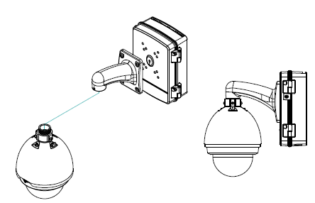 | It is to install on the wall.
Pole Mount | 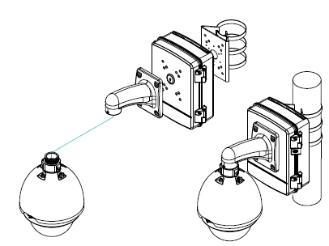 | It is for pole mount environment.  Note  Pole mount bracket model is PFA150（Sold separately）.
Corner Mount | 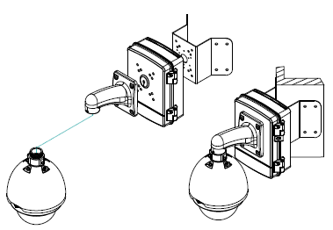 | It is for corner mount environment.  Note  Corner mount bracket model is PFA151（Sold separately）.

Optional Bracket
Installation  Bracket | Bracket Model
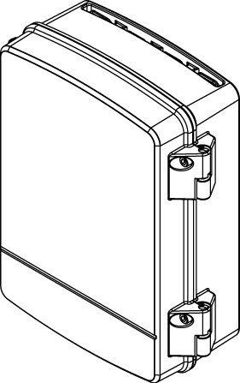  PFA141 | Note  The top cover of the PFA141 surveillance cabinet is plain. Can not install bracket.
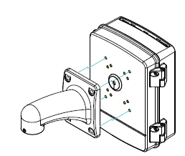  PFA140 | Bracket Model：PFB300W/PFB301W/PFB300S（Sold separately）.
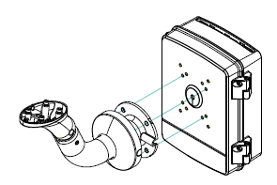  PFA140 | Bracket Model：PFB600W（Sold separately）.

Installation

Structure
All the steps and figures listed below are based on our PFA140 series product. See Figure 2-1.
Different models may have different setups. Slight difference may be found in the reference figures. You can refer to your actual purchased products.
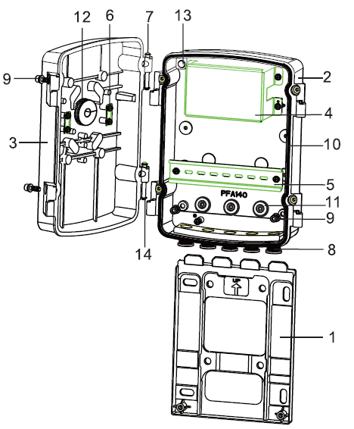
Figure 2-1
SN | Parts Name | No.
1 | Mounting plate | 1
2 | Bottom cover | 1
3 | Top cover | 1
4 | Electrical safety cover | 1
5 | Rail | 1
6 | Loop buckle | 2
7 | Shaft | 2
8 | M20 waterproof plug | 5
9 | M6 screw | 6
10 | Gasket | 1
11 | M20 gasket | 3
12 | Round gasket(diameter 30mm )  Note  The top cover of the PFA141 series product is plain and there is no gasket. | 1
13 | Waterproof film | 2
14 | Retaining ring | 4

Installation Steps
Use inner hex wrench (5.0mm) to unfasten the four M6 screws at the both sides of the device to open the cover.
Important
When close the surveillance cabinet, please move the top cover up for 2-3mm first and then close. Do not press down the top cover directly.

The following figures are based on the PFA140 surveillance cabinet. The PFA141 series product has the similar installation steps.

Step1
Install the mounting plate. Use four M8 expansion bolts (wall mount) or four M8 screws to secure (corner mount, pole mount). There are corresponding screw holes in the mounting plate. See Figure 2-2.
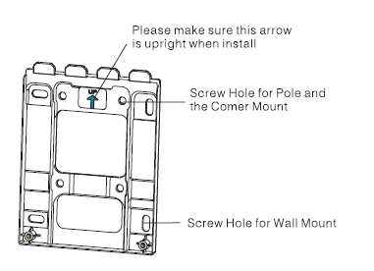
Figure 2-2
Important
For wall mount mode, use four expansion bolts to secure. Please make sure the height above the recessed head shall be less than 13mm after you fixed the bolts, in case it may affect the bottom cover installation.

Step2
When you pull the cable through the rear wall, you need to pull the cable through the gasket at the bottom cover.

Step3
Put the bottom cover to the mounting plate and use the two screws at the bottom to secure. See Figure 2-3.

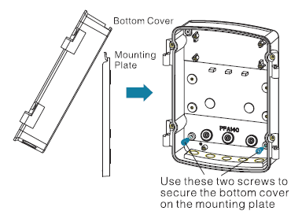
Figure 2-3
Step4
Install optional module(s) and connect cable. Please refer to 2.3 Optional Module Installation.

Step5
Install gasket. Please refer to Figure 2-4. Gasket Installation.

Step6
Install top cover. Turn the shaft to the left or right side and then fasten the E bulk at the both sides. Secure the four screws at the two sides. See Figure 2-5.
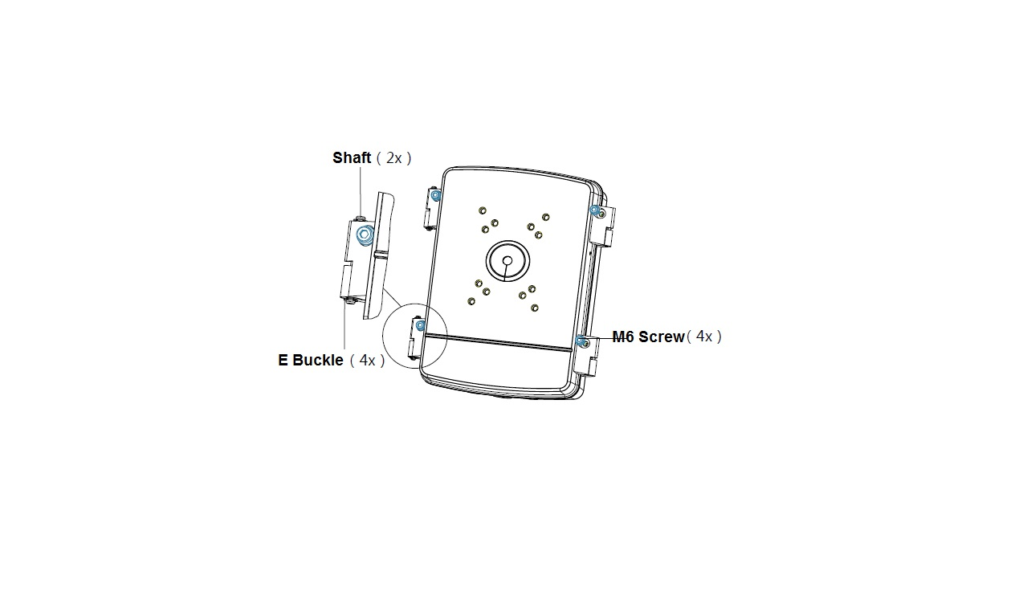
Figure 2-5

Optional Module Installation
The surveillance cabinet can hide the cable and various optional modules. It can guarantee neat environment and remove the risk of cable damage.

You can install power module in the surveillance cabinet. You can install air switch, lightening protection device, heater and etc on the rail (width: 35mm). See Figure 2-6. You can adjust installation position and sequence.
The following figure for reference only. The module size and cable connection mode may vary.
Note
Power module air switch lighting protection device and heater are not standard accessories. Please contact your local retailer for purchase information.
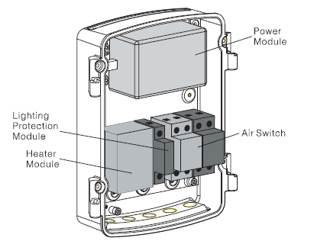
Figure 2-6

Gasket
The gasket installation is very important. Please make sure it is firmly secure, otherwise it may affect surveillance cabinet waterproof capability. See Figure 2-7 (PFA140 series) and Figure 2-8 (PFA141 series).
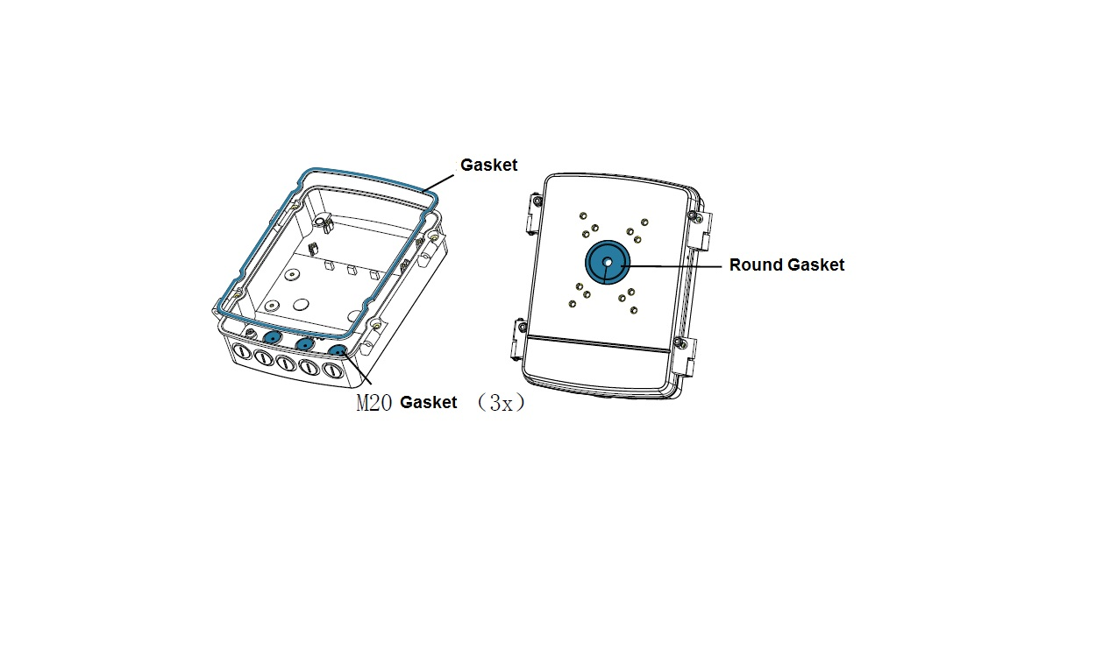
Figure 2-7
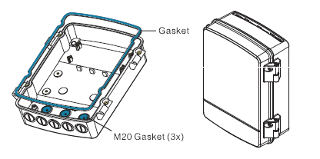
Figure 2-8
When you pull the cable through the gasket, you need to use a screw to pierce a hole and then gently force the cable through the gasket. Do not pierce the gasket with a knife or other sharp object.
For the cable pull through the M20 gasket, the diameter shall range from 3.5mm to 12mm. Do not force the connector into the gasket. Please pull the cable through the gasket and then connect the corresponding connector. See Figure 2-9.
There are two types of round gaskets. For the one with smaller center hole, which is fit for the cable with diameter of 4.5mm~8.5mm while for the one with bigger center hole, which is fit for the cable with diameter of 8.5mm~12.5mm. Please select the suitable round gasket according to the cable diameter.

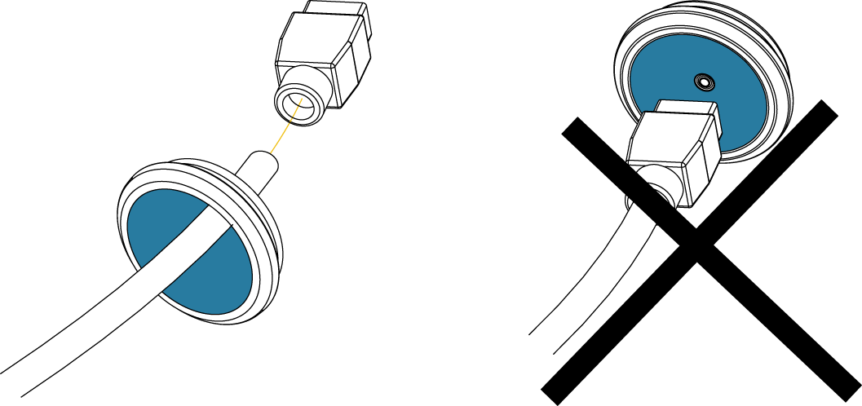
Figure 2-9

Appendix Specifications

Specifications
Model | PFA140/PFA141
Dimension | 297mm×248mm×107mm
Weight | 1.7kg
Protection Level | IP66
Working Environment | Indoor/outdoor
Working Temperature | -10℃～+60℃
Working Humidity | 0%～95%（No condensation）
Materials | Aluminum. SGCC
Color | White

Dimensions

PFA140
The dimension information is shown as in Figure 3-10.
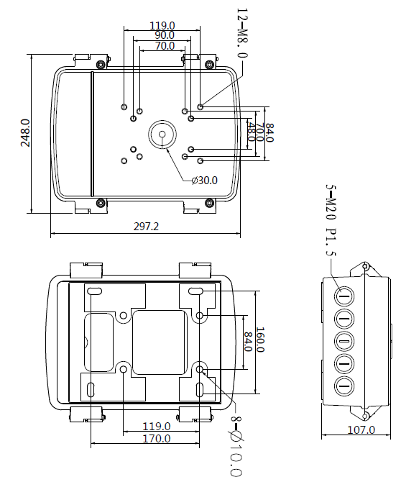
Figure 3-10

PFA141
The dimension information is shown as in Figure 3-11.

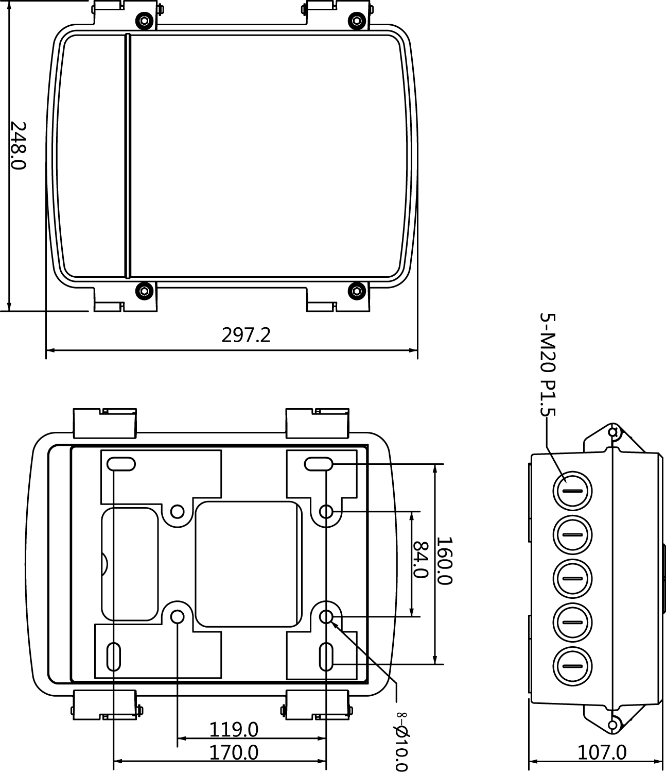
Figure 3-11

Appendix Toxic or Hazardous Materials or Elements

Component Name | Toxic or Hazardous Materials or Elements
Component Name | Pb | Hg | Cd | Cr VI | PBB | PBDE
Sheet Metal | ○ | ○ | ○ | ○ | ○ | ○
Die Pressed Casting | ○ | ○ | ○ | ○ | ○ | ○
Connection Cable | ○ | ○ | ○ | ○ | ○ | ○
Accessories | ○ | ○ | ○ | ○ | ○ | ○
Note
O: Indicates that the concentration of the hazardous substance in all homogeneous materials in the parts is below the relevant threshold of the SJ/T11363-2006 standard.

X: Indicates that the concentration of the hazardous substance of at least one of all homogeneous materials in the parts is above the relevant threshold of the SJ/T11363-2006 standard. During the environmental-friendly use period (EFUP) period, the toxic or hazardous substance or elements contained in products will not leak or mutate so that the use of these (substances or elements) will not result in any severe environmental pollution, any bodily injury or damage to any assets. The consumer is not authorized to process such kind of substances or elements, please return to the corresponding local authorities to process according to your local government statutes.

Note
- This manual is for reference only. Slight difference may be found in the user interface.
- All the designs and software here are subject to change without prior written notice.
- All trademarks and registered trademarks mentioned are the properties of their respective
owners.
- If there is any uncertainty or controversy, please refer to the final explanation of us.
- Please visit our website or contact your local service engineer for more information.

