PFH600N Housing User's Manual

Version 1.0.1

Table of Contents
1 General Introduction 1
1.1 Overview 1
1.2 Features 1
1.3 Dimensions 1
2 Housing Installation Instruction Guide 2
2.1 Lock/Unlock Housing 2
2.2 Camera Installation 2
3 Bracket Installation Guide 4
Appendix 1 Specifications 5
Appendix 2 Toxic or Hazardous Materials or Elements 6

Welcome
Thank you for purchasing our housing!
Please read the following safeguards and warnings carefully before you install or use the product!

Important Safeguards and Warnings
1．Electrical safety
All installation and operation here should conform to your local electrical safety codes.
We assume no liability or responsibility for all the fires or electrical shock caused by improper handling or installation.
2．Transportation security
Heavy stress, violent vibration or water splash are not allowed during transportation, storage and installation.
3．Installation
Do not apply power to the housing before completing installation.
Do not place objects on the housing.
4．Qualified engineers needed
All the examination and repair work should be done by the qualified service engineers.
We are not liable for any problems caused by unauthorized modifications or attempted repair.
5．Environment
The housing should be installed in a cool, dry place away from direct sunlight, inflammable, explosive substances and etc.
Please keep sound ventilation.

6. Accessories
Be sure to use all the accessories recommended by manufacturer.
Before installation, please open the package and check all the components are included.
Contact your local retailer ASAP if something is broken in your package.

General Introduction

Overview
The PFH600N housing (“housing”) adopts all-weather compact design. It can install camera and lens of various dimensions. It has built-in camera mounting plate. The IP66 compliance is suitable for various environments.

Features
- Compact design, concealed cable exit.
- ASA weather resistant material
- Fully-enclosed design, IP66 compliance.
- Optional installation modes and brackets.
- Suitable for cameras, block camera of various dimension.

Dimensions
The dimension of PFH600N is shown as below. The unit is mm. See Figure 1-1.

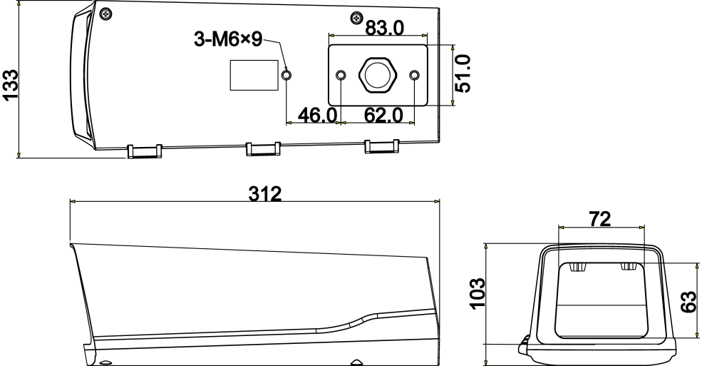
Figure 1-1

Housing Installation Instruction Guide

Lock/Unlock Housing
You can use screwdriver to fix or loosen the two M4 cross pan head screws on both sides of the housing to lock or unlock the housing. See Figure 2-2.

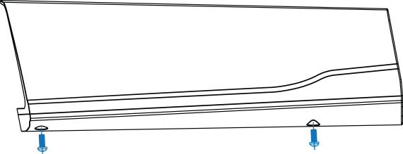
Figure 2-2

Camera Installation
Step 1: Take the camera bracket from the housing.
Step 2: Fix the camera on the camera bracket. See Figure 2-2
Step 3: Secure the camera bracket on the case. See Figure 2-3

Note
The camera lens shall be as near as to the front end of the bracket (Recommended distance is 1-2mm.) in case it affect the lens view angle. See figure 2-4.

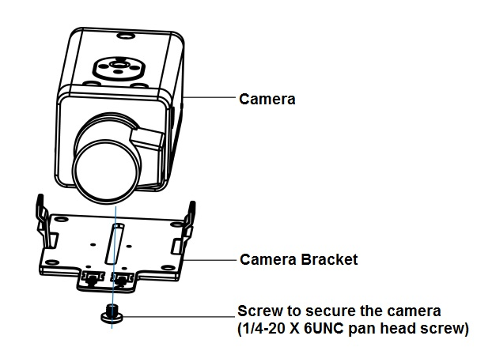

Figure 2-2

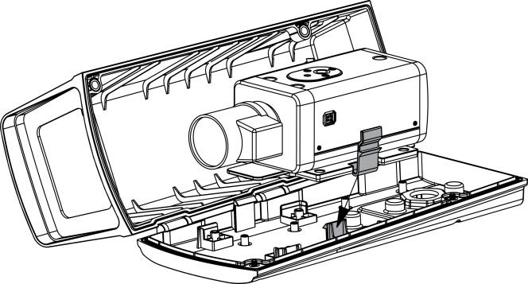
Figure 2-3

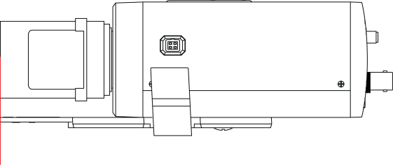
Figure 2-4
Note:
The distance between lens face and camera fixing hole has to be longer than 60mm, but shorter than 130mm.

Bracket Installation Guide
Installation Steps:
Step 1: Pull the cable through the inside of the bracket.
Step 2: Put the waterproof joint on the cables and then secure it firmly on the housing.
Step 3: Secure the bracket on the housing with M6 screws.

Note:
- The waterproof joint can be installed according to Figure 3-2.
- The bracket is not included in the housing basic configuration, please purchase separately if you want to use.

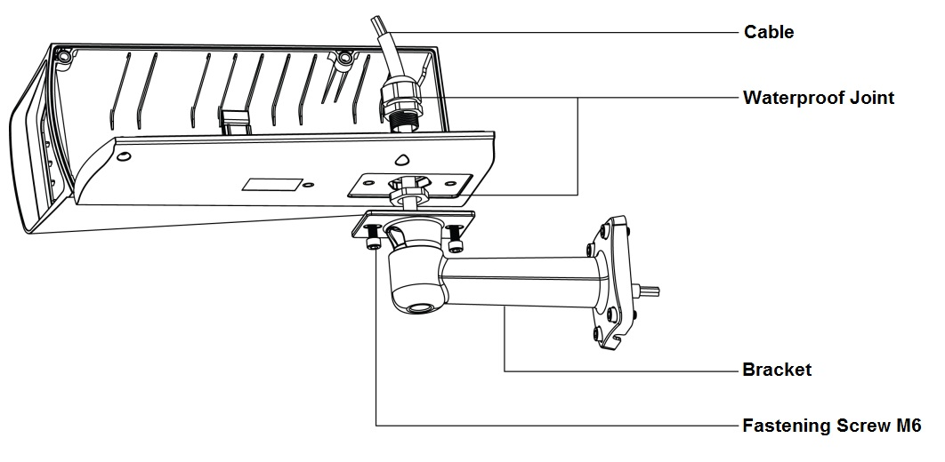

Figure 3-1

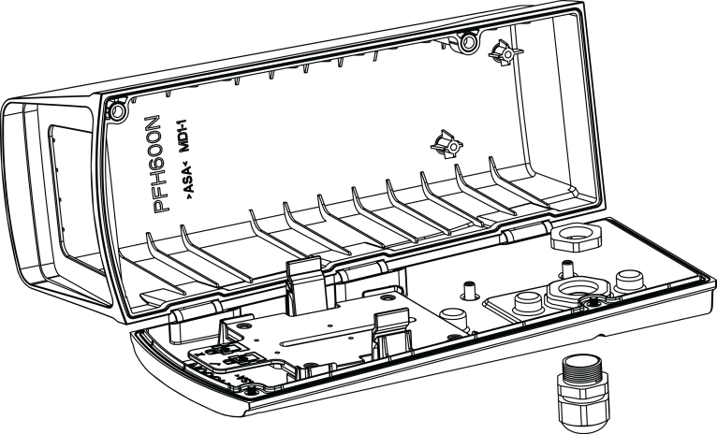
Figure 3-2

Appendix 1 Specifications

Product Model | DH-PFH600N
Dimension | 312mm×133mm×103mm
Camera Max Dimension | 211mm×73mm×78mm
Window Area | 63mm×72mm
Weight | 0.7Kg
Material | ASA, PC
Protection Level | IP66
Installation Environments | Indoor/Outdoor
Working Temperature | -30℃～+60℃
Working Humidity | ＜90%，no condensation

Appendix 2 Toxic or Hazardous Materials or Elements

Component Name | Toxic or Hazardous Materials or Elements
Component Name | Pb | Hg | Cd | Cr VI | PBB | PBDE
Sheet Metal | ○ | ○ | ○ | ○ | ○ | ○
Plastic Parts | ○ | ○ | ○ | ○ | ○ | ○
PCB | ○ | ○ | ○ | ○ | ○ | ○
Connection Cable | ○ | ○ | ○ | ○ | ○ | ○
Accessories | ○ | ○ | ○ | ○ | ○ | ○
Note
O: Indicates that the concentration of the hazardous substance in all homogeneous materials in the parts is below the relevant threshold of the SJ/T11363-2006 standard.

X: Indicates that the concentration of the hazardous substance of at least one of all homogeneous materials in the parts is above the relevant threshold of the SJ/T11363-2006 standard. During the environmental-friendly use period (EFUP) period, the toxic or hazardous substance or elements contained in products will not leak or mutate so that the use of these (substances or elements) will not result in any severe environmental pollution, any bodily injury or damage to any assets. The consumer is not authorized to process such kind of substances or elements, please return to the corresponding local authorities to process according to your local government statutes.

Note
- This manual is for reference only. Slight difference may be found in the user interface.
- All the designs and software here are subject to change without prior written notice.
- All trademarks and registered trademarks mentioned are the properties of their respective
owners.
- If there is any uncertainty or controversy, please refer to the final explanation of us.
- Please visit our website or contact your local service engineer for more information.

