Network Alarm Panel
Quick Start Guide

Version 1.0.0
Table of Contents
1 FEATURES AND SPECIFICATIONS 1
1.1 Overview 1
1.2 Features 1
1.3 Mainboard Ports 1
2 INSTALLATION 3
2.1 Project Installation 3
2.2 Tamper Switch Installation 3
3 Connection 5
4 Initial Setup 7
4.1 Modify IP 7
4.2 Protection Zone Setup 8
5 FAQ 11
Appendix Toxic or Hazardous Materials or Elements 12

Welcome
Thank you for purchasing our network alarm panel!
This quick start guide will help you become familiar with our device in a very short time.
Before installation and operation, please read the following safeguard and warning carefully!

Important Safeguard and Warning
1．Electrical safety
All installation and operation here should conform to your local electrical safety codes.
The product must be grounded to reduce the risk of electric shock.
We assume no liability or responsibility for all the fires or electric shock caused by improper handling or installation.
2．Transportation security
Heavy stress, violent vibration or water splash are not allowed during transportation, storage and installation.
3．Installation
Keep upwards. Handle with care.
Do not apply power to the alarm panel before completing installation.
Do not place objects on the device.
4．Qualified engineers needed
All the examination and repair work should be done by the qualified service engineers.
We are not liable for any problems caused by unauthorized modifications or attempted repair.
5．Environment
The alarm panel should be installed in a cool, dry place away from direct sunlight, inflammable, explosive substances and etc.
This series product shall be transported, storage and used in the specified environment.

6. Accessories
Be sure to use all the accessories recommended by manufacturer.
Before installation, please open the package and check all the components are included.
Contact your local retailer ASAP if something is broken in your package.

Before Start
About Alarm System
For the alarm system consists of the network alarm panel, though it has stable and reliable performance, it may become null in the following situations:
- The protection zone the intruder entering has not enabled the arm function or the intruder has enough knowledge to disable the system.
- The siren device installation position is not right; it does not have the warning function.
- The detector is null when there is an alarm outage and etc.
- The detector is not in the proper position and can not detect the corresponding zone.
- System can not generate an alarm when there is something wrong with the alarm signal transmission system (the service is disabled, there is malicious attack and etc).
- The device is null resulting from non-schedule maintenance of the alarm system.
About Installation Notice
- The installation engineers are recommended to check the system regularly such as once a month. It is to guarantee system long-term stable operation.
- The installation engineers are recommended to test the system regularly such as once a week.
- Please arrange some training classes for the end-user. It is to keep them familiar with the system.

System Test Notice
- After the installation, you can connect to the AC/DC power to test.
- You can test the all functions of the alarm panel after you complete all programming work.

FEATURES AND SPECIFICATIONS

Overview
The network alarm panel is a multiple-function alarm device integrating Ethernet, PSTN network, GPRS network transmission together. It supports keyboard programming and remote control.

This series product can be use in the smart building, community residence, perimeter alarm system, building security system, and some large-scale security systems such as school, factory, and warehouse. It is easy to connect to the platform software to integrate with other system.

Features
This series product has the following features:
- 10/100M self-adaptive Ethernet port.
- IP network, GRPS network, PSTN network to upload the alarm information.
- Alarm activation output and event activation output.
- 16-channel local alarm input and 4-channel local alarm output.
- 1-channel controlled siren output (12V DC)
- Abundant user rights.
- 24H protection zone, realtime protection zone, delay protection zone.
- 5 groups’ mobile phone setup, support alarm message alert.
- Support CID（Contact ID protocol）, support reuse phone.
- 8 LCD programming keyboard.
- Wireless remote control to arm/disarm the alarm panel.
- Alarm panel setup remotely via network.
- Remote user control and event search.
- Local 5,000 logs.
- Dual-power supplying. Main/slave power auto switch.

Mainboard Ports
The mainboard port interface is shown as below. See Figure 1-1.

Figure 1-1
Please refer to the following sheet for detailed information.
SN | Name | Function
1 | Alarm input port | 16-channel alarm input.  G: public end.  A1～A16 protection zone input.
2 | RS485 port | A1B1 connect to programming keyboard.
3 | Siren port | Connect to siren.
4 | +12V | 12V output.
5 | Accumulator port | Connect to 12V DC 7AH. lead-acid battery
6 | Alarm output port | 4-channel alarm output.
7 | 2G module | 2G module
8 | Wireless module | Wireless module
9 | Phone port | Connect to telephone.
10 | User cable port | Connect to user cable.
11 | LAN | Ethernet port.
12 | Power supplying port | Power supplying.

DEVICE INSTALLATION

Project Installation
This series product supports wall mount installation. Please refer to the steps listed below.
- Open the device package and then take out the plastic expansion bolts and self-tapping screw.
- Please refer to Figure 2-2 to dig five holes in the wall.
- Input four expansion bolts and then insert four self-tapping screws. DO NOT INSERT THE BOLT TO THE MIDDLE HOLE.
- Put the device on the screws and then insert the last self-tapping screw at the middle hole.
Figure 2-2

Tamper Switch Installation
Before the installation, please prepare the accessories. It includes: tamper switch, three screws and three nuts.
Open the cover of the device; secure the tamper switch on the device. See Figure 2-3.
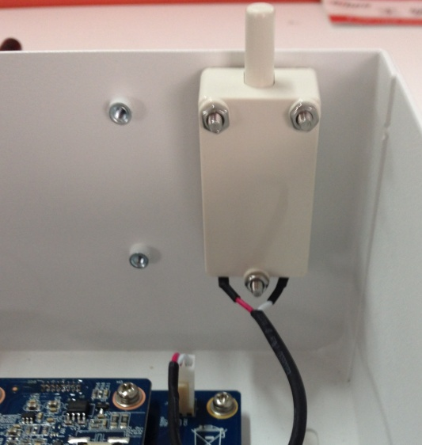
Figure 2-3
Insert the tamper switch to the main board. See Figure 2-4.
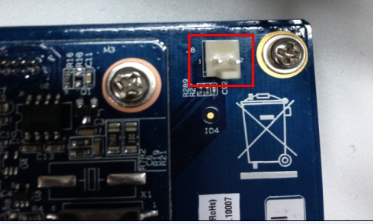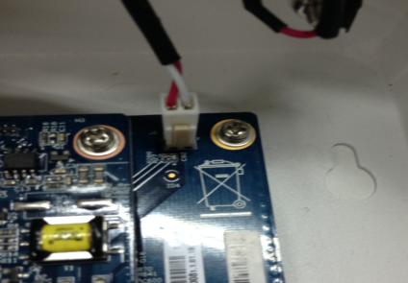
Figure 2-4

Connection

General Cable connection
Please refer to the following figure for detailed information. See Figure 3-5.
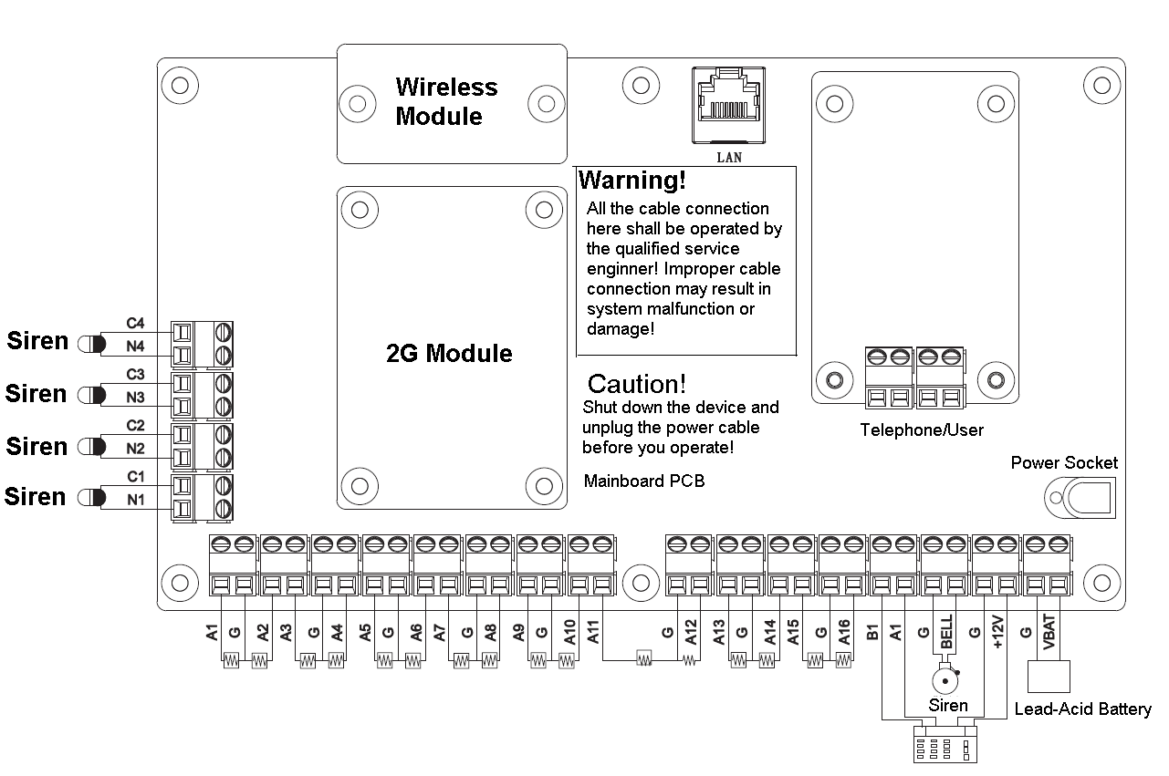
Figure 3-5

Detector Cable Connection
Please refer to the following figure for detailed information. See Figure 3-6.

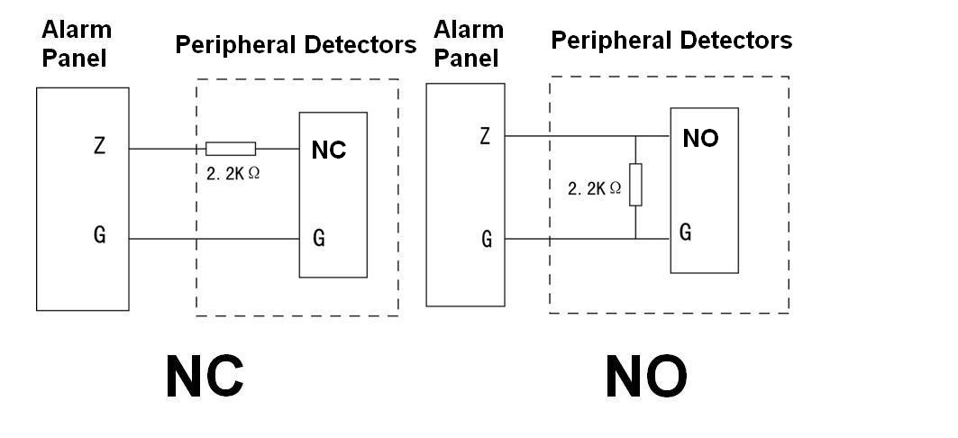
Figure 3-6

Alarm Output Cable Connection
Please refer to the following figures for detailed information. See Figure 3-7 and Figure 3-8.
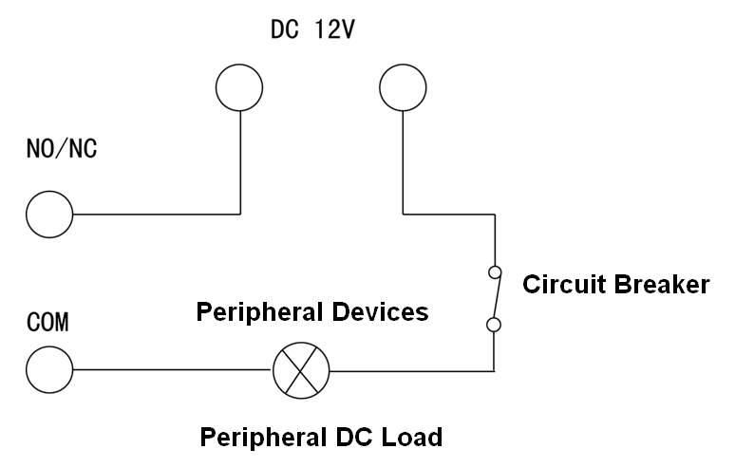
Figure 3-7
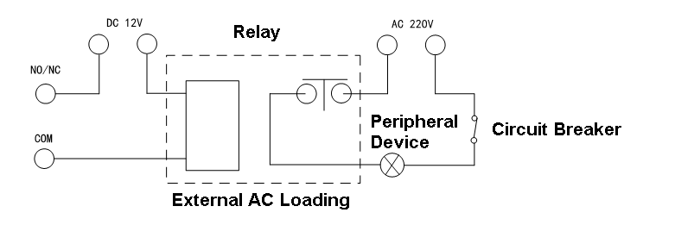
Figure 3-8

Initial Setup
After the device installation, you need to follow the contents below to set the initial setup.

Modify IP
You can go to the network setup interface to set device IP address, subnet mask, gateway and etc. Please follow the steps listed below.
- Open the device SDK client-end interface.
- On the bottom right dropdown list, select network setup. See Figure 4-9.
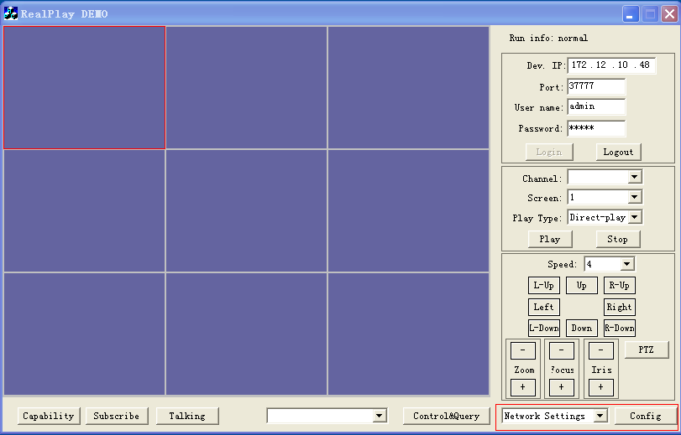
Figure 4-9
- Click Config button, you can see the following interface. See Figure 4-10.
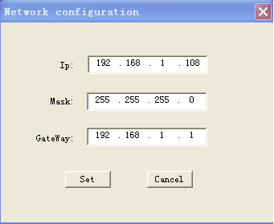
Figure 4-10
- Input device IP address, subnet mask, default gateway.
- Click Setup button to complete the setup.
Note
Device default setup is:
- IP: 192.168.1.108.
- Subnet mask: 255.255.255.0
- Gateway: 192.168.1.1.

Protection Zone Setup
On the on-off protection zone setup interface, you can set local alarm input channel, protection zone, sensor type, alarm activation parameters and etc.
Please follow the steps listed below.
- On the bottom right dropdown list, select on-off protection zone setup.
- Click Config button, you can see an interface shown as below. See Figure 4-11.
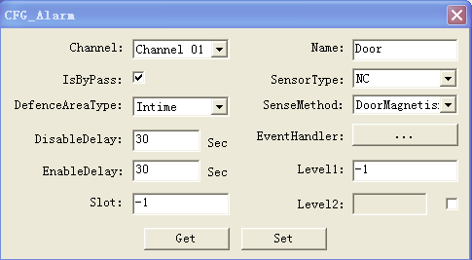
Figure 4-11
- Click Get button to view current setup.
Please refer to the following sheet for detailed information.
Parameter | Note
Channel name | Local alarm input channel. Device supports 16-channel alarm input.
Name | Customized channel name. It is for you to distinguish each channel.
Bypass | Read-only
Zone type | Protection zone report alarm time after it is armed.  - Realtime protection zone.  - Delaying protection zone.  - 24H protection zone.
Entry delay | In the entry delay mode, there is no trigger operation after the alarm is trigged for M seconds (M refers to the in delay value you set here). You can disarm during the M seconds. If you do not disarm, the protection zone is activated after M seconds. For example: after you enabled arm status and then set the in delay is 10s. System only enables link alarm after the alarm occurred for 10 seconds no matter the alarm has disappeared or still exists.
Exit delay | After you enable arm status, the arm operation becomes valid after N seconds (N refers to the exit delay value you set here). During the N seconds period, the alarm link operation is null. For example, after you enable out delay time 15s, there is no alarm link event during the first 15 seconds until the 15-second countdown ends.
Detector type | There are two modes: NO/NC.
Detector sense type | System supports the following detector modes：  - Door sensor  - Passive IR  - Active IR  - Call button  - Others
Activation setup | When there is an alarm input, device can auto trigger the alarm output channel. Please follow the steps listed below.
- Click button after the activation setup, you can see the following interace. See Figure 4-12.
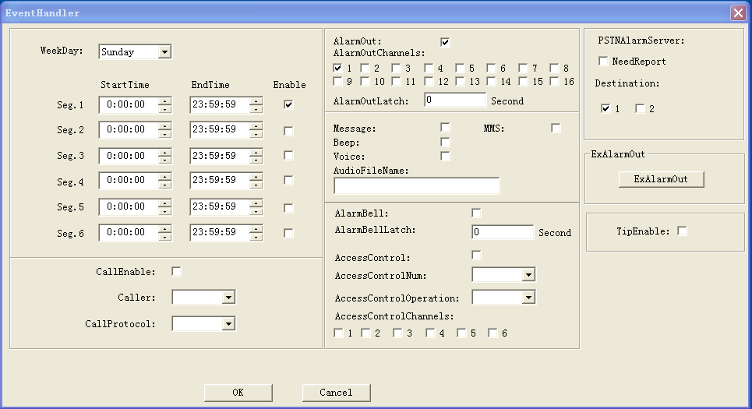
Figure 4-12
- You can set arm period manually if necessary. You can set different periods on each date. Check the box to enable the period. The unit is week.
- You can follow the following sheet to set activation parameters.
Parameter | Note
Call enable | You can check the box here to enable audio call function. (This function is null right now.)
Caller | The default caller is the device. (This function is null right now.)
Call protocol | Default protocol is Cellular. (This function is null right now.)
Alarm output | Check the box here to enable alarm output.
Alarm output channel | Select alarm output channel. Device supports 16-channel alarm output.
Upload alarm server | Check the box here to enable upload alarm to the server. (This function is null right now.)
MMS | Check the box here so that the device can send out the message when an alarm occurs.
Buzzer | Check the box here so that the device can beep when an alarm occurs.
Audio prompts | Check the box here so that the device can generate audio prompt when an alarm occurs.
Activation audio file Absolute path | After you enable audio prompt function, input the audio name here, you can use search file function to get.  (This function is null right now.)
Siren | Check the box here to enable siren function.
A&C | Check the box here to enable A&C function. (This function is null right now.)
A&C channel | Select A&C channel. (This function is null right now.)
A&C operation | The A&C options include：  - N/A  - Auto  - Open door  - Close door  - Always open  - Always close  This function is null right now.)
- Click Ok button to complete activation setup. System goes back to the on-off protection zone setup interface.
- Click Setup button to complete all setups.

FAQ
  - I can not arm via the SDK client-end.
The arm is only valid, after you connected all tamper switch resistance and there is no alarm from the protection zone.

  - I want the device to work only at night. Is it possible?
Please go to the protection setup interface to set the arm period. You can set the device is null on the daytime (6:00~18:00) and becomes valid at night (18:01~24:00/00:00~5:59). Please refer to chapter 4.2.

  - Why the detector is always alarming after I connected it to the device and armed?
The detector has two modes: NO/NC. All detectors shall connect the 2.2kΩ tail circuit resistance. For the NO detector, please parallel connect the resistance to the alarm panel. For the NC detector, please serial connect the resistance to the alarm panel.

  - I wan to trigger the siren after one protection zone is activated.
Please go to the protection setup interface to enable siren function. Please refer to chapter 4.2.

  - I want to trigger several sirens after one protection zone is activated.
The device BELL/G port can connect to the siren and provide power. If you want to connect to several sirens, you can connect to the alarm output port. Please note you need to connect extra power supplying for the sirens connected to the alarm output port.

  - I want to pair the remote control to the alarm panel.
You can go to the Web of the device (some series product may do not have Web) or use the keyboard to pair.

  - How many keyboards I can connect here?
Device max supports 8 keyboards.

  - How many wireless remote controls I can connect here?
Device max supports 8 wireless remote controls.

  - How can I get the network alarm panel user’s manual and SDK client?
Please contact your service engineer or your local retailer for more information.

Appendix Toxic or Hazardous Materials or Elements

Component Name | Toxic or Hazardous Materials or Elements
Component Name | Pb | Hg | Cd | Cr VI | PBB | PBDE
Sheet Metal(Case) | ○ | ○ | ○ | ○ | ○ | ○
Plastic Parts（Panel） | ○ | ○ | ○ | ○ | ○ | ○
Circuit Board | ○ | ○ | ○ | ○ | ○ | ○
Fastener | ○ | ○ | ○ | ○ | ○ | ○
Wire and Cable/AC Adapter | ○ | ○ | ○ | ○ | ○ | ○
Packing Material | ○ | ○ | ○ | ○ | ○ | ○
Accessories | ○ | ○ | ○ | ○ | ○ | ○

Note
O: Indicates that the concentration of the hazardous substance in all homogeneous materials in the parts is below the relevant threshold of the SJ/T11363-2006 standard.

X: Indicates that the concentration of the hazardous substance of at least one of all homogeneous materials in the parts is above the relevant threshold of the SJ/T11363-2006 standard. During the environmental-friendly use period (EFUP) period, the toxic or hazardous substance or elements contained in products will not leak or mutate so that the use of these (substances or elements) will not result in any severe environmental pollution, any bodily injury or damage to any assets. The consumer is not authorized to process such kind of substances or elements, please return to the corresponding local authorities to process according to your local government statutes

Note
- The quick start guide for reference only. Slight difference may be found in user interface.
- All the designs and software here are subject to change without prior written notice.
- All trademarks and registered trademarks mentioned are the properties of their respective owners.
- If there is any uncertainty or controversy, please refer to the final explanation of us.
- Please visit our website for more information.

