Four Door Access Controller

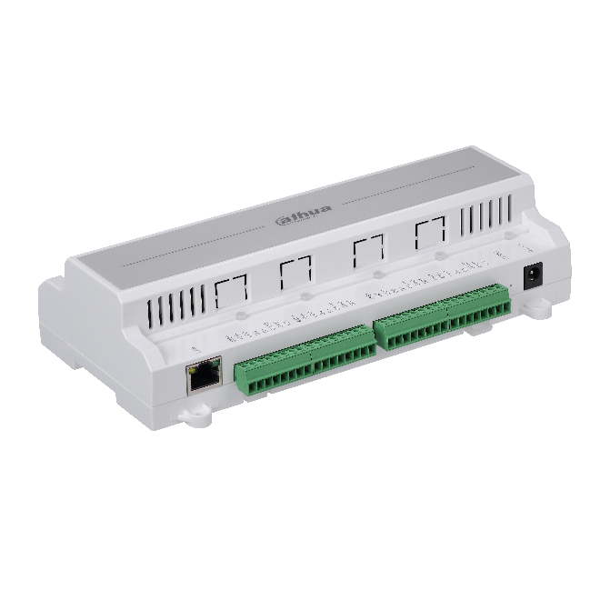

**ASC1204B**

**Features**

* Support 100,000 valid cards & 300,000 records
* Support multiple cards
* Support card, password, fingerprint and combination
* TCP/IP or RS-485 interface to PC
* Wiegand or RS-485 interface to readers(2/4 door)
* Door time out alarm, intrusion alarm, duress alarm and tamper alarm
* Anti-pass back, multi-door interlock, multi-card open
* Support 128 efficient time and holiday schedules
* Watch dog function ensure device free from halting
* Surface mounted installation

**Technical Specifications**

|  |  |  |  |
| --- | --- | --- | --- |
| **Model** | | | **ASC1204B** |
| **System** | | | |
| Main Processor | | | 32 Bit |
| Memory | | | 16M(32M External) |
| **Input/Output Ports** | | | |
| Input | | | Inputs x 9 ( door sensor x 4, exit button x 4, alarm x 1) |
| Output | | | Relay x 5(door lock x 4, alarm x 1 ) |
| Reader | | | Reader x 4 |
| **Capacity** | | | |
| Cardholders/Events | | | 100,000/150,000 |
| **Function** | | | |
| User Management | | General, VIP, Guest, Patrol, Black list, Force | |
| Alarm Function | | | Door time out alarm, Intrusion alarm, Duress alarm, Tamper alarm |
| Schedule Setting | | | Support 128 groups of schedule, 128 groups of period and 128 groups of holiday period |
| **Interface** | | | |
| To PC | RJ45(10/100M)/RS485 | | |
| To Reader | Wiegand/ RS485 | | |
| **Genreal** | | | |
| RTC | | | Yes |
| Ingress protection | | | IP55 |
| Power Supply | | | 9-15DC/500mA |
| Internal Battery | | | 1204C Support |
| Working Environment | | | -30℃-+60℃ |
| Working Humidity | | | ≤95% |
| Dimension(W×D×H) | | | 210*98*51mm |
| Weight | | | 0.5Kg |

**System Connection**

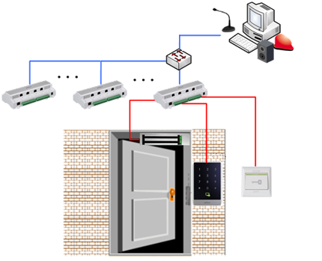

**Dahua Technology Co., Ltd.**

1187 BinAn Road, Binjiang District, Hangzhou, China

Tel: +86-571-87688883

Fax: +86-571-87688815

Email: [overseas@dahuatech.com](mailto:overseas@dahuatech.com)

www.dahuatech.com

*Design and specifications are subject to change without notice.

© 2015 Dahua Technology Co., Ltd.