|  |  |
| --- | --- |
| Model | ARK20C-W |
| Name | Wireless programming keyboard |
| Wireless Frequency | 433MHz |
| Transmit power | 10dBm |
| Transmit Distance | 1km（open area/no interference） |
| Tamper | Unit protection and leaving-wall protection |
| Installation Way | Portable, wall and 4X2 electricity box installation |
| Dimensions | 143*82*23 mm(L*W*H) |
| Weight | 0.25kg |
| Temperature | -10℃～50℃ |
| Humidity | < 95% |

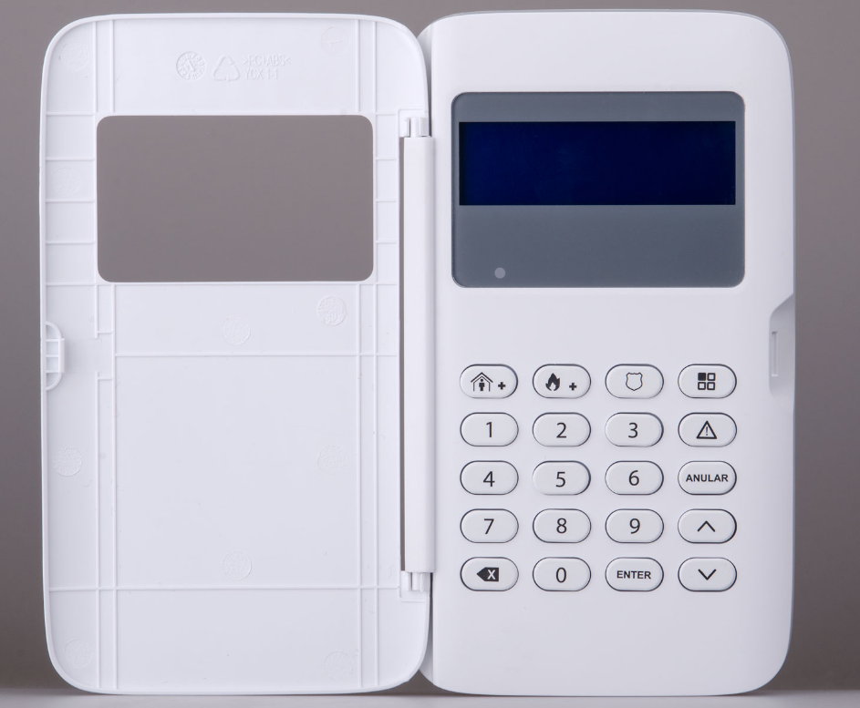

ARK20C-W